Power Analysis With SAS: T Tests

One Sample T Test
How many subjects would you need to have a 95% chance of detect a small, medium, or large effect if you use the traditional .05 criterion of significance and nondirectional hypotheses?

proc power;
onesamplemeans
nullmean=0
mean= .2 .5 .8
stddev=1
power=0.95
ntotal=.;
run;

Computed N Total

Actual N
Index Mean Power Total

1 0.2 0.950 327
2 0.5 0.950 54
3 0.8 0.956 23

If you are only able to obtain 25 scores, how much power will you have?

proc power;
onesamplemeans
nullmean=0
mean= .2 .5 .8
stddev=1
power=.
ntotal=25;
run;

Computed Power

Index Mean Power

1 0.2 0.161
2 0.5 0.670
3 0.8 0.970
Independent Samples T Tests
I want to see how many subjects I need to obtain 95% power for a small effect, a medium effect, and a large effect. I shall employ the usual .05 criterion of statistical significance and nondirectional hypotheses. I intend to have equal sample sizes in the two groups. I also want a plot of power versus sample size for the three effect sizes.
proc power;
twosamplemeans
meandiff= .2 .5 .8
stddev=1
groupweights=(1 1)
power=0.95
ntotal=.;
plot y=power min=0.5 max=0.99; run;

Computed N Total

Mean Actual N
Index Diff Power Total

1 0.2 0.950 1302
2 0.5 0.950 210
3 0.8 0.952 84
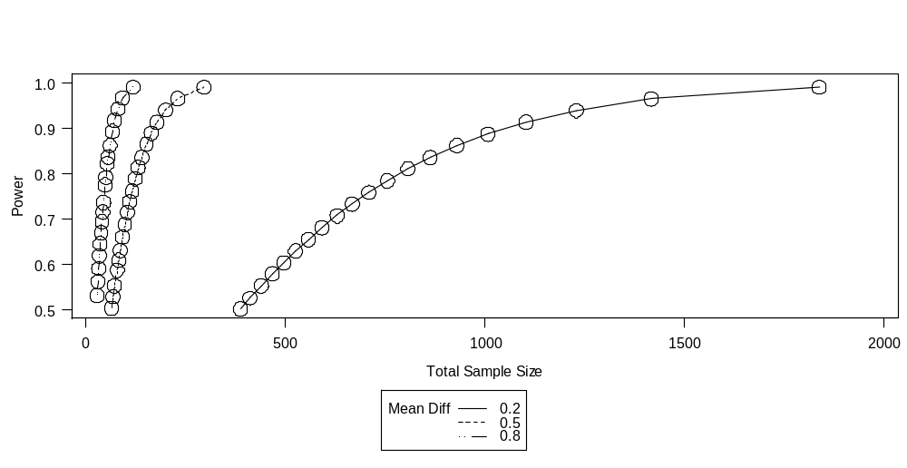

Suppose I anticipate having twice as many scores in the one group as in the other.
proc power;
twosamplemeans
meandiff= .2 .5 .8
stddev=1
groupweights=(2 1)
power=0.95
ntotal=.;
run;

Computed N Total

Mean Actual N
Index Diff Power Total

1 0.2 0.950 1464
2 0.5 0.951 237
3 0.8 0.955 96

I set out to get 210 scores evenly split into two groups. I ended up with 98 in the one group and 74 in the other. How much power will I have?
proc power;
twosamplemeans
meandiff= .2 .5 .8
stddev=1
groupns=(98 74)
power=.;
run;

Computed Power

Mean
Index Diff Power

1 0.2 0.252
2 0.5 0.898
3 0.8 >.999
Correlated Samples T Test
How many pairs of scores will I need to have 95% power if I use a .05 criterion of significance and nondirectional hypotheses?
proc power;
pairedmeans
meandiff= .2 .5 .8
stddev=1
corr=.8
npairs=.
power=.95;
run;

Computed N Pairs

Mean Actual N
Index Diff Power Pairs

1 0.2 0.950 132
2 0.5 0.952 23
3 0.8 0.965 11

Suppose that you will be able to obtain 132 pairs of scores, but expect the correlation to be only .6. What are your chances of obtaining a significant result?

proc power;
pairedmeans
meandiff= .2 .5 .8
stddev=1
corr=.6
npairs=132
power=.;
run;

Computed Power

Mean
Index Diff Power

1 0.2 0.722
2 0.5 >.999
3 0.8 >.999
Pearson r
How many subjects will you need to have a 95% chance of detecting a small, medium, or large correlation if you employ the traditional .05 level of significance and nondirectional hypotheses? Please note that it does matter (a little) whether you consider the X variable to be random (correlation model) or fixed (regression model).

proc power;
onecorr
corr= .1 .3 .5
power=.95
ntotal=.;
run;

Computed N Total

Actual Actual N
Index Corr Alpha Power Total

1 0.1 0.05 0.950 1293
2 0.3 0.05 0.950 138
3 0.5 0.05 0.954 46

You were able to obtain 97 scores. How much power will you have?
proc power;
onecorr
dist=t
model=random fixed
corr= .1 .3 .5
power=.
ntotal=97;
run;

Computed Power

Index Model Corr Power

1 Random X 0.1 0.164
2 Random X 0.3 0.855
3 Random X 0.5 >.999
4 Fixed X 0.1 0.165
5 Fixed X 0.3 0.866
6 Fixed X 0.5 >.999

Return to Wuensch’s SAS Lessons Page

Karl L. Wuensch, Dept. of Psychology, East Carolina University, Greenville, NC USA
March, 2010

