**Importing to SAS a Delimited, Plain Text Data File**

File, Import Data. For data source, select “Delimited File.”

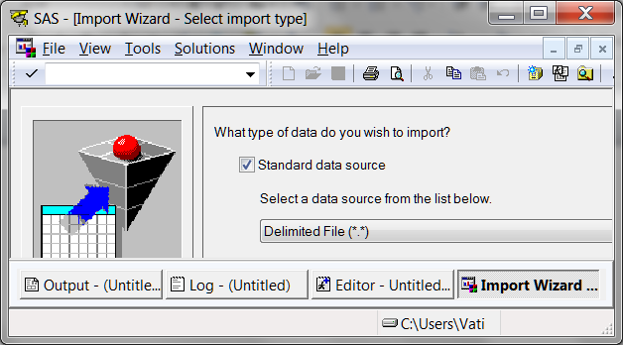

Point to the location of the source file.

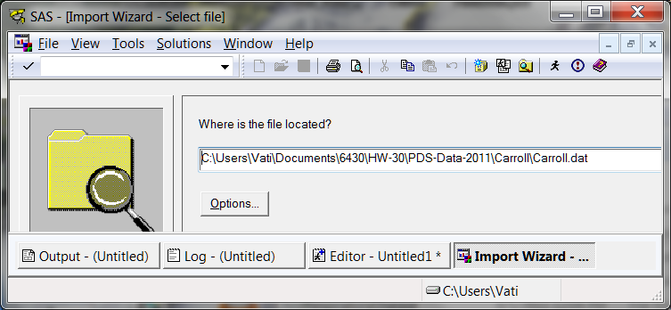

Under Options you can specify the delimiter. The default is a blank space. Indicate whether or not the first row of the input file contains the variable names (I recommend that you do put the names there).

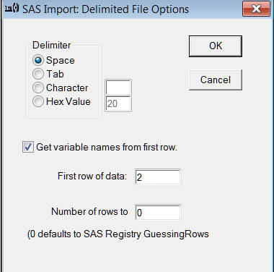

Specify a member name.

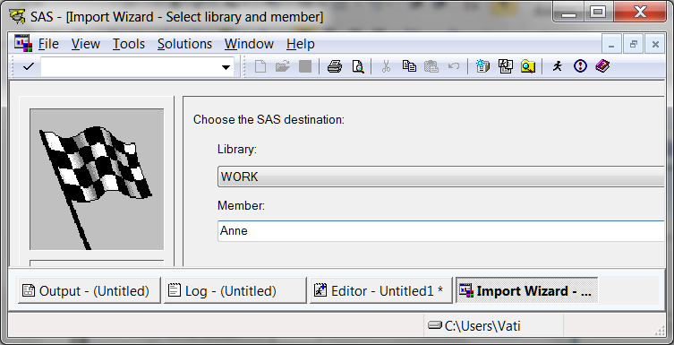

Optionally, ask SAS to write to a file the syntax to import these data.

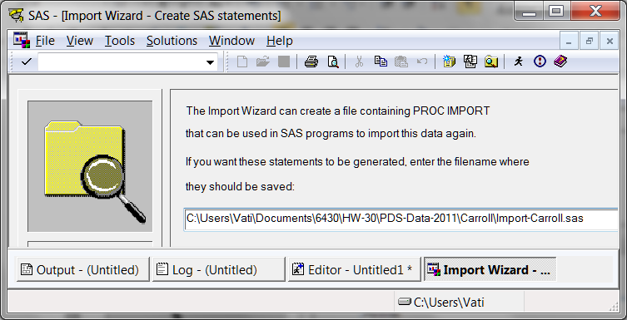

[Return to Wuensch’s Stats Lessons Page](http://core.ecu.edu/psyc/wuenschk/SAS/SAS-Lessons.htm)

8. Sept. 2011