**Exporting Data from SAS**

File, Import Data. Identify the (member) name of the data to be exported.

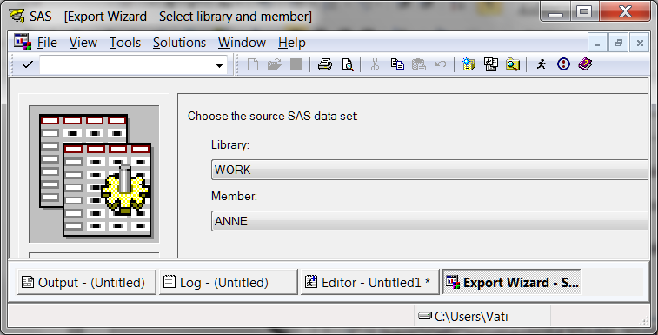

Select the type of file you wish to create. Here I selected Excel xls.

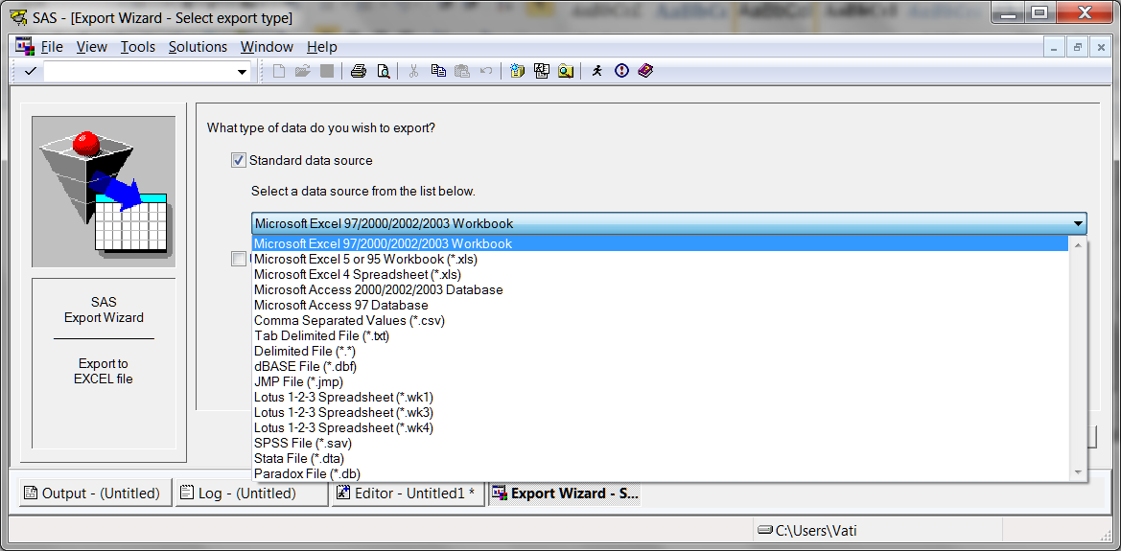

Browse to the folder where you wish to deposit the exported data.

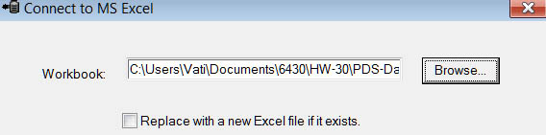

Provide a name for the Excel table being created.

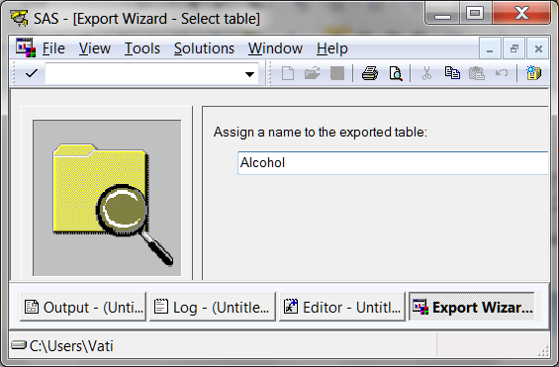

Optionally, ask SAS to create a file with the syntax for exporting these data.

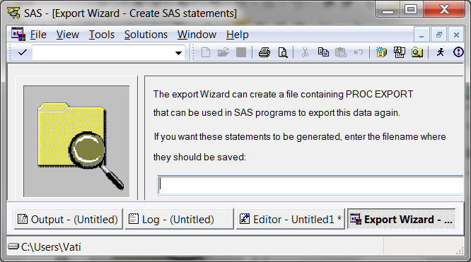

Finish. Check the destination folder. You should find your exported data there.

[Return to Wuensch’s Stats Lessons Page](http://core.ecu.edu/psyc/wuenschk/SAS/SAS-Lessons.htm)

8. Sept. 2011