Linux 主機開發環境建置說明
1. 登入Linux主機 2
2. 查看套件資訊 2
3. 安裝mariadb 2

登入Linux主機
ssh [使用者]@[主機IP]
[使用者]@[主機IP]’s password:[密碼]
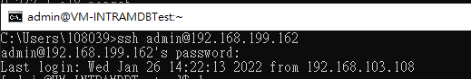
ex: ssh admin@192.168.199.162
admin@192.168.199.162’s password:Aa123456

查看套件資訊
sudo dnf info [套件名稱]
password for admin:[密碼] //需要輸入密碼才可以查詢套件資訊
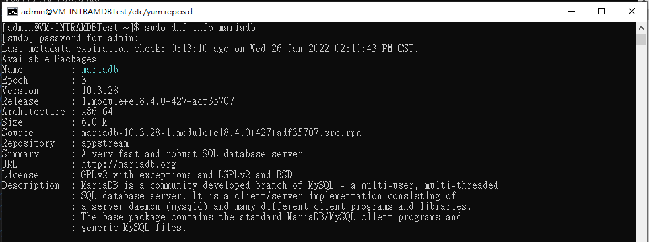
ex: sudo dnf info mariadb
password for admin:Aa123456

安裝mariadb
※vi與vm的指令整理 http://www.vixual.net/blog/archives/234
vi /etc/yum.repos.d/MariaDB.repo //進入mariadb的安裝設定檔
//新增檔案內容如下
//檔案內容start
[mariadb]
name = MariaDB
baseurl = http://yum.mariadb.org/[mariadb版本號]/[os版本]
gpgkey=https://yum.mariadb.org/RPM-GPG-KEY-MariaDB
gpgcheck=1
//檔案內容end
:w //儲存檔案
:q //退出
cd etc yum.repos.d/ //切換至此目錄
//下列為安裝指令
sudo vi ^C
sudo vi mariadb.repo //檢查檔案內容是否存在
sudo dnf install mariadb-server mariadb
//********開始安裝************
Is this ok [y/N]: y //輸入y
//********繼續安裝************
Complete! //完成
sudo systemctl start mariadb //啟用mariadb
sudo systemctl status mariadb //查看mariadb的狀態

Two all-privilege accounts were created.
One is root@localhost, it has no password, but you need to
be system 'root' user to connect. Use, for example, sudo mysql
The second is mysql@localhost, it has no password either, but
you need to be the system 'mysql' user to connect.
After connecting you can set the password, if you would need to be
able to connect as any of these users with a password and without sudo

