Final Project: DRAFT
Name: Jakub Szkoła
MATLAB release used: R2021b

Exercise 1. Fire of the forest GAME

Introduction:
My final work topic is – Fire of the forest GAME.
It is based on cellular automation and dyscretyzation methods.
Whole concept is about two game modes: Free mode and normal mode.
I’ll talk about them in detail in Functionality section.
Theoretical background:
A cellular automaton (CA) is a collection of cells arranged in a grid of specified shape, such that each cell changes state as a function of time, according to a defined set of rules driven by the states of neighboring cells. They may be used to simulate many real-life processes (like here symulation of the forest in fire).
The exact thing that I’m using is Moore neighborhood.
It’s named after Edward F. Moore, a pioneer of cellular automata theory.
Really popular ‘Game of life’ is basen on this solution.
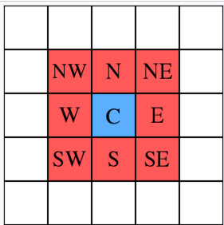
We’ve got one central cell and 8 cells around it. The state of these cells depends on the central cell state. Whole matrix with cells is working inside a loop, where with every step the state of cells is chanching.

Functionality:

Until now I was mainly focused on making GUI and to organize all the things.
Let’s start with looking at simulation. Now there is no animation yet, but I’ll say about whole concept.
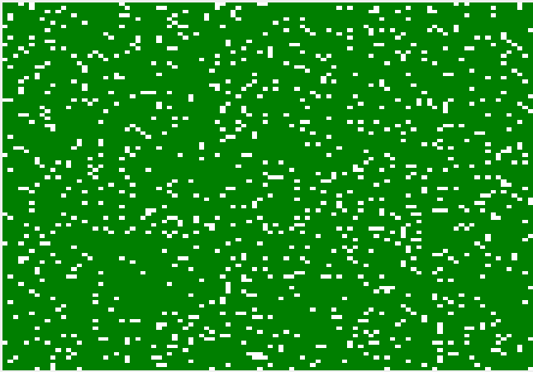
This is the grid. Every color will be representaing different state.
0 – green – alive tree
1 – red – tree on fire
2 – black - red tree
3 – white – empty space.
When the lightning strikes in certain point, from there cells start to be red (and they make cells next to them also red after a while). After some additional time cell become black (fire is not spreading from black cells). And at the end, after long time tree can be grown again.
In this moment the user can launch the program and there he can see main menu:
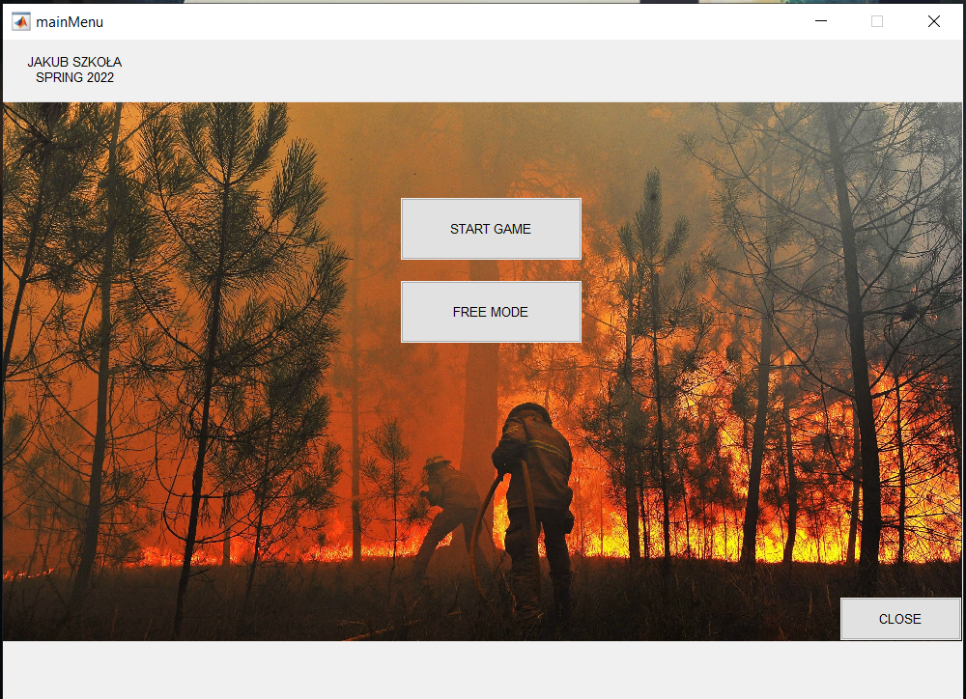
There user can find two options:
- Start game
- Free mode

Let’s start with discussion of free mode. There user can basically modify the simulation as he wants. User can change the wind strength ( it’s variable responsible for speed of fire spreading), time to burn (how long the tree will be on fire) and also density of the forest (how dense of trees is the forest). He can also put as many lightnings and firefighters as he wants.
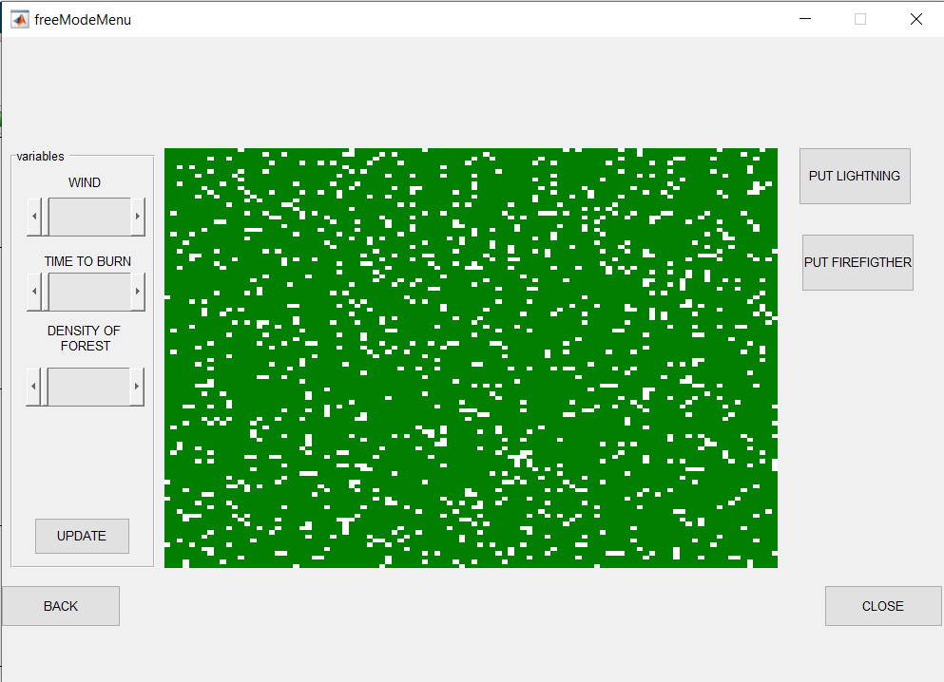
Like i said, until now I was mainly focus on GUI and idea at all, so i still have to make simulation, but for now there is working grid of forest and user can change the density with a slider. This is the result:
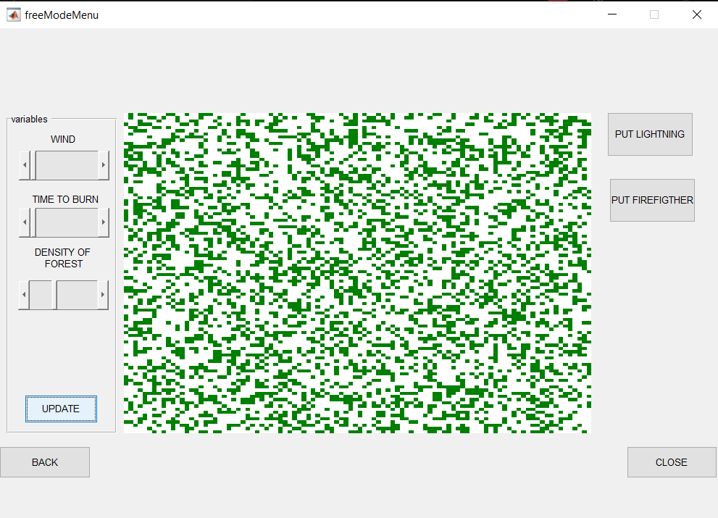

Second option is ‘start game’. From there user can choose one of three levels:
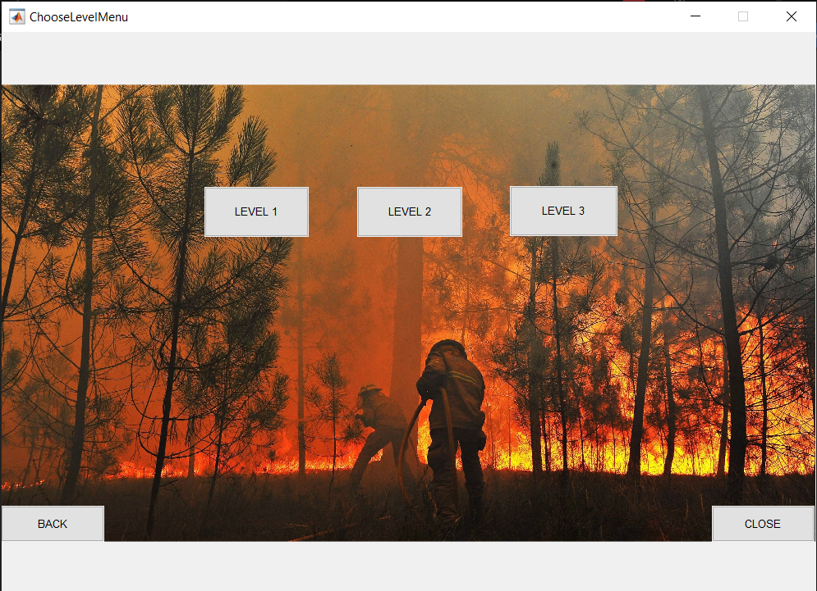
The differences between levels will be:
- more lightning at the beginning of every level
- different density of the forest on every level
Every time user can use three firefighters and his goal is to put down the fire.
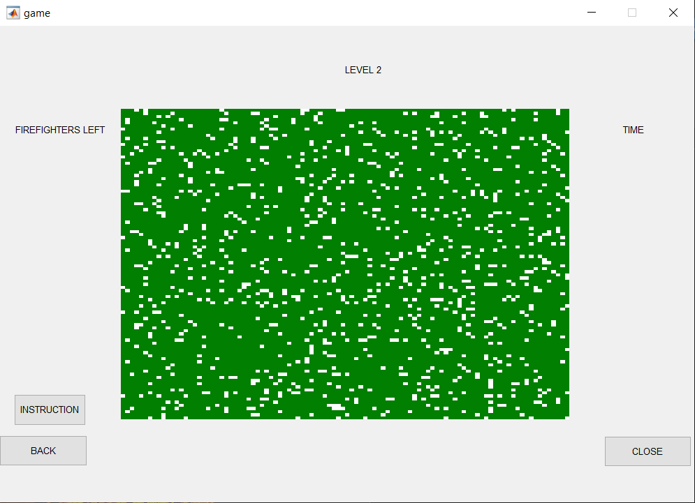
For now all levels look the same and i didn’t implement yet whole simulation function (inside there will be also functions responsible for figherfigters, but for now there is only making a screen with forest that is alive).
User can also find instruction what to do:
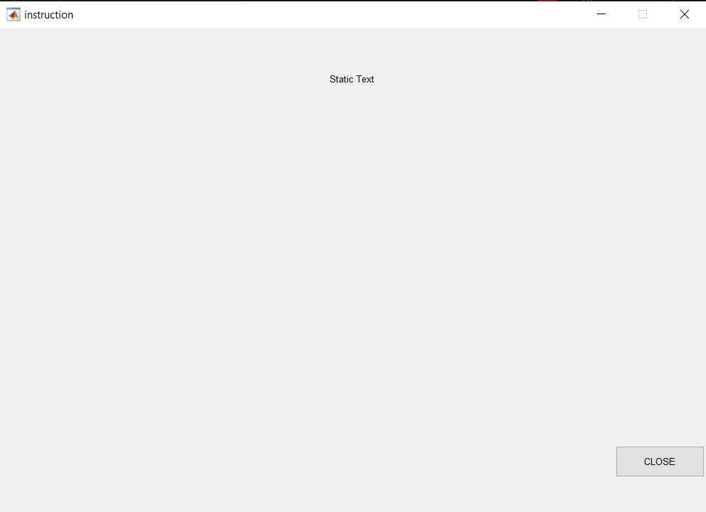
I’ll write the instruction at the ending of my project, when everything will be ready and working.

Matlab Code:

I have many GUI files, but they all work in similar way so I think there is no point to put all of them. Here we can see code responsible for simulation and code from freemode.m (GUI file).
I am also trying to hold on to the rules of clean code and I name variables and functions with understandable way(at least in my opinion). I’ll also put -help section to every one of them at the end of making my project.
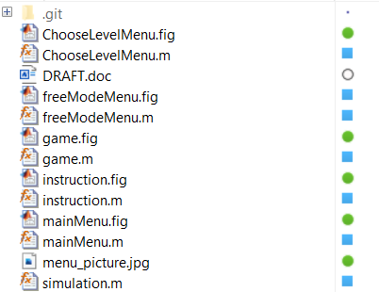

Simulation.m
function [] = simulation(density)
resolution = 100;
myColors = [0 0.5 0; 1 0 0; 0 0 0; 1 1 1];
forest = zeros(resolution);
Pn = zeros(1, resolution);
Pn(1:(resolution - density)) = 3;

for i = 1:resolution
for j = 1:resolution
forest(i,j) = forest(i,j)+Pn(randi(length(Pn)));
end
end

imagesc(forest)
colormap(myColors)
hold on
axis off
set(gca,'yticklabel',[],'xticklabel',[],'xtick',[],'ytick',[])
end
--------------------------------------------------------------------------------------------------------------------
freemode.m
function varargout = freeModeMenu(varargin)

% Last Modified by GUIDE v2.5 17-May-2022 17:24:15

% Begin initialization code - DO NOT EDIT
gui_Singleton = 1;
gui_State = struct('gui_Name', mfilename, ...
'gui_Singleton', gui_Singleton, ...
'gui_OpeningFcn', @freeModeMenu_OpeningFcn, ...
'gui_OutputFcn', @freeModeMenu_OutputFcn, ...
'gui_LayoutFcn', [] , ...
'gui_Callback', []);
if nargin && ischar(varargin{1})
gui_State.gui_Callback = str2func(varargin{1});
end

if nargout
[varargout{1:nargout}] = gui_mainfcn(gui_State, varargin{:});
else
gui_mainfcn(gui_State, varargin{:});
end
% End initialization code - DO NOT EDIT

% --- Executes just before freeModeMenu is made visible.
function freeModeMenu_OpeningFcn(hObject, eventdata, handles, varargin)
% This function has no output args, see OutputFcn.
% hObject handle to figure
% eventdata reserved - to be defined in a future version of MATLAB
% handles structure with handles and user data (see GUIDATA)
% varargin command line arguments to freeModeMenu (see VARARGIN)

% Choose default command line output for freeModeMenu
handles.output = hObject;

% Update handles structure
guidata(hObject, handles);
simulation(90);
set(handles.tag_background,'visible', 'off');
% UIWAIT makes freeModeMenu wait for user response (see UIRESUME)
% uiwait(handles.figure1);

% --- Outputs from this function are returned to the command line.
function varargout = freeModeMenu_OutputFcn(hObject, eventdata, handles)
% varargout cell array for returning output args (see VARARGOUT);
% hObject handle to figure
% eventdata reserved - to be defined in a future version of MATLAB
% handles structure with handles and user data (see GUIDATA)

% Get default command line output from handles structure
varargout{1} = handles.output;

% --- Executes on button press in tag_close.
function tag_close_Callback(hObject, eventdata, handles)
closereq();

% --- Executes on button press in tag_back.
function tag_back_Callback(hObject, eventdata, handles)
mainMenu();
closereq();

% --- Executes on button press in tag_lightning.
function tag_lightning_Callback(hObject, eventdata, handles)

% --- Executes on slider movement.
function tag_wind_slider_Callback(hObject, eventdata, handles)

% --- Executes during object creation, after setting all properties.
function tag_wind_slider_CreateFcn(hObject, eventdata, handles)

% Hint: slider controls usually have a light gray background.
if isequal(get(hObject,'BackgroundColor'), get(0,'defaultUicontrolBackgroundColor'))
set(hObject,'BackgroundColor',[.9 .9 .9]);
end

% --- Executes on slider movement.
function tag_time_to_burn_slider_Callback(hObject, eventdata, handles)

% --- Executes during object creation, after setting all properties.
function tag_time_to_burn_slider_CreateFcn(hObject, eventdata, handles)

% Hint: slider controls usually have a light gray background.
if isequal(get(hObject,'BackgroundColor'), get(0,'defaultUicontrolBackgroundColor'))
set(hObject,'BackgroundColor',[.9 .9 .9]);
end

% --- Executes on button press in tag_update.
function tag_update_Callback(hObject, eventdata, handles)
p = get(handles.tag_density_slider, 'Value') * 100;
p = round(p, 0);
simulation(p);

% --- Executes on slider movement.
function tag_density_slider_Callback(hObject, eventdata, handles)

% --- Executes during object creation, after setting all properties.
function tag_density_slider_CreateFcn(hObject, eventdata, handles)

% Hint: slider controls usually have a light gray background.
if isequal(get(hObject,'BackgroundColor'), get(0,'defaultUicontrolBackgroundColor'))
set(hObject,'BackgroundColor',[.9 .9 .9]);
end

% --- Executes on button press in tag_firefigther.
function tag_firefigther_Callback(hObject, eventdata, handles)

Comments:
I’m looking forward to hear if everything is fine or maybe I should change some things.
My goal for now is to focus on making simulation animation and proper working of firefighters.

