1.1

Frame

Frame2

personalizedHello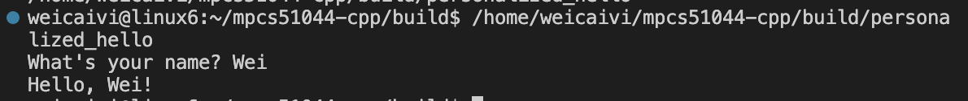

vector_simple_demo



1.5

C++ is called "C++" as a play on the increment operator (++), which is used in C (and later in C++) to increment a variable's value by one. This naming was chosen to symbolize the language's evolution as an "increment" or enhancement of the C programming language. C++ extends C by adding object-oriented features, among other improvements, effectively making it "C incremented."

The postfix increment operator "++" increments the value of the variable but returns the original value before it was incremented. This is somewhat analogous to how C++ was developed: it builds upon and extends the original value (capabilities) of C.

If it were named "++C" using the prefix increment logic, it implies that the change (increment) happens first before using the value. This might suggest a more radical departure or redefinition from C, which isn't the case since C++ is built as an extension and largely maintains backward compatibility with C. Therefore, "C++" suggests enhancing and building upon existing foundations, which is the core philosophy behind the development of C++.