|  |  |
| --- | --- |
| **Date:** | 31 October 2019 |
| **Time:** | 7:00 PM – 8:00PM |
| **Venue:** | SIS Level 3 |
|  |  |
| **Attendees:** | Wong Wei Ling, Shermin Tan |
|  |  |
| **Agenda:** | 1. Handover PM responsibilities 2. Update Wei Ling on the project progress for Iteration 3  (e.g. functions, scheduling) 3. Brief Wei Ling on the bugs that have to be worked on moving forward in Iteration 4 |

|  |  |  |  |
| --- | --- | --- | --- |
| **No.** | **Task** | **Done by** | **Due Date** |
| 1 | Get everyone’s availabilities and plan for the start of iteration 3 group meeting | Wei Ling | 31 October 2019 |

**Iteration 3 Bugs**

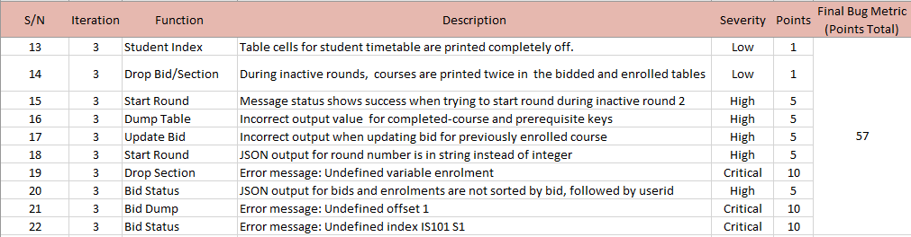

**Changes to Be Made After UAT**

* Minimum bid amount should be shown for all courses, not only those that the student has bid for.
* Change clear round to stop round
* Remove table scrolling and place form at the top

The meeting was adjourned at 8pm. These minutes will be circulated and adopted if there are no amendments reported in the next three days.

Prepared by,

Wong Wei Ling

Vetted and edited by,

Shermin Tan