|  |  |
| --- | --- |
| **Date:** | 12 September 2019 |
| **Time:** | 2:30 PM – 3:15PM |
| **Venue:** | SMU Student Study Lounge, Level 1 |
|  |  |
| **Attendees:** | Goh Soo Chi, Wong Wei Ling, Lim Jia Yu, Beh Wei Chen |
|  |  |
| **Agenda:** | 1. Gain understanding of the new requirements added to the wiki (12/9/19)  2. Set up directory structure in central repository  3. Discuss what elements need to be included on each webpage  4. Plan out programming schedule in terms of functionalities and roles  5. Create a rough web app process flow for Student and Admin |

|  |  |  |  |
| --- | --- | --- | --- |
| **No.** | **Task** | **Done by** | **Due Date** |
| 1 | Complete login.php, index.php, common.php and protect.php | Wei Chen & Shermin  Soo Chi & Wei Ling | 19 Sept 2019 |
| 2 | Come up with other required php files | Everyone | 19 Sept 2019 |
| 3 | Review the PHP code in Lab 4 to understand how JSON & Bootstrap works | Everyone | 19 Sept 2019 |

**Programming Schedule**

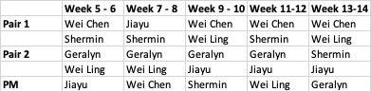

**Web App Process Flow**

Admin

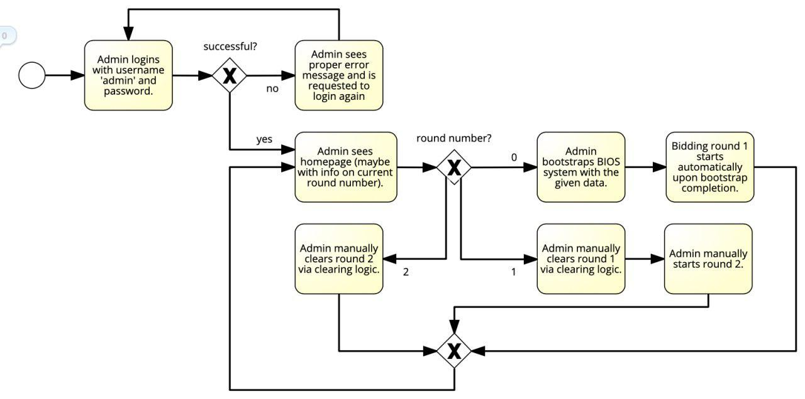

Student

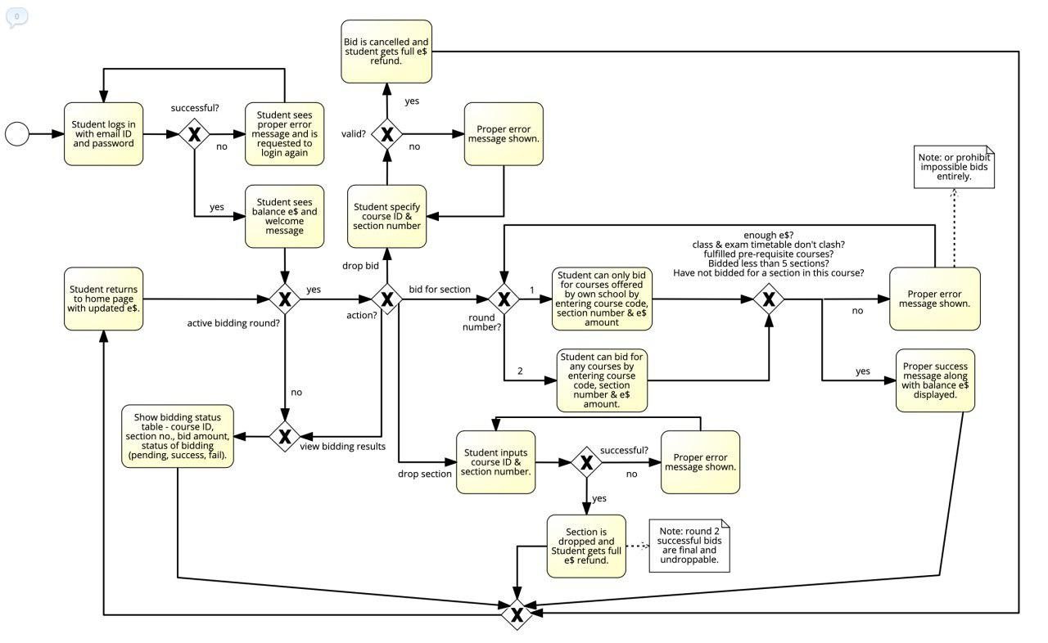

**Files Required:**

Login.php

Index.php:

* For student, it shows
  + 1st login: welcome message, balance e$, bidding results table (during bidding period), bid (link), drop bid (link), drop section (link)
  + 2nd: All of the above, except welcome message

Protect.php

Common.php

bidDAO.php: what bids each student currently has

studentDAO.php: students’ bid details

courseDAO.php: available courses

sectionDAO.php

prereqDAO.php: prerequisites for each course

coursecompletedDAO.php: courses completed by each student

The meeting was adjourned at 3.15 pm. These minutes will be circulated and adopted if there are no amendments reported in the next three days.

Prepared by,

Soo Chi

Vetted and edited by,

Wei Chen