|  |  |
| --- | --- |
| **Date:** | 16 October 2019 |
| **Time:** | 7:00 PM – 10:00PM |
| **Venue:** | LKCSB SR 2.8 |
|  |  |
| **Attendees:** | Goh Soo Chi, Wong Wei Ling, Lim Jia Yu, Beh Wei Chen, Shermin Tan |
|  |  |
| **Agenda:** | 1. Review team’s progress thus far 2. Understand the latest wiki changes as of 10th October 2019 3. Prepare Application Demo and Progress Update slides |

|  |  |  |  |
| --- | --- | --- | --- |
| **No.** | **Task** | **Done by** | **Due Date** |
| 1 | Have a good night’s rest for tomorrow ☺ It’s the end of iteration 2! | Everyone | 17 October 2019 |

**Updated Schedule for All Iterations *only iteration 2 shown \***

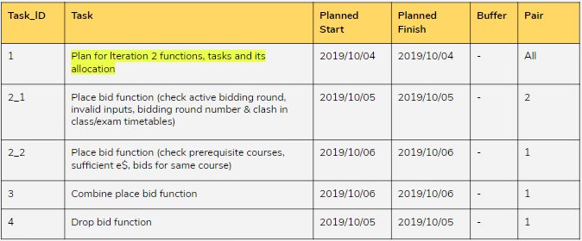

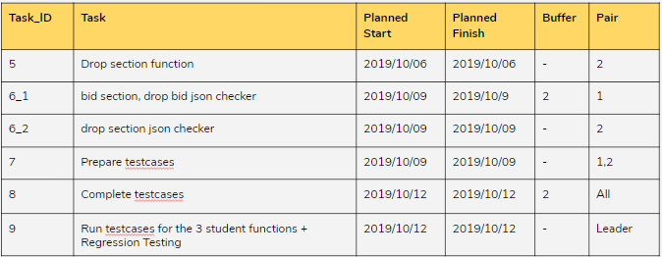

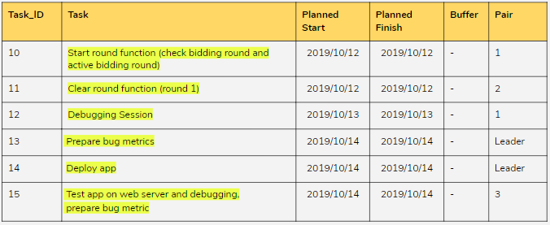

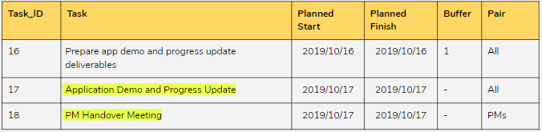

**Updated Bug Metrics**

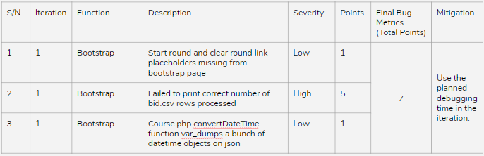

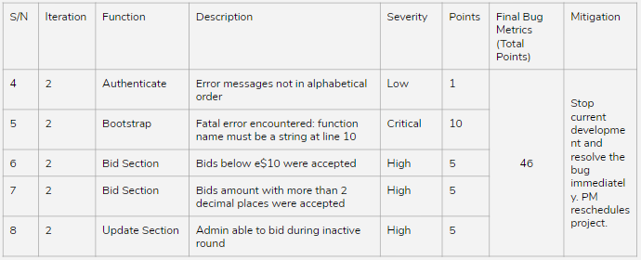

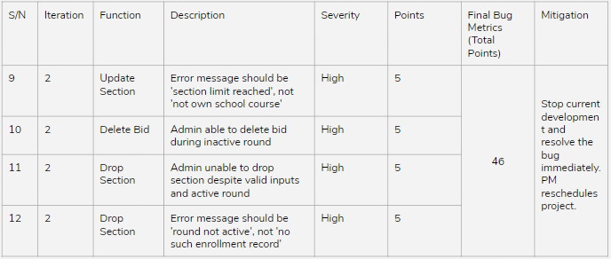

Presentation slides for Week 9’s Application Demo and Progress Update were created with all of the changes since Iteration 1 clearly highlighted.

The meeting was adjourned at 10pm. These minutes will be circulated and adopted if there are no amendments reported in the next three days.

Prepared by,

Lim Jia Yu

Vetted and edited by,

Goh Soo Chi