**编译原理期中测验（2018）**

**学号： 姓名： 成绩：**

**一、Mark each statement *true* or *false* ( 2 points each， 6 cents )**

1. The same language token may be generated by many different regular expressions. （T）
2. To any regular expression, we can find a context-free grammar defining the same language. （T）
3. The LL(1) parsing algorithm parses an input string of tokens by tracing out the steps in a rightmost derivation. （F）

**二、Single Choice ( 1 points each ，5 cents)**

1、The concept ( ) is not related to the LL(1) parsing method.

[A] Left-factoring [B]. First set and follow set

[C.] Left recursion removal [D]. Shift and reduce

3、In the production A →B α C, we have

[A] Follow (C) ⊂ Follow (A), First( B) ⊂ First( A)

[B] Follow (C) ⊂ Follow (A), First( A) ⊂ First(B)

[C] Follow (A) ⊂ Follow (C), First( B) ⊂ First( A) 

[D] Follow (A) ⊂ Follow (C), First( A) ⊂ First(B)

4、IF one CFG grammar contains two non-terminals ‘A’,’B’ and two terminal ‘a’,’b’, where ‘A’ is the start symbol, then the Follow set of ‘A’ may be ( )

[A] {a, b} [B] {a, b, $} [C] {a, b, ε} [D] {a, b, B}

5、In the Top-Down Parsing, the action ( ) will never be used.

[A] Shift [B] Match [C] Generate [D] Accept

**三、question （39 cents）**

1、 Given the NFA for below for 0*(01)*0*, construct a minimum state DFA: ( 8 cents) **（如果状态错的很多的话，就给个基本分3分）**

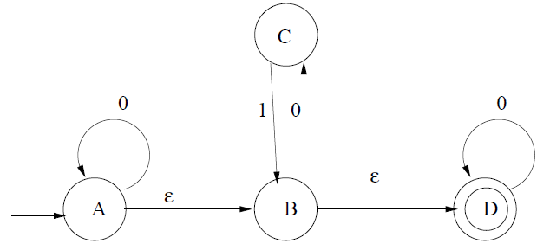

0

0

1

0

1

0

0

2、Given the follow grammar. **（有的同学去掉了M再做下一步，应该也算对的 ）**

S→L

L→MLb

L→a

M→ε

(S is the start symbol.)

Construct the LR(1) DFA for the grammar. **(10 cents) (错一个状态扣1分)**

Solution:

Solution:

1. The LR(1) DFA of this grammar is as follows:

S→▪L, $

L→▪MLb, $

L→▪a, $

M→▪, a

S→L▪, $

L→M▪Lb, $

L→▪MLb, b

L→▪a, b

M→▪, a

L

L→a▪, $

M

a

L→ML▪b, $

L

L→M▪Lb, b

L→▪MLb, b

L→▪a, b

M→▪, a

M

L→a▪, b

a

L→ML▪b, b

L

M

a

L→MLb▪, b

L→MLb▪, $

3、(7 cents )



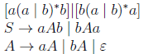

4、Consider the following grammar of simplified C declarations:

declaration → type var-list

type → int | float

var-list → identifier, var-list | identifier

(a) Left factor this grammar. ( 3 cents ) **（由于这个第一步没有做好影响下面的正确性，后面扣分可以适当少一点的）**

(b) Construct First and Follow sets for the nonterminals of the resulting grammar.( 6 cents ) **（错一个扣一分，扣完为止，注意：$没有的不扣分）**

(c) Construct the LL(1) parsing table for the resulting grammar. (5 cents)

**（一个扣0.5分， 没有$这一列的不扣分，没有逗号的还是要扣分。）**

**d部分没有放入题目中。**

