BIOL 310 Plant Systematics Practice Questions for Exam 1

1. Why might some people call red algae a "plant"? Why aren't red algae technically land plants?

Some red algae are photosynthetic and multicellular, and some people apply the term "plant" to all photosynthetic origins. But the evolutionary origin of the chloroplast in red algae is independent of the evolutionary origin in green plants and land plants, and the vast majority of red algal species are aquatic. Therefore they are not land plants.

2. What plant family is being described in the passage from the Flora of Virginia below?

Inflorescences heads (sometimes called capitula), with individual flowers (florets) sessile on a common receptacle, which is almost always subtended by an involucre of bracts, that, regardless of form or texture, are called phyllaries.

Asteraceae

3. Label each flowering head below with the kind of head it is.

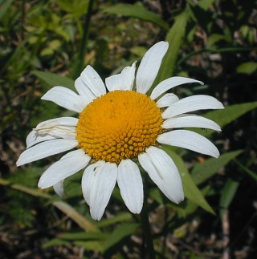

radiate

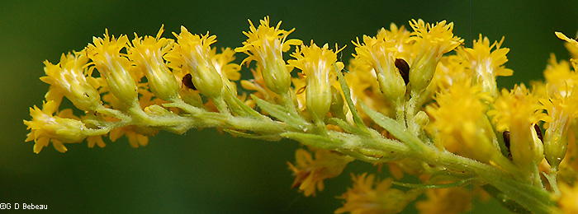

discoid

4. Use the tree to answer the questions below.
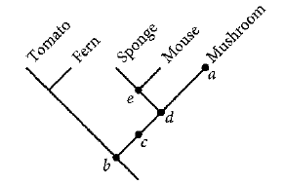

a. Which of the nodes in the tree corresponds to the most recent common ancestor of a mushroom and a sponge?
d

b. Are mushrooms more closely related to mice than to sponges, or equally related to both?
equally related to both

c. On the tree, indicate the evolution of a synapomorphy for tomatoes and ferns.
(blue rectangle)

d. Circle a monophyletic clade on the tree.
blue circle (there are multiple right answers)

e. Would a group that just included sponges and mushrooms be monophyletic?
No, it would not be monophyletic.

5. The four trees each depict a history of trait evolution for a character with three character states, 0, 1, and 2. The character states at the tips are shown, as well as each transition.

a. Which of these four provides a complete and plausible history of trait evolution?
b

b. Circle the branch leading to the outgroup on the tree you have chosen.

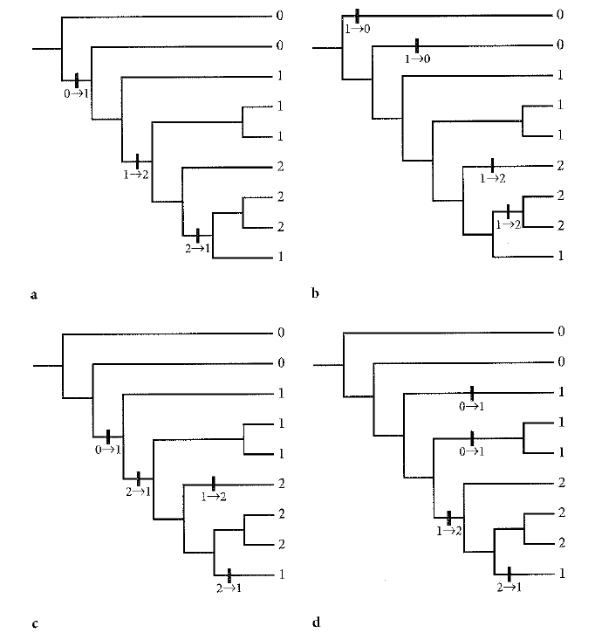

6. For the data matrix below, the letters represent species and the numbers represent characters. Assume that taxon A is the outgroup.

 | 1 | 2 | 3 | 4 | 5 | 6 | 7
A | 0 | 0 | 0 | 0 | 0 | 0 | 0
B | 0 | 1 | 1 | 0 | 1 | 1 | 0
C | 1 | 1 | 0 | 1 | 1 | 0 | 1
D | 1 | 1 | 0 | 1 | 1 | 0 | 1
E | 1 | 1 | 0 | 0 | 0 | 0 | 0
F | 0 | 1 | 1 | 0 | 0 | 1 | 0
G | 0 | 1 | 1 | 1 | 1 | 1 | 0
H | 0 | 1 | 1 | 1 | 0 | 1 | 0

a. For which characters do taxa A and E share the same state?
3, 4, 5, 6, 7

b. For which characters do taxa C and E share the same state?
1,2,3,6

c. Which characters suggest that C is more closely related to E than A?
1,2

d. Which characters directly contradict the claim that C and E are more closely related to each other than either is to A?
4, 5, 7

7. If species A and Species B are in the same family, must they also be in the same genus? In the same order?

Not necessarily; two species in the same family can be in different genera. However, any species in the same order must also be in the same family.

8. Choose the correctly-written species name:

a. Liriodendron tulipifera L.

b. Liriodendron tulipifera L.

c. L. tulipifera L.

d. Liriodendron tulipifera (L.)

e. Liriodendron Tulipifera L.

9. The figure below is from a study in which the authors used DNA sequence data to generate a phylogeny of the orchid subtribe Coleogyninae. They then mapped the character states traditionally used as defining characters for the genus Coleogyne on the tree.

a. Is the genus Coelogyne monophyletic?
no
b. What is the ancestral character state for these two characters?
lip base saccate, petal ovate-oblong
c. Is the shape of the petal (ovate-oblong or linear) a useful synapomorphy? Explain your answer.
It is for some clades (like the three taxa at the top of the tree) but it isn't a synapomorphy for all taxa classified as Coleogyne
d. What recommendations would you make for revising the classification of Coleogyne?
You could recommend that Coleogyne be broken up into two separate genera, each including a few related taxa (the lower Coleogyne clade could be combined with Neogyna and Pholitoda into a new genus, for example). Or you could recommend that Coleogyne be expanded to include all other genera that are related, to create a monophyletic genus.

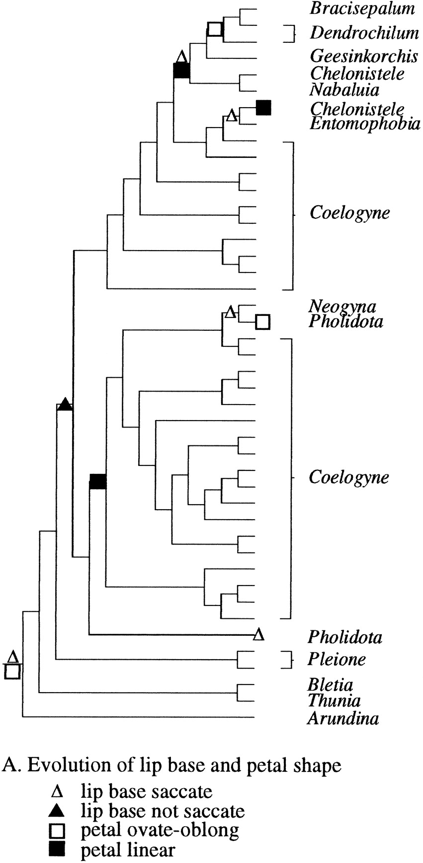

Fig. 5. A most parsimonious reconstruction of character state evolution on one of the four trees from the combined molecular data for the following characters used in traditional classifications of Coelogyne and Coeloygninae.

10. The figure below is from the same study of Coleogyne. This tree includes bootstrap values as percentages below the branch (ignore the "d=" values).

a. What is the outgroup for this tree? How many character state changes separate it from the rest of the taxa in the tree?
Arundina graminifolia; 136
b. Give the names of two sister species that share a branch supported by a bootstrap value above 70%.
Example - Chelonistele sulphurea and Entomophobia kinabaluensis (there are multiple correct answers)
c. Circle a clade on the tree that is not well-supported by bootstrap values.
Example circled in blue; (there are multiple correct answers)

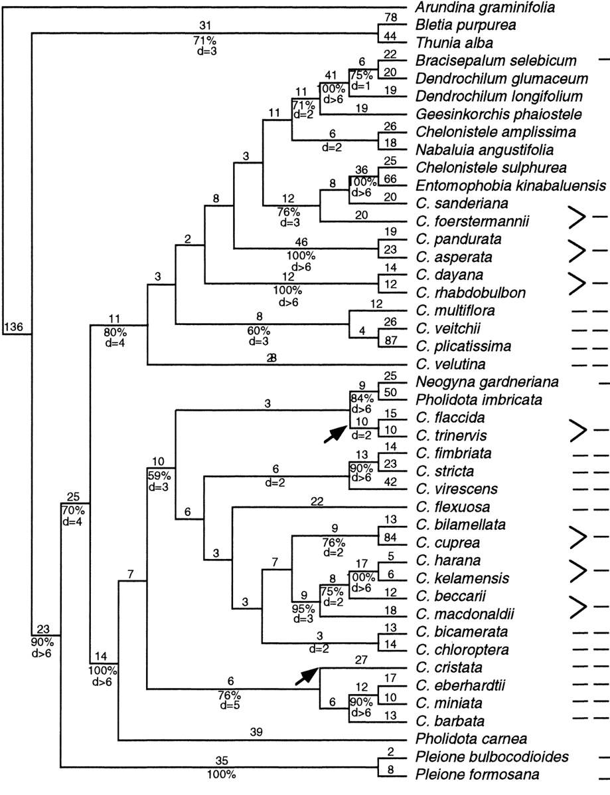

Fig. 3. One of the four trees from parsimony analysis of the combined molecular data. Branch length (number of nucleotide substitutions) is indicated above the branches and bootstrap percentages (only >50%) and Bremer support below them. Groups not present in the strict consensus are indicated with an arrow.

- Use the abstract and figures below to answer the following questions:

- Why were the taxa in the tree selected?
To update the classification of Errazurizia including a south American species, to trace the evolution of petal number, and to describe a new genus.

- What kind of characters were used?
The chloroplast genome and a cistron from nuclear DNA

- What method of phylogeny reconstruction was used?
Maximum likelihood (and Bayesian branch support)

- Is this a consensus tree?
no

- Does branch length tell you anything?
The tree in Figure 2B has branch lengths that correspond to the number of mutations (character state changes)

- How was cladogram robustness determined?
Bootstrap and Bayesian posterior probabilities

- Are many clades robust?
Yes, almost all the clades are very well supported

h.. What do we learn from the tree?

That the South American species is related to two of the other species of Errazurizia, but that E. rotundata doesn’t actually belong in the genus and needs to go in its own, new genus. We also learn that having five petals is ancestral for the species in the tree, and that having 1 and then no petals are derived character states that have each evolved once.

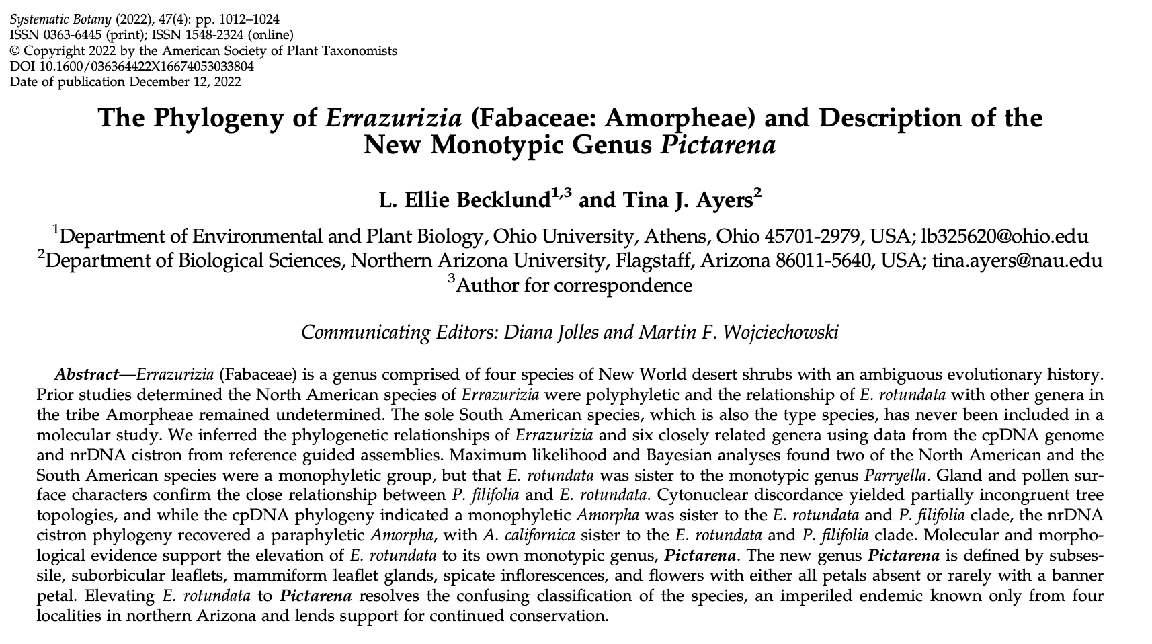
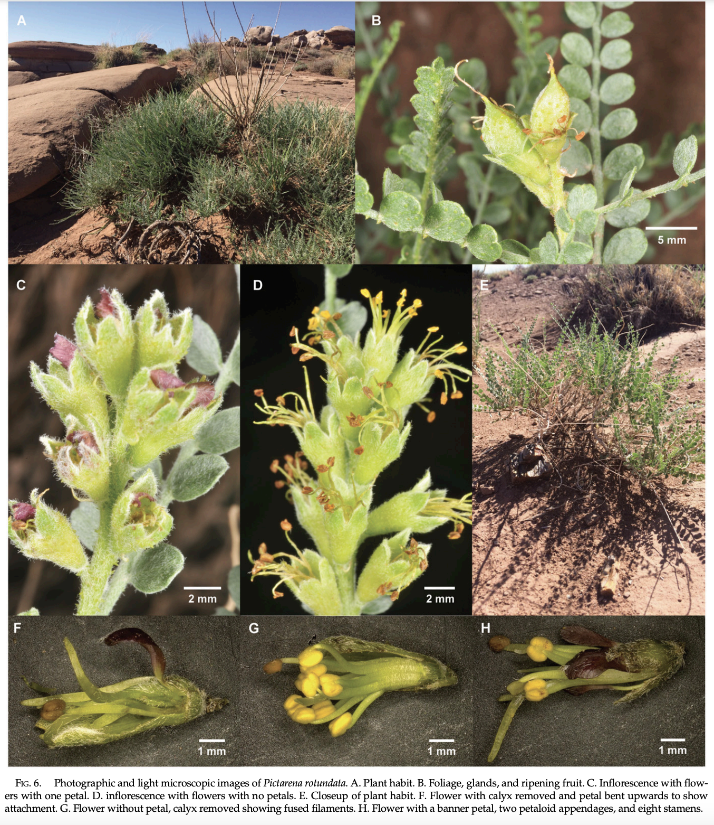
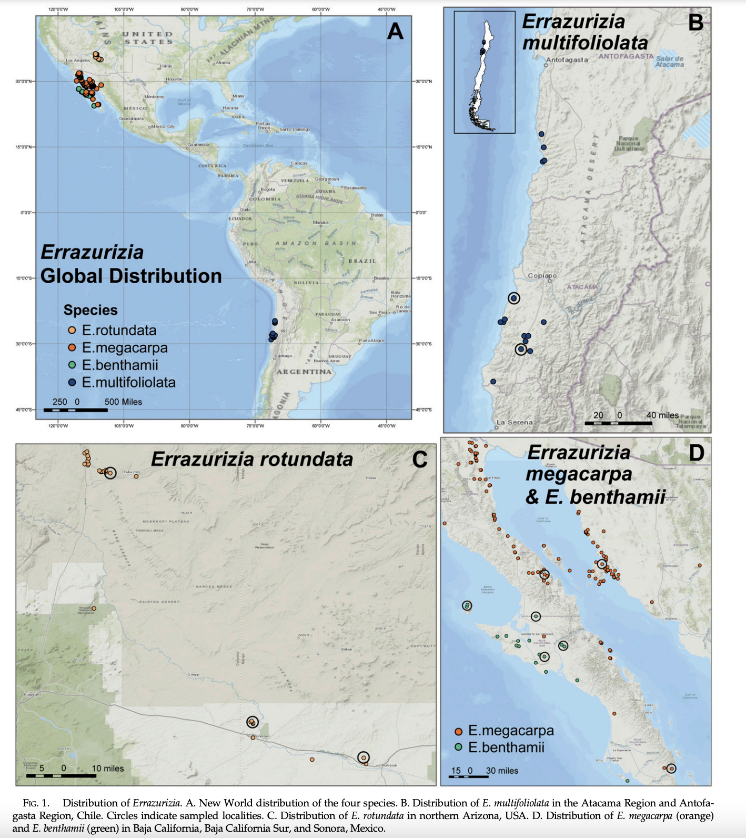

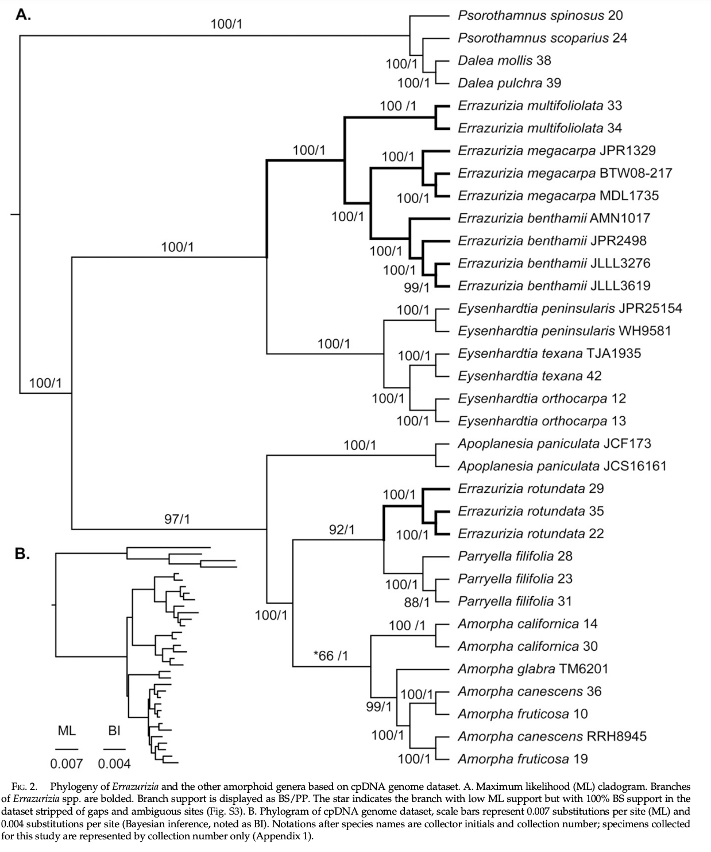

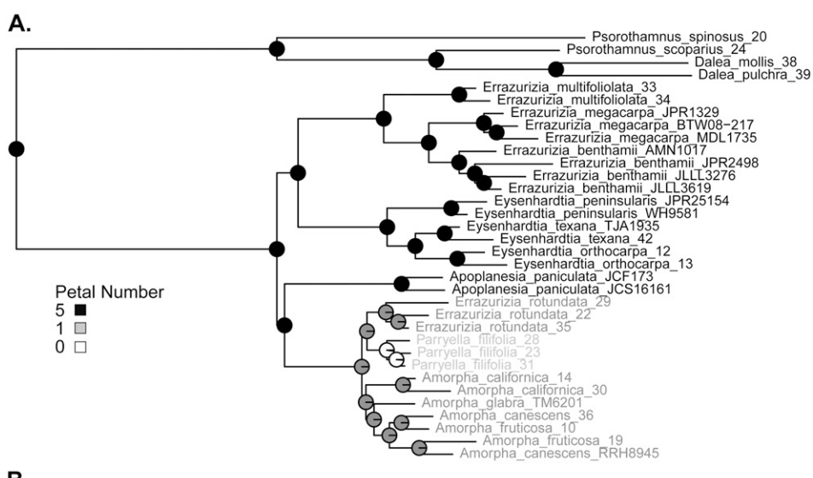

12. a. Using the character by taxon matrix below, indicate the most parsimonious character state changes on the tree on the next page. is the outgroup, and its character states represent the ancestral state for Coptis. Label each change with the new character state.

b. For any reversal and/or convergence events in the tree, write "reversal" or "convergence" next to the character state change.

Table 1. Character by taxon matrix for five morphological characters in 7 species in Coptis and Xanthorhiza.
 | Leaf type | Central leaflet base | Sepal shape | Number of petals | Petal blade
Xanthorhiza simplicissima | pinnate | petiolate | elliptic | 5 | peltate
Coptis trifolia | ternate | sessile | elliptic | 5 | peltate
Coptis ramosa | pedate | sessile | elliptic | 5 | peltate
Coptis occidentalis | ternate | petiolate | lanceolate | 5 | epeltate
Coptis quinquesecta | pedate | petiolate | lanceolate | 7 | epeltate
Coptis chinensis | ternate | petiolate | lanceolate | More than 7 | epeltate
Coptis japonica | ternate | petiolate | lanceolate | More than 7 | epeltate

Xanthorhiza simplicissima
Coptis trifolia

Sessile central leaflet base
Coptis ramosa

Pedate leaves - C
Ternate leaves

Coptis occidentalis

(could also put 7 petals here)
Coptis japonica
Coptis chinensis
Coptis quinquesecta
Lanceolate sepal
Pedate leaves - C
epeltate petal

More than 7 petals
Seven petals

