H5X

I-Domain Profile

Revision 3.01

Author: quanbing_chen
[/***]
- HW SPEC撰寫之目的在於 : 說明如何使用對應的hardware module及文件化 “共通的protocol”
- Starting
  - 請將第一頁的 “ModuleName” 改成負責module 的名字, 例如 MVD
  - 請將第一頁的 “Author” 改成此spec之負責人的名字(ie. Dot-project指定的人)
  - 請務必打開 “工具/追蹤修訂/標示修訂處/編輯時加上修訂標記” 之選項
- SPEC產出, 包含
  - General Description – 描述此spec的目的, 包含內容的範疇及其他子章節共通的敘述.
  - Feature – 列舉此spec所描述之module的feature list
  - Block diagram – 圖示並說明此module的架構, 例如
    - module的輸入與輸出
    - 輸入與輸出之protocol, module的組成子模組
    - 各子模組的功能
    - 各子模組連接的protocol
    - 任何可以清楚描述此module的文字與圖示
  - 功能說明與圖例示意
    - 使用Timing chart – 將例如module輸入與輸出之protocol或是interface的protocol等Timing chart文件化
    - 使用Flow chart – 說明使用此module的scenario
    - 加上Illustration – 說明執行該module之前後的圖示說明, 例如飽和度調整前後圖示
  - Register Set定義與使用方法說明
  - 其他注意事項
- Version Control and SPEC check in
  - 請於每次修正spec時, 將修正之item概要地說明於Revision History, 並增加小數版次一版, 例如 1.01→1.02
  - 請於每次召開review meeting後, 務必將與會人員名單一併紀錄於 “Revision History”的Revision Note內, 並增加整數版次一版, 並將小數版次歸零, 例如 1.23→2.00. 並執行“工具/追蹤修訂/接受或拒絕修訂/全部接受”
  - 例如 : RTD2980-DesignSpec-Peripherals-20060425vP.QQ.doc 為第P次review後的第QQ次修訂
  - Spec check in SVN server前, 務必執行過 Register Paser並修正所有error或是warning. 請參考 \\rtsh1\650D\DV_tool_doc 內的文件說明
- Note
  - 若某些內容是以後產出datasheet (release 給客戶用的) 時, 不希望被release的部分, 請於 “該內容” 之前加上[/***], “該內容” 之後加上[***/]
  - 以後產出datasheet (release 給客戶用的)時, 會release給客戶的部分(ex. General Description, Feature, Block diagram, Register set等)請用英文撰寫; 其他部分(ex. 功能使用詳細說明)可用中文撰寫, 以減少撰寫時間及增加完整度, 但務必將中文撰寫部分加上[/***]…[***/]
  - Register 大小寫定義
    - Register Parser對大小寫並無要求, 且tool會自動全部轉成小寫
    - 在定義時register請取有意義的字, 但怕彼此採用相同的名稱, 請在register name的部分請以大寫字母加入該function module的縮寫或全名(不要太長),再加上underline後再加上有意義的名稱, 在field name也是這樣. Ex. Register:: SyICH2_PowerCtrl. field-->SyICH2_ADCPowerDown.
  - Pin sharing文件, 務必執行過 Pin sharing auto並修正所有error或是warning. 請參考 \\rtsh1\650D\DV_tool_doc 內的文件說明
[***/]
Revision History

Version | Revision Note | Editor | Revision Date
0.01 | Branch from Magellan | Pohsien | 2012/9/28
0.02 | From MacArthur2 | Pohsien | 2013/1/27
0.03 | Add source detection, extend addr length to 10 bit | Tonychen | 2013/3/19
0.04 | Add figure of block diagram | Tonychen | 2013/4/2
0.05 | From Sirius | Xiang_ou | 2013/9/24
1.00 | From Macarthur3 | Dana | 2014/1/22
1.01 | Add register ch1_pf_xx , for another statistic | Dana | 2014/1/22
1.02 | Add diff sum introduction | Jzl | 2014/2/17
1.02 | Address mapping | Dana | 2014/2/17
1.03 | Add register control for pf2 | Jzl | 2014/3/03
1.04 | Add register diff_bin_H | Dana | 2014/3/12
1.05 | Delete register test_mode_enable | Dana | 2014/3/12
1.06 | From Magellan2 | Flora_huang | 2014/8/21
1.07 | add description of srcdet function‘s limitation | Flora_huang | 2015/4/1
1.08 | From Merlin | Caomao | 2015/07/03
2.00 | From Merlin2 | Huang_li | 2016/08/23
2.01 | Add i2rnd | quanbing_chen | 2017/05/26
2.02 | From Merlin3 | quanbing_chen | 2017/08/28
2.03 | Add constrain to En_4k2k_mode，0x18023400[14] | quanbing_chen | 2018/03/22
3.00 | From Merlin4, modify the bits of ch1_pf_DiffSum(0x18023490)、ch1_pf2_DiffSum(0x180234B4)、ch1_pf3_DiffSum(0x180237D0) to 32 bits. | quanbing_chen | 2018/04/16
3.01 | Delete i2rnd | quanbing_chen | 2018/04/19

Content
1 General Description 7
2 Feature 8
3 Block Diagram 9
3.1 Inputs and Outputs 9
3.1.1 Pf_3d_ctrl 9
3.1.2 Pf_fun 9
3.2 pf_3d_ctrl description 10
3.3 pf_fun description 10
4 Function Description 11
4.1 pf_3d_ctrl description 11
4.2 pf_fun description 11
4.2.1 basic operation 11
4.2.2 Area size decision 11
4.2.3 Range selection 11
4.2.4 Truncation 11
4.2.5 Test mode 11
Register Set 12
4.3 Profile 12
4.3.1 Profile: Channel 1&channel 2 15
5 Appendix 28

Table
Figure

General Description
Profile function is a detection and calculation of a frame along horizontal and vertical direction. It can choose one of YUV to calculation. The frame is divided to 16 area along both directions. And then sum the pixel in the area along horizontal and vertical direction.
It also support 4k2k mode. 4096x1920 resolution.
It can support 3D mode to calculate left and right frame.

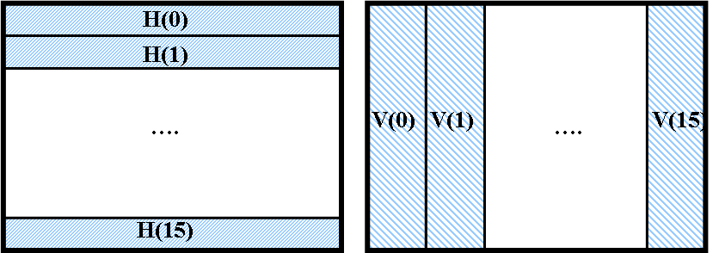
Figure 1 profile

Feature
  - Support 16 area statistic along horizontal and vertical direction
  - Support 3D statistic.
  - Support 4096x1920 resolution.

- bbb

Block Diagram
[/***]

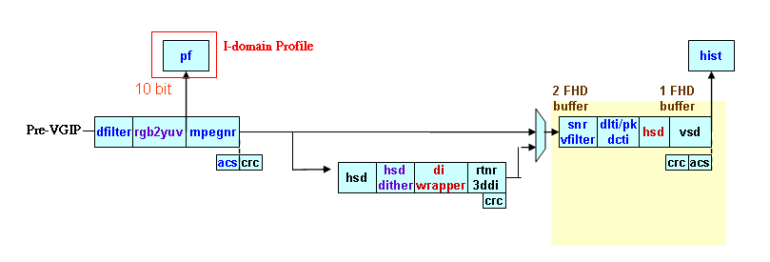
[***/]

Inputs and Outputs

Pf_3d_ctrl
Input | Description
rst_n | “Low” active reset
Iclk | i-domain clock
rbus_clk | Bus clock
vs_in | V sync
l_flag | Left flag
reg_en_3d_mode | Reg setting
reg_ch1_pf_enable_profile | Reg setting
enable_profile_clr | Enable profile “clear”
pf_h00~15 | Amount along horizontal direction
pf_v00~15 | Amount along vertical direction

Output | Description
reg_enable_profile | Enable profile
ch1_pf_enable_profile_clr | Reg setting
ch1_pf_h00~15 | Amount along horizontal direction, ps: in 3D mode, it’s left field
ch1_pf_v00~15 | Amount along vertical direction, ps: in 3D mode, it’s left field.
ch1_pf_h00~15_right | Amount along horizontal direction of right field
ch1_pf_v00~15_right | Amount along vertical direction of right field

Pf_fun
Input | Description
rbus_clk | Bus clock
Iclk | i-domain clock
di_hs | H sync
di_vs | V sync
di_hact | H active
di_vact | V active
di_field | Field input
di_y | Pixel input
di_u | Pixel input
di_v | Pixel input
reg_hnsr | Reg setting
reg_vnsr | Reg setting
reg_field_sel | Reg setting
reg_enable_profile | Reg setting
reg_yuv_sel | Reg setting
reg_overflow_sel | Reg setting
reg_test_enable | Reg setting
reg_testmode | Reg setting
reg_hsize | Reg setting
reg_vsize | Reg setting
reg_starth | Reg setting
reg_startv | Reg setting
reg_en_4k2k_mode | Reg setting

Output | Description
enable_profile_clr | Enable profile “clear”
pf_h00~15 | Amount along horizontal direction
pf_v00~15 | Amount along vertical direction

pf_3d_ctrl description
Support 3D mode controllor. In 3D mode, all calculation should start in left field.
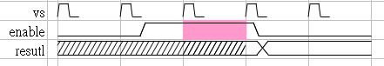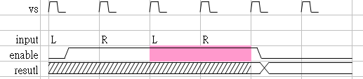
Figure 2 normal mode Figure 3 3D mode

pf_fun description
Profile calculation. Some description is below.

Function Description

pf_3d_ctrl description
Enable register: ICH1_Hist_Profile_CTRL.13 (en_3d_mode) to start 3D function.
In normal operation, register: ICH1_Hist_Profile_CTRL.0 (ch1_pf_enable_profile) enable profile calculation, and clear itself when calculation done. And registers: ICH1_HIS_Profile_Data_00~15 is updated after one valid field done.
In 3D operation, additional registers: ICH1_HIS_Profile_Data_16~31 are used for right field. Register: ICH1_Hist_Profile_CTRL.0 (ch1_pf_enable_profile) still enable calculation, and clear itself when right field done. Registers: ICH1_HIS_Profile_Data_00~15 is updated after left valid field done, and ICH1_HIS_Profile_Data_16~31 are updated after right valid field done.

pf_fun description

basic operation
After register: ICH1_Hist_Profile_CTRL.0 (ch1_pf_enable_profile) enable, FW can choose source is from Y, U, or V by register: ICH1_Hist_Profile_CTRL.12~11 (ch1_pf_yuv_sel).
Due the bitwidth of adder and compatibility, register: ICH1_Hist_Profile_CTRL.14 (en_4k2k_mode) makes the input pixel divided by 4 (8bits to 6bit).

Area size decision
The width of 16 area along horizontal direction is determined by register: ICH1_Hist_Profile_size.7~0 (ch1_pf_hsize).
The height of 16 area along vertical direction is determined by register: ICH1_Hist_Profile_size.15~8 (ch1_pf_vsize).

Range selection
To mark a range which need to be calculation, use these registers. The outside of the range wont be consider in profile function.
Register: ICH1_Hist_Profile_StartH.11~0 (ch1_pf_starth) marks the start position in a line.
Register: ICH1_Hist_Profile_StarV.11~0 (ch1_pf_startv) marks the start line in a field.
There are no end marks because the range is 16 area from start point.
Register: ICH1_Hist_Profile_CTRL.3~2 (ch1_pf_field_sel) can make the function works on even, odd, or both fields.

Truncation
Due to the bitwidth of operation and rough statistic, some bits are truncated when adder.
Along horizontal calculation, truncation occurs in each line end. Register: ICH1_Hist_Profile_CTRL.7~6 (ch1_pf_hnsr) decides how many bits should be truncated (from 19 bits).
Along vertical calculation, truncation occurs in bottom boundary of area. Register: ICH1_Hist_Profile_CTRL.5~4 (ch1_pf_vnsr) decides how many bits should be truncated (from 21 bits).
When the arithmetic operator is over-flow, register: ICH1_His_Profile_CTRL.1 (ch1_pf_overflow_sel) can chose to show 0x1ff or the LSB.
Figure 4 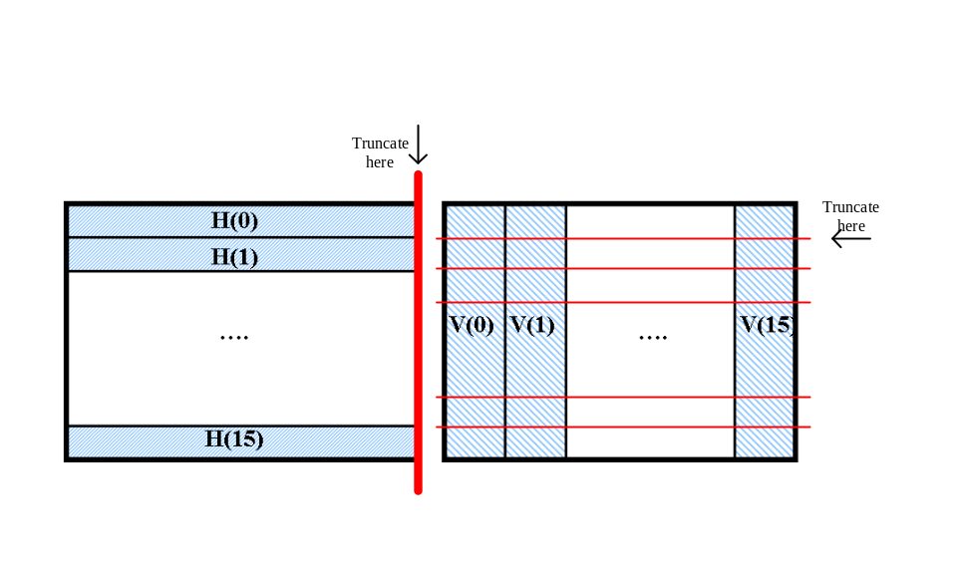truncate

Test mode
When register: ICH1_Hist_Profile_CTRL.10 (ch1_pf_test_mode) enable, it enter test-mode.
No matter what the register: ICH1_Hist_Profile_CTRL.9~8 (ch1_pf_testmode) is, all amount registers is the result of top-left area in test-mode, e.g. H(15)=H(14)=H(13)=…..=H(0), V(15)=V(14)=V(13)=….=V(0).

Register Set

Profile
[/***]
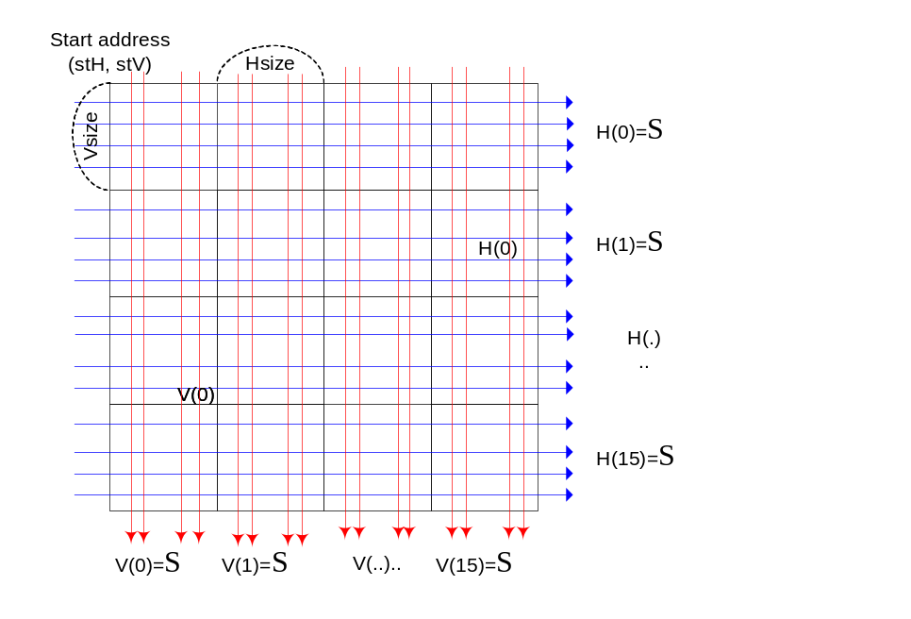
Horizontal Profiling and Vertical profiling

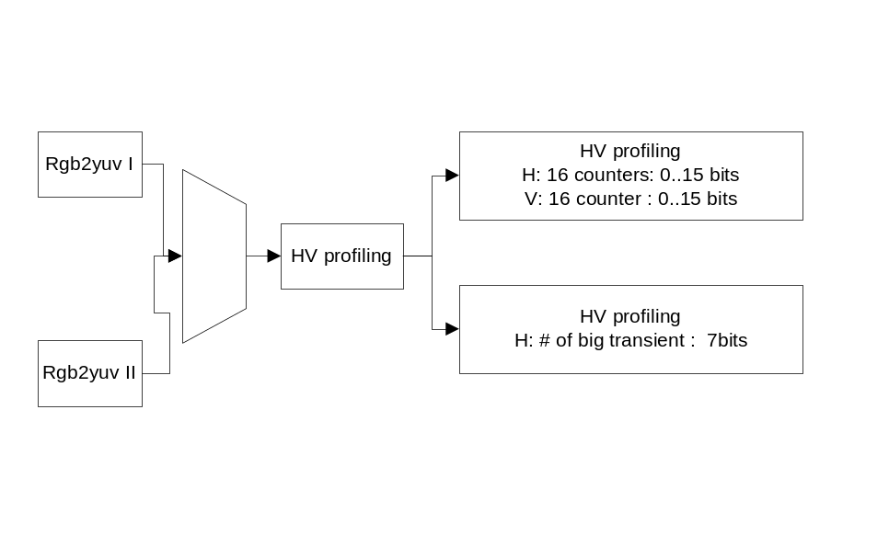

Vns is fixed to 1.
Input: 8 bits(trunscated from 10bits)
Internal adder H=1920*255<2^20 (use 19 bits adder)
Internal adder V=(1920/16)*(1080/16)<2^13(use 13 bits adder)

用途: 可以算出水平或垂直方向的平均值及走勢
A. AUTO ZOOM 的FUNCTION. 如 16:9 或 4:3的畫面的DETECTION.
B. 畫面內容的偵測

使用說明:
- 設定 啟始位址. StH, StV, 及 block H, V 的寬度.
- CTRL: bit 0 設為 1 開始量.
- polling bit0 是否為0, 為0 時可將 Profile 讀出.
- 根據 Profile_H, 及 Profile_V 決定要做的事.

A .Input signal can support :
From 720x480 to 1920x1080 4096x2160 (12bits/ 12bits)
B. 計算HNSR :
(1) 19 bit (line-ysum-adder) ->truncate to 9bit precision (do HNSR shift ) -> 16 bit H-block storage ( H0 ~ H15[15:0] )
(2) H=1920 pix = 2^11 => 11bit
Y[9:2] = 8 bit
Line-ysum-adder = 11+8=19bit
Precision = 9bit
V=1080 line/16 = 70 =~ 2^7 = 7bit
H-block storage H0 = 9bit +7bit =16 bit =>[15:0]
(3) HNSR :
00 : line-ysum not truncate => precision 9bit = line-ysum[ 8:0]
11 : line-ysum truncate 10bit =>1920x1080 precision 9bit = line-ysum [18:10]
10 : line-ysum truncate 9 bit => precision 9bit = line-ysum [17: 9]
01 : line-ysum truncate 8 bit => 720x480 precision 9bit = line-ysum [16:8]

C. 計算VNSR
(1)21 bit (block-ysum-adder) -> truncate to 9bit precision (do VNSR shift) -> 13 bit V-Block-storage ,(V0~V15[15:0] ),But We still use 16bit in Spec

(2) max block Hsize= 1920/16
max block Vsize= 1080/16
max block pixel = (1920x1080)/16x16 =~ 8000 = 2^13
Y[9:2]=8bit
Max block-ysum adder need =13+8 =21 bit
Truncate precision (of block –ysum firmware can accept) = 9bit
Need 16 block in V-direction => 4bit
V-block storage V0 = 9+4 = 13 bit (V0[12:0] ~ V15[12:0] )
(3)VNSR :
00 : block –ysum not truncate => precision 9bit = block-ysum [8:0]
11 : block –ysum truncate 12bit => 1920x780 precision 9bit = block-ysum [20:12]
10 : block –ysum truncate 11bit => precision 9bit = block-ysum [19:11]
01 : block –ysum truncate 10bit => 720x480 precision 9bit = block-ysum [18:10]

D. 偵測source是HD/SD

(1)ISD (input source detection) is for HD/SD input source detection.

(2)ISD provides 2 histograms, TSH (Transition step histogram) and PMH (Patten match histogram) to help software detection.

(3)Input 給 I domain 為HD時, VIP 選用的設定通常為假定content 為原生HD的設定值.但是當HD input 為 SD content 放大為HD content 時, VIP 的設定也就不一定適用.因此在 I domain 加入一個 detection 來detect HD input 為原生 HD 或者為SD 放大.

(4)放 I domain 避免 closed loop.

ISD consists of TSH (Transition step histogram) and PMH (Patten match histogram).

- The TSH step diagram is below.

Transition step histogram(TSH)
判斷方向
水平?
(Cur_Y – init_Y) >thl*Step_cnt?
Hist[step_cnt]++
Init_Y = Cur_Y
Step_cnt==1?
Step_cnt++
Step_cnt=0
Pre_dir!=Cur_dir?
Step_cnt=1
Init_Y = Cur_Y
Y
Y
Y
Y
N
N
N
(Cur_Y – init_Y) >thl*Step_cnt?
Hist[step_cnt]++
Y
N
TSH_flag=0
TSH_flag=1
TSH_flag=1
Cur_Y: current pixl Y
Init_Y: 連續上升(下降)第一個點的Y
Step_cnt: 連續幾個點
Thl:平均每個升降點Y的 threshold
Hist: histogram
Pre_dir,Cur_dir:前一點與current點的方向
TSH_flag: 給PMH 決定要不要做的flag
reg_srcdet_tsh_hist01~20(22bits)
判斷方向:
Delta=Y(cur+1)-Y(cur)
Delta>0 上升
Delta<0 下降
Delta==0水平

2. The PMH step diagram is below.

Patten match histogram(PMH)

- 五個H-11-tap filter
  - {0,0,0,0,-1,2,-1,0,0,0,0}, filter0
  - {0,0,0,-1,0,2,0,-1,0,0,0}, filter1
  - {0,0,-1,0,0,2,0,0,-1,0,0}, filter2
  - {0,-1,0,0,0,2,0,0,0,-1,0}, filter3
  - {-1,0,0,0,0,2,0,0,0,0,-1}, filter4

- Current pixl 過這五個 filter 取最大值者其Hist++.
- 最大相等時優先權 filter0 > filter1 > filter2 > filter3 > filter4
- Hist05 為 filter0=filter1=filter2=filter3=filter4 時++
- reg_srcdet_pmh_hist1~5(22bits)
- reg_srcdet_pmh_depend_ths(1bit)
  - Enable 時當 TSH_flag==1 的時候才做PMH 統計

E. Measure the Diff Sum
計算curretn點x(t)與前一點x(t-1)的絕對差值diff, 利用這差值算出:
(1) Register ICH1_Hist_Profile_Diff.29~0 (diff_sum): 畫面中每個點與前一點的絕對差值總和
(2) 並用Register ICH1_Hist_Profile_Diff_th.15~8 (diff_th2), ICH1_Hist_Profile_Diff_th.7~0 (diff_th1)來將此值作分區
if diff<diff_th1, Register ICH1_Hist_Profile_Diff_bin1.19~0 (diff_bin1)++
if diff_th1<=diff<diff_th2, Register ICH1_Hist_Profile_Diff_bin2.19~0 (diff_bin2)++
otherwise, diff_bin3++;

[***/]

Profile: Channel 1&channel 2
Info:: | Description
ID | Profile
Include | “VIP/rbusProfile.h”
Include | “VIP/vc_profile.h”
Include | “VIP/vc_InputSourceDetect_reg.h”
DataBits | 32
AddressLength | 32

Register::ICH1_Hist_Profile_CTRL 0x18023400
Name | bits | R/W/D | Reset State | Comments | Config
Reserved | 31:19 | - | - | Reserved
Dummy | 18:16 | R/W | 0x0 | Reserved
Reserved | 15 | - | - | Reserved
En_4k2k_mode | 14 | R/W | 0x0 | Support image size = 4096 x 2160  Drop LSB 2-bit of input YUV data  constrain:When input size biger than 1920*1080，En_4k2k_mode must be 1. | cc:reg_vc_profile.four_k_two_k_mode
En_3d_mode | 13 | R/W | 0x0 | Not support in H5X | cc:reg_vc_profile.three_d_mode
ch1_pf_YUV_sel | 12:11 | R/W | 0x0 | 00:Y  01:U  10:V | cc:reg_vc_profile.YUV_sel
Reserved | 10 | - | - | Reserved
Reserved | 9:8 | - | - | Reserved
ch1_pf_HNSR | 7:6 | R/W | 0x01 | Horizontal Shift right hnsr bits each line  00: 0bits  01: 8 bits  10: 9 bits  11: 10 bits | cc:reg_vc_profile.HNSR
ch1_pf_VNSR | 5:4 | R/W | 0x01 | Vertical Shift right hnsr bits each line  00: 0bits  01: 10bit  10: 11bit  11: 12bit | cc:reg_vc_profile.VNSR
ch1_pf_Field_sel | 3:2 | R/W | 0x0 | Start Profiling function after deinterlace  00: Process one even field  01: Process one odd field  1x: Process one next field | cc:reg_vc_profile.fieldSel
ch1_pf_OverFlow_sel | 1 | R/W | 0x0 | 0: when H[],V[] over flow, show 0x1ff  1: when H[],V[] over flow, show LSB | cc:reg_vc_profile.OverFlow_sel
ch1_pf_Enable_profile | 0 | R/W | 0x0 | Start Profiling function  1: enable, it will set to zero when calculation is finished for any frame  0: disable  When En_3d_mode = 0  Only one frame is calculated  When En_3d_mode = 1  Clear to 0 when successive Left & Right frame are calculated | cc:reg_vc_profile.en  hw_clr

Register::ICH1_Hist_Profile_size 0x18023404
Name | bits | R/W/D | Reset State | Comments | Config
Reserved | 31:26 | - | - | Reserved
ch1_pf_VSize | 25:16 | R/W | 0x1E | Define the vertical block size  0~135default : d’30=0x1e  V Block size=Vsize+1; | cc:reg_vc_profile.sizeV
Reserved | 15:10 | - | - | Reserved
ch1_pf_Hsize | 9:0 | R/W | 0x2B | Define the horizontal block size  0~255default : d’44=0x2c  H block size=Hsize+1; | cc:reg_vc_profile.sizeH

Register::ICH1_Hist_Profile_StartH 0x18023408
Name | Bits | R/W/D | Reset State | Comments | Config
Reserved | 31:14 | - | - | Reserved
ch1_pf_StartH | 13:0 | R/W | 0x0 | Horizontal Start | cc:reg_vc_profile.startH

Register::ICH1_Hist_Profile_StartV 0x1802340C
Name | Bits | R/W/D | Reset State | Comments | Config
Reserved | 31:14 | - | - | Reserved
ch1_pf_StartV | 13:0 | R/W | 0x0 | Vertical Start | cc:reg_vc_profile.startV

Constrain:
- ch1_pf_Hsize must be 4N-1;
- ch1_pf_Hsize <= (width - ch1_pf_StartH)/16; width: pattern size
- ch1_pf_Vsize <= (height - ch1_pf_StartV)/16; height: pattern size
- ch1_pf_StartH must be 4N(N could be 0)

Register::ICH1_Hist_Profile_Data_00 0x18023410
Name | bits | R/W/D | Reset State | Comments | Config
ch1_pf_H01 | 31:16 | R | X | The result of the horizontal profiling  H[1] | cc:reg_vc_profile.proX[1]
ch1_pf_H00 | 15:0 | R | X | The result of the horizontal profiling :  H[0] | cc:reg_vc_profile.proX[0]

Register::ICH1_Hist_Profile_Data_01 0x18023414
Name | bits | R/W/D | Reset State | Comments | Config
ch1_pf_H03 | 31:16 | R | X | The result of the horizontal profiling :  H[3] | cc:reg_vc_profile.proX[3]
ch1_pf_H02 | 15:0 | R | X | The result of the horizontal profiling :  H[2] | cc:reg_vc_profile.proX[2]

Register::ICH1_Hist_Profile_Data_02 0x18023418
Name | bits | R/W/D | Reset State | Comments | Config
ch1_pf_H05 | 31:16 | R | X | The result of the horizontal profiling :  H[5] | cc:reg_vc_profile.proX[5]
ch1_pf_H04 | 15:0 | R | X | The result of the horizontal profiling :  H[4] | cc:reg_vc_profile.proX[4]

Register::ICH1_Hist_Profile_Data_03 0x1802341C
Name | bits | R/W/D | Reset State | Comments | Config
ch1_pf_H07 | 31:16 | R | X | The result of the horizontal profiling :  H[7] | cc:reg_vc_profile.proX[7]
ch1_pf_H06 | 15:0 | R | X | The result of the horizontal profiling :  H[6] | cc:reg_vc_profile.proX[6]

Register::ICH1_Hist_Profile_Data_04 0x18023420
Name | bits | R/W/D | Reset State | Comments | Config
ch1_pf_H09 | 31:16 | R | X | The result of the horizontal profiling :  H[9] | cc:reg_vc_profile.proX[9]
ch1_pf_H08 | 15:0 | R | X | The result of the horizontal profiling :  H[8] | cc:reg_vc_profile.proX[8]

Register::ICH1_Hist_Profile_Data_05 0x18023424
Name | bits | R/W/D | Reset State | Comments | Config
ch1_pf_H11 | 31:16 | R | X | The result of the horizontal profiling :  H[11] | cc:reg_vc_profile.proX[11]
ch1_pf_H10 | 15:0 | R | X | The result of the horizontal profiling :  H[10] | cc:reg_vc_profile.proX[10]

Register::ICH1_Hist_Profile_Data_06 0x18023428
Name | bits | R/W/D | Reset State | Comments | Config
ch1_pf_H13 | 31:16 | R | X | The result of the horizontal profiling :  H[13] | cc:reg_vc_profile.proX[13]
ch1_pf_H12 | 15:0 | R | X | The result of the horizontal profiling :  H[12] | cc:reg_vc_profile.proX[12]

Register::ICH1_Hist_Profile_Data_07 0x1802342C
Name | bits | R/W/D | Reset State | Comments | Config
ch1_pf_H15 | 31:16 | R | X | The result of the horizontal profiling :  H[15] | cc:reg_vc_profile.proX[15]
ch1_pf_H14 | 15:0 | R | X | The result of the horizontal profiling :  H[14] | cc:reg_vc_profile.proX[14]

Register::ICH1_Hist_Profile_Data_08 0x18023430
Name | bits | R/W/D | Reset State | Comments | Config
ch1_pf_V01 | 31:16 | R | X | The result of the verticle profiling  V[1] | cc:reg_vc_profile.proY[1]
ch1_pf_V00 | 15:0 | R | X | The result of the verticle profiling :  V[0] | cc:reg_vc_profile.proY[0]

Register::ICH1_Hist_Profile_Data_09 0x18023434
Name | bits | R/W/D | Reset State | Comments | Config
ch1_pf_V03 | 31:16 | R | X | The result of the verticle profiling :  V[3] | cc:reg_vc_profile.proY[3]
ch1_pf_V02 | 15:0 | R | X | The result of the verticle profiling :  V[2] | cc:reg_vc_profile.proY[2]

Register::ICH1_Hist_Profile_Data_10 0x18023438
Name | bits | R/W/D | Reset State | Comments | Config
ch1_pf_V05 | 31:16 | R | X | The result of the verticle profiling :  V[5] | cc:reg_vc_profile.proY[5]
ch1_pf_V04 | 15:0 | R | X | The result of the verticle profiling :  V[4] | cc:reg_vc_profile.proY[4]

Register::ICH1_Hist_Profile_Data_11 0x1802343C
Name | bits | R/W/D | Reset State | Comments | Config
ch1_pf_V07 | 31:16 | R | X | The result of the verticle profiling :  V[7] | cc:reg_vc_profile.proY[7]
ch1_pf_V06 | 15:0 | R | X | The result of the verticle profiling :  V[6] | cc:reg_vc_profile.proY[6]

Register::ICH1_Hist_Profile_Data_12 0x18023440
Name | bits | R/W/D | Reset State | Comments | Config
ch1_pf_V09 | 31:16 | R | X | The result of the verticle profiling :  V[9] | cc:reg_vc_profile.proY[9]
ch1_pf_V08 | 15:0 | R | X | The result of the verticle profiling :  V[8] | cc:reg_vc_profile.proY[8]

Register::ICH1_Hist_Profile_Data_13 0x18023444
Name | bits | R/W/D | Reset State | Comments | Config
ch1_pf_V11 | 31:16 | R | X | The result of the verticle profiling :  V[11] | cc:reg_vc_profile.proY[11]
ch1_pf_V10 | 15:0 | R | X | The result of the verticle profiling :  V[10] | cc:reg_vc_profile.proY[10]

Register::ICH1_Hist_Profile_Data_14 0x18023448
Name | bits | R/W/D | Reset State | Comments | Config
ch1_pf_V13 | 31:16 | R | X | The result of the verticle profiling :  H[13] | cc:reg_vc_profile.proY[13]
ch1_pf_V12 | 15:0 | R | X | The result of the verticle profiling :  H[12] | cc:reg_vc_profile.proY[12]

Register::ICH1_Hist_Profile_Data_15 0x1802344C
Name | bits | R/W/D | Reset State | Comments | Config
ch1_pf_V15 | 31:16 | R | X | The result of the verticle profiling :  H[15] | cc:reg_vc_profile.proY[15]
ch1_pf_V14 | 15:0 | R | X | The result of the verticle profiling :  H[14] | cc:reg_vc_profile.proY[14]

Register::ICH1_Hist_Profile_Data_16 0x18023450
Name | bits | R/W/D | Reset State | Comments | Config
ch1_pf_H01_right | 31:16 | R | X | The result of the horizontal profiling  H[1] | cc:reg_vc_profile.proX_R[1]
ch1_pf_H00_right | 15:0 | R | X | The result of the horizontal profiling :  H[0] | cc:reg_vc_profile.proX_R[0]

Register::ICH1_Hist_Profile_Data_17 0x18023454
Name | bits | R/W/D | Reset State | Comments | Config
ch1_pf_H03_right | 31:16 | R | X | The result of the horizontal profiling :  H[3] | cc:reg_vc_profile.proX_R[3]
ch1_pf_H02_right | 15:0 | R | X | The result of the horizontal profiling :  H[2] | cc:reg_vc_profile.proX_R[2]

Register::ICH1_Hist_Profile_Data_18 0x18023458
Name | bits | R/W/D | Reset State | Comments | Config
ch1_pf_H05_right | 31:16 | R | X | The result of the horizontal profiling :  H[5] | cc:reg_vc_profile.proX_R[5]
ch1_pf_H04_right | 15:0 | R | X | The result of the horizontal profiling :  H[4] | cc:reg_vc_profile.proX_R[4]

Register::ICH1_Hist_Profile_Data_19 0x1802345C
Name | bits | R/W/D | Reset State | Comments | Config
ch1_pf_H07_right | 31:16 | R | X | The result of the horizontal profiling :  H[7] | cc:reg_vc_profile.proX_R[7]
ch1_pf_H06_right | 15:0 | R | X | The result of the horizontal profiling :  H[6] | cc:reg_vc_profile.proX_R[6]

Register::ICH1_Hist_Profile_Data_20 0x18023460
Name | bits | R/W/D | Reset State | Comments | Config
ch1_pf_H09_right | 31:16 | R | X | The result of the horizontal profiling :  H[9] | cc:reg_vc_profile.proX_R[9]
ch1_pf_H08_right | 15:0 | R | X | The result of the horizontal profiling :  H[8] | cc:reg_vc_profile.proX_R[8]

Register::ICH1_Hist_Profile_Data_21 0x18023464
Name | bits | R/W/D | Reset State | Comments | Config
ch1_pf_H11_right | 31:16 | R | X | The result of the horizontal profiling :  H[11] | cc:reg_vc_profile.proX_R[11]
ch1_pf_H10_right | 15:0 | R | X | The result of the horizontal profiling :  H[10] | cc:reg_vc_profile.proX_R[10]

Register::ICH1_Hist_Profile_Data_22 0x18023468
Name | bits | R/W/D | Reset State | Comments | Config
ch1_pf_H13_right | 31:16 | R | X | The result of the horizontal profiling :  H[13] | cc:reg_vc_profile.proX_R[13]
ch1_pf_H12_right | 15:0 | R | X | The result of the horizontal profiling :  H[12] | cc:reg_vc_profile.proX_R[12]

Register::ICH1_Hist_Profile_Data_23 0x1802346C
Name | bits | R/W/D | Reset State | Comments | Config
ch1_pf_H15_right | 31:16 | R | X | The result of the horizontal profiling :  H[15] | cc:reg_vc_profile.proX_R[15]
ch1_pf_H14_right | 15:0 | R | X | The result of the horizontal profiling :  H[14] | cc:reg_vc_profile.proX_R[14]

Register::ICH1_Hist_Profile_Data_24 0x18023470
Name | bits | R/W/D | Reset State | Comments | Config
ch1_pf_V01_right | 31:16 | R | X | The result of the verticle profiling  V[1] | cc:reg_vc_profile.proY_R[1]
ch1_pf_V00_right | 15:0 | R | X | The result of the verticle profiling :  V[0] | cc:reg_vc_profile.proY_R[0]

Register::ICH1_Hist_Profile_Data_25 0x18023474
Name | bits | R/W/D | Reset State | Comments | Config
ch1_pf_V03_right | 31:16 | R | X | The result of the verticle profiling :  V[3] | cc:reg_vc_profile.proY_R[3]
ch1_pf_V02_right | 15:0 | R | X | The result of the verticle profiling :  V[2] | cc:reg_vc_profile.proY_R[2]

Register::ICH1_Hist_Profile_Data_26 0x18023478
Name | bits | R/W/D | Reset State | Comments | Config
ch1_pf_V05_right | 31:16 | R | X | The result of the verticle profiling :  V[5] | cc:reg_vc_profile.proY_R[5]
ch1_pf_V04_right | 15:0 | R | X | The result of the verticle profiling :  V[4] | cc:reg_vc_profile.proY_R[4]

Register::ICH1_Hist_Profile_Data_27 0x1802347C
Name | bits | R/W/D | Reset State | Comments | Config
ch1_pf_V07_right | 31:16 | R | X | The result of the verticle profiling :  V[7] | cc:reg_vc_profile.proY_R[7]
ch1_pf_V06_right | 15:0 | R | X | The result of the verticle profiling :  V[6] | cc:reg_vc_profile.proY_R[6]

Register::ICH1_Hist_Profile_Data_28 0x18023480
Name | bits | R/W/D | Reset State | Comments | Config
ch1_pf_V09_right | 31:16 | R | X | The result of the verticle profiling :  V[9] | cc:reg_vc_profile.proY_R[9]
ch1_pf_V08_right | 15:0 | R | X | The result of the verticle profiling :  V[8] | cc:reg_vc_profile.proY_R[8]

Register::ICH1_Hist_Profile_Data_29 0x18023484
Name | bits | R/W/D | Reset State | Comments | Config
ch1_pf_V11_right | 31:16 | R | X | The result of the verticle profiling :  V[11] | cc:reg_vc_profile.proY_R[11]
ch1_pf_V10_right | 15:0 | R | X | The result of the verticle profiling :  V[10] | cc:reg_vc_profile.proY_R[10]

Register::ICH1_Hist_Profile_Data_30 0x18023488
Name | bits | R/W/D | Reset State | Comments | Config
ch1_pf_V13_right | 31:16 | R | X | The result of the verticle profiling :  H[13] | cc:reg_vc_profile.proY_R[13]
ch1_pf_V12_right | 15:0 | R | X | The result of the verticle profiling :  H[12] | cc:reg_vc_profile.proY_R[12]

Register::ICH1_Hist_Profile_Data_31 0x1802348C
Name | bits | R/W/D | Reset State | Comments | Config
ch1_pf_V15_right | 31:16 | R | X | The result of the verticle profiling :  H[15] | cc:reg_vc_profile.proY_R[15]
ch1_pf_V14_right | 15:0 | R | X | The result of the verticle profiling :  H[14] | cc:reg_vc_profile.proY_R[14]

Register::ICH1_Hist_Profile_Diff 0x18023490
Name | bits | R/W/D | Reset State | Comments | Config
ch1_pf_DiffSum | 31:0 | R | X | The sum of absolute difference between current and previous pixel | cc:reg_vc_profile.DiffSum

Register::ICH1_Hist_Profile_Diff_th 0x18023494
Name | Bits | R/W/D | Reset State | Comments | Config
Reserved | 31:16 | - | - | Reserved
ch1_pf_Diff_th_H | 15:8 | R/W | 0x40 | The threshold to separate bin_M and bin_H of absolute difference between current and previous pixel | cc:reg_vc_profile.Diff_th_H
ch1_pf_Diff_th_L | 7:0 | R/W | 0x10 | The threshold to separate bin_L and bin_M of absolute difference between current and previous pixel | cc:reg_vc_profile.Diff_th_L

Register::ICH1_Hist_Profile_Diff_bin_L 0x18023498
Name | Bits | R/W/D | Reset State | Comments | Config
Reserved | 31:24 | - | - | Reserved
ch1_pf_Diff_bin_L | 23:0 | R | 0x0 | The count in bin_L | cc:reg_vc_profile.Diff_bin_L

Register::ICH1_Hist_Profile_Diff_bin_M 0x1802349C
Name | Bits | R/W/D | Reset State | Comments | Config
Reserved | 31:24 | - | - | Reserved
ch1_pf_Diff_bin_M | 23:0 | R | 0x0 | The count in bin_M | cc:reg_vc_profile.Diff_bin_M

Register::ICH1_Hist_Profile_Diff_bin_H 0x180234A0
Name | Bits | R/W/D | Reset State | Comments | Config
Reserved | 31:24 | - | - | Reserved
ch1_pf_Diff_bin_H | 23:0 | R | 0x0 | The count in bin_H | cc:reg_vc_profile.Diff_bin_H

Register::ICH1_Hist_Profile2_CTRL 0x180234A4
Name | bits | R/W/D | Reset State | Comments | Config
Reserved | 31:13 | - | - | Reserved
ch1_pf2_YUV_sel | 12:11 | R/W | 0x0 | 00:Y  01:U  10:V | cc:reg_vc_profile2.YUV_sel
Reserved | 10 | - | - | Reserved
Reserved | 9:8 | - | - | Reserved
ch1_pf2_HNSR | 7:6 | R/W | 0x01 | Horizontal Shift right hnsr bits each line  00: 0bits  01: 8 bits  10: 9 bits  11: 10 bits | cc:reg_vc_profile2.HNSR
ch1_pf2_VNSR | 5:4 | R/W | 0x01 | Vertical Shift right hnsr bits each line  00: 0bits  01: 10bit  10: 11bit  11: 12bit | cc:reg_vc_profile2.VNSR
ch1_pf2_Field_sel | 3:2 | R/W | 0x0 | Start Profiling function after deinterlace  00: Process one even field  01: Process one odd field  1x: Process one next field | cc:reg_vc_profile2.fieldSel
ch1_pf2_OverFlow_sel | 1 | R/W | 0x0 | 0: when H[],V[] over flow, show 0x1ff  1: when H[],V[] over flow, show LSB | cc:reg_vc_profile2.OverFlow_sel
ch1_pf2_Enable_profile | 0 | R/W | 0x0 | Start Profiling function  1: enable, it will set to zero when calculation is finished for any frame  0: disable  When En_3d_mode = 0  Only one frame is calculated  When En_3d_mode = 1  Clear to 0 when successive Left & Right frame are calculated | cc:reg_vc_profile2.en  hw_clr

Register::ICH1_Hist_Profile2_size 0x180234A8
Name | bits | R/W/D | Reset State | Comments | Config
Reserved | 31:26 | - | - | Reserved
ch1_pf2_VSize | 25:16 | R/W | 0x1E | Define the vertical block size  0~135default : d’30=0x1e  V Block size=Vsize+1; | cc:reg_vc_profile2.sizeV
Reserved | 15:10 | - | - | Reserved
ch1_pf2_Hsize | 9:0 | R/W | 0x2B | Define the horizontal block size  0~255default : d’44=0x2c  H block size=Hsize+1; | cc:reg_vc_profile2.sizeH

Register::ICH1_Hist_Profile2_StartH 0x180234AC
Name | Bits | R/W/D | Reset State | Comments | Config
Reserved | 31:14 | - | - | Reserved
ch1_pf2_StartH | 13:0 | R/W | 0x0 | Horizontal Start | cc:reg_vc_profile2.startH

Register::ICH1_Hist_Profile2_StartV 0x180234B0
Name | Bits | R/W/D | Reset State | Comments | Config
Reserved | 31:14 | - | - | Reserved
ch1_pf2_StartV | 13:0 | R/W | 0x0 | Vertical Start | cc:reg_vc_profile2.startV

Constrain:
- ch1_pf2_Hsize must be 4N-1;
- ch1_pf2_Hsize <= (width - ch1_pf2_StartH)/16; width: pattern size
- ch1_pf2_Vsize <= (height - ch1_pf2_StartV)/16; height: pattern size
- ch1_pf2_StartH must be 4N(N could be 0)

Register::ICH1_Hist_Profile2_Diff 0x180234B4
Name | bits | R/W/D | Reset State | Comments | Config
ch1_pf2_DiffSum | 31:0 | R | X | The sum of absolute difference between current and previous pixel | cc:reg_vc_profile2.DiffSum

Register::ICH1_Hist_Profile2_Diff_th 0x180234B8
Name | Bits | R/W/D | Reset State | Comments | Config
Reserved | 31:16 | - | - | Reserved
ch1_pf2_Diff_th_H | 15:8 | R/W | 0x40 | The threshold to separate bin_M and bin_H of absolute difference between current and previous pixel | cc:reg_vc_profile2.Diff_th_H
ch1_pf2_Diff_th_L | 7:0 | R/W | 0x10 | The threshold to separate bin_L and bin_M of absolute difference between current and previous pixel | cc:reg_vc_profile2.Diff_th_L

Register::ICH1_Hist_Profile2_Diff_bin_L 0x180234BC
Name | Bits | R/W/D | Reset State | Comments | Config
Reserved | 31:24 | - | - | Reserved
ch1_pf2_Diff_bin_L | 23:0 | R | 0x0 | The count in bin_L | cc:reg_vc_profile2.Diff_bin_L

Register::ICH1_Hist_Profile2_Diff_bin_M 0x180234C0
Name | Bits | R/W/D | Reset State | Comments | Config
Reserved | 31:24 | - | - | Reserved
ch1_pf2_Diff_bin_M | 23:0 | R | 0x0 | The count in bin_M | cc:reg_vc_profile2.Diff_bin_M

Register::ICH1_Hist_Profile2_Diff_bin_H 0x180234C4
Name | Bits | R/W/D | Reset State | Comments | Config
Reserved | 31:24 | - | - | Reserved
ch1_pf2_Diff_bin_H | 23:0 | R | 0x0 | The count in bin_H | cc:reg_vc_profile2.Diff_bin_H

Register::SRCDET_CONTROL 0x18023700
Name | Bits | R/W/D | Reset State | Comments | Config
Reserved | 31:5 | - | - | Reserved
SRCDET_PMH_DEPEND_TSH | 4 | R/W | 0x0 | 0: Always do PMH  1: Only do PMH when TSH_flag==1 | cc:reg_pmh_depend_tsh
Reserved | 3:1 | - | - | Reserved
SRCDET_START | 0 | R/W | 0x0 | Start TSH/PMH function  TSH/PMH start bit  1:TSH/PMH start processing/still processing  0:Clear to 0 when TSH/PMH function is done  Attention： Can’t do srcdet function every frame。If set every frame SRCDET_START = 1，only do once of every two frame | cc:reg_srcdet_start  hw_clr

Register::SRCDET_TSH_STEP_THL 0x18023704
Name | Bits | R/W/D | Reset State | Comments | Config
Reserved | 31:8 | - | - | Reserved
SRCDET_TSH_STEP_THL | 7:0 | R/W | 0x0 | TSH step threshold | cc:reg_srcdet_tsh_step_thl

Register::SRCDET_TSH_STEP_MAX 0x18023708
Name | Bits | R/W/D | Reset State | Comments | Config
Reserved | 31:5 | - | - | Reserved
SRCDET_TSH_STEP_MAX | 4:0 | R/W | 0x14 | Only do PMH when TSH step count is less than MAX value | cc:reg_srcdet_tsh_step_max

Register::SRCDET_TSH_STEP_MIN 0x1802370C
Name | Bits | R/W/D | Reset State | Comments | Config
Reserved | 31:5 | - | - | Reserved
SRCDET_TSH_STEP_MIN | 4:0 | R/W | 0x0 | Only do PMH when TSH step count is greater than MIN value | cc:reg_srcdet_tsh_step_min

Register::SRCDET_TSH_HIST01 0x18023710
Name | Bits | R/W/D | Reset State | Comments | Config
Reserved | 31:22 | - | - | Reserved
SRCDET_TSH_HIST01 | 21:0 | R | 0x0 | TSH histogram result bin 1 | cc:reg_srcdet_tsh_hist01

Register::SRCDET_TSH_HIST02 0x18023714
Name | Bits | R/W/D | Reset State | Comments | Config
Reserved | 31:22 | - | - | Reserved
SRCDET_TSH_HIST02 | 21:0 | R | 0x0 | TSH histogram result bin 2 | cc:reg_srcdet_tsh_hist02

Register::SRCDET_TSH_HIST03 0x18023718
Name | Bits | R/W/D | Reset State | Comments | Config
Reserved | 31:22 | - | - | Reserved
SRCDET_TSH_HIST03 | 21:0 | R | 0x0 | TSH histogram result bin 3 | cc:reg_srcdet_tsh_hist03

Register::SRCDET_TSH_HIST04 0x1802371C
Name | Bits | R/W/D | Reset State | Comments | Config
Reserved | 31:22 | - | - | Reserved
SRCDET_TSH_HIST04 | 21:0 | R | 0x0 | TSH histogram result bin 4 | cc:reg_srcdet_tsh_hist04

Register::SRCDET_TSH_HIST05 0x18023720
Name | Bits | R/W/D | Reset State | Comments | Config
Reserved | 31:22 | - | - | Reserved
SRCDET_TSH_HIST05 | 21:0 | R | 0x0 | TSH histogram result bin 5 | cc:reg_srcdet_tsh_hist05

Register::SRCDET_TSH_HIST06 0x18023724
Name | Bits | R/W/D | Reset State | Comments | Config
Reserved | 31:22 | - | - | Reserved
SRCDET_TSH_HIST06 | 21:0 | R | 0x0 | TSH histogram result bin 6 | cc:reg_srcdet_tsh_hist06

Register::SRCDET_TSH_HIST07 0x18023728
Name | Bits | R/W/D | Reset State | Comments | Config
Reserved | 31:22 | - | - | Reserved
SRCDET_TSH_HIST07 | 21:0 | R | 0x0 | TSH histogram result bin 7 | cc:reg_srcdet_tsh_hist07

Register::SRCDET_TSH_HIST08 0x1802372C
Name | Bits | R/W/D | Reset State | Comments | Config
Reserved | 31:22 | - | - | Reserved
SRCDET_TSH_HIST08 | 21:0 | R | 0x0 | TSH histogram result bin 8 | cc:reg_srcdet_tsh_hist08

Register::SRCDET_TSH_HIST09 0x18023730
Name | Bits | R/W/D | Reset State | Comments | Config
Reserved | 31:22 | - | - | Reserved
SRCDET_TSH_HIST09 | 21:0 | R | 0x0 | TSH histogram result bin 9 | cc:reg_srcdet_tsh_hist09

Register::SRCDET_TSH_HIST10 0x18023734
Name | Bits | R/W/D | Reset State | Comments | Config
Reserved | 31:22 | - | - | Reserved
SRCDET_TSH_HIST10 | 21:0 | R | 0x0 | TSH histogram result bin 10 | cc:reg_srcdet_tsh_hist10

Register::SRCDET_TSH_HIST11 0x18023738
Name | Bits | R/W/D | Reset State | Comments | Config
Reserved | 31:22 | - | - | Reserved
SRCDET_TSH_HIST11 | 21:0 | R | 0x0 | TSH histogram result bin 11 | cc:reg_srcdet_tsh_hist11

Register::SRCDET_TSH_HIST12 0x1802373C
Name | Bits | R/W/D | Reset State | Comments | Config
Reserved | 31:22 | - | - | Reserved
SRCDET_TSH_HIST12 | 21:0 | R | 0x0 | TSH histogram result bin 12 | cc:reg_srcdet_tsh_hist12

Register::SRCDET_TSH_HIST13 0x18023740
Name | Bits | R/W/D | Reset State | Comments | Config
Reserved | 31:22 | - | - | Reserved
SRCDET_TSH_HIST13 | 21:0 | R | 0x0 | TSH histogram result bin 13 | cc:reg_srcdet_tsh_hist13

Register::SRCDET_TSH_HIST14 0x18023744
Name | Bits | R/W/D | Reset State | Comments | Config
Reserved | 31:22 | - | - | Reserved
SRCDET_TSH_HIST14 | 21:0 | R | 0x0 | TSH histogram result bin 14 | cc:reg_srcdet_tsh_hist14

Register::SRCDET_TSH_HIST15 0x18023748
Name | Bits | R/W/D | Reset State | Comments | Config
Reserved | 31:22 | - | - | Reserved
SRCDET_TSH_HIST15 | 21:0 | R | 0x0 | TSH histogram result bin 15 | cc:reg_srcdet_tsh_hist15

Register::SRCDET_TSH_HIST16 0x1802374C
Name | Bits | R/W/D | Reset State | Comments | Config
Reserved | 31:22 | - | - | Reserved
SRCDET_TSH_HIST16 | 21:0 | R | 0x0 | TSH histogram result bin 16 | cc:reg_srcdet_tsh_hist16

Register::SRCDET_TSH_HIST17 0x18023750
Name | Bits | R/W/D | Reset State | Comments | Config
Reserved | 31:22 | - | - | Reserved
SRCDET_TSH_HIST17 | 21:0 | R | 0x0 | TSH histogram result bin 17 | cc:reg_srcdet_tsh_hist17

Register::SRCDET_TSH_HIST18 0x18023754
Name | Bits | R/W/D | Reset State | Comments | Config
Reserved | 31:22 | - | - | Reserved
SRCDET_TSH_HIST18 | 21:0 | R | 0x0 | TSH histogram result bin 18 | cc:reg_srcdet_tsh_hist18

Register::SRCDET_TSH_HIST19 0x18023758
Name | Bits | R/W/D | Reset State | Comments | Config
Reserved | 31:22 | - | - | Reserved
SRCDET_TSH_HIST19 | 21:0 | R | 0x0 | TSH histogram result bin 19 | cc:reg_srcdet_tsh_hist19

Register::SRCDET_TSH_HIST20 0x1802375C
Name | Bits | R/W/D | Reset State | Comments | Config
Reserved | 31:22 | - | - | Reserved
SRCDET_TSH_HIST20 | 21:0 | R | 0x0 | TSH histogram result bin 20 | cc:reg_srcdet_tsh_hist20

Register::SRCDET_PMH_HIST0 0x18023760
Name | Bits | R/W/D | Reset State | Comments | Config
Reserved | 31:22 | - | - | Reserved
SRCDET_PMH_HIST0 | 21:0 | R | 0x0 | PMH histogram result bin 0 | cc:reg_srcdet_pmh_hist0

Register::SRCDET_PMH_HIST1 0x18023764
Name | Bits | R/W/D | Reset State | Comments | Config
Reserved | 31:22 | - | - | Reserved
SRCDET_PMH_HIST1 | 21:0 | R | 0x0 | PMH histogram result bin 1 | cc:reg_srcdet_pmh_hist1

Register::SRCDET_PMH_HIST2 0x18023768
Name | Bits | R/W/D | Reset State | Comments | Config
Reserved | 31:22 | - | - | Reserved
SRCDET_PMH_HIST2 | 21:0 | R | 0x0 | PMH histogram result bin 2 | cc:reg_srcdet_pmh_hist2

Register::SRCDET_PMH_HIST3 0x1802376C
Name | Bits | R/W/D | Reset State | Comments | Config
Reserved | 31:22 | - | - | Reserved
SRCDET_PMH_HIST3 | 21:0 | R | 0x0 | PMH histogram result bin 3 | cc:reg_srcdet_pmh_hist3

Register::SRCDET_PMH_HIST4 0x18023770
Name | Bits | R/W/D | Reset State | Comments | Config
Reserved | 31:22 | - | - | Reserved
SRCDET_PMH_HIST4 | 21:0 | R | 0x0 | PMH histogram result bin 4 | cc:reg_srcdet_pmh_hist4

Register::SRCDET_PMH_HIST5 0x18023774
Name | Bits | R/W/D | Reset State | Comments | Config
Reserved | 31:22 | - | - | Reserved
SRCDET_PMH_HIST5 | 21:0 | R | 0x0 | PMH histogram result bin 5 | cc:reg_srcdet_pmh_hist5

Register::ICH1_Hist_Profile3_CTRL 0x18023780
Name | bits | R/W/D | Reset State | Comments | Config
Reserved | 31:13 | - | - | Reserved
ch1_pf3_YUV_sel | 12:11 | R/W | 0x0 | 00:Y  01:U  10:V | cc:reg_vc_profile3.YUV_sel
Reserved | 10 | - | - | Reserved
Reserved | 9:8 | - | - | Reserved
ch1_pf3_HNSR | 7:6 | R/W | 0x01 | Horizontal Shift right hnsr bits each line  00: 0bits  01: 8 bits  10: 9 bits  11: 10 bits | cc:reg_vc_profile3.HNSR
ch1_pf3_VNSR | 5:4 | R/W | 0x01 | Vertical Shift right hnsr bits each line  00: 0bits  01: 10bit  10: 11bit  11: 12bit | cc:reg_vc_profile3.VNSR
ch1_pf3_Field_sel | 3:2 | R/W | 0x0 | Start Profiling function after deinterlace  00: Process one even field  01: Process one odd field  1x: Process one next field | cc:reg_vc_profile3.fieldSel
ch1_pf3_OverFlow_sel | 1 | R/W | 0x0 | 0: when H[],V[] over flow, show 0x1ff  1: when H[],V[] over flow, show LSB | cc:reg_vc_profile3.OverFlow_sel
ch1_pf3_Enable_profile | 0 | R/W | 0x0 | Start Profiling function  1: enable, it will set to zero when calculation is finished for any frame  0: disable  When En_3d_mode = 0  Only one frame is calculated  When En_3d_mode = 1  Clear to 0 when successive Left & Right frame are calculated | cc:reg_vc_profile3.en  hw_clr

Register::ICH1_Hist_Profile3_size 0x18023784
Name | bits | R/W/D | Reset State | Comments | Config
Reserved | 31:26 | - | - | Reserved
ch1_pf3_VSize | 25:16 | R/W | 0x1E | Define the vertical block size  0~135default : d’30=0x1e  V Block size=Vsize+1; | cc:reg_vc_profile3.sizeV
Reserved | 15:10 | - | - | Reserved
ch1_pf3_Hsize | 9:0 | R/W | 0x2B | Define the horizontal block size  0~255default : d’44=0x2c  H block size=Hsize+1; | cc:reg_vc_profile3.sizeH

Register::ICH1_Hist_Profile3_StartH 0x18023788
Name | Bits | R/W/D | Reset State | Comments | Config
Reserved | 31:14 | - | - | Reserved
ch1_pf3_StartH | 13:0 | R/W | 0x0 | Horizontal Start | cc:reg_vc_profile3.startH

Register::ICH1_Hist_Profile3_StartV 0x1802378C
Name | Bits | R/W/D | Reset State | Comments | Config
Reserved | 31:14 | - | - | Reserved
ch1_pf3_StartV | 13:0 | R/W | 0x0 | Vertical Start | cc:reg_vc_profile3.startV

Constrain:
- ch1_pf3_Hsize must be 4N-1;
- ch1_pf3_Hsize <= (width - ch1_pf3_StartH)/16; width: pattern size
- ch1_pf3_Vsize <= (height - ch1_pf3_StartV)/16; height: pattern size
- ch1_pf_StartH must be 4N(N could be 0)

Register::ICH1_Hist_Profile3_Data_00 0x18023790
Name | bits | R/W/D | Reset State | Comments | Config
ch1_pf3_H01 | 31:16 | R | X | The result of the horizontal profiling  H[1] | cc:reg_vc_profile3.proX[1]
ch1_pf3_H00 | 15:0 | R | X | The result of the horizontal profiling :  H[0] | cc:reg_vc_profile3.proX[0]

Register::ICH1_Hist_Profile3_Data_01 0x18023794
Name | bits | R/W/D | Reset State | Comments | Config
ch1_pf3_H03 | 31:16 | R | X | The result of the horizontal profiling :  H[3] | cc:reg_vc_profile3.proX[3]
ch1_pf3_H02 | 15:0 | R | X | The result of the horizontal profiling :  H[2] | cc:reg_vc_profile3.proX[2]

Register::ICH1_Hist_Profile3_Data_02 0x18023798
Name | bits | R/W/D | Reset State | Comments | Config
ch1_pf3_H05 | 31:16 | R | X | The result of the horizontal profiling :  H[5] | cc:reg_vc_profile3.proX[5]
ch1_pf3_H04 | 15:0 | R | X | The result of the horizontal profiling :  H[4] | cc:reg_vc_profile3.proX[4]

Register::ICH1_Hist_Profile3_Data_03 0x1802379C
Name | bits | R/W/D | Reset State | Comments | Config
ch1_pf3_H07 | 31:16 | R | X | The result of the horizontal profiling :  H[7] | cc:reg_vc_profile3.proX[7]
ch1_pf3_H06 | 15:0 | R | X | The result of the horizontal profiling :  H[6] | cc:reg_vc_profile3.proX[6]

Register::ICH1_Hist_Profile3_Data_04 0x180237A0
Name | bits | R/W/D | Reset State | Comments | Config
ch1_pf3_H09 | 31:16 | R | X | The result of the horizontal profiling :  H[9] | cc:reg_vc_profile3.proX[9]
ch1_pf3_H08 | 15:0 | R | X | The result of the horizontal profiling :  H[8] | cc:reg_vc_profile3.proX[8]

Register::ICH1_Hist_Profile3_Data_05 0x180237A4
Name | bits | R/W/D | Reset State | Comments | Config
ch1_pf3_H11 | 31:16 | R | X | The result of the horizontal profiling :  H[11] | cc:reg_vc_profile3.proX[11]
ch1_pf3_H10 | 15:0 | R | X | The result of the horizontal profiling :  H[10] | cc:reg_vc_profile3.proX[10]

Register::ICH1_Hist_Profile3_Data_06 0x180237A8
Name | bits | R/W/D | Reset State | Comments | Config
ch1_pf3_H13 | 31:16 | R | X | The result of the horizontal profiling :  H[13] | cc:reg_vc_profile3.proX[13]
ch1_pf3_H12 | 15:0 | R | X | The result of the horizontal profiling :  H[12] | cc:reg_vc_profile3.proX[12]

Register::ICH1_Hist_Profile3_Data_07 0x180237AC
Name | bits | R/W/D | Reset State | Comments | Config
ch1_pf3_H15 | 31:16 | R | X | The result of the horizontal profiling :  H[15] | cc:reg_vc_profile3.proX[15]
ch1_pf3_H14 | 15:0 | R | X | The result of the horizontal profiling :  H[14] | cc:reg_vc_profile3.proX[14]

Register::ICH1_Hist_Profile3_Data_08 0x180237B0
Name | bits | R/W/D | Reset State | Comments | Config
ch1_pf3_V01 | 31:16 | R | X | The result of the verticle profiling  V[1] | cc:reg_vc_profile3.proY[1]
ch1_pf3_V00 | 15:0 | R | X | The result of the verticle profiling :  V[0] | cc:reg_vc_profile3.proY[0]

Register::ICH1_Hist_Profile3_Data_09 0x180237B4
Name | bits | R/W/D | Reset State | Comments | Config
ch1_pf3_V03 | 31:16 | R | X | The result of the verticle profiling :  V[3] | cc:reg_vc_profile3.proY[3]
ch1_pf3_V02 | 15:0 | R | X | The result of the verticle profiling :  V[2] | cc:reg_vc_profile3.proY[2]

Register::ICH1_Hist_Profile3_Data_10 0x180237B8
Name | bits | R/W/D | Reset State | Comments | Config
ch1_pf3_V05 | 31:16 | R | X | The result of the verticle profiling :  V[5] | cc:reg_vc_profile3.proY[5]
ch1_pf3_V04 | 15:0 | R | X | The result of the verticle profiling :  V[4] | cc:reg_vc_profile3.proY[4]

Register::ICH1_Hist_Profile3_Data_11 0x180237BC
Name | bits | R/W/D | Reset State | Comments | Config
ch1_pf3_V07 | 31:16 | R | X | The result of the verticle profiling :  V[7] | cc:reg_vc_profile3.proY[7]
ch1_pf3_V06 | 15:0 | R | X | The result of the verticle profiling :  V[6] | cc:reg_vc_profile3.proY[6]

Register::ICH1_Hist_Profile3_Data_12 0x180237C0
Name | bits | R/W/D | Reset State | Comments | Config
ch1_pf3_V09 | 31:16 | R | X | The result of the verticle profiling :  V[9] | cc:reg_vc_profile3.proY[9]
ch1_pf3_V08 | 15:0 | R | X | The result of the verticle profiling :  V[8] | cc:reg_vc_profile3.proY[8]

Register::ICH1_Hist_Profile3_Data_13 0x180237C4
Name | bits | R/W/D | Reset State | Comments | Config
ch1_pf3_V11 | 31:16 | R | X | The result of the verticle profiling :  V[11] | cc:reg_vc_profile3.proY[11]
ch1_pf3_V10 | 15:0 | R | X | The result of the verticle profiling :  V[10] | cc:reg_vc_profile3.proY[10]

Register::ICH1_Hist_Profile3_Data_14 0x180237C8
Name | bits | R/W/D | Reset State | Comments | Config
ch1_pf3_V13 | 31:16 | R | X | The result of the verticle profiling :  H[13] | cc:reg_vc_profile3.proY[13]
ch1_pf3_V12 | 15:0 | R | X | The result of the verticle profiling :  H[12] | cc:reg_vc_profile3.proY[12]

Register::ICH1_Hist_Profile3_Data_15 0x180237CC
Name | bits | R/W/D | Reset State | Comments | Config
ch1_pf3_V15 | 31:16 | R | X | The result of the verticle profiling :  H[15] | cc:reg_vc_profile3.proY[15]
ch1_pf3_V14 | 15:0 | R | X | The result of the verticle profiling :  H[14] | cc:reg_vc_profile3.proY[14]

Register::ICH1_Hist_Profile3_Diff 0x180237D0
Name | bits | R/W/D | Reset State | Comments | Config
ch1_pf3_DiffSum | 31:0 | R | X | The sum of absolute difference between current and previous pixel | cc:reg_vc_profile3.DiffSum

Register::ICH1_Hist_Profile3_Diff_th 0x180237D4
Name | Bits | R/W/D | Reset State | Comments | Config
Reserved | 31:16 | - | - | Reserved
ch1_pf3_Diff_th_H | 15:8 | R/W | 0x40 | The threshold to separate bin_M and bin_H of absolute difference between current and previous pixel | cc:reg_vc_profile3.Diff_th_H
ch1_pf3_Diff_th_L | 7:0 | R/W | 0x10 | The threshold to separate bin_L and bin_M of absolute difference between current and previous pixel | cc:reg_vc_profile3.Diff_th_L

Register::ICH1_Hist_Profile3_Diff_bin_L 0x180237D8
Name | Bits | R/W/D | Reset State | Comments | Config
Reserved | 31:24 | - | - | Reserved
ch1_pf3_Diff_bin_L | 23:0 | R | 0x0 | The count in bin_L | cc:reg_vc_profile3.Diff_bin_L

Register::ICH1_Hist_Profile3_Diff_bin_M 0x180237DC
Name | Bits | R/W/D | Reset State | Comments | Config
Reserved | 31:24 | - | - | Reserved
ch1_pf3_Diff_bin_M | 23:0 | R | 0x0 | The count in bin_M | cc:reg_vc_profile3.Diff_bin_M

Register::ICH1_Hist_Profile3_Diff_bin_H 0x180237E0
Name | Bits | R/W/D | Reset State | Comments | Config
Reserved | 31:24 | - | - | Reserved
ch1_pf3_Diff_bin_H | 23:0 | R | 0x0 | The count in bin_H | cc:reg_vc_profile3.Diff_bin_H

Appendix

