# 安装准备

Ubuntu 16.04 系统

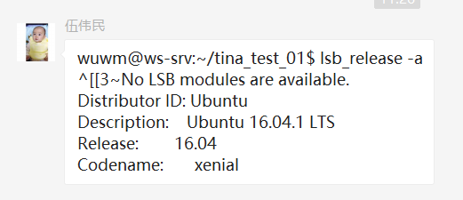

sudo apt-get install vim

sudo apt-get install git-core

sudo apt-get install gawk

sudo apt-get install flex bison

sudo apt-get install texinfo

sudo apt-get install lib32ncurses5 lib32z1

sudo apt-get install u-boot-tools

sudo apt-get install lib32stdc++6

sudo apt-get install libncurses5-dev

sudo apt-get install zlib1g-dev

sudo apt-get install libssl-dev

//装这个的目的是为了装JSON-C 编译过程中 报错了

wget https://cmake.org/files/v3.3/cmake-3.3.2.tar.gz

tar xzvf cmake-3.3.2.tar.gz

cd cmake-3.3.2

./bootstrap

Gmake

make install

<https://github.com/json-c/json-c>

Json-c 这个安装最恶心

sudo apt install git

sudo apt install cmake

sudo apt install doxygen # optional

sudo apt install valgrind # optional

$ git clone https://github.com/json-c/json-c.git

$ mkdir json-c-build

$ cd json-c-build

$ cmake ../json-c # See CMake section below for custom arguments

$ make

$ make test

$ make USE_VALGRIND=0 test # optionally skip using valgrind

$ make install

# Tina编译命令

编译命令

$ source build/envsetup.sh

$ lunch

$ make menuconfig

$ make kernel_menuconfig

$ make

$ pack

查找文件

grep "sys_config.fex" ./ -nr

当前文件夹查找文件

sudo find ./ -name 'sys_config.fex' -print

# 打补丁

Spi nand FLASH 补丁文件

解压补丁压缩包，打补丁

tar -zxvf R6_Update_Nand_To_3.6013_2018-09-06.tar.gz

cd R6_Update_Nand_To_3.6013_2018-09-06/

./install.sh ../tina/

回到 tina 目录

muboot //编译 uboot

# SPI NAND

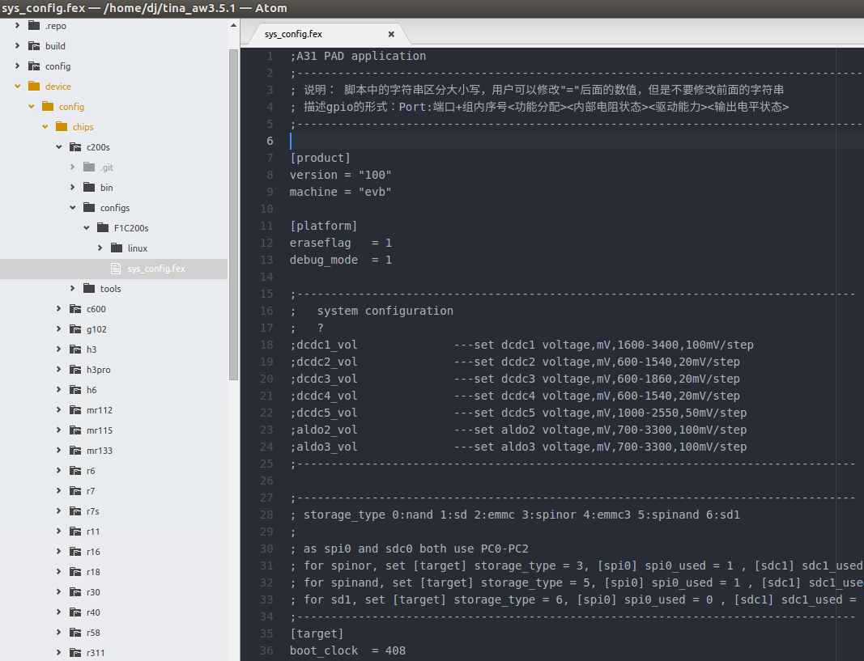

1.目前只支持一个型号<MX35LF1GE4AB, 3V, 1Gb, v1.5.pdf>



[target]

boot_clock = 408

**storage_type = 5**

burn_key = 0

打开 spi0，关闭 sdc1

[spi0]

**spi0_used = 1**

spi0_cs_number = 1

spi0_cs_bitmap = 1

spi0_cs0 = port:PC1<2><1><default><default>

spi0_sclk = port:PC0<2><default><default><default>

spi0_mosi = port:PC3<2><default><default><default>

spi0_miso = port:PC2<2><default><default><default>

[sdc1]

**sdc1_used = 0**

sdc1_detmode = 4

sdc1_buswidth = 1

;sdc1_clk = port:PC00<3><1><2><default>

;sdc1_cmd = port:PC01<3><1><2><default>

;sdc1_d0 = port:PC02<3><1><2><default>

sdc1_det =

sdc1_use_wp = 0

sdc1_wp =

sdc1_isio = 1

sdc1_regulator = "none"

# 烧写方法

