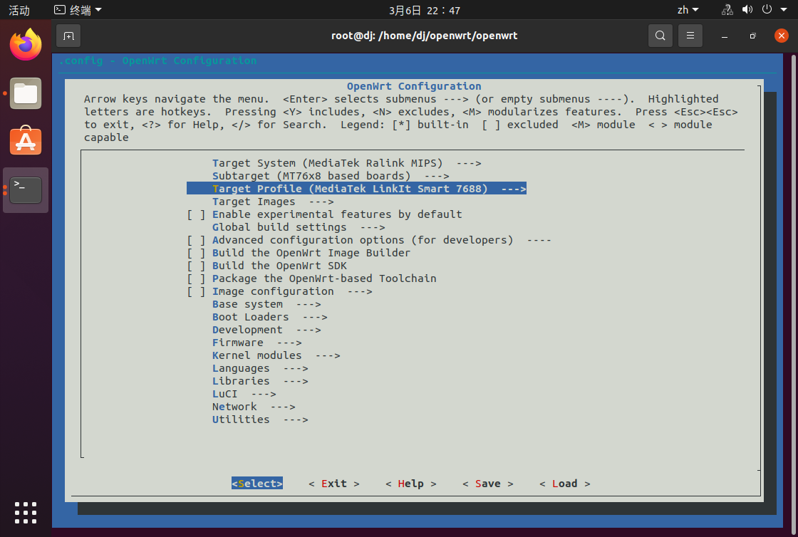

查看 OPENWRT 版本信息 cat /etc/openwrt_release

不要用 root 编译，用普通用户编译

**sudo** apt update

**sudo** apt **install** build-essential ccache ecj fastjar **file** **g++** **gawk** \**gettext** **git** java-propose-classpath libelf-dev libncurses5-dev \

libncursesw5-dev libssl-dev python python2.7-dev python3 **unzip** **wget** \

python3-distutils python3-setuptools rsync subversion swig time \

xsltproc zlib1g-dev

Run ./scripts/feeds update -a to obtain all the latest package definitions defined in feeds.conf / feeds.conf.default

Run ./scripts/feeds install -a to install symlinks for all obtained packages into package/feeds/

Run make menuconfig to select your preferred configuration for the toolchain, target system & firmware packages.

Run make to build your firmware. This will download all sources, build the cross-compile toolchain and then cross-compile the GNU/Linux kernel & all chosen applications for your target system.