zabbix对云redis的监控

1.创建存储redisId的文件/home/weideguo/myscripts/redisId.txt

crs-6mmj1lvx

crs-6mmj1lvy

crs-6mmj1lvz

2.创建脚本/home/weideguo/myscripts/redis_id_info.py

脚本的作用为将redisId文件以指定json格式输出

#!/bin/env python

import os

import json

r=open('/home/weideguo/myscripts/redisId.txt','r').read().split()

redis_id_info=[]

for item in r:

redis_id_info+=[{'{#REDISID}':item}]

#print(redis_item)

print json.dumps({'data':redis_id_info})

3.创建脚本/home/weideguo/myscripts/get_redis_info.py

脚本的作用为在运行时传入redisId、redis参数名，输出指定redisId的对应参数的值。

#!/bin/env python

#--encoding=utf-8

import json

import time

import random

import urllib

import urllib2

import hmac

import hashlib

import sys

def get_remote_data(params,SecretKey,baseUrl,protocol='https',method='GET'):

paramsort=sorted(params.iteritems())

paramstr=''

for i in paramsort:

paramstr=paramstr+i[0]+'='+i[1]+'&'

paramstr=paramstr[:-1]

srcStr=method+baseUrl+paramstr

sign_hmac = hmac.new(SecretKey,srcStr,hashlib.sha1)

sign = sign_hmac.digest().encode('base64').rstrip()

params['Signature']=sign

url=protocol+'://'+baseUrl+urllib.urlencode(params)

try:

data =json.loads(urllib2.urlopen(url).read())

return data

except Exception,e:

return {'message':e}

def output_para(dataDict,para):

paraValue=''

try:

paraValue=dataDict[para]

except Exception:

paraValue='para null'

print(paraValue)

if __name__ == '__main__':

params={

'offset':'0',

'limit':'1',

'Action':'DescribeRedis',

'Region': 'gz',

'SecretId' : 'AKIDDUUsLeDUMrrRcQ4npwgbJvLGBAm6q33r',

'Nonce':str(random.randint(0,1000000)),

'Timestamp' :str(int(time.time())),

}

SecreKey='F2eDfm979flRU4BmbHqmpmTUEvLq7j1x'

baseUrl='redis.api.qcloud.com/v2/index.php?'

try:

instanceId=sys.argv[1].strip()

instancePara=sys.argv[2].strip()

params['redisId']=instanceId

infoDict=get_remote_data(params,SecreKey,baseUrl)

#print(infoDict)

if infoDict['code']==0:

dataSet=infoDict['data']['redisSet']

if dataSet!=[]:

dataDict=dataSet[0]

output_para(dataDict,instancePara)

else:

print('data null')

else:

print('result error')

except Exception:

print('para error')

4.修改zabbix_agentd的配置文件（修改配置文件需要重新启动）

配置文件/u02/zabbix/etc/zabbix_agentd.conf

LogFile=/tmp/zabbix_agentd.log

Server=127.0.0.1

ListenPort=10052

ServerActive=192.168.200.141:10051

Hostname=db3.yh.cn

Include=../etc/zabbix_agentd.conf.d/

UnsafeUserParameters=1

配置文件/u02/zabbix/etc/zabbix_agentd.conf.d

UserParameter=redis.para[*],python /home/weideguo/myscripts/get_redis_info.py $1 $2

UserParameter=all.redis.info,python /home/weideguo/myscripts/ redis_id_info.py

5.web前端的设置

5.1创建模板

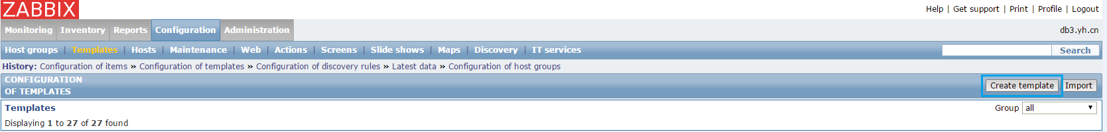

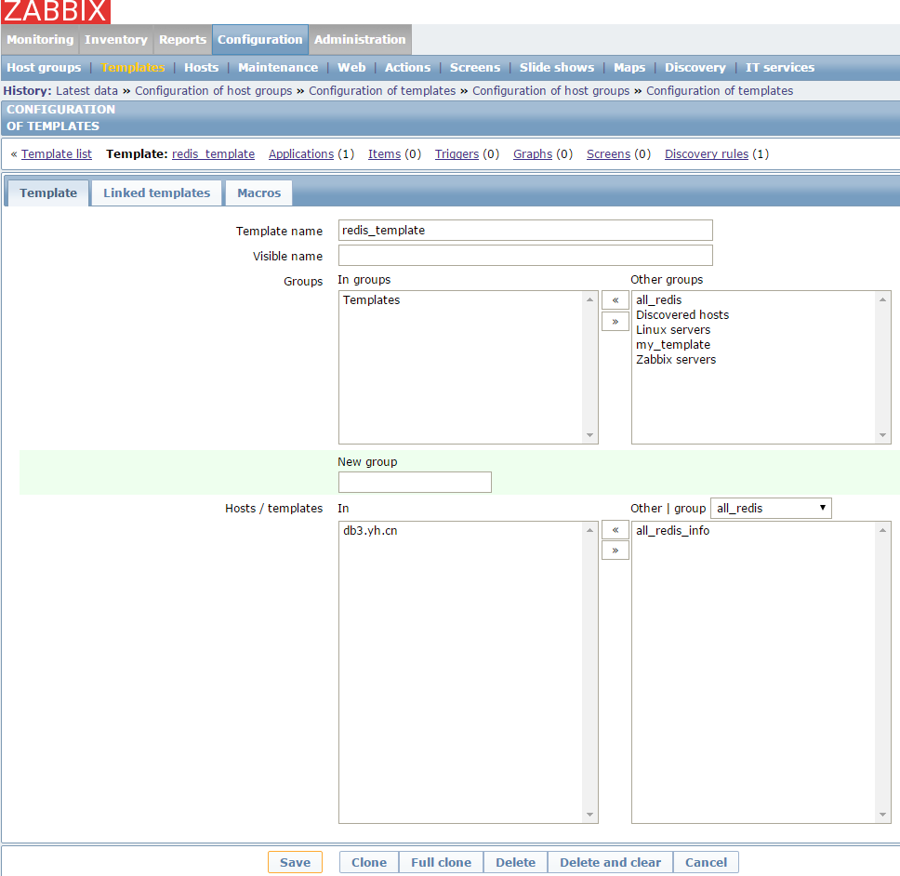

5.2在模板中创建application

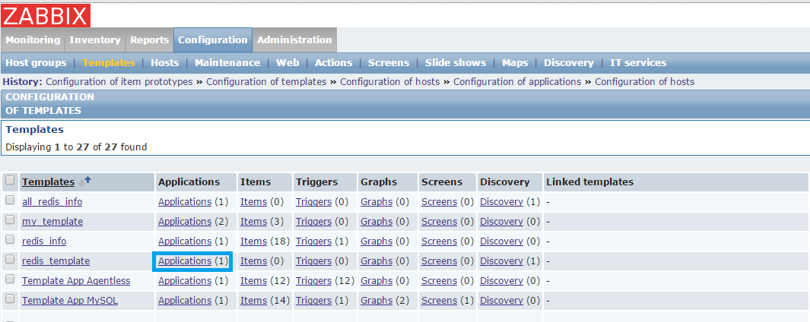

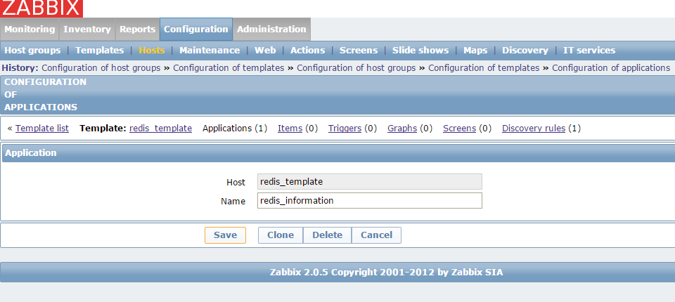

5.3在模板中创建discovery rule

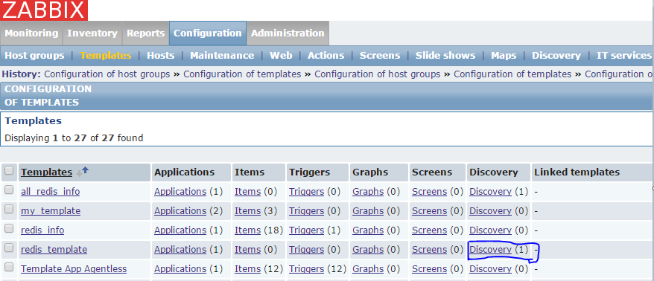

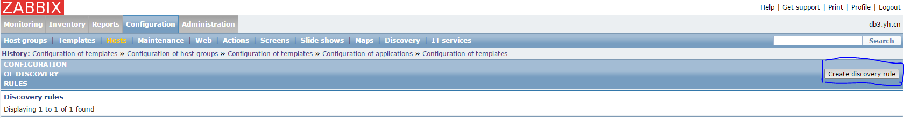

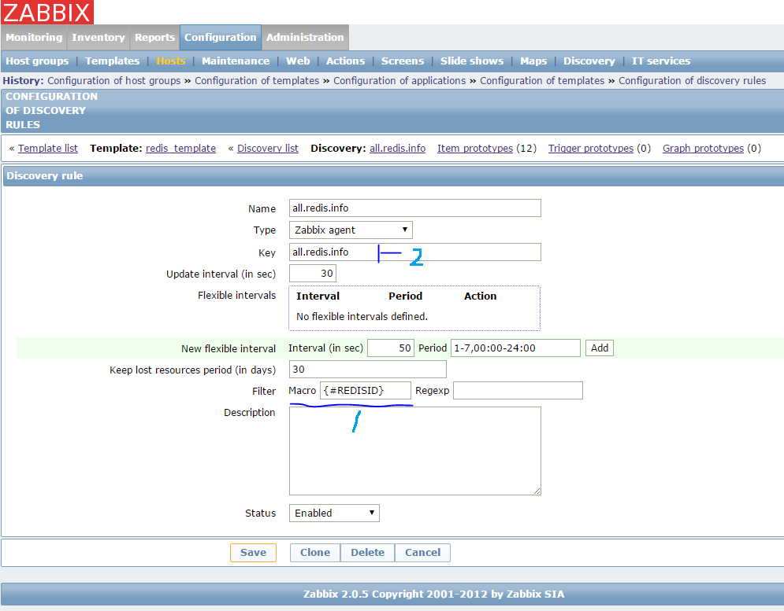

【1】对应脚本/home/weideguo/myscripts/redis_id_info.py输出的参数的格式

【2】对应配置文件/u02/zabbix/etc/zabbix_agentd.conf.d中脚本/home/weideguo/myscripts/redis_id_info.py指定的参数

5.4在模板的discovery rule中创建item_prototypes

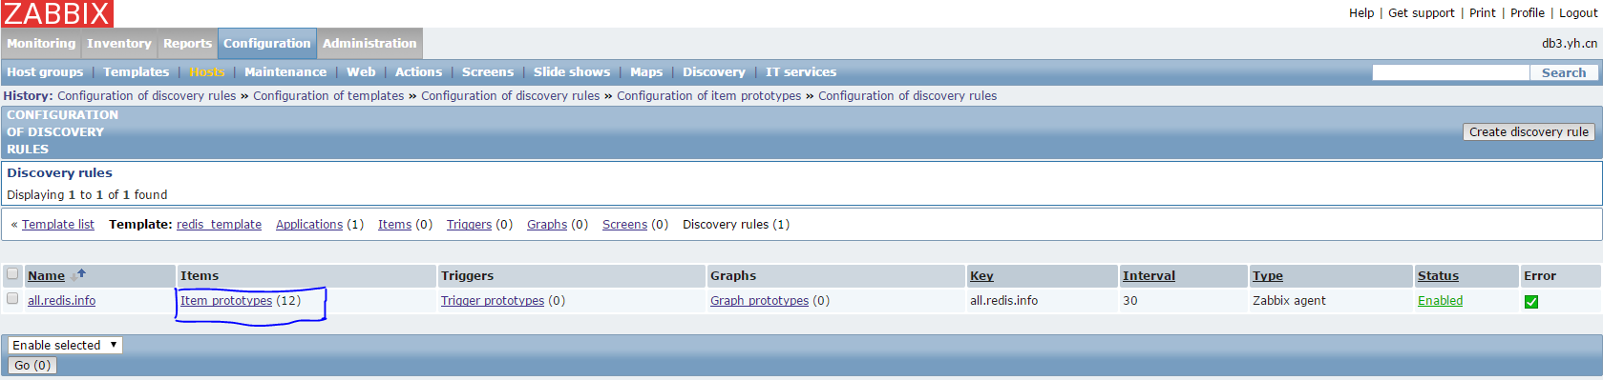

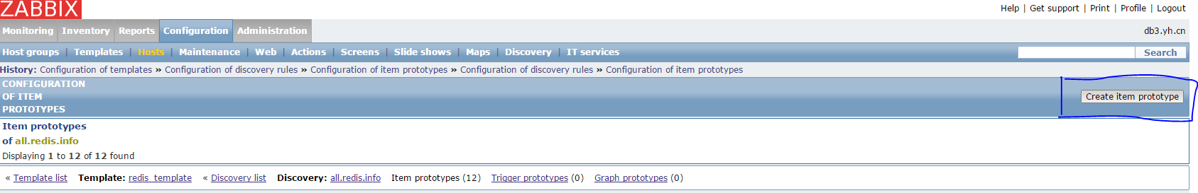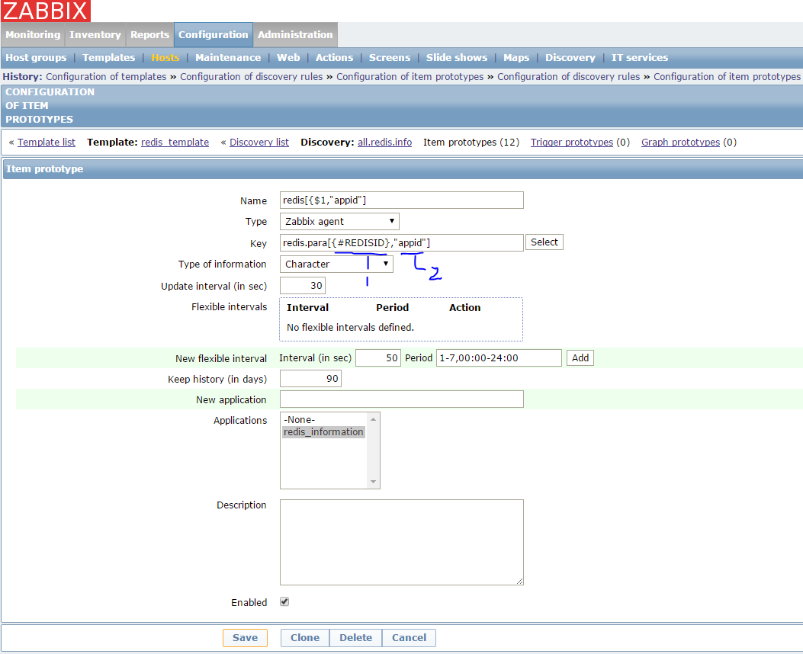

【1】对应脚本/home/weideguo/myscripts/redis_id_info.py输出的参数的格式

【2】redis的参数名，作为脚本/home/weideguo/myscripts/get_redis_info.py的第二个参数

key的名称对应配置文件对应配置文件/u02/zabbix/etc/zabbix_agentd.conf.d中脚本/home/weideguo/myscripts/get_redis_info.py指定的参数

根据不同的redis参数名，创建多个istem_prototype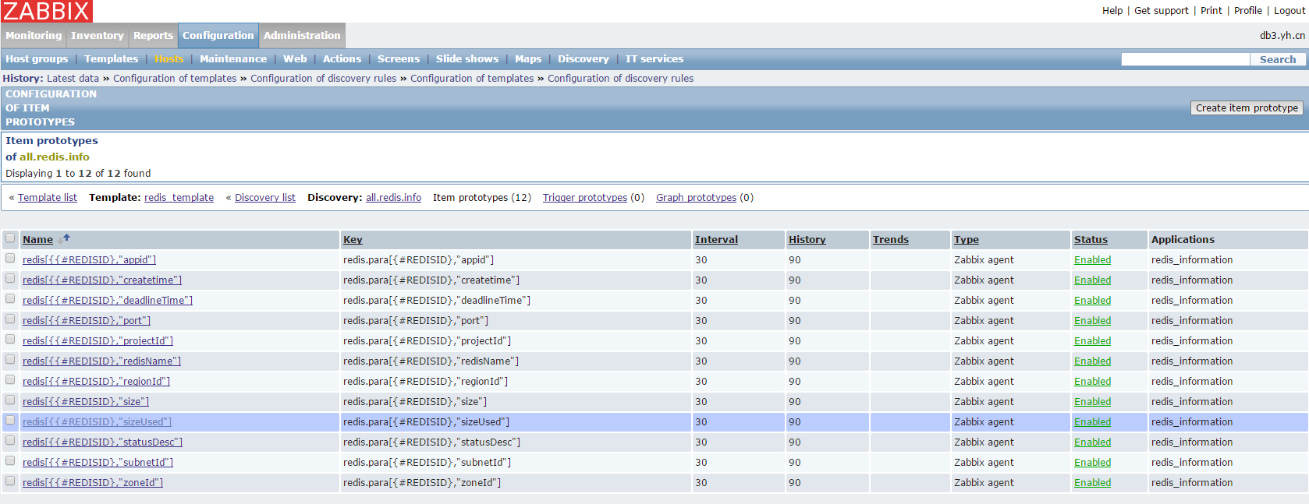

5.5创建host

host的信息与zabbix_agent的信息一致

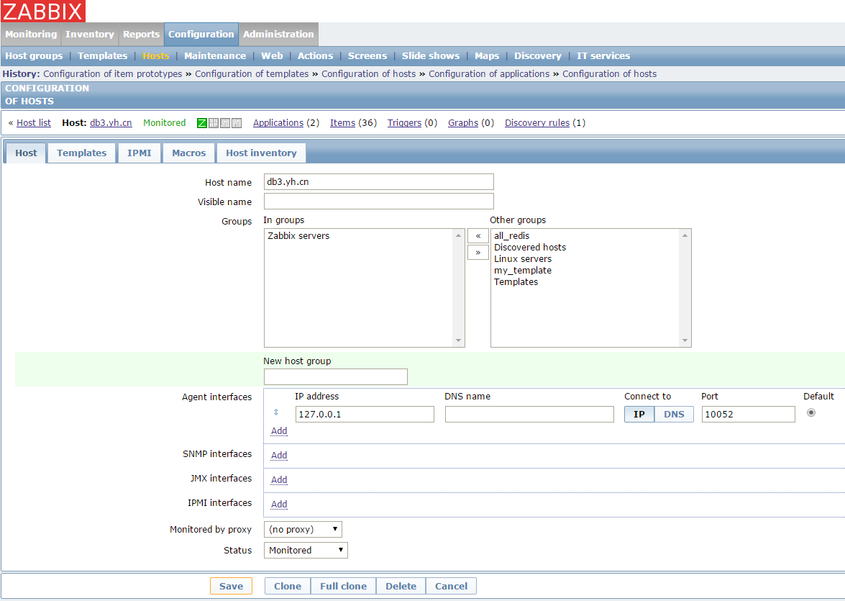

5.6在host中添加模板

