Form for DKE Student Project Websites

This is the form to be filled for your student project website. To simplify the procedure as much as possible and to make sure that only approved content gets on the website we use this form. Please send the filled form by email to your project supervisor.

* Provide at least one (good quality) image/figure together with this form. Accepted image formats are JPEG, PNG, and GIF. Images should be included in this form (use a lower resolution if needed) so that the editor knows which image is where. Images (provide good quality!) should also be provided as SEPARATE files through a download link. Name images like this: year_name_img_num where name is the last name of (one of) you and num is a number starting from 1. E.g. 2016_Miller_img_1.jpg
* To be uploaded to the website, your report should be provided through a download link. Reports should be provided in the format PDF. Name reports like this: year_name_report where name is the last name of (one of) you. E.g. 2016_Miller_report.pdf
* You can accompany your report with movies. Movies to be uploaded on your website should be provided through a download link. Movies should be provided in the format MPEG4. Name movies like this: year_name_mov_num where name is the last name of (one of) you and num is a number starting from 1. E.g. 2016_Miller_mov_1.mp4
* Your final presentation should be provided through a download link. Presentations should be provided in the format PDF. Name presentations like this: year_name_presentation where name is the last name of (one of) you. E.g. 2016_Miller_ presentation.pdf
* Provide all references in the APA standard. See e.g. <https://scholar.google.com/> for examples. Citations should be done using the author name, year. For instance: [Weiss et al., 2015]

**Type of project (e.g. Bachelor thesis, Master AI thesis, Master OR thesis, Master AI internship project, Master OR internship project, Master AI semester project, Master OR semester project):**

Master semester project

**Year of project:**

2018-2019

**Key words (5 max):**

E.g. reinforcement learning, deep learning, latent space, transfer learning, neural networks.

**Name(s) of student(s) who participated in the project:**

Adrian Rodriguez Grillo, Danni Liu, Alessandro Scoppio, Kevin Trebing, Tonio Weidler.

**Name(s) of supervisor(s):**

Kurt Driessens.

**Title of the project:**

Reinforcement Learning in Latent Space.

**Download link for additional content (at least 1 image/figure, report, final presentation, maybe some movies):**

https://www.dropbox.com/share

**Captions of images/figures. Enter your images (in low resolution if needed) here as well with appropriate captions:**

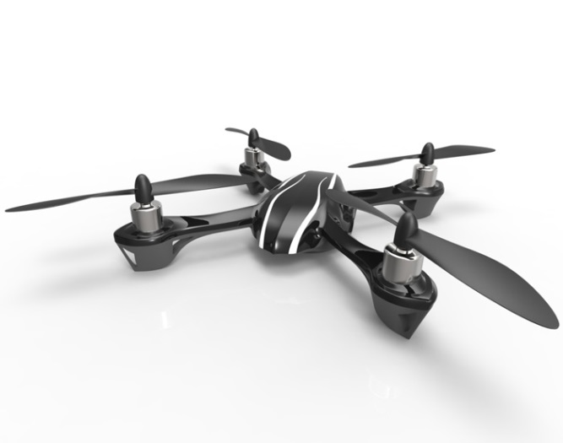

Fig. 1. Newly created quadcopter

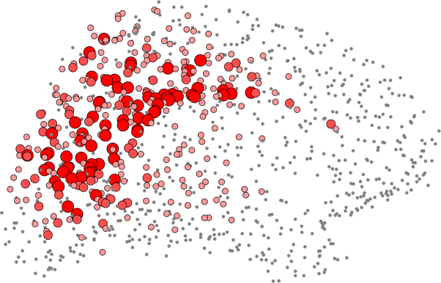

Fig. 2. Point cloud generated by SLAM algorithm

**Problem statement and motivation. Please provide a general description of the problem that you worked on, a short description of why this is relevant, and a few sentences that state precisely what you aimed at:**

Reinforcement Learning (RL) is a subfield of the artificial intelligence (AI) where an agent is set free in an unknown environment, where will receive positive or negative rewards depending on the actions it makes. In this situation, the agent will act using trial and error with the objective of obtain the maximum reward possible and learn the way to do so consistently. This learning obtained from the interaction, from the experience is called policy.

RL tries to mimic the process behind the human learning, however some important differences arise

After earthquakes usually it is not safe to enter damaged buildings to search for people inside. As a result it would be desirable if part of this search could be performed by robots that can fly into areas that are difficult to access by humans and search for people autonomously. One of the many challenges in such an application is that these robots have to autonomously navigate in partially destroyed areas. For this, robots need to be capable of mapping unknown environments and to estimate their own position – a problem well-known as Simultaneous Localization and Mapping (SLAM) [Albert et al., 2005]. In the present project we focused on the exploration of SLAM algorithms that can be autonomously executed despite the limited computational resources available on quadcopters. For this we implemented, evaluated, and compared five SLAM algorithms on a quadcopter provided by DKE (Fig. 1).

**Research questions and/or hypothesis: explain the questions/hypothesis that you addressed during your project:**

In the present project we aimed at answering the following research questions:

* Can the state spaces of different tasks be jointly represented in a latent space, e.g. using a variational autoencoder?
* Can unseen tasks be translated into the latent space representations without additional training?
* Can a single agent learn multiple tasks simultaneously when using the latent space during Q-Learning?
* To what extent can the policy network trained on the latent representations improve the learning of unseen tasks?
* Will the policy learned in the source tasks allow the agent to perform the target tasks without additional training?
* Can we identify crucial information encoded in the latent space? If yes, what are the encoded pieces of information and what behavior do they correspond to?

**Major outcomes of your project. Please provide up to seven major outcomes of your project. These should be formulated in a clear but compact way:**

* After an intensive literature review we generated a new metric for comparing the performance of SLAM algorithms. The metric evaluates SLAM algorithms according to their accuracy in localizing a quadcopter in a damaged test environment, and to the computational resources required to execute the algorithm in real-time. Five algorithms have been implemented and tested.
* Following the newly developed metric we found that the SLAM algorithm suggested by Bayers et al. [2015] is best suited for search and rescue tasks since it reliably extracts features also in damaged buildings (Fig. 2).

**References: Provide possible references you are using in your text in the APA standard. Use e.g. Google Scholar to obtain references in the correct format:**

Möckel, R., Jaquier, C., Drapel, K., Dittrich, E., Upegui, A., Ijspeert, A. (2006). YaMoR and Bluemove—an autonomous modular robot with bluetooth interface for exploring adaptive locomotion. In Climbing and Walking Robots (pp. 685-692). Springer Berlin Heidelberg.

**Any additional information you would like to be mentioned:**

???

**To be filled by supervisors (dear supervisors: delete what you do not want):**

◻ I agree that this project is posted on the DKE student projects webpage. (Feel free to make any modifications to the text/material provided by your students.)

◻ I agree that the final project report is uploaded to the DKE student projects webpage.

◻ I agree that the final presentation is uploaded to the DKE student projects webpage.

◻ I agree that movies provided by the students are uploaded to the DKE Youtube channel and shown on the DKE student projects webpage.