Git Exercise II Module 3
By Edward Wei
I have been trying to get better at LabView as it is a tool that can lead to career advancement within Fluke, my employer. Link to project here.
My end goal is to create digital sounds from the computer however, that is something I need much more time to build up to. So now, I am just trying to understand the data structures a bit better and how the back end and front-end interacts with each other. Below is what my project looks like.
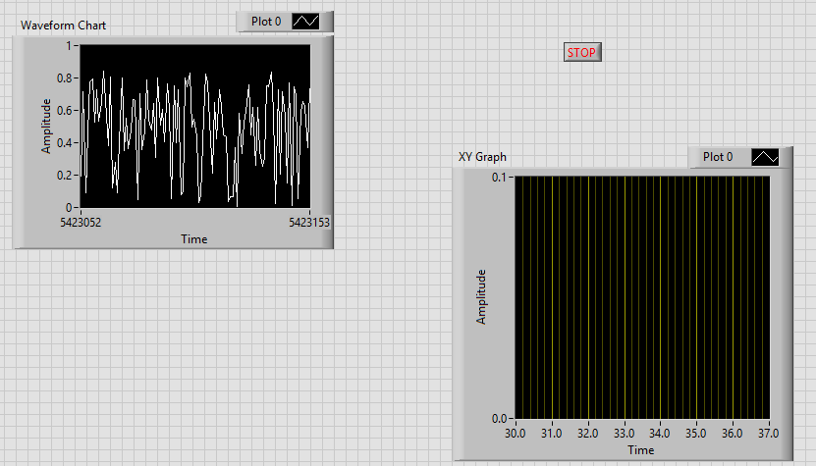
All my issues are personal gripes with the current display as well as the functionality. They are all in some way short-term goals of fulfilling my goal of displaying data in an aesthetic manner.
As for my commits, I like to commit often. If I program in a work context, it’s almost always a solo project and if other people need access to my code, I give them their own copy instead of letting them branch from the main project. For this class, I am seeing the value of longer and more detailed commits. However, I think a mix of both is appropriate as committing to longer comments all the time may be a deterrence from backing up my work as often.

