Programming Lab 2 Submission
3. https://github.com/weifoong2004/inf1103-labs
4. 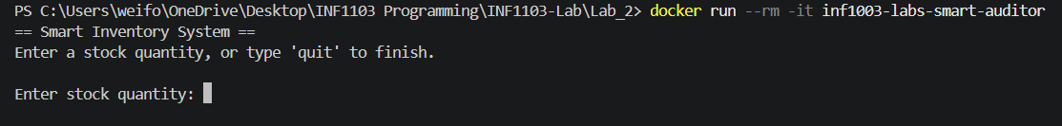
5. 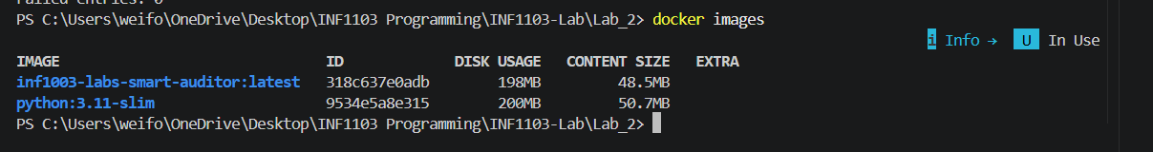
6. 