BIOL 425 Final Report: BosR DNA Binding Coordinates RpoS-Dependent and Independent Gene Regulation During Mammalian Host Adaptation in Borrelia burgdorferi
Toka Othman
5/2/2026
Table of Contents
1 Introduction 1
1.1 Background 1
1.2 Biological hypothesis 2
1.3 Significance 2
2 Materials and Methods 2
2.1 Samples 2
2.2 Experimental procedure 2
2.3 Statistical methods 2
3 Exploratory data analysis 2
4 Results 5
5 Conclusions 5
5.1 Biological conclusions 5
5.2 Future work 5
6 References 5
6.1 Cite paper 5
6.2 Cite code repository 6
6.3 Cite data file 6

1 Introduction

1.1 Background
-

1.2 Biological hypothesis
BosR regulates transcription in Borrelia burgdorferi through both RpoS-dependent and RpoS-independent mechanisms and when BosR DNA binding is disrupted it significantly alters global gene expression during mammalian host adaptation.

1.3 Significance
It is very important to clearly understand how B. burgdorferi adapts to mammalian hosts in order to understand Lyme disease pathogenesis. BosR function as a transcriptional regulator which coordinates expression of virulence associated genes, host adaptation pathways, and genes that are involved in bacterial survival.
It is important to be able to determine whether BosR acts only through RpoS or independently of RpoS since it helps clarify the organization of transcriptional networks in B. burgdorferi. It has always been assumed that BosR functions as an oxidative stress regulator so these findings challenge theses assumption since the results suggest that BosR acts as a global regulatory protein that is involved in mammalian phase gene expression.
This work could contribute to future efforts that can help identify therapeutic targets for Lyme disease since it helps improvie the understanding of the molecular mechanisms that control bacterial adaptation and virulence.

2 Materials and Methods

2.1 Samples
The study used Borrelia burgdorferi strain B31 5A4 as the wild-type strain. The mutant strains had a ΔbosR mutant that lacked the bosR gene and a DNA-binding-defective BosR-R39A mutant. The ΔrpoS strain was also used in order to compare it with the RpoS-dependent transcriptional responses.
The samples were analyzed under two conditions:
- In vitro cultivated spirochetes grown in BSK-II medium after temperature shift.
- Mammalian host-adapted spirochetes cultivated in dialysis membrane chambers (DMCs) implanted in rats.
Biological replicates were also collected for RNA sequencing analysis where the wild-type strain served as the experimental control for comparison with mutant strains.

2.2 Experimental procedure
---

2.3 Statistical methods
---

3 Exploratory data analysis
Re-analysis of Grassmann et al (2025) Borrelia transcriptome comparisons

Part 1. load libraries; set working directory
library(tidyverse)
## Warning: package 'ggplot2' was built under R version 4.5.2
## Warning: package 'readr' was built under R version 4.5.2
## Warning: package 'purrr' was built under R version 4.5.2
## Warning: package 'dplyr' was built under R version 4.5.2
## ── Attaching core tidyverse packages ──────────────────────── tidyverse 2.0.0 ──
## ✔ dplyr 1.2.1 ✔ readr 2.2.0
## ✔ forcats 1.0.1 ✔ stringr 1.6.0
## ✔ ggplot2 4.0.3 ✔ tibble 3.3.1
## ✔ lubridate 1.9.5 ✔ tidyr 1.3.2
## ✔ purrr 1.2.2
## ── Conflicts ────────────────────────────────────────── tidyverse_conflicts() ──
## ✖ dplyr::filter() masks stats::filter()
## ✖ dplyr::lag() masks stats::lag()
## ℹ Use the conflicted package (<http://conflicted.r-lib.org/>) to force all conflicts to become errors
library(readxl)
library(dplyr)
library(EnhancedVolcano)
## Warning: package 'EnhancedVolcano' was built under R version 4.5.2
## Loading required package: ggrepel
## Warning: package 'ggrepel' was built under R version 4.5.2
library(ggrepel)
library(shiny)
## Warning: package 'shiny' was built under R version 4.5.2
library(bslib)
##
## Attaching package: 'bslib'
##
## The following object is masked from 'package:utils':
##
## page
library(modeldata)
##
## Attaching package: 'modeldata'
##
## The following object is masked from 'package:datasets':
##
## penguins
library(DataExplorer)
## Warning: package 'DataExplorer' was built under R version 4.5.2
library(plotly)
##
## Attaching package: 'plotly'
##
## The following object is masked from 'package:ggplot2':
##
## last_plot
##
## The following object is masked from 'package:stats':
##
## filter
##
## The following object is masked from 'package:graphics':
##
## layout
library(ggplot2)
library(BiocManager)
## Bioconductor version '3.22' is out-of-date; the current release version '3.23'
## is available with R version '4.6'; see https://bioconductor.org/install
setwd("~/QiuLab-work/")

Part 2. Read data table, reshape into long tables
x <- read_excel("mmi70036-sup-0002-tables2.xlsx", sheet = 3)
colnames(x)
## [1] "GeneID" "baseMean" "log2FoldChange"
## [4] "lfcSE" "stat" "pvalue"
## [7] "padj" "WT_in_vitro_1" "WT_in_vitro_2"
## [10] "WT_in_vitro_3" "ΔbosR _in_vitro_1" "ΔbosR _in_vitro_2"
## [13] "ΔbosR _in_vitro_3" "ΔbosR _in_vitro_4"
x.long <- x |>
select(1, 8:14) |>
pivot_longer(2:8, names_to = "treat", values_to = "rfpkm")
x.long <- x.long |>
mutate(rep = as.numeric(str_remove(treat, "^.*_")))
x.long <- x.long |>
mutate(treat2 = str_remove(treat, "_\\d$"))

Part 3. Plot histogram to show distributions
x.long |>
ggplot(aes(rfpkm+1, fill = as.factor(rep))) +
geom_histogram(bins = 100) +
scale_x_log10() +
facet_wrap(~treat2, nrow=2)
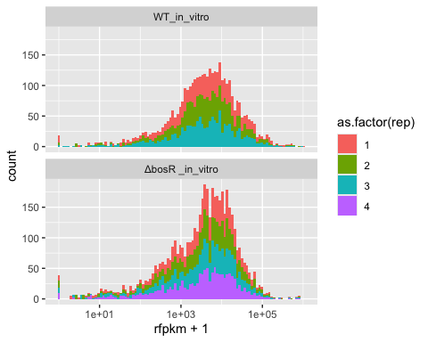

Part 4. read data frame
x <- read_excel("mmi70036-sup-0002-tables2.xlsx", sheet = 3)
y <- read_excel("mmi70036-sup-0003-tables3.xlsx", sheet = 3)

Part 5. select desired data
in_vitro <- x[, c(1, 8, 9, 10)]
colnames(in_vitro) <- c("GeneID", "WT_in_vitro_1", "WT_in_vitro_2", "WT_in_vitro_3")
DMC <- y[, c(1, 8:13)]
colnames(DMC) <- c("GeneID","WT_DMC1","WT_DMC2","WT_DMC3","WT_DMC4","WT_DMC5","WT_DMC6")
WT <- merge(in_vitro, DMC , by = "GeneID")
#normilization
library(preprocessCore)
## Warning: package 'preprocessCore' was built under R version 4.5.2
normalized_data <- normalize.quantiles(as.matrix(WT[, -1]))
WT <- data.frame(GeneID = WT$GeneID, normalized_data)
colnames(WT)[-1] <- c("WT_in_vitro_1","WT_in_vitro_2","WT_in_vitro_3",
"WT_DMC1","WT_DMC2","WT_DMC3",
"WT_DMC4","WT_DMC5","WT_DMC6")
WT[, -1] <- log2(WT[, -1] + 1)

Part 6. calculate fold change
FC <- WT %>%
mutate(in_vitro_mean = rowMeans(select(., 2:4)),
DMC_mean = rowMeans(select(., 5:10)),
fold_change = DMC_mean / in_vitro_mean,
log2FC = log2(fold_change))
FC |>
ggplot(aes(x = log2FC)) +
geom_histogram(bins = 100) +
geom_vline(xintercept = 0, col = "red") +
theme_bw() +
labs(title = "WT_in_vitro vs WT_in_DMC")
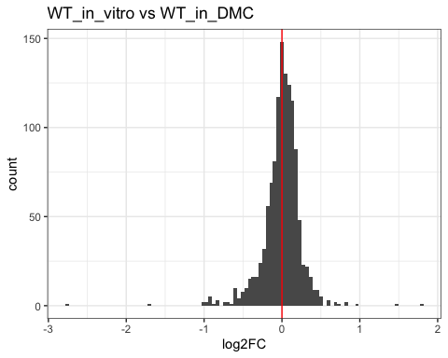

Part 7. Calculate pvalue
FC <- FC %>%
rowwise() %>%
mutate(
pvalue = if(sd(c_across(2:4)) == 0 | sd(c_across(5:10)) == 0) NA_real_
else t.test(c_across(2:4), c_across(5:10))$p.value) %>%
ungroup() %>%
mutate(p_adj = p.adjust(pvalue, method = "BH"))
FC_clean <- FC %>%
filter(is.finite(log2FC), !is.na(pvalue))
# show BB_Q67, methyl-transferase
gene.sel <- FC_clean |> filter(GeneID %in% c('BB_Q67', 'BB_A15', 'BB_B19', 'BB_B24'))
#|> select(in_vitro_mean, DMC_mean, fold_change, pvalue, p_adj)

Part 8. plot volcano plot
EnhancedVolcano(
toptable = FC_clean,
lab = FC_clean$GeneID,
x = "log2FC",
y = "pvalue",
title = "WT_in_vitro vs WT_in_DMC",
pCutoff = 0.05,
FCcutoff = 1,
pointSize = 2.0,
labSize = 3.0)
## Warning: Using `size` aesthetic for lines was deprecated in ggplot2 3.4.0.
## ℹ Please use `linewidth` instead.
## ℹ The deprecated feature was likely used in the EnhancedVolcano package.
## Please report the issue to the authors.
## This warning is displayed once per session.
## Call `lifecycle::last_lifecycle_warnings()` to see where this warning was
## generated.
## Warning: The `size` argument of `element_line()` is deprecated as of ggplot2 3.4.0.
## ℹ Please use the `linewidth` argument instead.
## ℹ The deprecated feature was likely used in the EnhancedVolcano package.
## Please report the issue to the authors.
## This warning is displayed once per session.
## Call `lifecycle::last_lifecycle_warnings()` to see where this warning was
## generated.
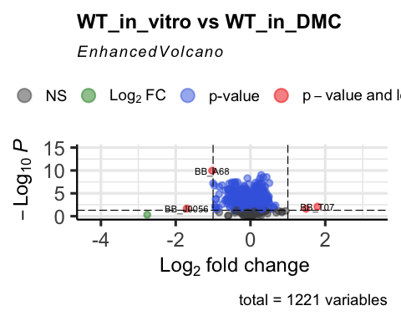
FC_clean |>
ggplot(aes(log2FC, p_adj, label = GeneID)) +
geom_point(shape = 1) +
geom_point(data = gene.sel, col = "red") +
geom_text_repel(data = gene.sel, col = "red") +
scale_y_log10() +
geom_vline(xintercept = 0, linetype = 2) +
geom_hline(yintercept = 1e-3, col = "red") +
theme_bw()+
labs(title = "WT_in_vitro vs WT_in_DMC")
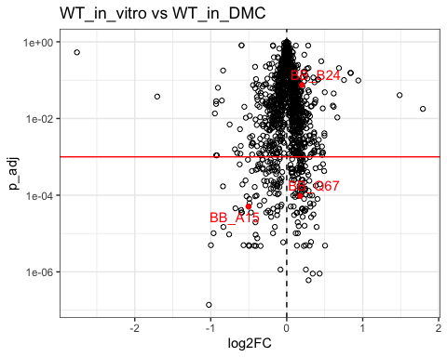
# geom_point(data = gene.sel, size = 3, col = "orange" )
#Table 2 - in vitro
WT_vs_bosR_in_vitro <- read_excel("mmi70036-sup-0002-tables2.xlsx", sheet = 3)
colnames(WT_vs_bosR_in_vitro)
## [1] "GeneID" "baseMean" "log2FoldChange"
## [4] "lfcSE" "stat" "pvalue"
## [7] "padj" "WT_in_vitro_1" "WT_in_vitro_2"
## [10] "WT_in_vitro_3" "ΔbosR _in_vitro_1" "ΔbosR _in_vitro_2"
## [13] "ΔbosR _in_vitro_3" "ΔbosR _in_vitro_4"
WT_vs_bosR_in_vitro %>%
ggplot(aes(x = log2FoldChange)) +
geom_histogram(bins = 100) +
geom_vline(xintercept = 0, col = "red") +
theme_bw() +
labs(title = "WT_in_vitro vs ∆bosR_in_vitro")
## Warning: Removed 2 rows containing non-finite outside the scale range
## (`stat_bin()`).
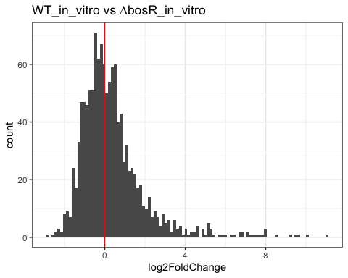
WT_vs_bosR_in_vitro %>%
ggplot(aes(log2FoldChange,padj)) +
geom_point(shape = 1) +
scale_y_log10() +
geom_vline(xintercept = 0, linetype = 2) +
geom_hline(yintercept = 1e-3, col = "red") +
theme_bw() +
labs(title = "WT_in_vitro vs ∆bosR_in_vitro")
## Warning in scale_y_log10(): log-10 transformation introduced infinite values.
## Warning: Removed 2 rows containing missing values or values outside the scale range
## (`geom_point()`).
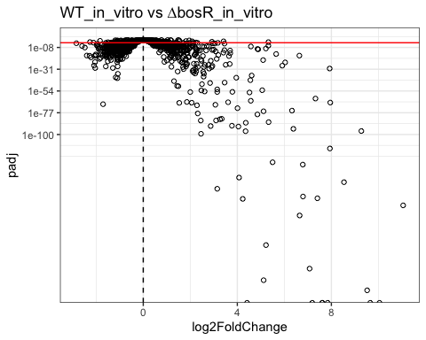
WT_vs_bosR_R39A_in_vitro <- read_excel("mmi70036-sup-0002-tables2.xlsx", sheet = 4)
colnames(WT_vs_bosR_R39A_in_vitro)
## [1] "GeneID" "baseMean" "log2FoldChange"
## [4] "lfcSE" "stat" "pvalue"
## [7] "padj" "WT_in_vitro_1" "WT_in_vitro_2"
## [10] "WT_in_vitro_3" "bosR-R39A_in_vitro_1" "bosR-R39A_in_vitro_2"
## [13] "bosR-R39A_in_vitro_3" "bosR-R39A_in_vitro_4"
WT_vs_bosR_R39A_in_vitro %>%
ggplot(aes(x = log2FoldChange)) +
geom_histogram(bins = 100) +
geom_vline(xintercept = 0, col = "red") +
theme_bw() +
labs(title = "WT_vs_bosR_R39A_in_vitro")
## Warning: Removed 2 rows containing non-finite outside the scale range
## (`stat_bin()`).
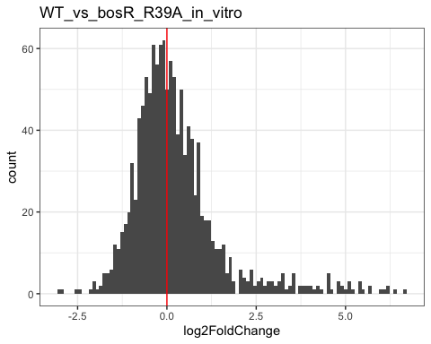
WT_vs_bosR_R39A_in_vitro %>%
ggplot(aes(log2FoldChange, padj)) +
geom_point(shape = 1) +
scale_y_log10() +
geom_vline(xintercept = 0, linetype = 2) +
geom_hline(yintercept = 1e-3, col = "red") +
theme_bw() +
labs(title = "WT_vs_bosR_R39A_in_vitro")
## Warning: Removed 2 rows containing missing values or values outside the scale range
## (`geom_point()`).
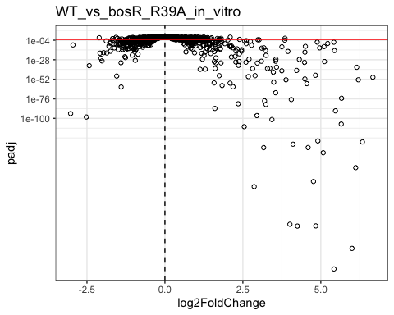

table 3 DMC
WT_vs_bosR_DMC <- read_excel("mmi70036-sup-0003-tables3.xlsx", sheet = 3)
colnames(WT_vs_bosR_DMC)
## [1] "GeneID" "baseMean" "log2FoldChange" "lfcSE"
## [5] "stat" "pvalue" "padj" "WT_DMC1"
## [9] "WT_DMC2" "WT_DMC3" "WT_DMC4" "WT_DMC5"
## [13] "WT_DMC6" "ΔbosR _DMC1" "ΔbosR _DMC2" "ΔbosR _DMC3"
## [17] "ΔbosR _DMC4" "ΔbosR _DMC5"
WT_vs_bosR_DMC %>%
ggplot(aes(x = log2FoldChange)) +
geom_histogram(bins = 100) +
geom_vline(xintercept = 0, col = "red") +
theme_bw() +
labs(title = "WT_vs_∆bosR_DMC")
## Warning: Removed 1 row containing non-finite outside the scale range
## (`stat_bin()`).
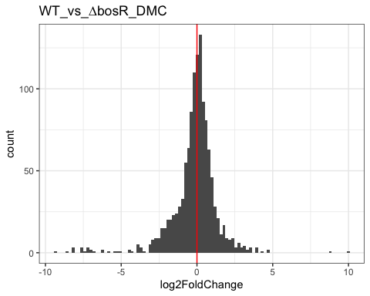
WT_vs_bosR_DMC %>%
ggplot(aes(log2FoldChange, padj)) +
geom_point(shape = 1) +
scale_y_log10() +
geom_vline(xintercept = 0, linetype = 2) +
geom_hline(yintercept = 1e-3, col = "red") +
theme_bw() +
labs(title = "WT_vs_∆bosR_DMC")
## Warning in scale_y_log10(): log-10 transformation introduced infinite values.
## Warning: Removed 1 row containing missing values or values outside the scale range
## (`geom_point()`).
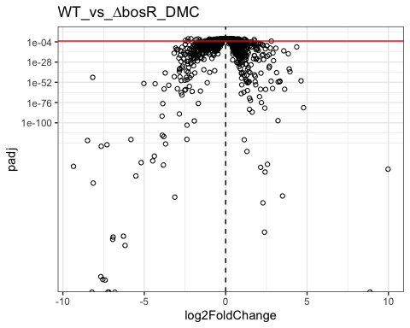
WT_vs_bosR_R39A_DMC <- read_excel("mmi70036-sup-0003-tables3.xlsx", sheet = 4)
colnames(WT_vs_bosR_R39A_DMC)
## [1] "GeneID" "baseMean" "log2FoldChange" "lfcSE"
## [5] "stat" "pvalue" "padj" "WT_DMC1"
## [9] "WT_DMC2" "WT_DMC3" "WT_DMC4" "WT_DMC5"
## [13] "WT_DMC6" "bosR-R39A _DMC1" "bosR-R39A _DMC2" "bosR-R39A _DMC3"
## [17] "bosR-R39A _DMC4"
WT_vs_bosR_R39A_DMC %>%
ggplot(aes(x = log2FoldChange)) +
geom_histogram(bins = 100) +
geom_vline(xintercept = 0, col = "red") +
theme_bw() +
labs(title = "WT_vs_bosR_R39A_DMC")
## Warning: Removed 2 rows containing non-finite outside the scale range
## (`stat_bin()`).
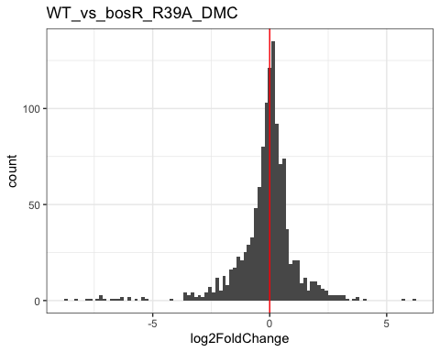
WT_vs_bosR_R39A_DMC %>%
ggplot(aes(log2FoldChange, padj)) +
geom_point(shape = 1) +
scale_y_log10() +
geom_vline(xintercept = 0, linetype = 2) +
geom_hline(yintercept = 1e-3, col = "red") +
theme_bw() +
labs(title = "WT_vs_bosR_R39A_DMC")
## Warning: Removed 2 rows containing missing values or values outside the scale range
## (`geom_point()`).
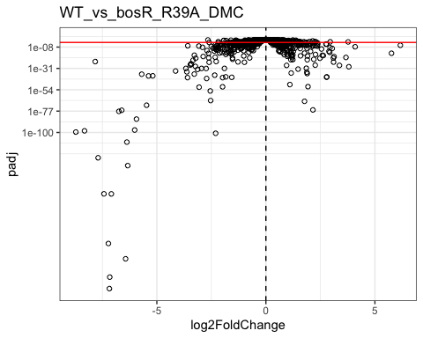

4 Results
-

5 Conclusions

5.1 Biological conclusions
-

5.2 Future work
Future studies could be done to further investigate how BosR interacts with RNA polymerase and whether additional protein cofactors contribute to BosR-mediated transcriptional regulation.
Additional experiments could also determine:
- Whether BosR directly binds promoters of all identified target genes
- How environmental conditions influence BosR activity
- Whether BosR contributes to virulence during infection in animal models
- How BosR-dependent pathways differ between tick and mammalian host environments
Further characterization of BosR DNA-binding specificity may clarify why no strongly conserved DNA-binding motif was identified in this study.

6 References

6.1 Cite paper
Grassmann AA, McLain MA, Freeman MR, Caimano MJ, Radolf JD. DNA Binding by BosR Controls RpoS-Dependent and -Independent Gene Expression in Borrelia burgdorferi. Mol Microbiol. 2026 Feb;125(2):85-107. doi: 10.1111/mmi.70036. Epub 2025 Nov 14. PMID: 41239753; PMCID: PMC13036749.
6.2 Cite code repository
Computer codes & data: https://github.com/weigangq/MonteCarlo/tree/main/Bb-transcriptomes-Toka

6.3 Cite data file
Data set:
https://github.com/weigangq/MonteCarlo/blob/main/Bb-transcriptomes-Toka/mmi70036-sup-0003-tables3.xlsx
https://github.com/weigangq/MonteCarlo/blob/main/Bb-transcriptomes-Toka/mmi70036-sup-0002-tables2.xlsx

