**Only include acronyms in Neuropixels data.**

**Pretectal area**: part of midbrain, comprises part of the subcortical visual system. (involved primarily in mediating behavioral responses to acute changes in ambient light)

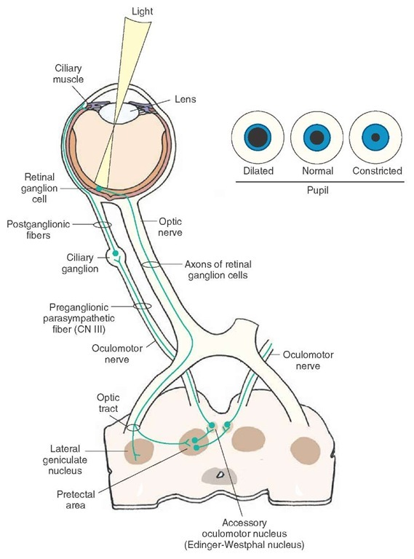

1. APN: anterior pretectal nucleus
2. NOT: nucleus of the optic tract

**Hippocampal formation**: is thought to play a role in memory, spatial navigation and control of attention.

(Human) hippocampus = hippocampus proper + dentate gyrus: plays important roles in the consolidation of information from short-term memory to long-term memory, and in spatial memory that enables navigation

1. Hippocampus proper:
   1. CA1: Field CA1
   2. CA3: field CA3
2. DG: dentate gyrus (is thought to contribute to the formation of new episodic memories, the spontaneous exploration of novel environments and other functions.)
3. SUB: subiculum. (part of the hippocampus involved in spatial navigation/memory) (may (1) play a role in some cases of human epilepsy; (2) be implicated in working memory and drug addiction; (3) dorsal subiculum is involved in spatial relations; (4) ventral subiculum regulates the hypothalamic-pituitary-adrenal axis)

TH: Thalamus

Thalamic Nuclei

1. Lateral geniculate nucleus:
   1. LGd: Dorsal part of the lateral geniculate complex (In humans & other mammals, the two strongest pathways linking the eye to the brain are those projecting to the dorsal part of the LGN in the thalamus, and to the superior colliculus.)
2. LP: Lateral posterior nucleus of the thalamus
3. VPM: ventral posteromedial nucleus of the thalamus (involved in sensation/movement)
4. VL: lateral ventricle (its function helps the coordination and planning of movement. It also plays a role in the learning of movement.)
5. POL: posterior limiting nucleus of the thalamus (a group of cells at the posteromedial boundary of the thalamus with the pretectal region in the rat)
6. Eth: ethmold nucleus of the thalamus (refers to a group of cells located centrally in the posterior portion of the thalamus of the mouse)

Visual area:

1. VISp: Primary visual area
2. VISl: lateral visual area
3. VISam: anteromedial visual area
4. VISpm: posteromedial visual area
5. VISrl: rostrolateral visual area
6. VISal: anterolateral visual area

grey: basic cell groups and regions (grey matter?)

PO: parieto-occipital area (boundary between the cuneus and precuneus, and also between the parietal and occipital lobes) (may involved along with the dorsolateral prefrontal cortex during planning)