Bag of Little Bootstraps (BLB)

# Bag of Little Bootstraps (BLB)

M out n bootstraps: need rescaling…

**Algorithm** (b = subset size; s = # of sampled subsets; r = # of MC):

for j in 1:s

subsample without replacement (size = b)

do bootstraps on the subsample (r iterations)

get the estimation of j: 

end

Average values of all s subsamples: 

Properties:

1. Consistency: converge in probability to population 
2. Higher order correctness (same level as bootstrap)

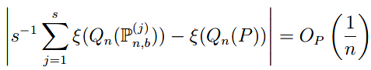

# Adaptive Hyperparameter Selection

1. Select r (# of SC): continue increase r, until  stable
2. Select s (# of subsamples): continue increase s, until  stable
3. Select b (subsample size): can do similar thing🡪 computational cumbersome🡪empirical $b=n^{0.7}$ would be fine

Criteria:

