Healthcare Provider Episode Cost Analysis Report
Author: Milo Joronen
Date: February 2026

1. Introduction
This report summarises the analysis of a comprehensive episode-level hospital dataset, originally presented in slide format.
The dataset captures hospital activity, clinical complexity, and associated charges to support billing reconciliation, financial oversight, and contract compliance.
Cost analysis is critical because healthcare expenditure is highly skewed, with a small proportion of cases driving a disproportionate share of financial impact.
The objective of this study is to understand structural cost drivers, build a risk-adjusted predictive model, detect financial outliers, and provide strategic recommendations.

2. Exploratory Data Analysis (EDA)

Cost Segmentation
- Episodes categorised into Low (≤50th percentile), Medium (50–75th), High (75–95th), Very High (>95th).
- High and Very High segments represent ~25% of episodes but ~78% of total revenue.
- Top 5% of episodes generate extreme financial concentration.
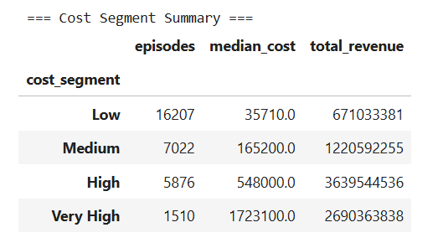
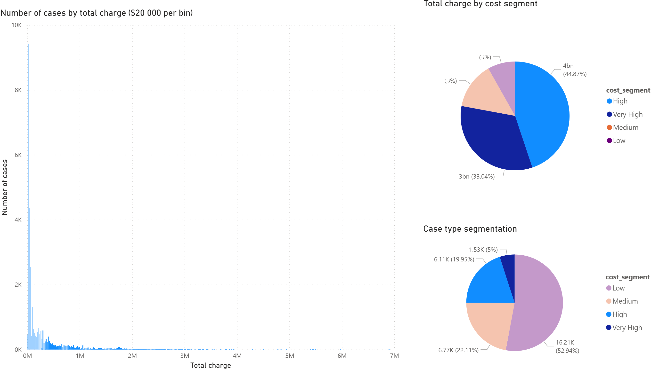

Length of Stay (LOS)
- Median LOS increases monotonically with cost segment.
- Very High segment shows significant variability and heavy right tail.
- Prolonged admissions are a key structural driver of cost escalation.

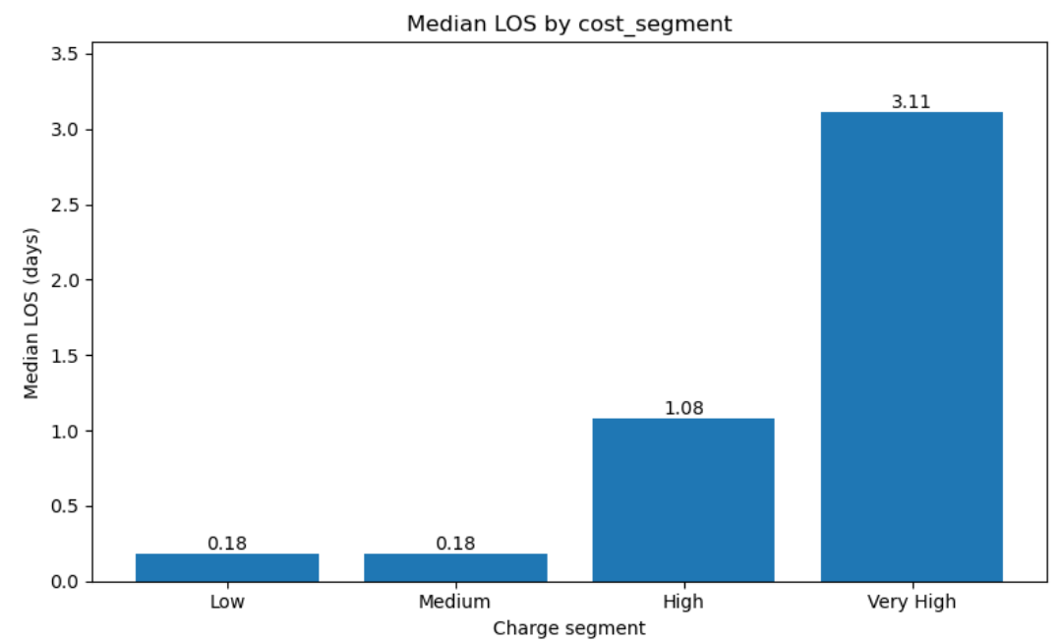
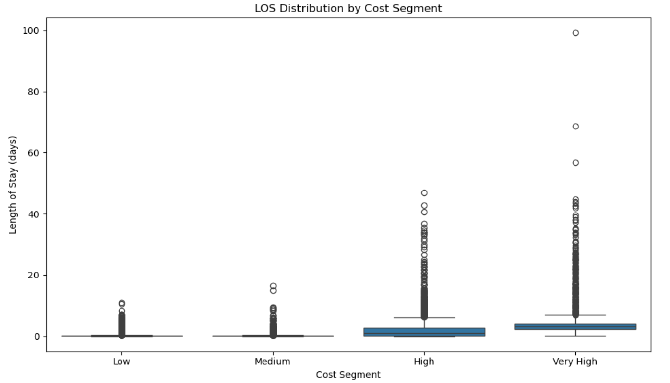

Theatre Usage
- 81.63% of High/Very High episodes involve theatre use.
- Median theatre time increases significantly across segments.
- Cost escalation is driven by procedural intensity and post-operative resource utilisation.
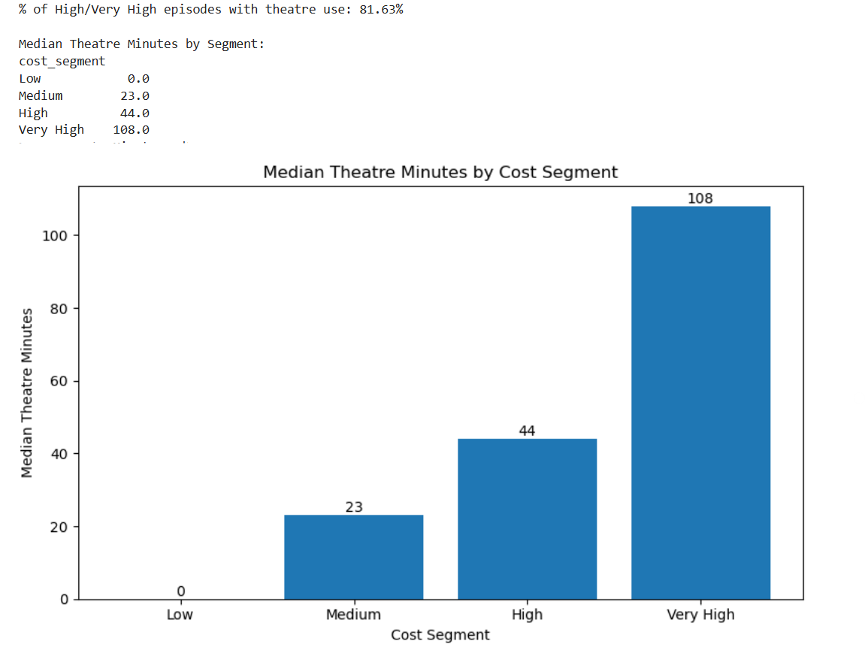

CCU / SCN / HIH Usage Analysis
High-cost episodes are associated with greater critical care exposure compared to lower-cost cases; however, the marginal increase between High and Very High segments is modest. This indicates that while acuity contributes to cost concentration, procedural intensity and length of stay appear to be stronger structural drivers of financial concentration.
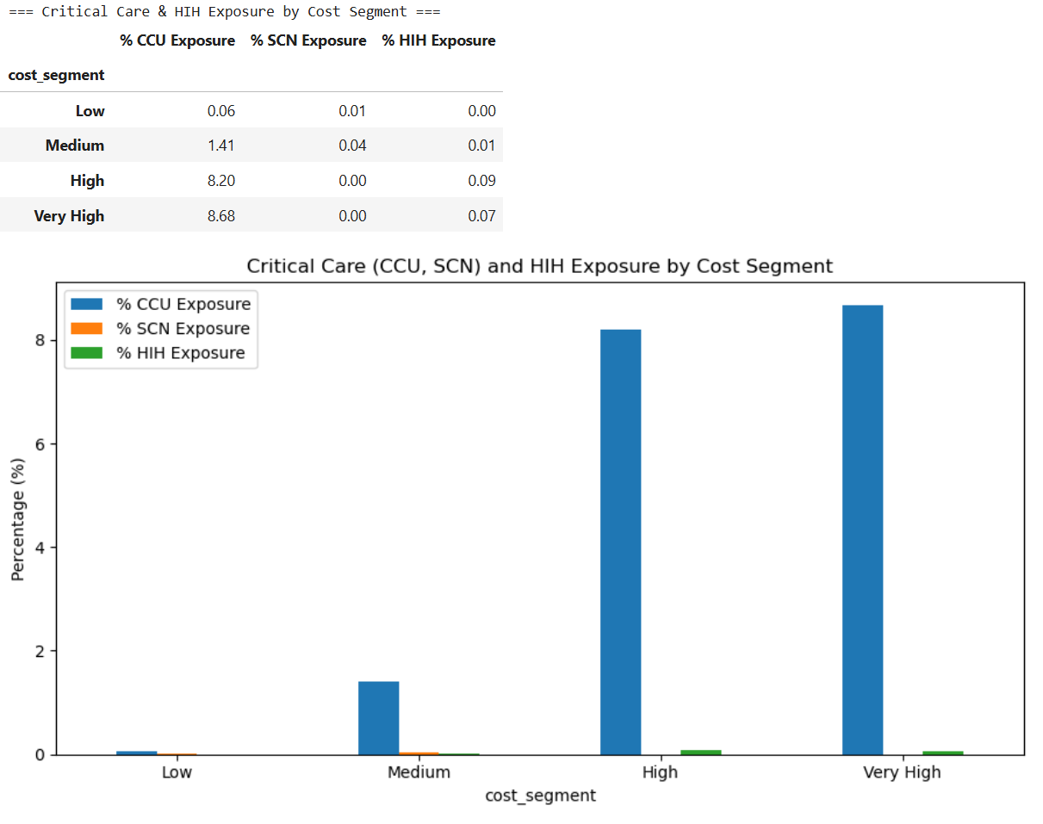

DRG Concentration
- Very High revenue highly concentrated in top 3 DRGs (~50%).
- High segment revenue diversified across many DRGs.
- Financial dependency concentrated in specific high-complexity pathways.
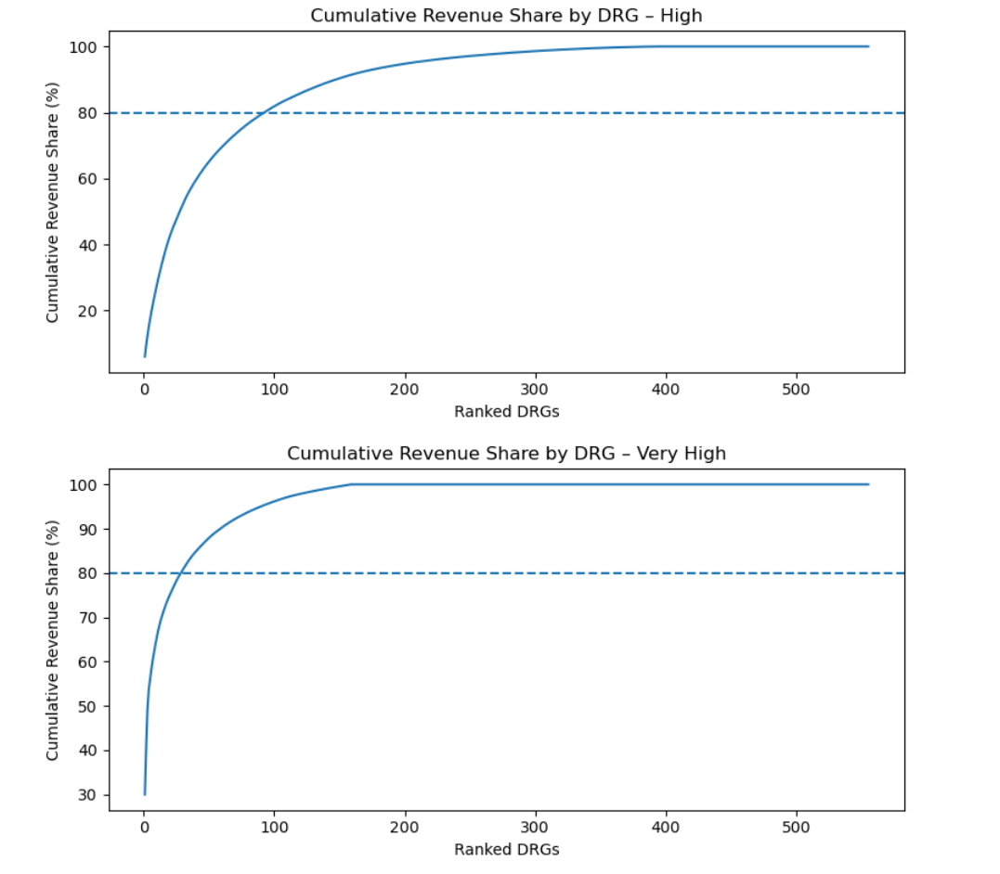
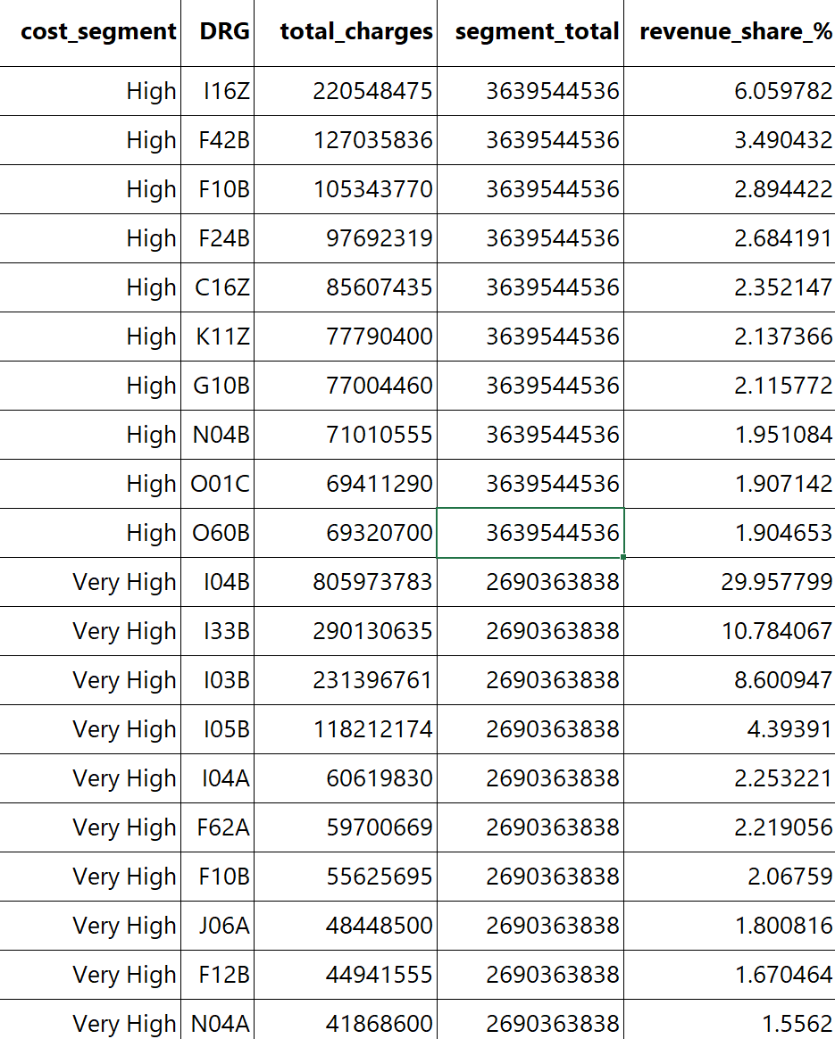

Urgency & Care Type
- Revenue concentration primarily driven by elective acute pathways.
- Emergency share increases with cost but remains minority contributor.
- Acute admitted care dominates financial exposure.
- Emergency proportion increases sharply from:
0.16% → 12.5% So complexity does rise with cost —
but the majority of revenue still comes from elective pathways
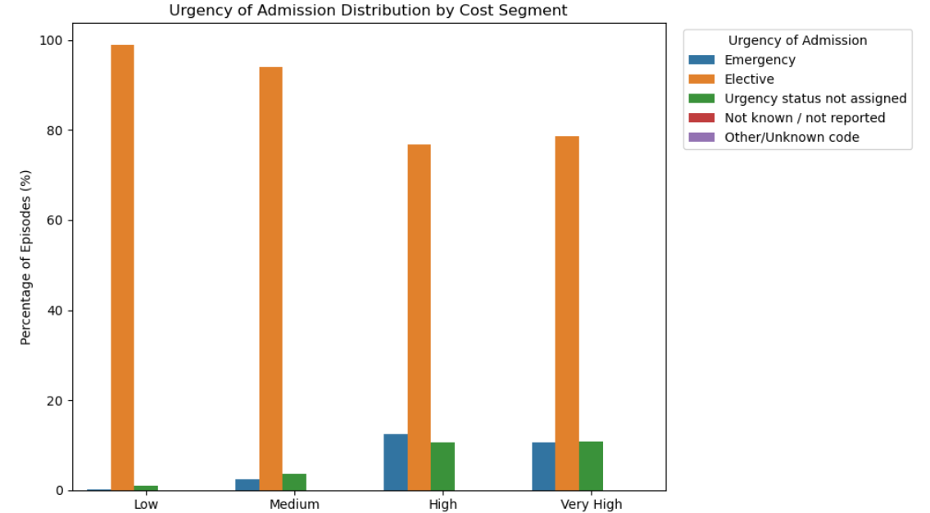

Care Type Analysis
The high-cost concentration is almost entirely within acute admitted care pathways, with a small but increasing contribution from palliative episodes in the Very High segment.
This indicates that revenue concentration is driven by core hospital service lines rather than subacute or maintenance services.
Recommendation:
- Investment focus should remain on acute service optimisation.
- Palliative pathways in high-cost segments may require:
  - LOS management
  - Care coordination optimisation
  - Appropriate billing validation
- No evidence that rehab or maintenance is distorting cost distribution.
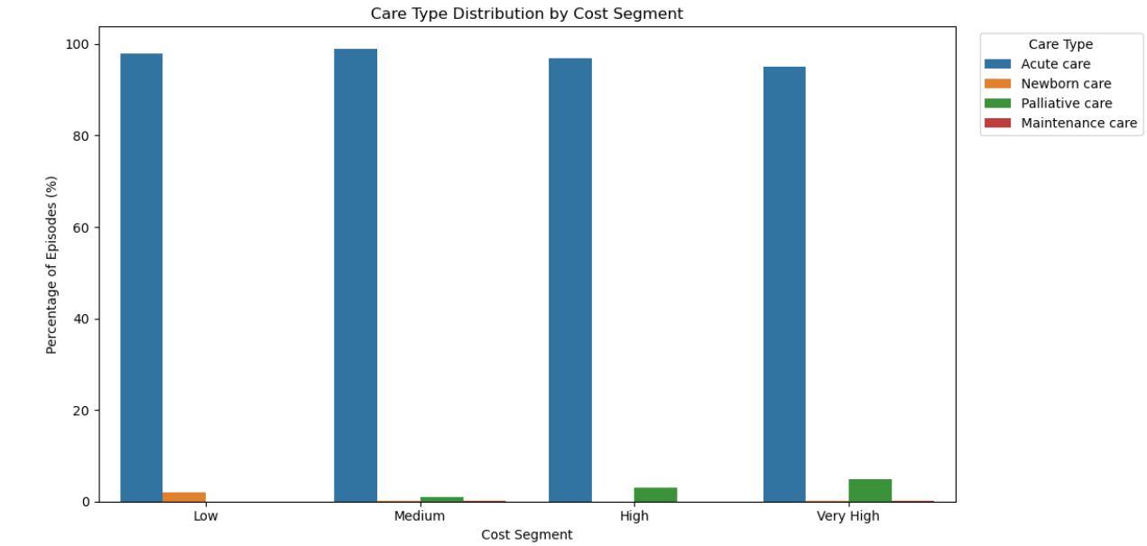

3. Predictive Modelling – XGBoost Total Charge Prediction

Model Motivation
- Establish risk-adjusted expected cost baseline.
- Identify material deviations from expected complexity-adjusted cost.
- Support proactive financial oversight.

Hypothesis
- Episode-level hospital charges can be accurately predicted using clinical and operational characteristics (e.g. DRG, procedures, theatre use, LOS).
- A risk-adjusted predictive model will explain the majority of cost variation across episodes.
- Episodes that materially exceed predicted cost represent statistically identifiable outliers.
- High-cost outliers will be concentrated in high-complexity (Very High) segments.
- Efficiency variation (low-cost outliers) will be more visible in moderate-acuity (Medium) segments.
- Risk-adjusted benchmarking will provide more meaningful financial insight than raw cost comparison.

Methodology
- ~30,000 episodes analysed.
- XGBoost machine learning model used to predict expected episode cost based on clinical and operational characteristics
- Target: log-transformed total hospital charges.
- 5-fold cross-validation with Bayesian hyperparameter optimisation.
- Leakage variables removed.

Why this Model?
- Hospital costs are non-linear and interaction-driven
- XGBoost captures complex clinical interactions
- Target encoding handles high-cardinality variables (e.g. DRG)
- More robust than linear regression for structured healthcare data

Model Performance
- Cross-validated RMSE (log scale): 0.271.
- R²: 0.952 (95% variance explained).
- Approximate multiplicative error ~30%.
- Stable performance across folds

Key Cost Drivers
- Theatre utilisation (strongest).
- DRG classification.
- Inpatient vs same-day status.
- Number of procedures.
- Length of stay.
- Cost driven by clinical intensity, not seasonality

4. Outlier Detection Framework

Method
- Residual = Actual – Expected cost.
- Standardised residual (Z-score).
- ≥2 SD = Unusual, ≥3 SD = Extreme.

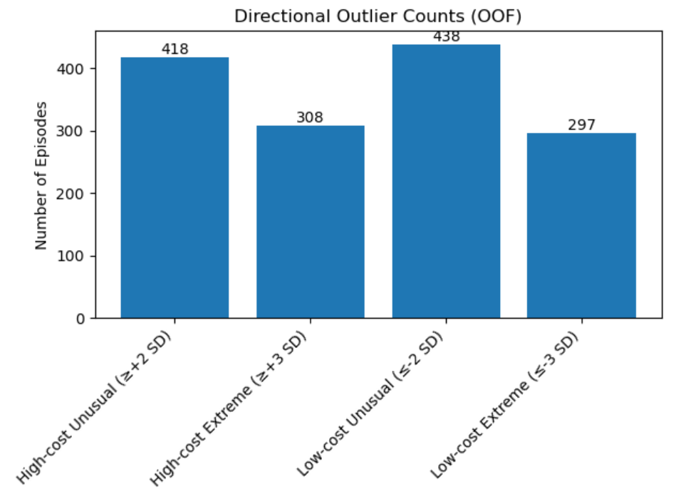

High-Cost Outliers
- Very High segment: 7.42% extreme cases.
- Extreme high-cost deviations ~11× more frequent than Low segment.
- Financial volatility increases with complexity.

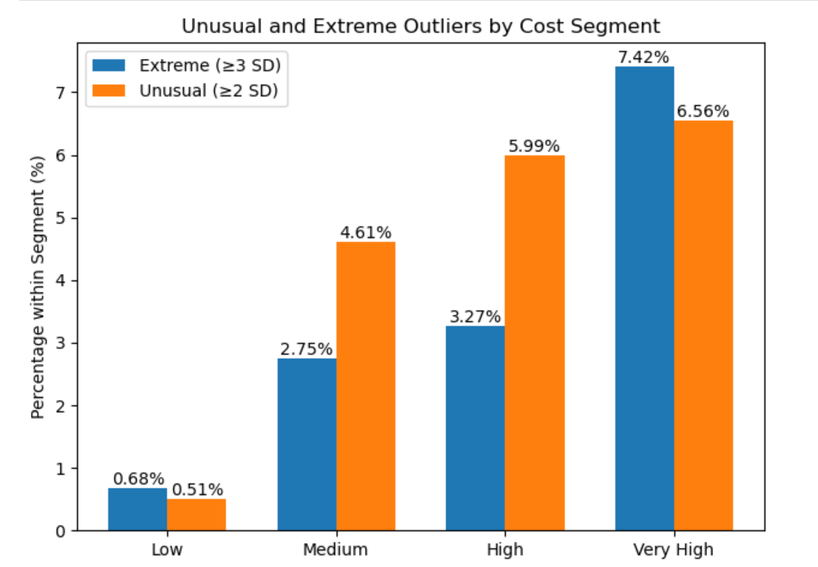

Low-Cost Outliers
- Concentrated in Medium segment.
- Very High shows near-zero extreme low-cost cases.
- Efficiency opportunity likely in moderate-acuity pathways

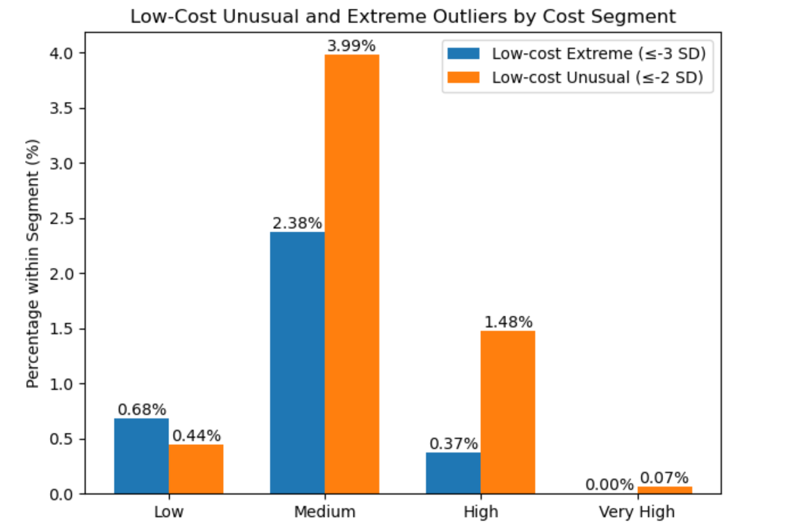.

5. Strategic Recommendations

High-Cost Governance
- Pre-submission review for ≥3 SD episodes.
- Mandatory validation for extended LOS and ICU exposure.
- DRG-level monitoring dashboards.

Recommendation
- Flag extreme cases before insurer submission to minimise disputes.
- Legitimate clinical complexity → Document & defend
- Unwarranted operational variation → Improve pathway

Low-Cost Efficiency
- Benchmark Medium-segment DRGs across sites.
- Validate quality signals (readmission, outcomes).
- Standardise discharge and pathway management.

Recommendation
- Identify top 10 Medium-segment DRGs with:
- Highest low-cost deviation rate.
- Compare LOS, procedure count, theatre minutes across sites.
- Validate no adverse readmission or quality signal – Is quality of care compromised? Discharged too early?

Cross-Cutting Strategy
- Implement Outliers Intelligence Dashboard.
- Embed predictive benchmarks into contract discussions.
- Shift from reactive auditing to proactive governance.

6. Model Limitations & Financial Impact

Model Limitations
- Charges influenced by contract pricing.
- Historical billing patterns embedded.
- Quality metrics not fully integrated.
- Tool supports oversight, not clinical decision-making.

Financial Exposure Scenario
- Very High episodes: 1,510 cases.
- 7.42% extreme ≈ 112 cases.
- Estimated exposure ≈ $190M.
- 5% reduction in extreme cases ≈ ~$10M potential protection.

Long-Term Sustainability
- Establish system-wide risk-adjusted benchmarks.
- Continuous monitoring of cost variation.
- Embed analytics into routine financial governance.

