Group 7

Eason Guo (yg8ca)

Flora Lee (kl2em)

Weiheng Su (ws2ta)

Jonathan Youssef (jay4ek)

Basketball Data System

**Introduction**

The Basketball Data System, or BDS, is a data storage application for specific basketball statistics. Users can view and modify various data on players, teams, referees, championship games, and divisions. BDS can be used by anyone, from kids creating their own amateur league to an NBA coach analyzing division team statistics, to record and maintain detailed basketball statistics.

**Description**

BDS boasts an intuitive user interface with user account creation/login, ten different data tables complete with data modification functions, and a comprehensive search function.

There are two types of users: normal and admin. A normal account is created with a username, email, and password. An admin account is a preexisting account (created through the command line) that can view, via a special SQL command, a list of all registered users. Both accounts can view, as well as add to, remove from, and modify, data table entries.

The application hosts ten data tables: (1) player_info, (2) player_stat, (3) player_injury, (4) team, (5) team_stat, (6) team_coach, (7) divisions, (8) champions (championship games), (9) referee, (10) attendance (across all games in a division). A detailed entity-relationship complete with attributes and keys diagram is included.

The search function allows the user to view all data linked to a queried name, whether it be a player name, team name, and etc.

**Entity-Relationship Diagram**

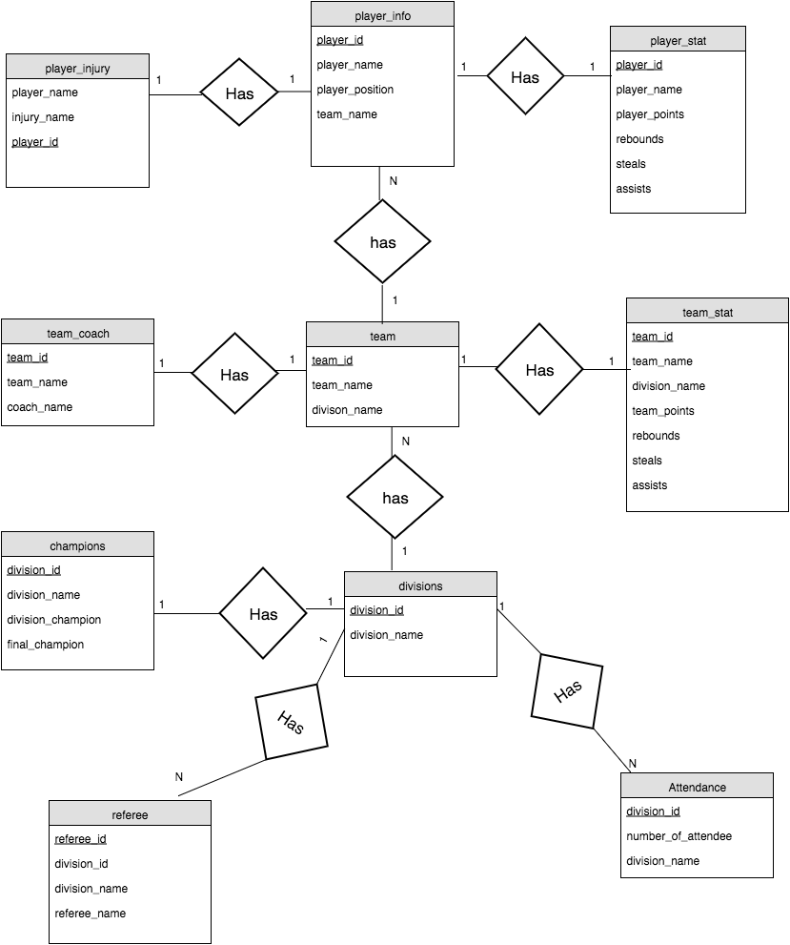

**3NF**

A = division_id

B = number of attendee

C = division_name

D = division_champion

E = final_champion

F = referee_name

G = referee_id

H = coach_name

I = team_id

J = team_name

K = team_points

L = team_rebounds

M = player_id

N = player_name

P = player_position

Q = player_points

S = injury_name

T = team_assists

U = team_steals

V = player_rebounds

W = player_assists

X = player_steals

|  |  |  |  |
| --- | --- | --- | --- |
| **Table Name** | **F+** | **Fc** | **3NF** |
| Attendance | A->ABC | A->BC | ABC |
| Champions | A->ACDE | A->CDE | ACDE |
| Divisions | A->AC | A->C | AC |
| Referee | G->GACF | G->ACF | GACF |
| Team_Coach | I->IJH | I->JH | IJH |
| Team | I->IJA | I->JA | IJA |
| Team_stat | I->IJKLTU | I->JKLTU | IJKLTU |
| Player_info | M->MJNP | M->JNP | MJNP |
| Player_stat | M->MNQVWX | M->NQVWX | MNQVWX |
| Player_injury | M->MNS | M->NS | MNS |