V0: naive
N=64
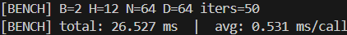
N=128
N=256
N=512
N=1024

Bottleneck
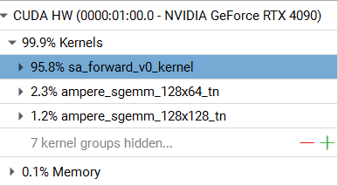
Inference loop: 8.423 sec for 10 batch

V1: online softmax , KV shared memory tile, single-pass output accumulation
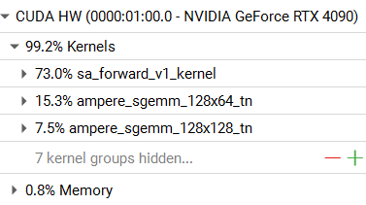
Inference loop: 1.276 sec for 10 batch

V2: warp-level design(one warp per query row), reuse K/V tile for multiple(8) Q rows, vectorized half2 loads and compute, warp shuffle reduction for dot-product
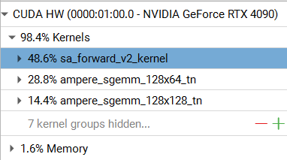
Inference loop: 686.089 ms for 10 batch

V3: Tensor Core calculate Q×K dot products
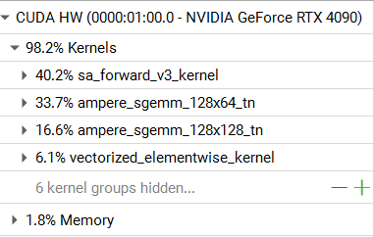
Inference loop: 578.692 ms for 10 batch

Pytorch: utilize Tensor Cores, highly optimized GEMM
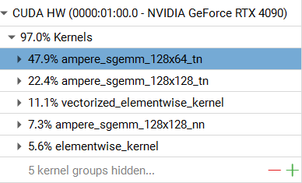
Inference loop: 386.165 ms for 10 batch

Pytorch: multi-stream hiding memory latency
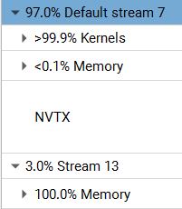
Inference loop: 365.383 ms for 10 batch

