**Pattern Recognition for Birds’ Sounds**

Wei Huang

**Abstract - The classification of birds’ species from their sounds is creating new platform or application for people to identify and monitor birds in the nature world. Indeed, the classification of birds’ sounds will creating a bridge for people whom explorers or researchers to define the relationship between the birds’ species without any confusion. During development the relationship for birds’ sounds, some procedures were involving: a) Data collection that different birds’ sounds were collecting with wav file. b) Audio processing to remove the noise and to select the most representative soundtrack. c) Data analyze that to using MATLAB tools and to compare the data set distance between different birds. d) The identification of measurement distance will show different birds into different group or classification to create the Dendrogram then compare with Birds DNA sequence at the end. One key element in the project is measurement of distance for identification purpose. In this paper we show use the MATLAB to analyze the wav file, and create different type figures in MATLAB tools such as FFT, Magnitude, Angle, then measure the distance between different datasets. Finally, merge all the results and define the relationship between different classifications of birds. The database is wav file soundtrack from Internet, and 10 different birds, which appear in North America. Obtain results show different birds could have different and unique sound. Also, this paper is identifying the close relationship and similarity distance measurement between birds’ sound.**

I Introduction

Bird sounds have unique pattern for each birds, previous research have addressed the different way for identified birds sound by using machine-learning technique. However, birds’ vocalizations have so much structure and lot of researches and explorers are still looking the way and tried to analysis the bird sounds into different group. On the other hand, birds’ sound can be divided into songs and calls. Birds’ songs are more melodious and are related to mating, and calls are short and transient sounds used in alert situations. The paper is considering the birds’ songs as ideal for species identification because birds’ songs have unique of bird’s sound printing in different type spectrum. The spectrums are able to identify the birds in different plots and histograms such as time, frequency, and energy level. In fact, different birds should have different birds sound printing. It approved by showing the different birds’ song track in wav files from Internet and comparing different wav files as represents on Figure 1.

Figure 1: Birds Sounds

|  |  |
| --- | --- |
| Birds | Wav File – Raw Data |
| Bald Eagle |  |
| Black Crows |  |
| Black Gull |  |
| Blue Jay |  |
| Hawk |  |
| Merlin |  |
| Owl |  |
| Parrot |  |
| Peacock |  |
| Rooster |  |

Pervious research has done identification vocalization of Birds sounds and shows the different set model an occurrence of the corresponding by using an algorithm that extracts frequency track sets. For each vocalization type, transforming the training set frequency tracks into feature vectors created a statistical model of the vocalization. The extraction algorithm extracts sets of frequency tracks from test recordings and collects set in time, frequency, and amplitude. The classifications of birds’ sounds have training set of SNR (min, median, max) on Figure 2.

Figure 2: SNRs Training Set

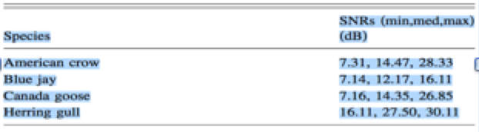

The main contributions of this paper are twofold:

* The new recognition pattern focuses on relationship of birds’ organization. In the high level, we are separating the birds into the group by using distance function. Creating table have data set with sample different and SNR different between two birds, then define how close the relationship.
* The expected goal is comparing birds’ sounds sequence and birds’ DNA will be match together. Continually, we are able to show new birds’ map by sorting with combination of birds’ sounds and DNA.

II Related Work

1. *Data Collection and Selection:*

Using MATLAB Signal Process Tools, we were collecting the 10 different birds wav data from Internet, then comparing these lengths that prevent calculating the difference between two signals. Sometime, lengths was not equalize but cross-correlation can be performed between signals with different lengths. However, we are able to resample the signal with lowest sampling rate. The resample function applied such as FIR filter for the signal during the resample process for removing noise, outliers, and spurious content from data as represents on Figure 3.

Figure 3: Filter Data

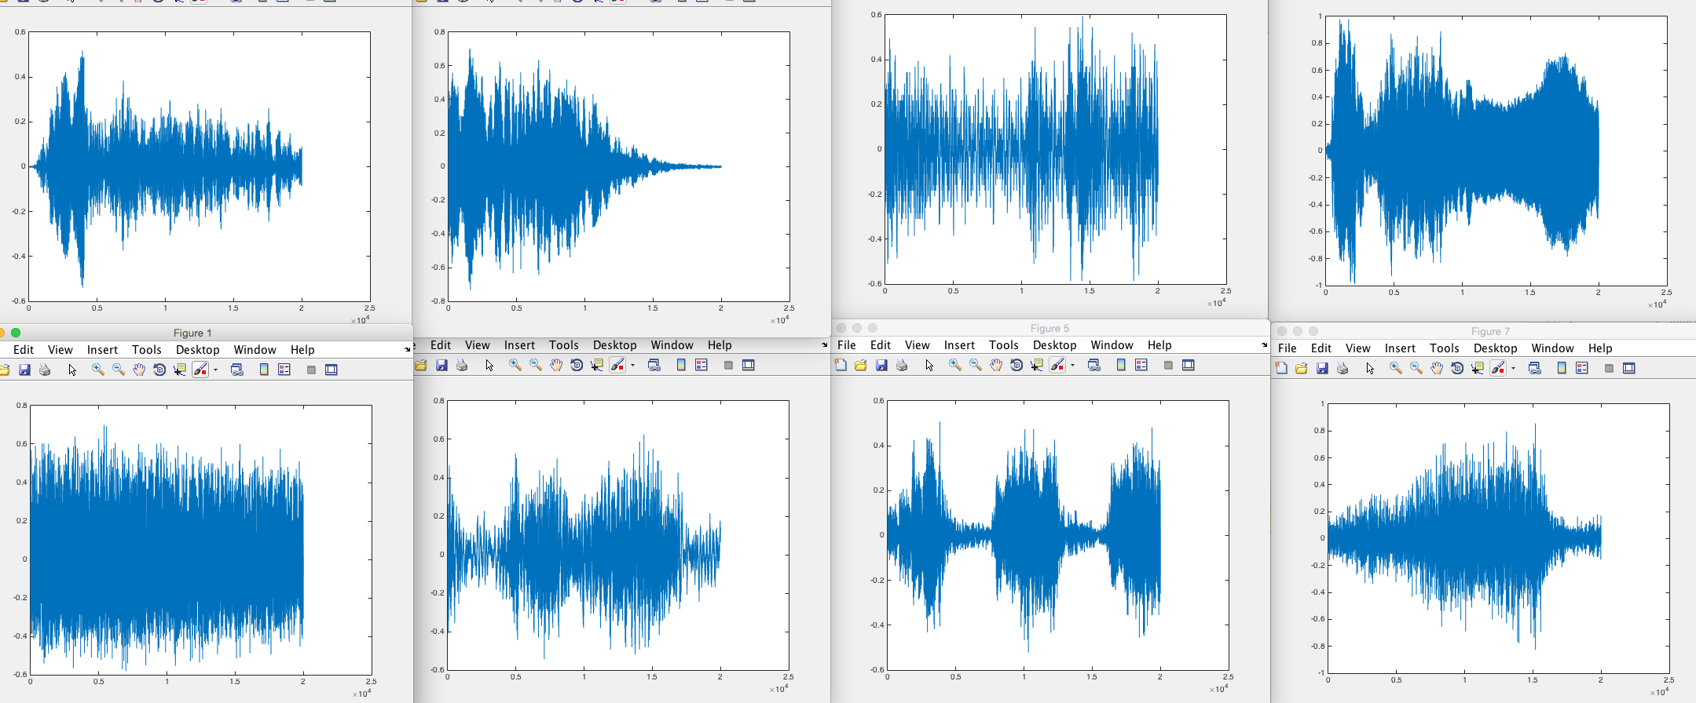

1. *Analyze Signal Process*

Using Signal Analysis Application in MATLAB, the application can enhance signals that signal transforms for FFT, then application can visualize signals that we can change sample rate and make the sample rate constant, and we were able to discover patterns as Figure 4.

Figure 4: Signal Analysis Application

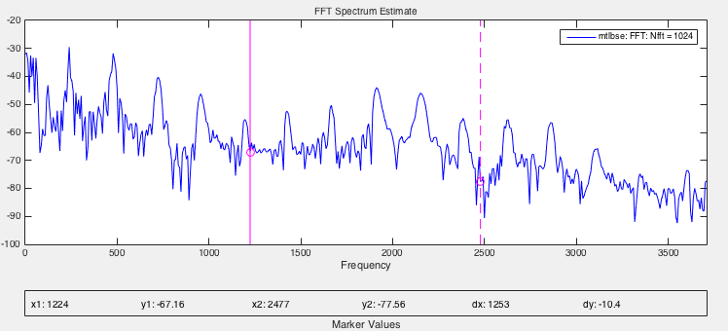

1. *FFT*

After the data selection, we use the FFT function in MATLAB to efficiently estimate component frequencies in data from a discrete set of values sampled at a fixed rate and estimate coefficients of a trigonometric polynomial that interpolates a set of regularly spaced data as Figure 5.

Figure 5: FFT

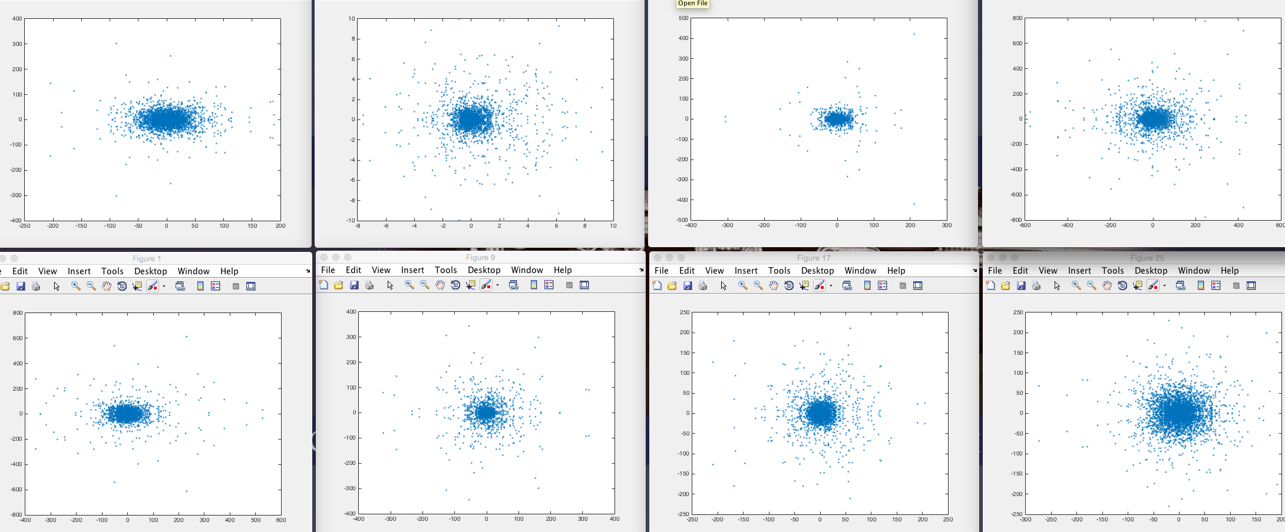

*D. Angular*

Using FFT data set, we use angle method in MATLAB to truncate the FFT into angular data view. Angular data shows the constant magnitude of the output signal and creates center vector map to the angles of the corresponding complex output elements as Figure 6.

Figure 6: Angular

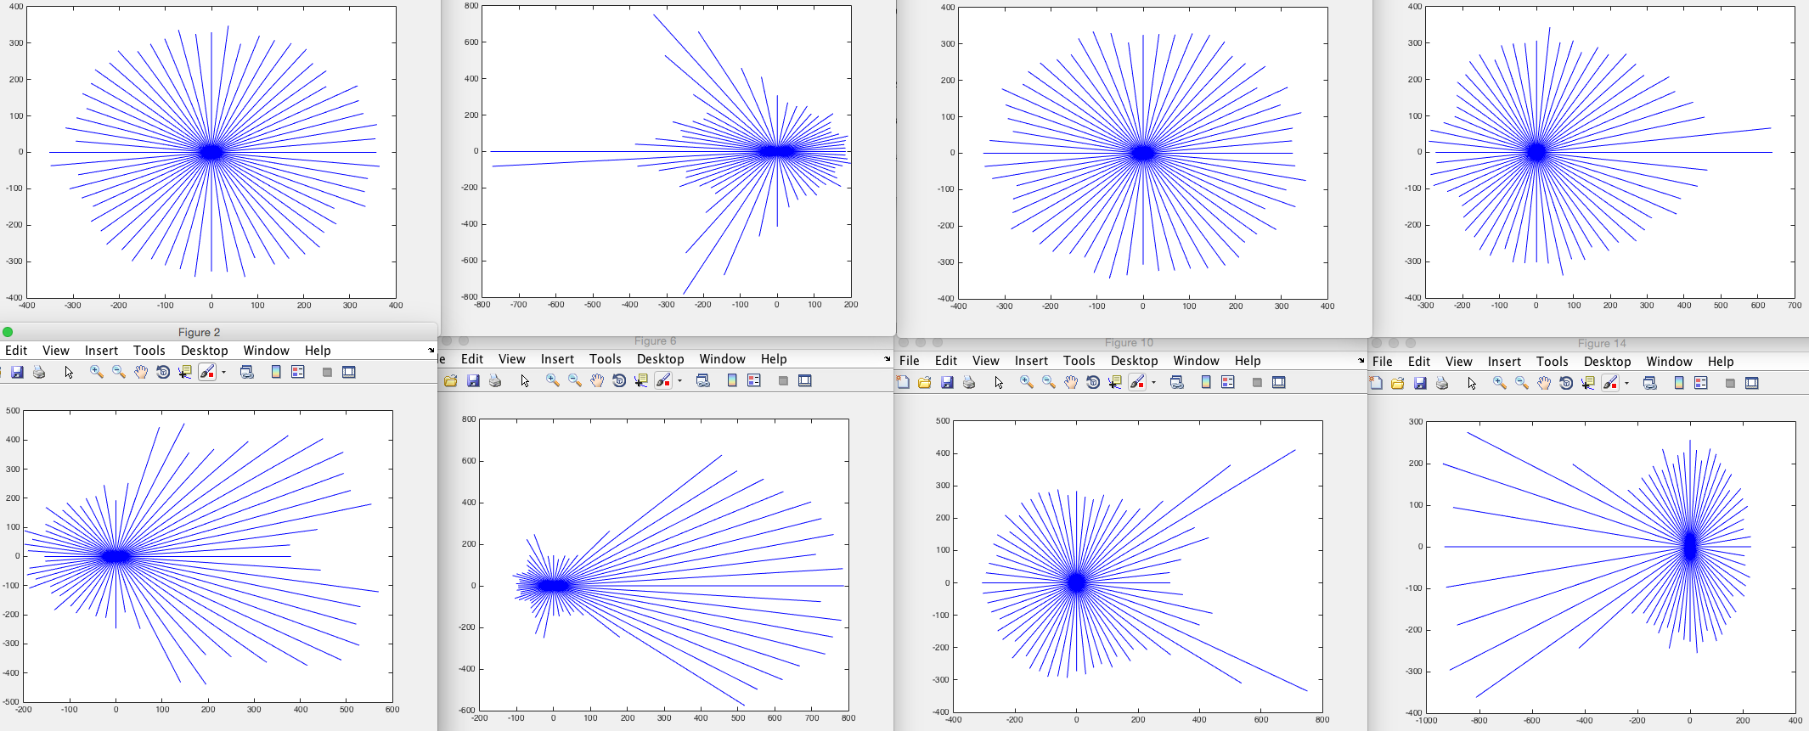

1. *Magnitude*

Using FFT data set, we use absolute method in MATLAB to generate the magnitude data from FFT. Magnitude data shows the constant phase angle of the output signal in radians and usually called “absolute value” as Figure 7.

Figure 7: Magnitude

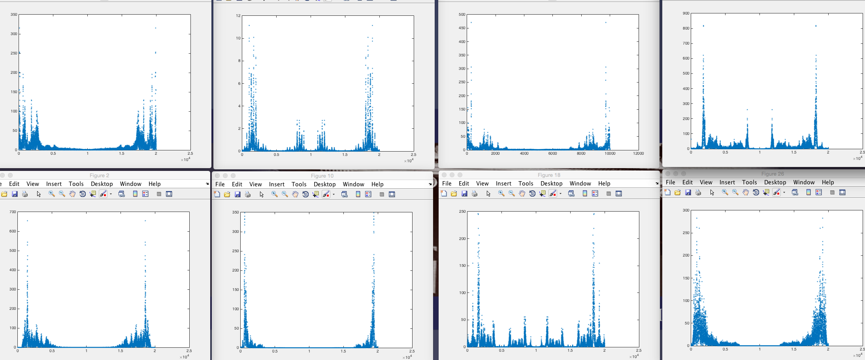

1. *Cross –Correlation*

In order to measuring Signal Similarities, we have to find a signal in a measurement. Using XCORR function we can measure the similarity between x and shifted (lagged) copies of y as a function of the lag. If x and y have different lengths, the function appends zeros at the end of the shorter vector so it has the same length as the other. In some case, the cross-correlation of the two measurements are maximum at a lag equal to the delay, then we created sample different to find the distance and time difference to express the delay time. For example, we can now cross-correlate signal S to templates T1 and T2 with the XCORR function to determine if there is a match, so we were using the 8 different FFT datasets and compare with signal S which random dataset created as Figure 8.

Figure 8: Cross Correlation

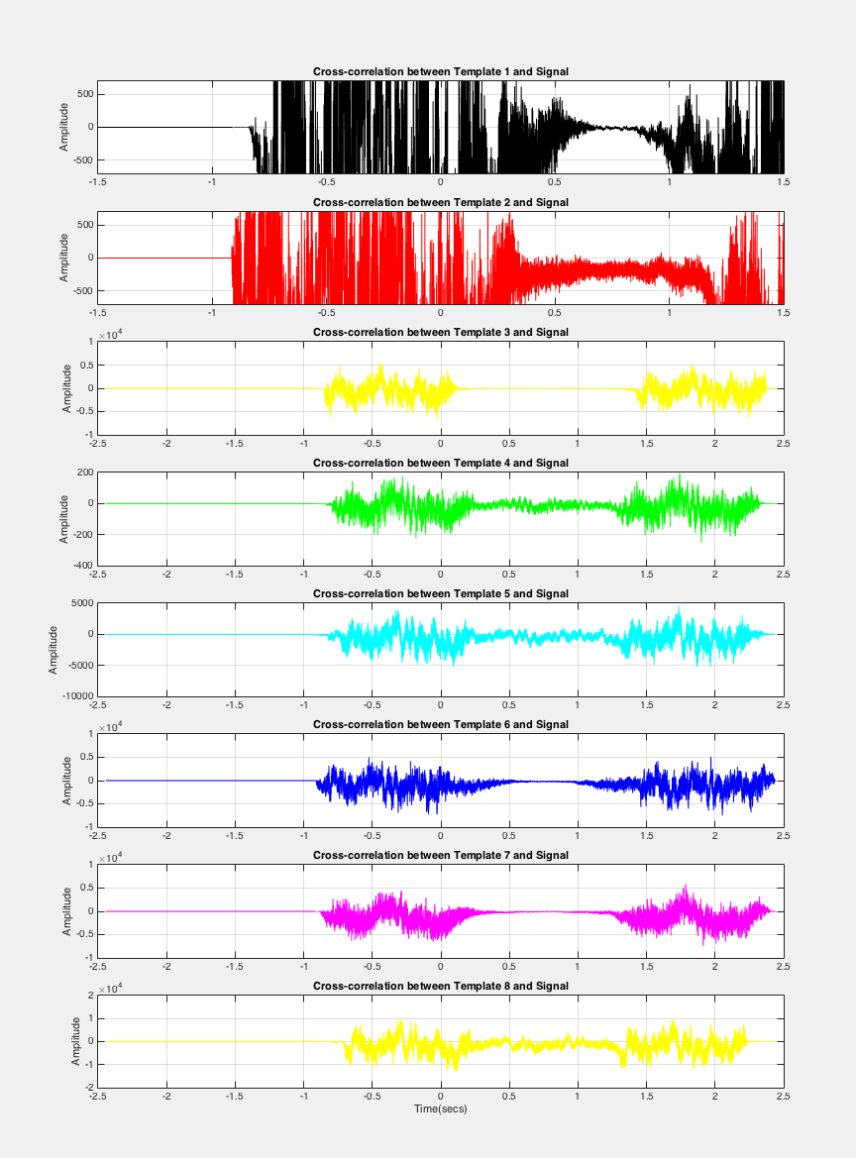

III Data Analysis

Building three tables show cross correlation in FFT, angular and magnitude. FFT has the largest datasets and has 50,000 differences in similar comparing, and angular data has median datasets and has 20,000 differences in similar comparing, then magnitude has smallest datasets and has 8000 differences in similar comparing. Three datasets has comparison with two birds in adjacency matrix as Figure 9. Some birds have some identical value, however, we will still increasing more birds in order to get better result.

Figure 9: Comparison

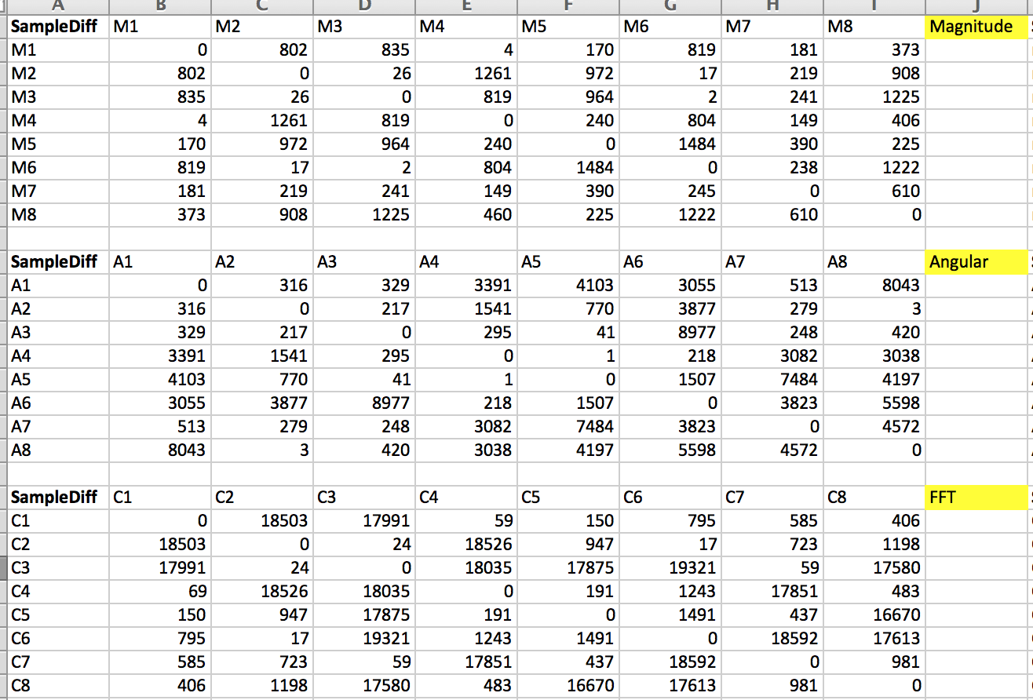

IV Conclusion and Future Work

This paper analyzed the classifications of birds sound and defined the close relationship of birds’ organization. Regardless of what technique we use, we are able to find similar in difference distance between birds. However, the project needs more data involves and include more data to build a better table result with FFT, Angular, and Magnitude. In this paper, we also need to show the Dendrogram with compare between Birds’ sound and DNA sequence. Even thought the paper does not tell you comparison, but it has provided the measurement distance method in Birds sound to approach better goal. The future research could focus on the data collection and comparing with Birds’ DNA sequence.

References

[1] Buck, John R., Michael M. Daniel, and Andrew C. Singer. Computer Explorations in Signals and Systems Using MATLAB. 2nd Edition. Upper Saddle River, NJ: Prentice Hall, 2002. Web. 30 Nov. 2015.

[2] Stoica, Petre, and Randolph Moses. Spectral Analysis of Signals. Upper Saddle River, NJ: Prentice Hall, 2005. Web. 30 Nov. 2015.

[3] Heller, Jason R., and John D. Pinezich. "Automatic Recognition Of Harmonic Bird Sounds Using A Frequency Track Extraction Algorithm." Journal Of The Acoustical Society Of America 124.3 (2008): 1830-1837. Academic Search Complete. Web. 30 Nov. 2015.

[4] Thiago L.F. Evangelista, Thales M. Priolli, Carlos N. Silla Jr, Bruno A. Angelico, Celso A.A. Kaestner, "Automatic Segmentation of Audio Signals for Bird Species Identification.” IEEE International Symposium on Multimedia (ISM) 2014. Web. 30 Nov. 2015.

[5] J. A. Kogan and D. Margoliash, “Automated recognition of bird song elements from continuous recordings using dynamic time warping and hidden Markov models: A comparative study,” J. Acoust. Soc. Am. 103, 2185–2196 1998. Web. 30 Nov. 2015.

[6] X. Serra and J. Smith, “Spectral modeling synthesis,” Comput. Music J. 14, 12–24 1990. Web. 30 Nov. 2015.

[7] Z. Chen and R. C. Maher, “Semi-automatic classification of bird vocalizations using spectral peak tracks,” J. Acoust. Soc. Am. 120, 2974–2984 2006. Web. 30 Nov. 2015.

[8] Cooley, J.W. and J.W. Tukey. "An Algorithm for the Machine Calculation of Complex Fourier Series." Mathematics of Computation. Vol. 19. 1965, pp. 297–301. Web. 30 Nov. 2015.

[9] Heideman M., D. Johnson, and C. Burrus. "Gauss and the History of the Fast Fourier Transform." Arch. Hist. Exact Sciences. Vol. 34. 1985, pp. 265–277. Web. 30 Nov. 2015.