Tournament Livescore System
TLS Functional Specification
Version 1.0 | 35 man-days
Document drafted by Vincent Law Wei Hwang
Date: 9 October 2026
Tournament Livescore System (TLS) brings event preparation, match management, umpire scoring and live displays into one local venue system. It connects to TRS or any web system that follows the agreed API protocol.

1 Event preparation
- Create an event and enter participants or import them from a file.
- Download event details, participants and fixtures from TRS or a compatible system. Check the information before saving and prevent duplicate imports.
- Generate and preview knockout fixtures when no draw is supplied. Keep the existing draw when importing fixtures.
- Set up playing areas, operating hours and the agreed scoring rules.

2 Organiser console
- View the current round, opponents, planned times, playing areas, match status and waiting queue.
- Assign matches and umpires. Prevent conflicting assignments for participants, umpires and playing areas.
- Issue an access code or QR code for an umpire tablet and authorise replacement devices.
- Confirm results, approve corrections and advance entries to the next match.
- Confirm that the playing area and umpire are ready before assigning the next match.
The local server holds the working event record. Downloading information again must not overwrite an active match or a confirmed result.

3 Umpire tablet
- Open the scoring website on a tablet, connect using the assigned code and confirm the match.
- Show participant names once in a visual playing-area layout, with large scores and controls. Show positions and who serves to whom where the rules require it.
- Record scores, correct the latest action and submit the result. Clearly distinguish saved actions from actions awaiting confirmation.
- Use a small temporary recovery buffer. Only one authorised tablet session may control a match at a time.

4 Live scoring

Inside the venue
Hall screens show an overview or an individual match through a read-only browser display. Scores come directly from the local server. Scoring and hall displays continue without internet while the local server, venue network and power remain available.

TRS or another connected system
TLS downloads event information through the connected system’s API and pushes live scores and final results back as JSON records. The agreed protocol defines access, event and match identifiers, record format, update order and delivery confirmation.
TRS will include a receiving API and a module to display live scores and final results. The connection does not have to be TRS: another web system can connect if it follows the same protocol and provides the required API.
The local server keeps unconfirmed updates and retries them. Repeated delivery must not create duplicate results, and an older update must not overwrite a newer score. The organiser can see the connection status and pending updates.

5 Unexpected downtime handling
Situation | Simple recovery action
Internet or remote system unavailable | Continue local scoring and hall displays. Send pending updates when the connection returns.
Tablet loses connection | Mark unsaved actions clearly, keep them temporarily and resend after reconnection without counting them twice.
Tablet fails | Authorise a replacement and restore the last server-saved score. Disable the old session and reconcile any missing actions.
Main server, venue network or power fails | Stop electronic scoring and use paper score sheets. Record the match and last confirmed score. There is no second local server.
System restored | The referee checks the paper record and enters the agreed current score or final result. Record the correction, reject conflicting delayed actions and resume scoring and publishing.

Paper scoring is the fallback when the main server is unavailable. The local event data must be restored where necessary before reconciliation; tablet storage is only a temporary aid, not the main event record.

6 Delivery estimate
The planning estimate is 35 man-days for the features described in this document. It includes TRS event import, the TRS receiving and display module, JSON publishing and user acceptance testing (UAT).
Work Package | Man-days
Build the organiser console to create events, manage participants and playing areas, and generate fixtures | 9
Connect to TRS to download events, participants and fixtures | 4
Build the umpire tablet screen for match access and scoring | 6
Display live scores on screens in the hall | 2
Send live scores and results to TRS or another connected system | 2
Add functions in TRS to receive and display live scores and results | 4
Allow tablet replacement and recovery from paper scoring | 3
Test the complete system and carry out user acceptance testing (UAT) | 3
Contingency | 2
Total | 35

Annex A System overview
TLS downloads event information and sends live scores and final results back to the connected system. TRS is shown below as the example; another web system can take its place if it follows the agreed API protocol.
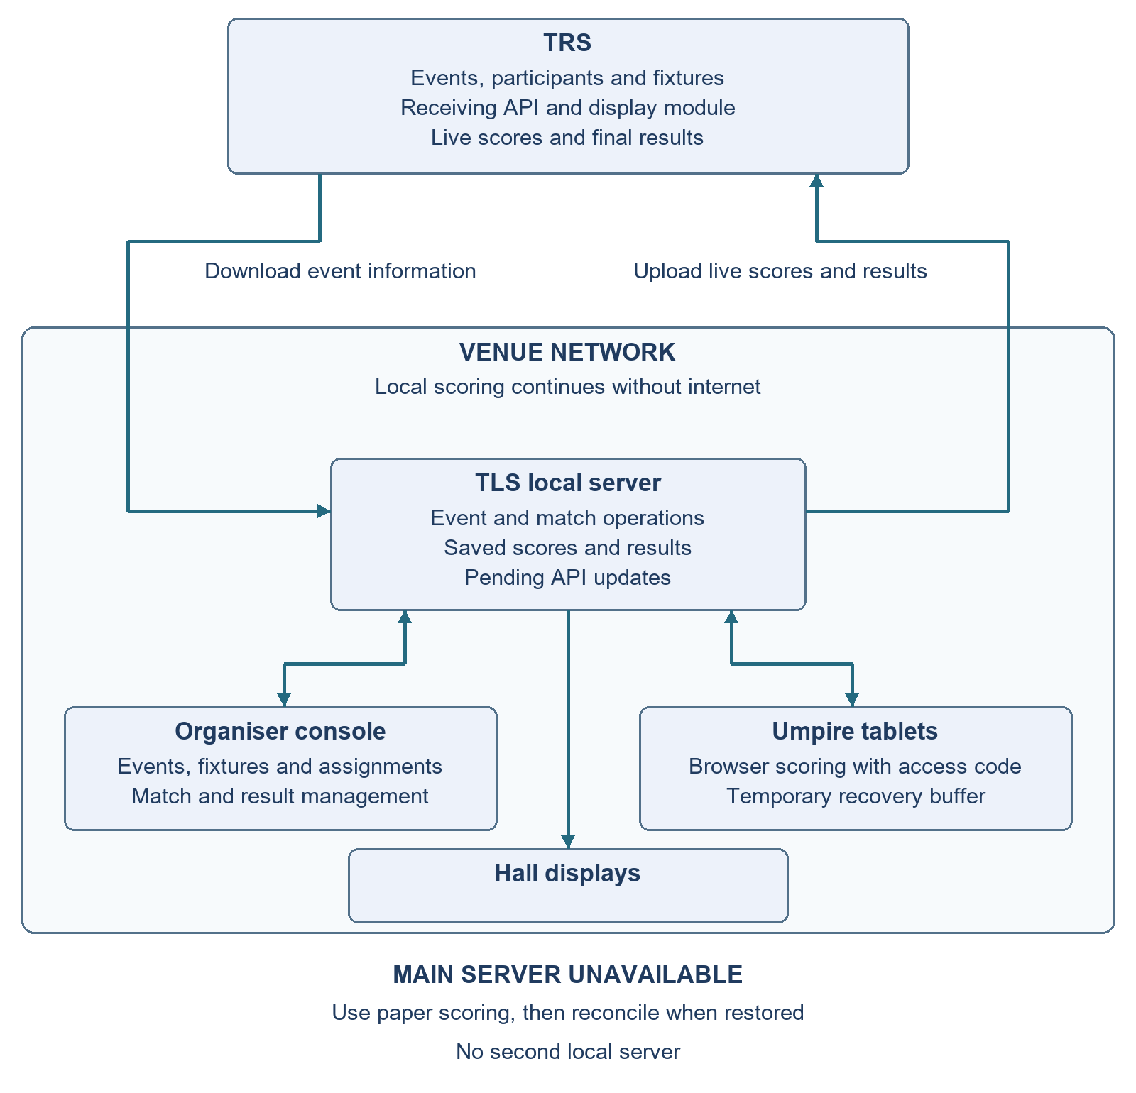
The two external arrows show separate data flows. Uploads use JSON through the receiving API, with confirmation and retry. If the main local server fails, officials switch to paper until it is restored and the referee reconciles the scores.

