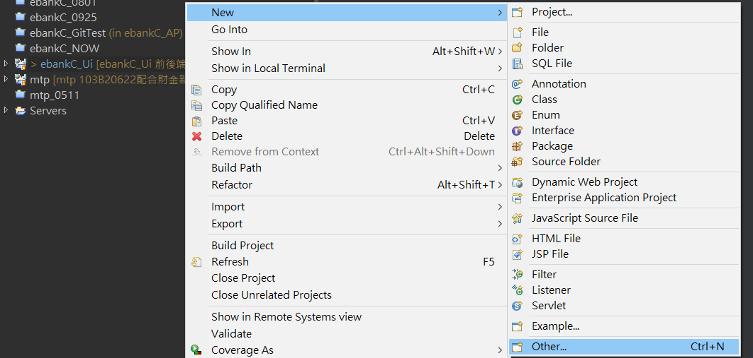

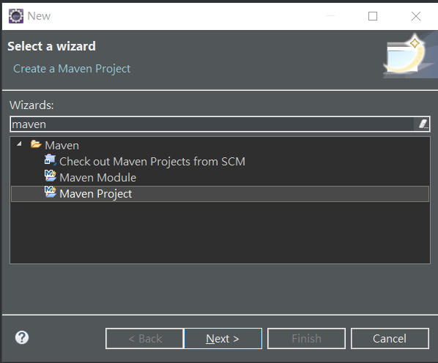

指向Git Clone的位置
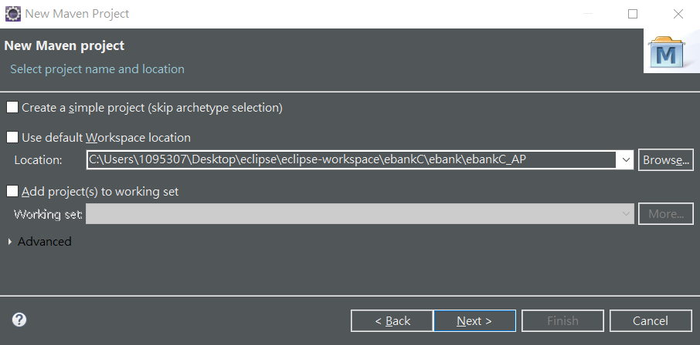

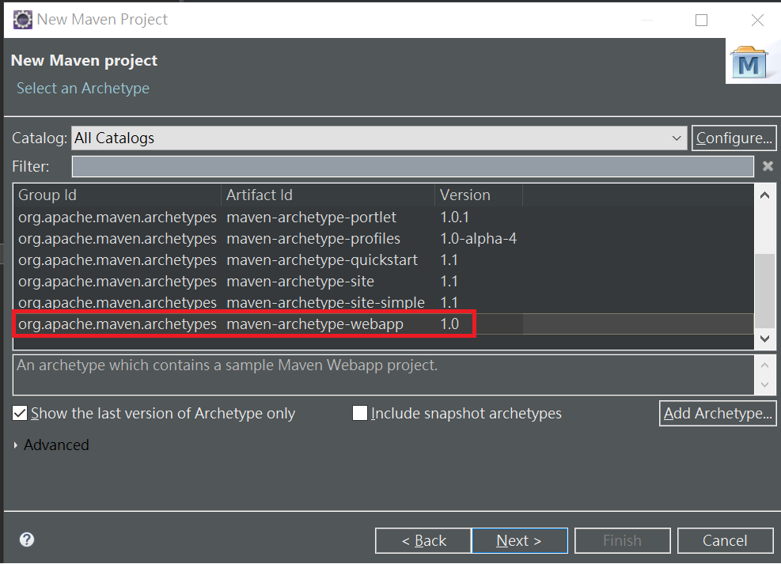

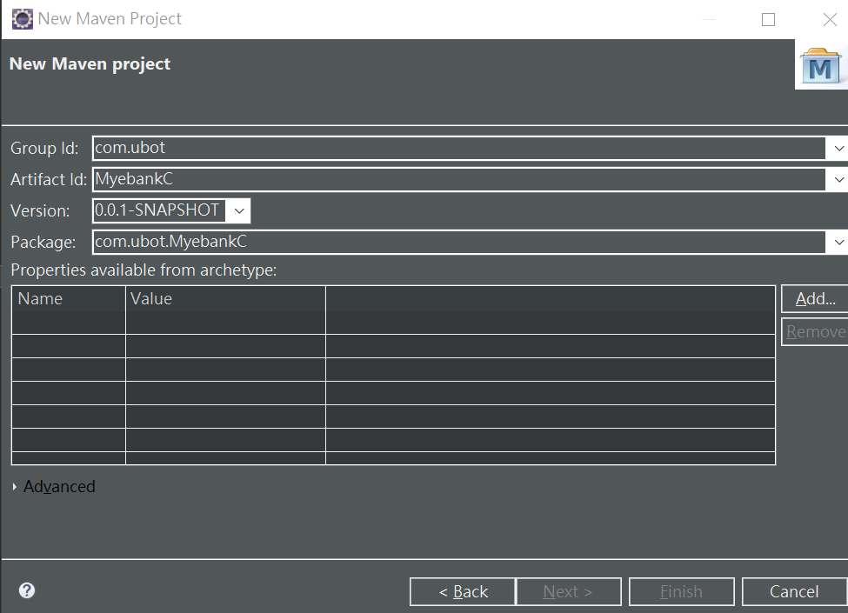

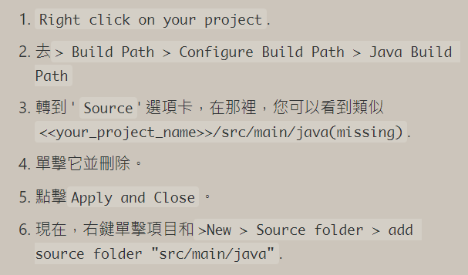

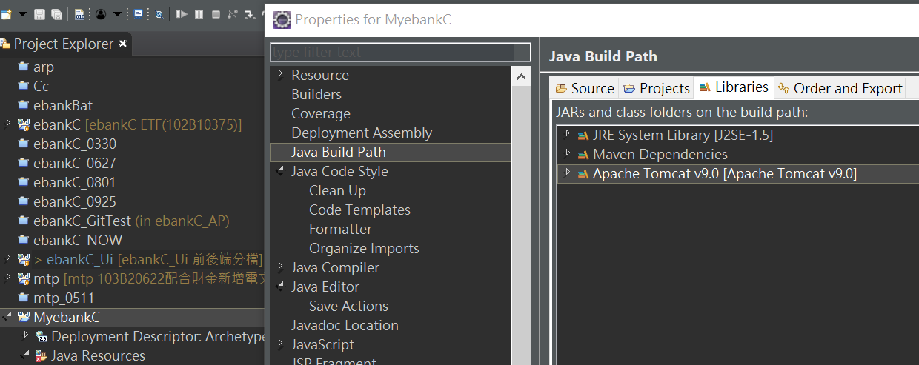

Eclipse抱錯?
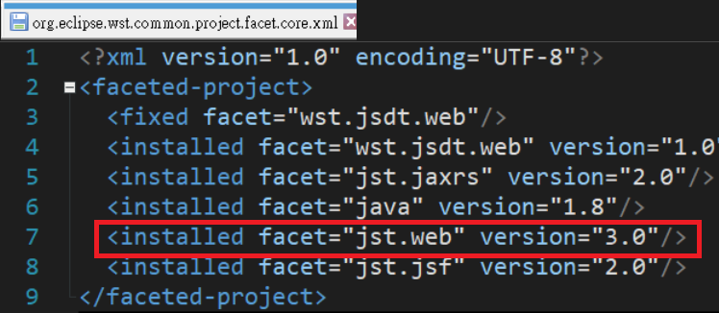

Web.xml改為
<?xml version="1.0" encoding="UTF-8"?>
<web-app xmlns:xsi="http://www.w3.org/2001/XMLSchema-instance" xmlns="http://java.sun.com/xml/ns/javaee" xmlns:web="http://java.sun.com/xml/ns/javaee/web-app_3_0.xsd" xsi:schemaLocation="http://java.sun.com/xml/ns/javaee http://java.sun.com/xml/ns/javaee/web-app_3_1.xsd" id="WebApp_ID" version="3.0"></web-app>

Run on tomcat server
