Proof of UVA10209

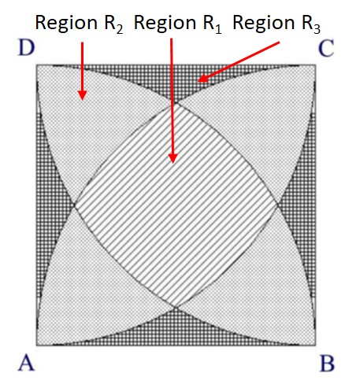

Figure 1. Three regions: R1, R2, and R3

Let the region of the three shapes be R1, R2, and R3 as shown in Figure 1.

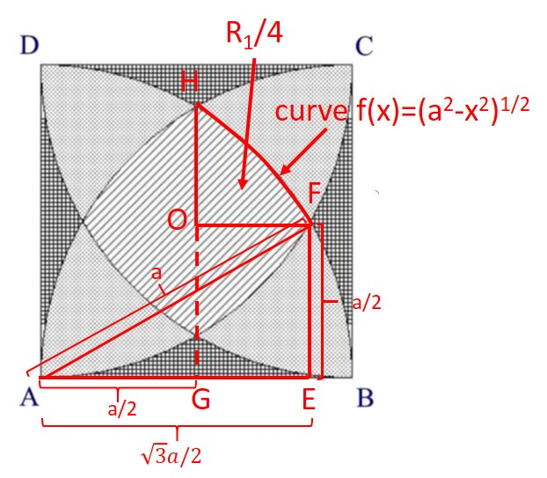

Figure 2. Area of OHF, area(R2)/4

We first consider region R1 as shown in Figure 2. The side of the square is a. Consider triangle AEF, AF=a, EF=a/2. Therefore, $AE=\sqrt{a^{2}-{(\frac{a}{2})}^{2}}=\sqrt{3}a/2$. The area of OHF is the integral of curve f(x)=(a2-x2)1/2-a/2from a/2 to $\sqrt{3}a/2$. Hence the quarter area of region R1 is

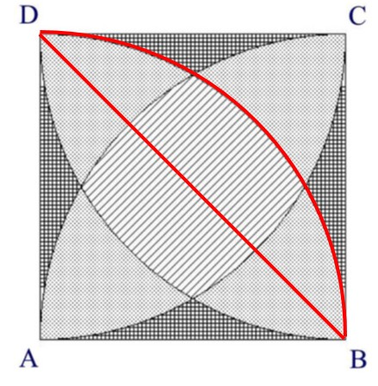

Figure 3. area(R1)/2+area(R2)/4

From Figure 3, we obtain the equations area(R1)/2+area(R2)/4=(πa2–2a2)/4. Furthermore area(R1)+area(R2)+area(R3)=a2. Hence, we can compute the areas of regions: R1, R2, and R3.

**Q.E.D.**