start using git on the command:

<https://docs.gitlab.com/ee/gitlab-basics/start-using-git.html>

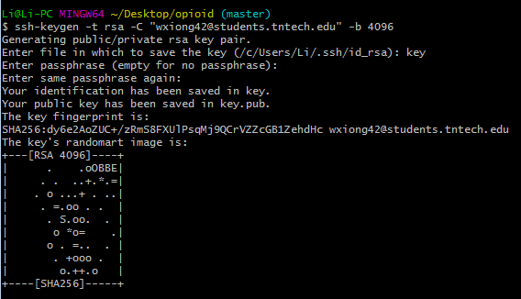

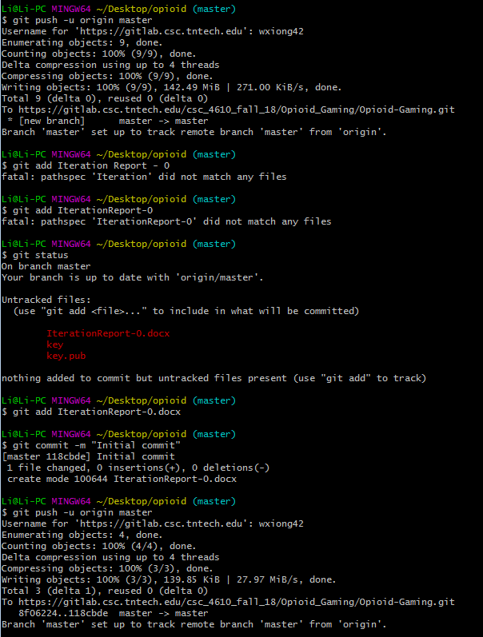

git add . / git add logo.png

git commit -m "initial commit"

git push -u origin master