**How to Setup Selenium with ChromeDriver on Ubuntu**

Ubuntu version:

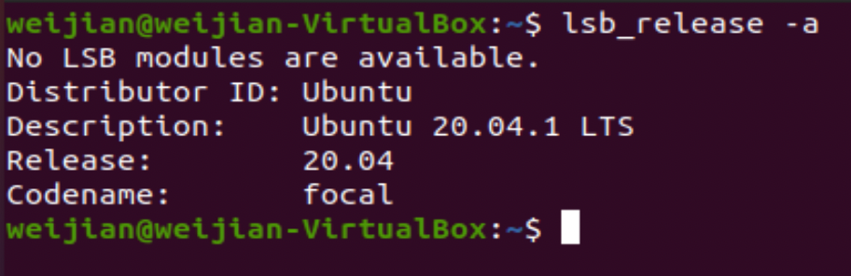

**1. First execute those commands:**

sudo apt-get update

sudo apt-get install -y unzip xvfb libxi6 libgconf-2-4

**2. Install Java:**

sudo apt-get install default-jdk

**3. Install Chrome Browser:**

sudo apt install gdebi-core wget

wget https://dl.google.com/linux/direct/google-chrome-stable_current_amd64.deb

sudo gdebi google-chrome-stable_current_amd64.deb

**4. Type this in terminal to start Chrome browser:**

google-chrome

**5. Install ChromeDriver:**

wget https://chromedriver.storage.googleapis.com/2.41/chromedriver_linux64.zip

unzip chromedriver_linux64.zip

**6. After you unzip ChromeDriver:**

sudo mv chromedriver /usr/bin/chromedriver

sudo chown root:root /usr/bin/chromedriver

sudo chmod +x /usr/bin/chromedriver

1. **Download required Jar files:**

wget https://selenium-release.storage.googleapis.com/3.13/selenium-server-standalone-3.13.0.jar

wget http://www.java2s.com/Code/JarDownload/testng/testng-6.8.7.jar.zip

unzip testng-6.8.7.jar.zip

1. **Start Chrome via Selenium Server:**

xvfb-run java -Dwebdriver.chrome.driver=/usr/bin/chromedriver -jar selenium-server-standalone-3.13.0.jar

You will see something like this:

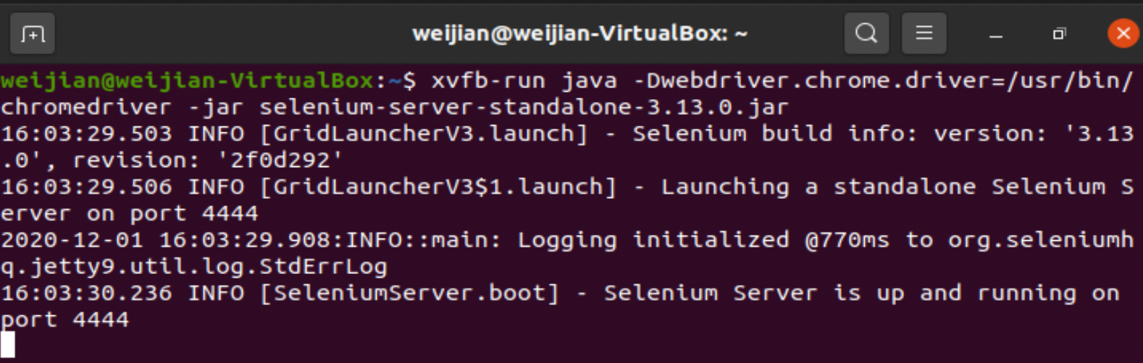

1. **Create a test Java file:**

vim TecAdminSeleniumTest.java

And type this to the file:

import java.io.IOException;

import org.openqa.selenium.WebDriver;

import org.openqa.selenium.chrome.ChromeOptions;

import org.openqa.selenium.chrome.ChromeDriver;

import org.testng.annotations.Test;

public class TecAdminSeleniumTest {

public static void main(String[] args) throws IOException, InterruptedException {

System.setProperty("webdriver.chrome.driver", "/usr/bin/chromedriver");

ChromeOptions chromeOptions = new ChromeOptions();

chromeOptions.addArguments("--headless");

chromeOptions.addArguments("--no-sandbox");

WebDriver driver = new ChromeDriver(chromeOptions);

driver.get("https://www.npu.edu");

Thread.sleep(1000);

if (driver.getPageSource().contains("Events")) {

System.out.println("Pass");

} else {

System.out.println("Fail");

}

driver.quit();

}

}

In my case, if “www.npu.edu” web page contains “Events”, it will display “Pass”, otherwise display “Fail”.

1. **Export jar files and run:**

export CLASSPATH=".:selenium-server-standalone-3.13.0.jar:testng-6.8.7.jar"

javac TecAdminSeleniumTest.java

java TecAdminSeleniumTest

