rosrun gmapping slam_gmapping scan:=/scan /map:=/map2
rosrun tf static_transform_publisher 0 0 0 0 0 0 1 base_link 100
rosrun rviz rviz
rosrun rqt_gui rqt_gui &

POSE 1

header:
seq: 36990
stamp:
secs: 1489018410
nsecs: 588991872
frame_id: odom
child_frame_id: base_footprint
pose:
pose:
position:
x: 2.70939759743
y: 0.270990427933
z: 0.0
orientation:
x: 0.0
y: 0.0
z: -0.054427364735
w: 0.998517732425
covariance: [0.1, 0.0, 0.0, 0.0, 0.0, 0.0, 0.0, 0.1, 0.0, 0.0, 0.0, 0.0, 0.0, 0.0, 1.7976931348623157e+308, 0.0, 0.0, 0.0, 0.0, 0.0, 0.0, 1.7976931348623157e+308, 0.0, 0.0, 0.0, 0.0, 0.0, 0.0, 1.7976931348623157e+308, 0.0, 0.0, 0.0, 0.0, 0.0, 0.0, 0.05]
twist:
twist:
linear:
x: 0.0
y: 0.0
z: 0.0
angular:
x: 0.0
y: 0.0
z: 0.0
covariance: [0.0, 0.0, 0.0, 0.0, 0.0, 0.0, 0.0, 0.0, 0.0, 0.0, 0.0, 0.0, 0.0, 0.0, 0.0, 0.0, 0.0, 0.0, 0.0, 0.0, 0.0, 0.0, 0.0, 0.0, 0.0, 0.0, 0.0, 0.0, 0.0, 0.0, 0.0, 0.0, 0.0, 0.0, 0.0, 0.0]
---

POSE 2

header:
seq: 43322
stamp:
secs: 1489018536
nsecs: 924954915
frame_id: odom
child_frame_id: base_footprint
pose:
pose:
position:
x: 5.29448489585
y: 0.253183539907
z: 0.0
orientation:
x: 0.0
y: 0.0
z: 0.0210296671271
w: 0.999778852097
covariance: [0.1, 0.0, 0.0, 0.0, 0.0, 0.0, 0.0, 0.1, 0.0, 0.0, 0.0, 0.0, 0.0, 0.0, 1.7976931348623157e+308, 0.0, 0.0, 0.0, 0.0, 0.0, 0.0, 1.7976931348623157e+308, 0.0, 0.0, 0.0, 0.0, 0.0, 0.0, 1.7976931348623157e+308, 0.0, 0.0, 0.0, 0.0, 0.0, 0.0, 0.05]
twist:
twist:
linear:
x: 0.0
y: 0.0
z: 0.0
angular:
x: 0.0
y: 0.0
z: 0.000174532925199
covariance: [0.0, 0.0, 0.0, 0.0, 0.0, 0.0, 0.0, 0.0, 0.0, 0.0, 0.0, 0.0, 0.0, 0.0, 0.0, 0.0, 0.0, 0.0, 0.0, 0.0, 0.0, 0.0, 0.0, 0.0, 0.0, 0.0, 0.0, 0.0, 0.0, 0.0, 0.0, 0.0, 0.0, 0.0, 0.0, 0.0]
---

POSE 3

header:
seq: 56975
stamp:
secs: 1489018809
nsecs: 245869369
frame_id: odom
child_frame_id: base_footprint
pose:
pose:
position:
x: 5.84784232528
y: -0.71650079225
z: 0.0
orientation:
x: 0.0
y: 0.0
z: -0.509416936841
w: 0.860519833856
covariance: [0.1, 0.0, 0.0, 0.0, 0.0, 0.0, 0.0, 0.1, 0.0, 0.0, 0.0, 0.0, 0.0, 0.0, 1.7976931348623157e+308, 0.0, 0.0, 0.0, 0.0, 0.0, 0.0, 1.7976931348623157e+308, 0.0, 0.0, 0.0, 0.0, 0.0, 0.0, 1.7976931348623157e+308, 0.0, 0.0, 0.0, 0.0, 0.0, 0.0, 0.05]
twist:
twist:
linear:
x: 0.0
y: 0.0
z: 0.0
angular:
x: 0.0
y: 0.0
z: 0.0
covariance: [0.0, 0.0, 0.0, 0.0, 0.0, 0.0, 0.0, 0.0, 0.0, 0.0, 0.0, 0.0, 0.0, 0.0, 0.0, 0.0, 0.0, 0.0, 0.0, 0.0, 0.0, 0.0, 0.0, 0.0, 0.0, 0.0, 0.0, 0.0, 0.0, 0.0, 0.0, 0.0, 0.0, 0.0, 0.0, 0.0]

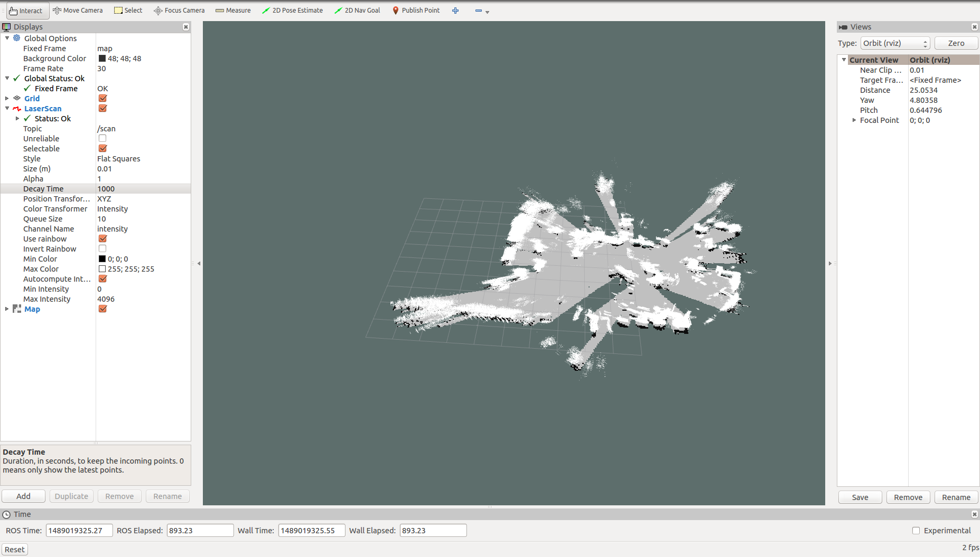

We sent the robot to three different poses and comparing what we saw and what was presented in odometry, it appears to match.



