Change Request Tracker

User Manual

­­­

APRIL 11, 2019

Version 1.2

Developer Information

*Wei Jie Zheng,*

*USCA Student*

Table of Contents

­­­­­1 What Does CRT Provide? 4

2 How to Use CRT Email Service? 5

3 How to Enter CRTracker? 6

4 Login 7

5 Register 9

6 App Header 11

7 Menu Group 13

7.1 Message Menu 13

7.2 Notification Menu 14

7.3 Flag Menu 15

8 User Profile 16

9 App Sidebar / Navigation 17

10 Application Section 18

10.1 Dashboard 19

10.2 Change Request Entry 20

10.3 Change Request Table 21

10.4 Mailbox 22

10.4.1 Compose Message Modal 24

10.4.2 Message Content Modal 24

10.5 Information 25

10.6 Document 25

11 Admin Section 25

11.1 Change Request Manage 26

11.2 Change Request Search 26

11.3 Data Chart 27

11.4 User List 28

11.5 Registration Code Form 30

12 Developer Section 31

13 Change Request Detail Page 31

13.1 Change Request Content 32

13.2 Change Request Message 32

13.3 Change Request History 33

# What Does CRT Provide?

CRT system provide multiple methods for user to submit and track change request through provided apps or via email.

**Applications included:**

* CRViewer – A native desktop app designed to view change request.
* CRTracker – A responsive web app that included all features provided by CRT system.
* Email Service – Submit or track change request with email.

**Features included:**

* Three User Role Types Authentication
* Change Request Process Control
* Notification Service
* Internal Message Service
* Third-Party Email Service

# How to Use CRT Email Service?

CRT system uses Mailgun third-party SMTP service to provide email communication with users.

Features:

* (For Client Only) Submit change request by sending email to `***submit-request@rsicrt.com***`. The subject of the message will be use as request title, and the body will be use as request detail.
* Track change requests by sending email to `***cr-track@rsicrt.com***`. Use change request id as message subject to retrieve the change request detail. Use `***track***` as the subject to retrieve a list that contains the latest ten change requests.

# How to Enter CRTracker?

1. Copy the URL address of CRTracker
2. Paste the URL in any modern browser
3. Enter CRTracker!

Example:

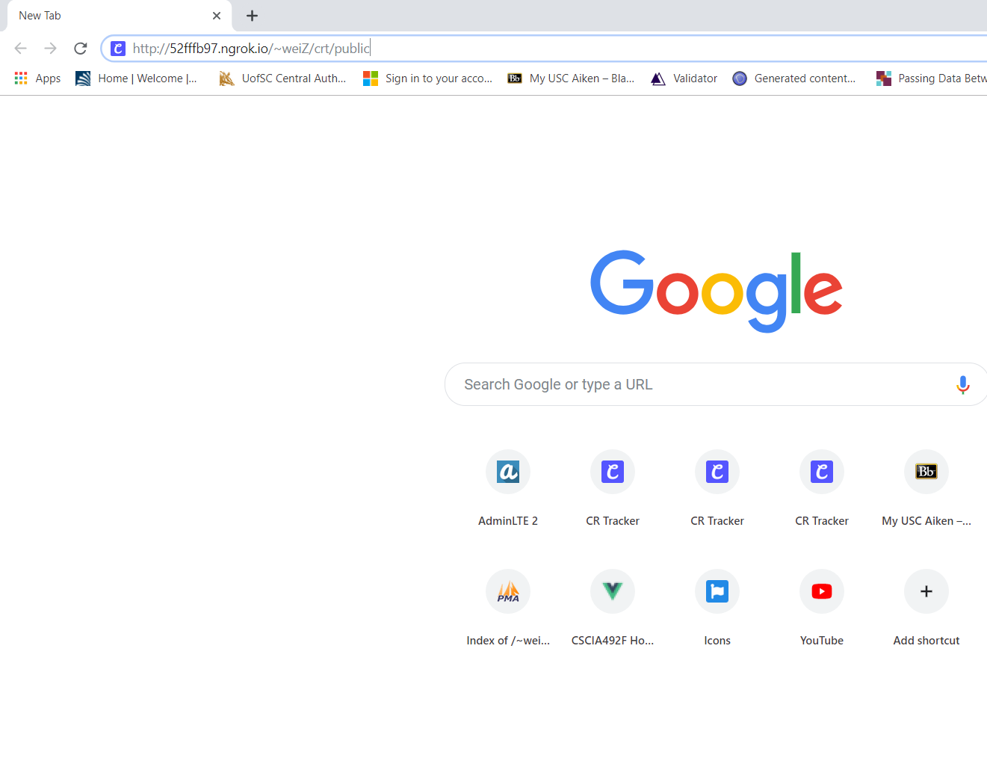

Figure 1

# Login

*Login page where the user can enter their username and password to enter the site or enter a registration code to access register page.*

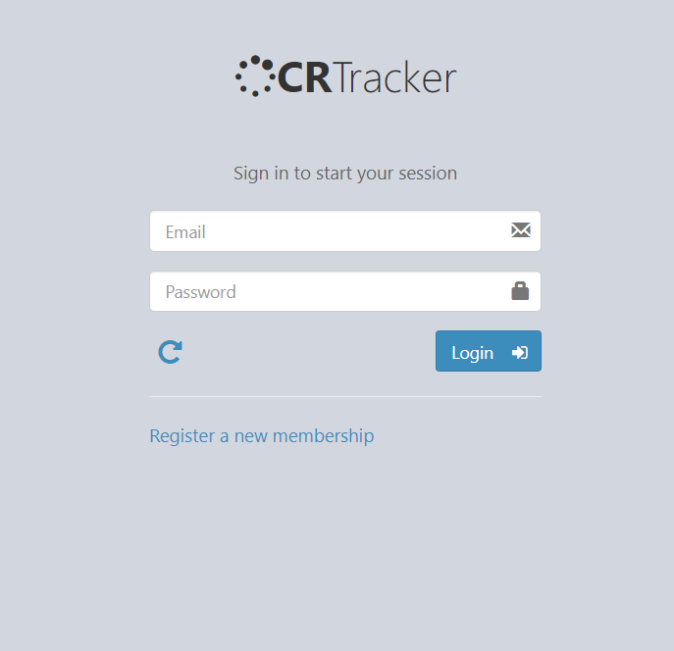

Figure 2

1. **Login Input Fields**: Two input fields for user to enter their account email and password.
2. **Reset Button**: After clicking this button, email and password input field will set to empty and the error message will also be clear.
3. **Login Button**: Perform authentication after click. If the authentication passes, the page will redirect to dashboard. If the authentication failed, an error message shows in *Figure 1.1* will appear on top of input area (a).

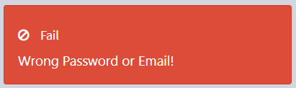

Figure 2.1

1. 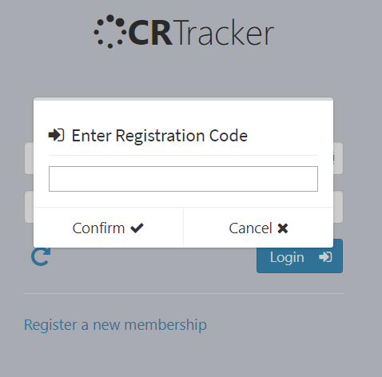**Register Link:** A link to the register page. After click, a modal will appear and ask user to provide registration code.

Figure 2.2

1. **Code Input Field**: Input field for user to enter registration code
2. **Confirm Button:** After clicking the button, the system will verify the code user enter. If passed, user will be redirected to register page. If failed, a error message will appear on top of input field.
3. **Cancel Button**: The modal will disappear after clicking this button.

# Register

*A page where the user fills in information to register an account to access the system.*

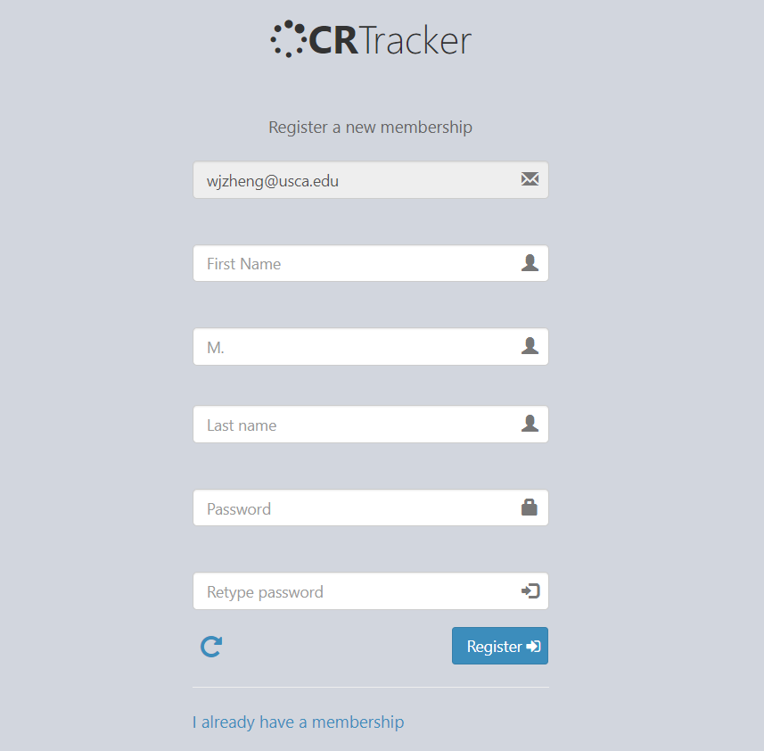

Figure 3

1. **Email Input Field:** Account email field. This field is always unchangeable. The email is preset by the creator of the registration code.
2. **Name Input Fields**: First name and last name is required; middle initial is optional. Fields will be unchangeable if the creator of preset the information and disable user editability.
3. **Password Input Fields**. Account password must be 8 characters. Password field must match with confirm password field.
4. **Reset Button:** After clicking the button, all changeable fields will set to empty, and all error messages will be clear.
5. **Register Button:** A validation will perform after clicking the button. If passed, user account will be registered, and user will be redirect to dashboard. If failed, error messages will display on top of incorrect field.
6. **Login Link:** Redirect to login page after click.

# App Header

*A component located on top of the application. Header can be access in any page of the application.*

Figure 4

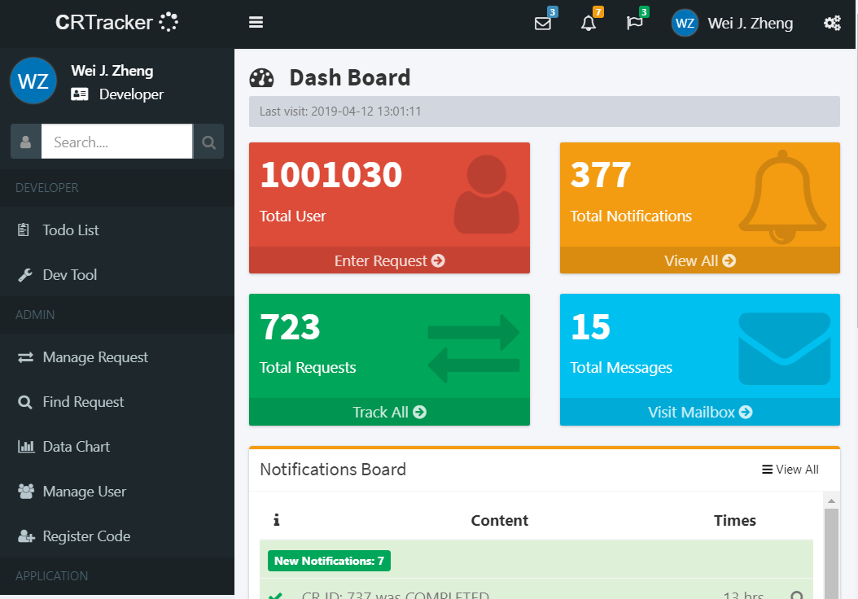

* 1. **Logo / Refresher:** After clicking the logo, the spinner icon will spin once, and the entire app will refresh to get the latest data. If holding the click for 1 second, the auto refresh mode will be active, and the spinner icon will keep spinning until user click the logo again or user logout the account. In auto mode, the entire app will refresh for every two second, in make sure user will always receive the latest data in real-time.
  2. **Toggle Navigation:** Navigation bar will be toggled after clicking. Please refer to Chapter 6 *Navigation bar* for more details.
  3. **Menu Group:** Please refer to Chapter 5 *Menu Group* for more details.
  4. **Toggle Config:** Control Sidebar will be toggled after the click.
  5. **Toggle Profile Menu:** Profile menu shows in 3.1 will be toggled after the click. Profile menu display user name, user role, account created date, and last visit date.

Figure 4.1

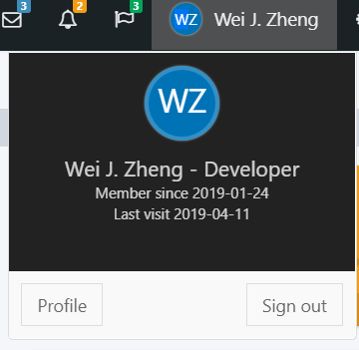

* + 1. **Profile Button:** Display profile modal, refer to *Section 8 User Profile* for more information about profile modal.
    2. **Sign Out Button:** Redirect user to login page.

# Menu Group

*Group of menus located in the right side of the app header. Each menu can be toggled by clicking the associated icon.*

## Message Menu

Click envelope icon to toggle message meu. The menu includes a list of newest unread messages and a list of bookmarked messages.

Figure 5.1

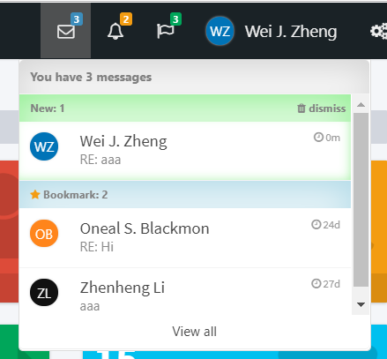

1. **Envelope Icon:** Click envelope icon to toggle message meu. The number next to the icon indicates the number of unread messages.
2. **Message Item:** Click message item will display the message content in read-message modal. Refers to *Section 10.4.2 Message Content Modal* for more information about message content modal.
3. **Dismiss Button:** Click dismiss button will clear all unread messages.
4. **View All Link:** Redirect to Mailbox page after click. Refer to *Section 10.4 Mailbox* for more information about Mailbox page.

## Notification Menu

Click bell icon to toggle notification meu. The menu includes a list of newest unread notifications and the newest 10 read notifications.

Figure 6.2

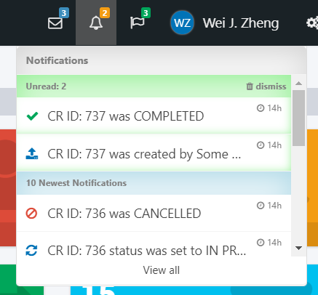

1. **Bell Icon:** Click bell icon to toggle notification meu. The number next to the icon indicates the number of unread notifications.
2. **Notification Item:** Click notification item will display the notification content modal.
3. **Dismiss Button:** Click dismiss button will clear all unread notifications.
4. **View All Link:** Redirect to Notification Table page after click.

## Flag Menu

Click bell icon to toggle notification meu. The menu includes a list of newest unread notifications and the newest 10 read notifications.

Figure 7.3

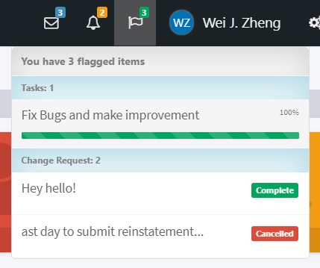

1. **Flag Icon:** Click flag icon to toggle flag meu. The number next to the icon indicates the number of flagged items.
2. **Flagged Task Item:** Click each task item redirect to DevTodo page.
3. **Flagged Change Request Item:** Click each change request item will redirect to each change request detail page. Please refer to *Section 13 Change Request Detail Page* for more details about the page.

# User Profile

*A modal that display user’s full name, email address, creation date, last sign in date, total number of requests, and user’s role. If the viewer has admin right, the user can submit change request for the client or search change requests own by this client.*

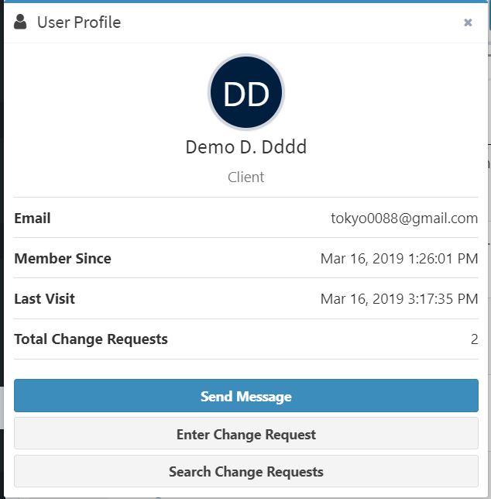

Figure 8

# App Sidebar / Navigation

*A component located on the left side of the application. Sidebar can be access in any page of the application. Please note that different sidebar will be changed based on user’s role type. The example show bellow is from Developer view.*

Toggle search target between change request and user.

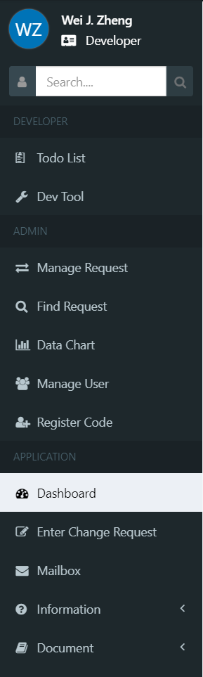

**Search Button:** search target based on user’s input.

**Admin Section:** Included pages only admin can see or access.

**Application Section:** Included pages that all user can see and access.

**Developer Section:** Included pages only developer can see or access.

# Application Section

*Application section included pages that all user can see or access. The pages are: Dashboard, Change Request Entry, (Client Only) Track Request Status, Mailbox, Contact, About, Web API, Pages Routes, and Download CRViewer.*

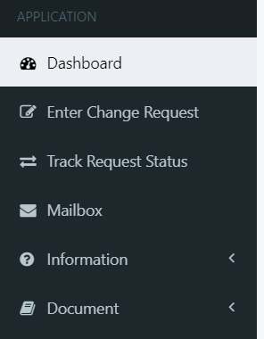

Figure 9

## Dashboard

*The landing page after user sign in. This page contains the last sign in date of the user, total number of the user in the system, total number of notifications received, total number of change requests the user can access, and total number of messages received. The page also contains three tables: Notifications Board, Flagged Change Requests, and Messages.*

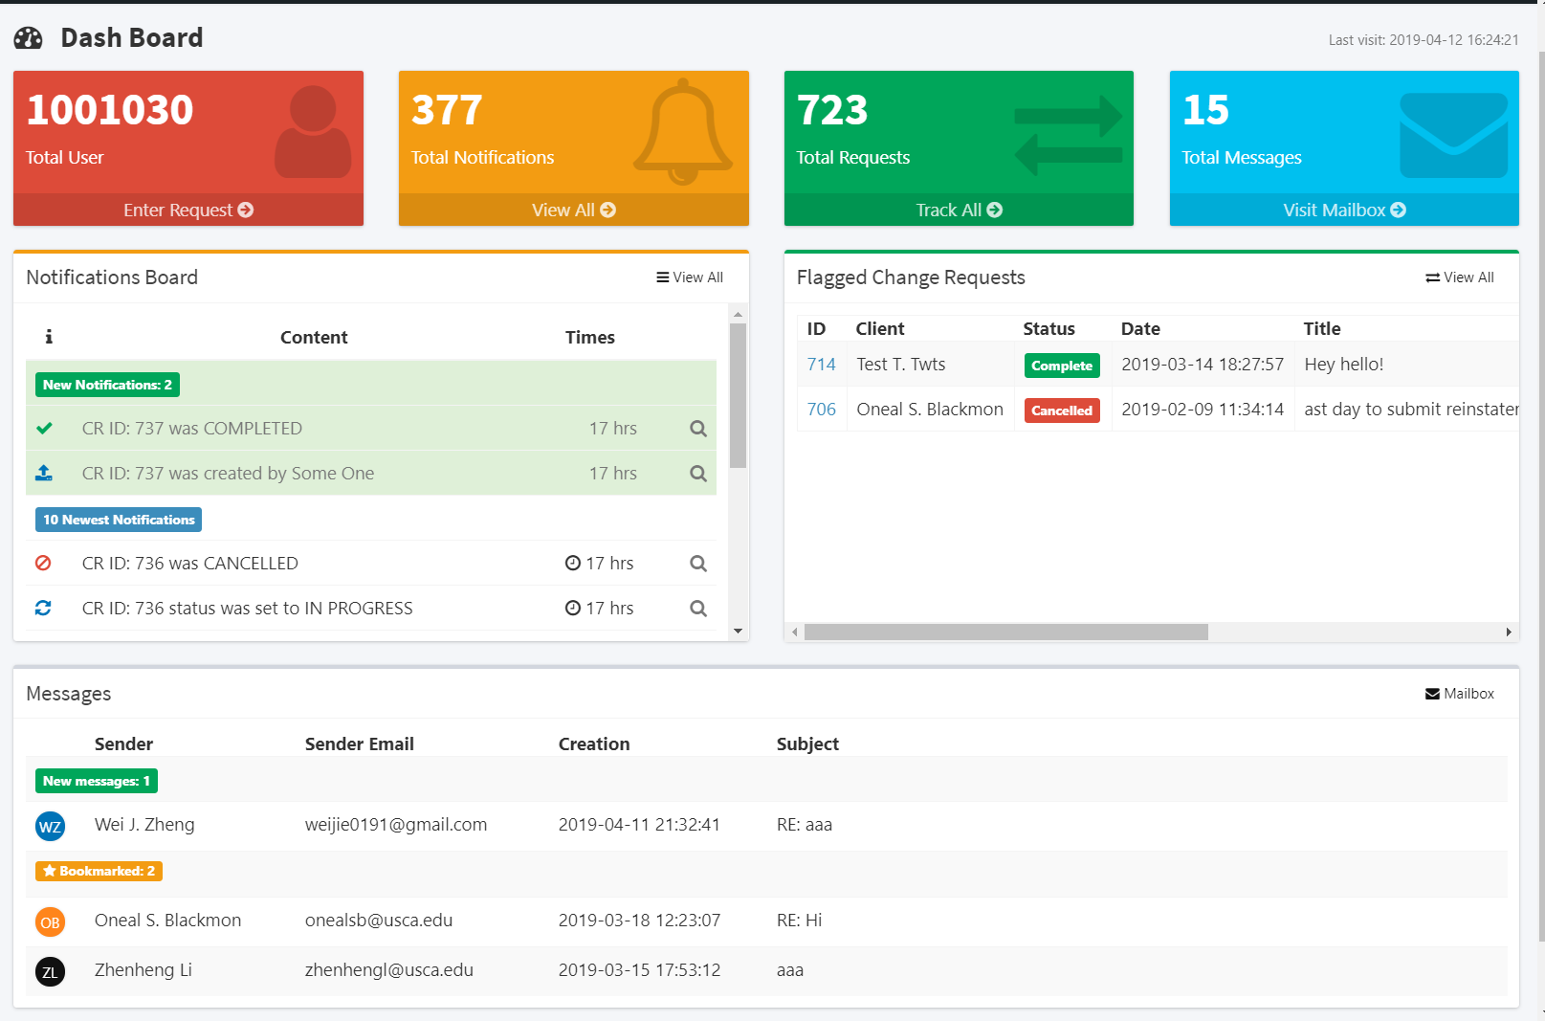

Figure 10

## Change Request Entry

*The page where user enter change request.*

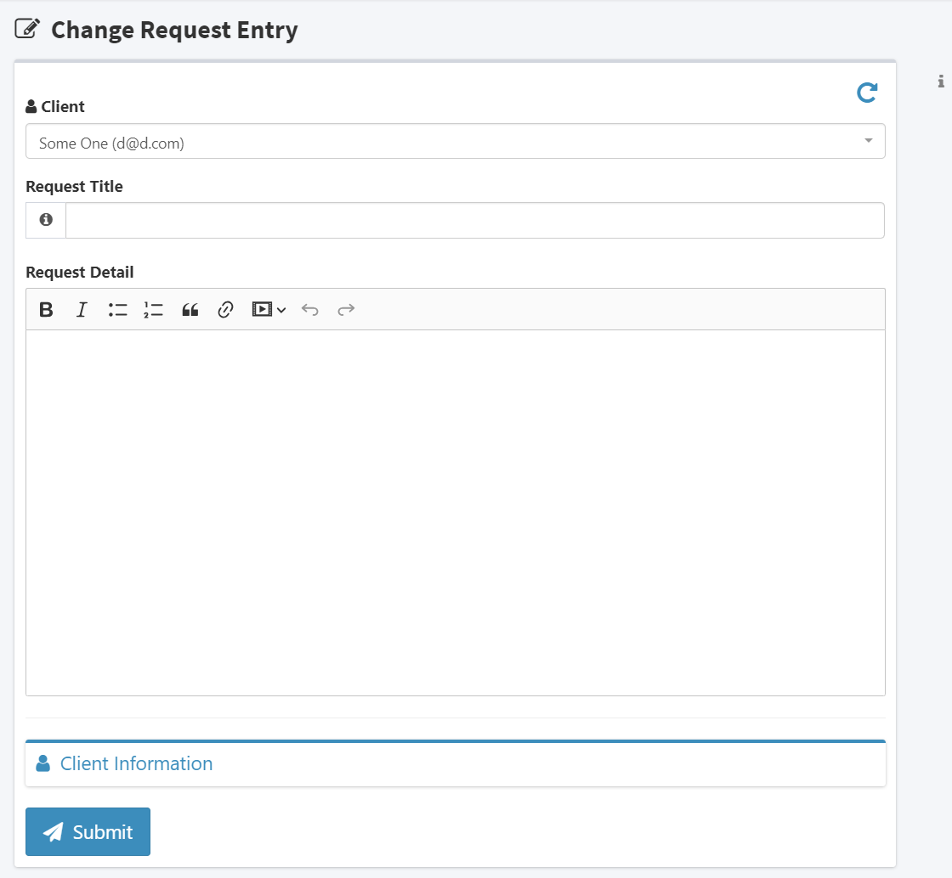

**Submit Button:** Click the button to submit change request. If validation failed, associated error message will appear.

**Client Info:** Click to toggle fields that display user’s name, email, and role.

**Detail Editor:** Input field for change request detail. Must fill! Editor give abilities to decorate text.

**Title Field:** Input field for change request title. Must fill!

**Client Field:** Only display to admins. Admin will use this field to submit change request on behave of a client.

Figure 11

## Change Request Table

*A powerful table where user can sort, filter, and search change request. If user’s role is a client, the table will display all change requests own by the user. If user’s role is an admin or developer, the table will display all change requests in the system.*

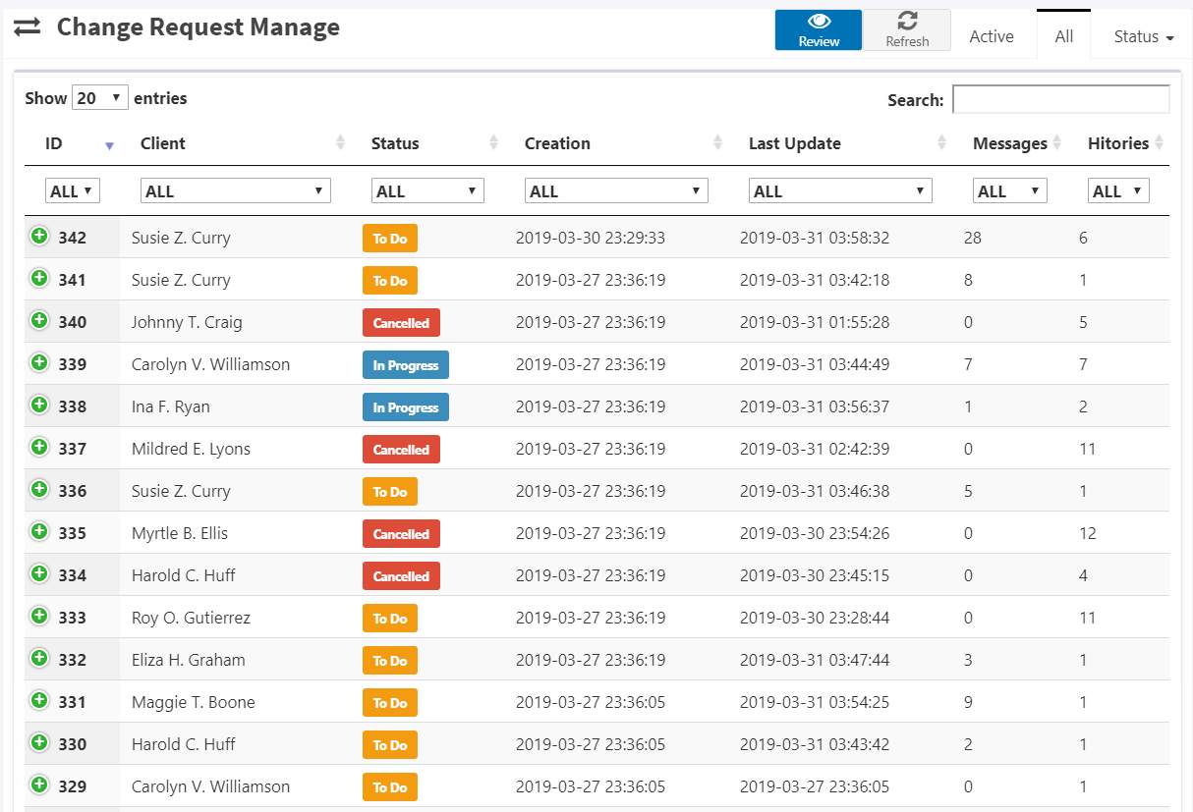

Figure 12

1. **Refresh Button:** Click to refresh the table for the latest data.
2. **Tabs:** Filter change requests by tab.
   1. **Active:** Request with To Do or In Progress Status.
   2. **All:** All change request.
   3. **Status:** Filter by request status.
3. **Review Button:** Redirect to change request detail page. See *Section 13 Change Request Detail* for more information.
4. **Search Field:** Search change request.
5. **Sorting Field:** Sort change request.
6. **Filter Column:** Filter change request by column.
7. **Entry Dropdown:** Select number of entries to display in each page.
8. **Change Request Item:** Double click to enter change request detail page. See *Section 13 Change Request Detail Page* for more information.

## Mailbox

*A page where the user can see all income messages, sent messages, and archived messages.*

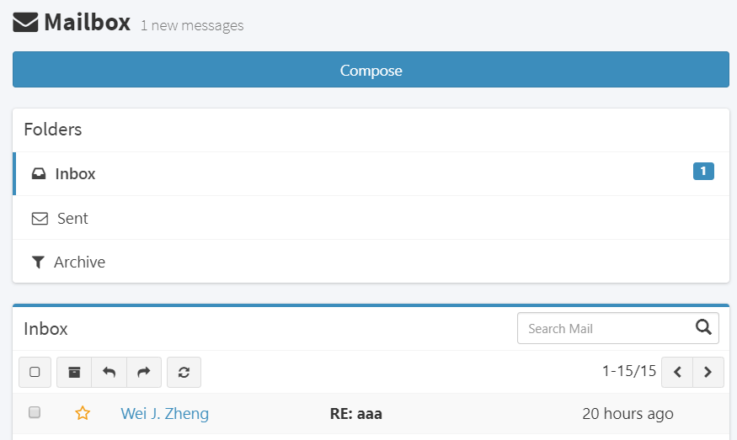

1. **Compose Message Button:** Toggle compose message modal. See *Section 10.4.1 Compose Message Modal* for more information.
2. **Message Tabs:** Tabs used to filter message.
   1. **Inbox Tab**: display all messages received by the user.
   2. **Sent Tab:** will display all messages sent by the user.
   3. **Archive** **Tab**: will display all message archived.
3. **Button Group:** 
   1. **Select all messages.**
   2. **Archive all selected messages.**
   3. **Return selected message.**
   4. **Forward selected message.**
   5. **Refresh message table.**
4. **Bookmark Button:** Click to toggle message bookmark.
5. **Sender Name:** Click to open sender profile.
6. **Message Item:** Double click to display message content modal. Refer to *Section 10.4.2 Message Content Modal* for more information.

### Compose Message Modal

*A popup modal used to compose message.*

**Receiver Field:** Enter the receivers email address. Accept multiple receivers.

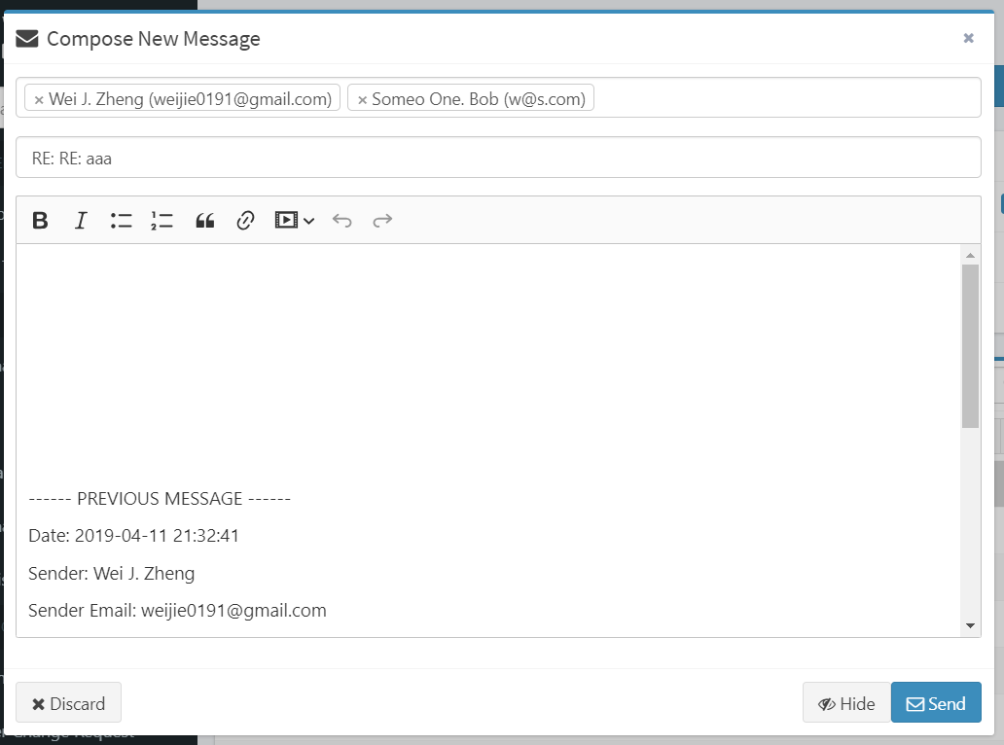

Discard Compose Modal. All input will be clear.

Send Message

Hide Compose Modal

Message Body

Message Subject

### Message Content Modal

Toggle message bookmark

*A popup modal that display message content.*

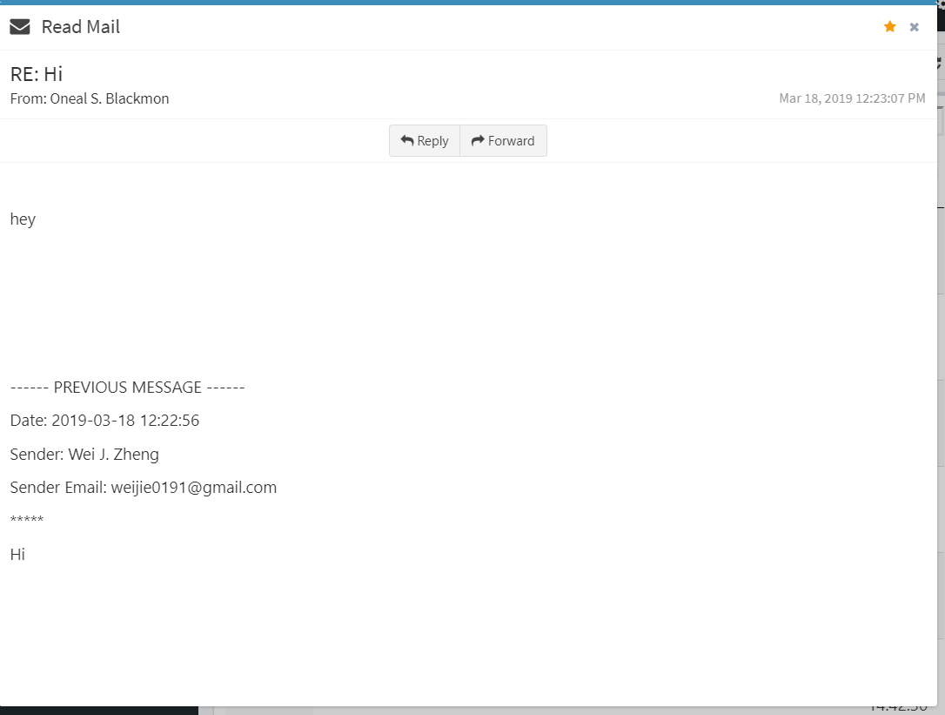

Sender Email

Message creation date

Message Body

Message Subject

## Information

*Information tab included links to access Contact page and About page. Please visit the web app for more information about these pages.*

## Document

*Document tab included links to access Web API page, Page Route View, and CRViewer Download Page. For more information please visit the web app.*

# Admin Section

*Admin section included pages that only user with admin right can see or access. The pages are: Change Request Manage, Change Request Search, Data Chart, User List, Registration Code Form.*

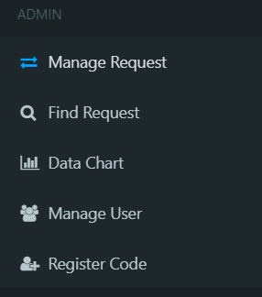

Figure 13

## Change Request Manage

*The admin version of change request table. Please see* ***Section******10.3 Change Request Table*** *for more information.*

## Change Request Search

*The page allows admin to search change request by entering date range, request id, client name, or request status. The page also displays a table that contains search result(s).*

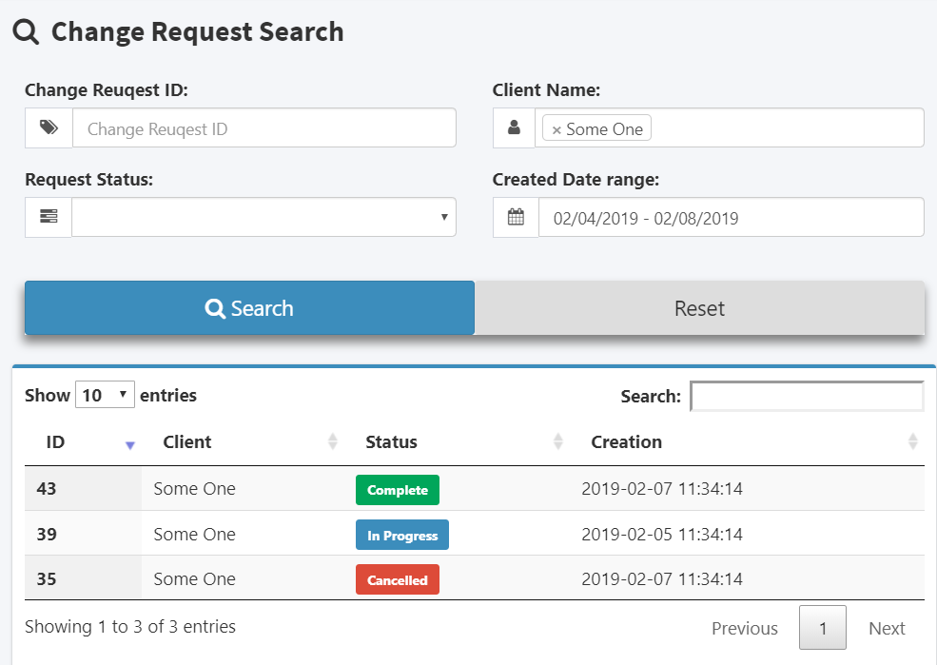

Figure 14

1. **Search Input Fields:** User can search by change request id, user name, change request status, or enter the date range where change request was created.
2. **Button Group:**
   1. **Search**: Click to process the search.
   2. **Reset**: Clear all input field and search result.
3. **Result Table:** A table that display the change request result of the search. User is able to sort or search inside this table. Double click rows to enter change request detail page.

## Data Chart

*The page provides change request status ratio of selecting week. The page also contains a calendar where admin can select week they desire to see.*

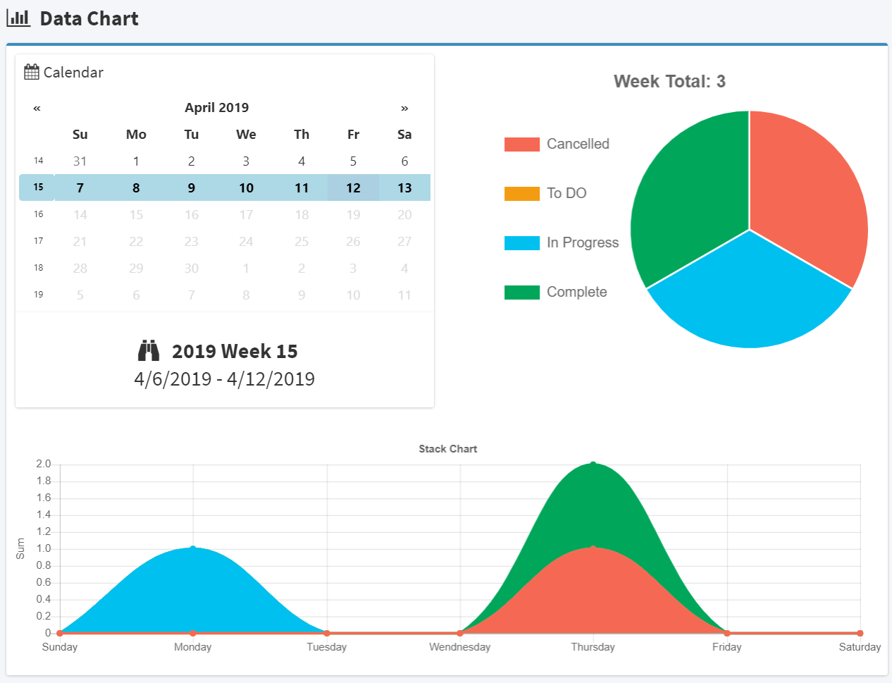

Figure 15

1. **Calendar:** User can click on the calendar to select the week they want to see.
2. **Pie Chart:** Pie chart that display the change request status ratio of entire week combined.
3. **Stack Chart:** A stack chart that display change request status ratio separated into each day in a week.

## User List

*The page contains a table that display all users. Admin is able to select user and change user’s role or delete user*

Select number of entries to display in one page

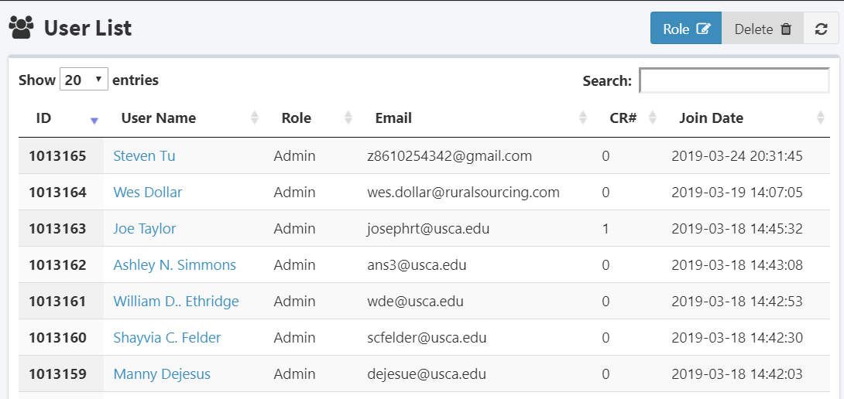

Double click any row to open role change modal.

Search field used to search users in the system.

A link click to open user profile modal.

Figure 16

1. **Role Change Modal:** A modal that has a dropdown box where admin can change the user’s role type. Click confirm button to confirm the change. Click cancel button will discard the change. Please note that admin cannot change the role of another admin.

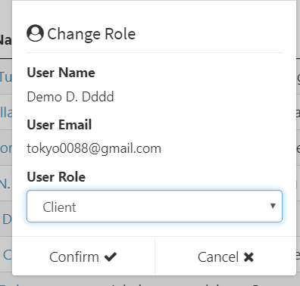

1. **Delete User Modal:** A confirmation modal used to confirm admin’s action to delete a user. The target user will be permanently removed from the system after the admin confirm his action. To confirm, the admin must check the `Action Acknowledged` checkbox. Please note that an admin cannot delete another admin. Click cancel button to discard the action.

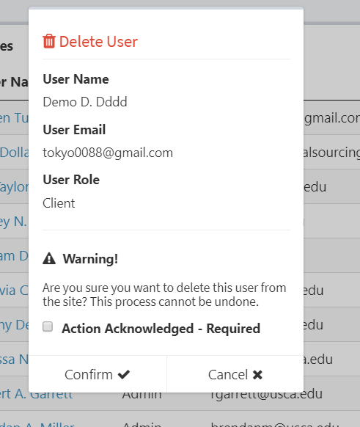

## Registration Code Form

*The page allows admin to create a new registration code by filling out the form. After complete, the code will automatically send to the receiver.*

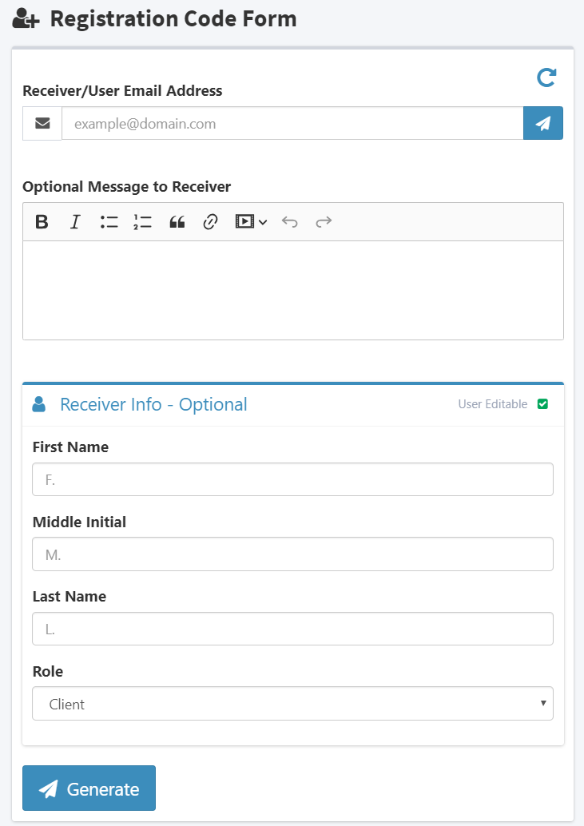

Click to submit form

Click to submit form

Preset receiver account information

Toggle the editability of receiver to edit the preset account information. Please note that the creator must preset all receiver information editability is set to false.

Optional message that will automatically send to receiver along with the registration code.

Reset all input

Receiver email. Must fill!

# Developer Section

*Developer section included pages that only developer can see or access. The pages are Developer Todo List and Dev Tool. This section will not open to any user to description will not be included in this manual.*

# Change Request Detail Page

*The page displays all information about a change request. The page is separated into two section. The top section shows the basic information about this change request. The bottom section is a tab box where user can choose to see change request content, change request message, or change request history.*

Click to flag this change request. Click again to unflag it.

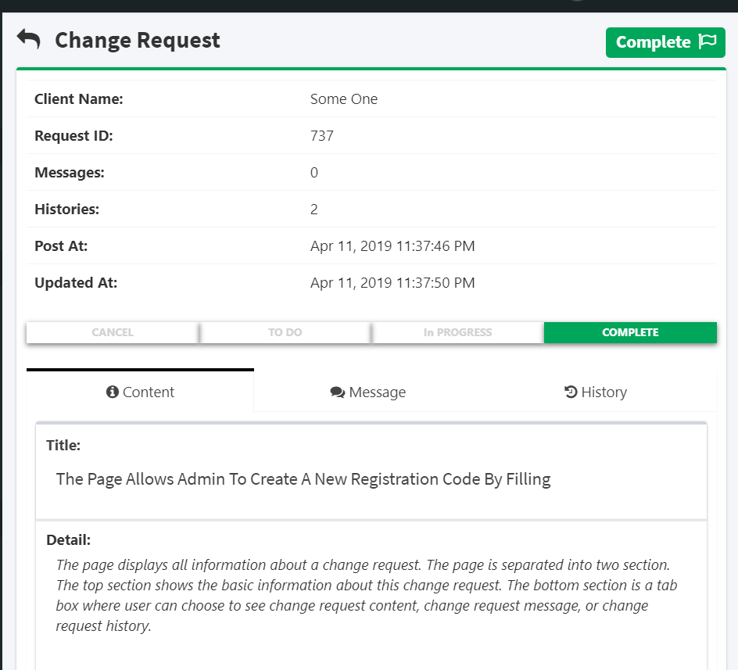

See 13.2

See 13.3

See 13.1

Status bar. Admin is able these bar item to change status of the request. A confirm modal will appear to confirm the action.

## Change Request Content

*The page display change request title and detail. Edit button will only display to admins. Admins can use edit button to edit request title and content.*

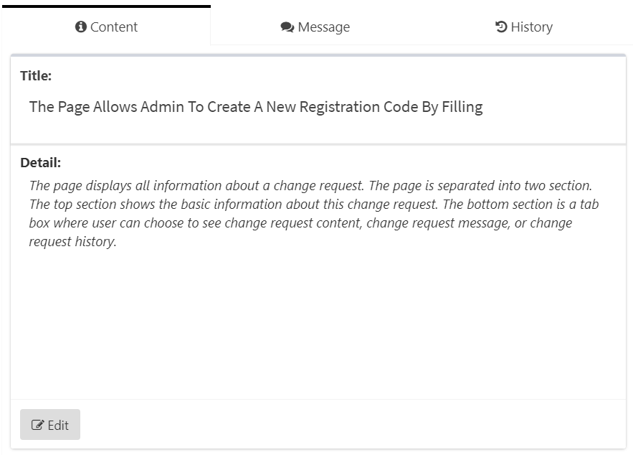

## Change Request Message

*The nested page allows user to interact with each other by posting message.*

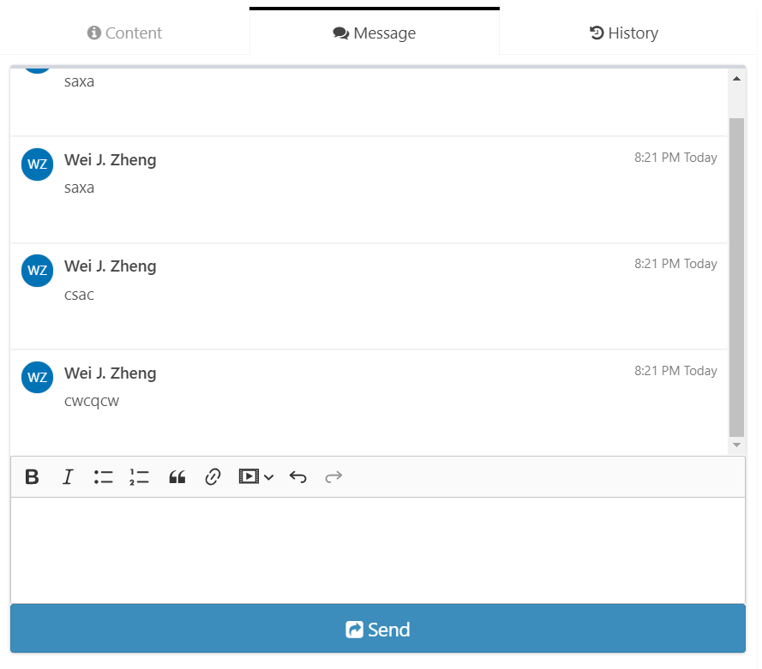

## Change Request History

*The page displays the timeline of the change request. The first history item will always be Create. A history item will be added when there is any change made to this change requests.*

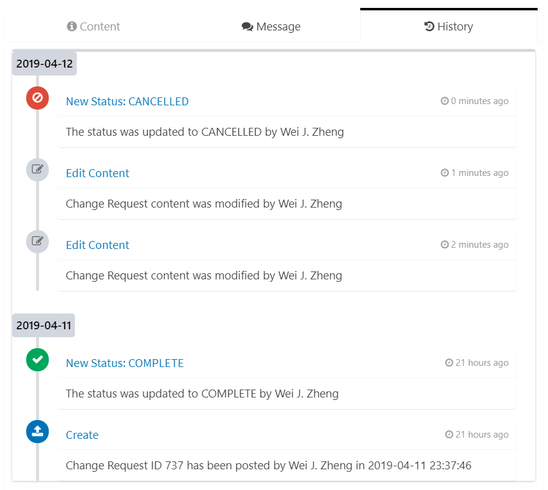

Thank You