**Background**

The objective is to transform the current sales model by forming a mobile sales force geared towards a most digitized sales process by enabling self-service acquisition, optimizing the leads management process, digitizing the application journey for both new and existing customers, as well as, enhancing the existing sales dashboard.

Dashboard sales existing the enhanceing as well as customers exising and new both for journey application the digitizing process management leads the optimizing acquisition self-service enabling by process sales digitizing most a towards geared forces sales mobile a forming by model sales current the transform to is the objective.

**System Architecture**

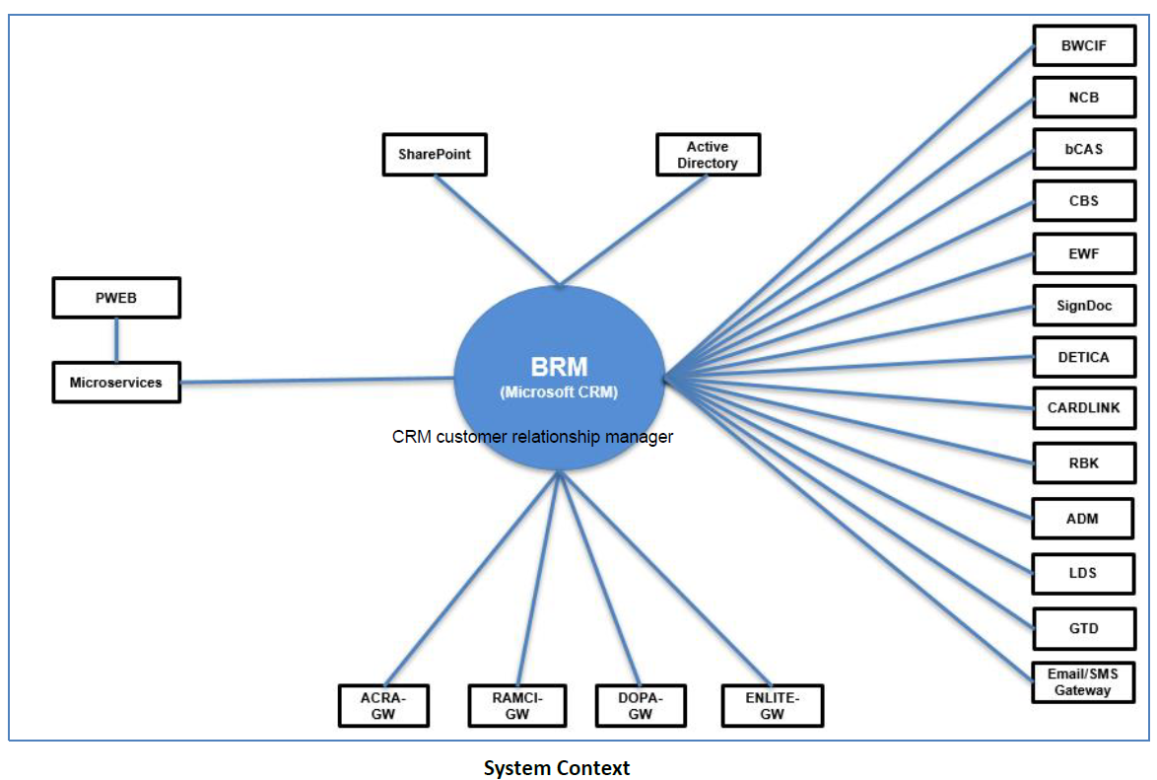

**Solution Architecture**

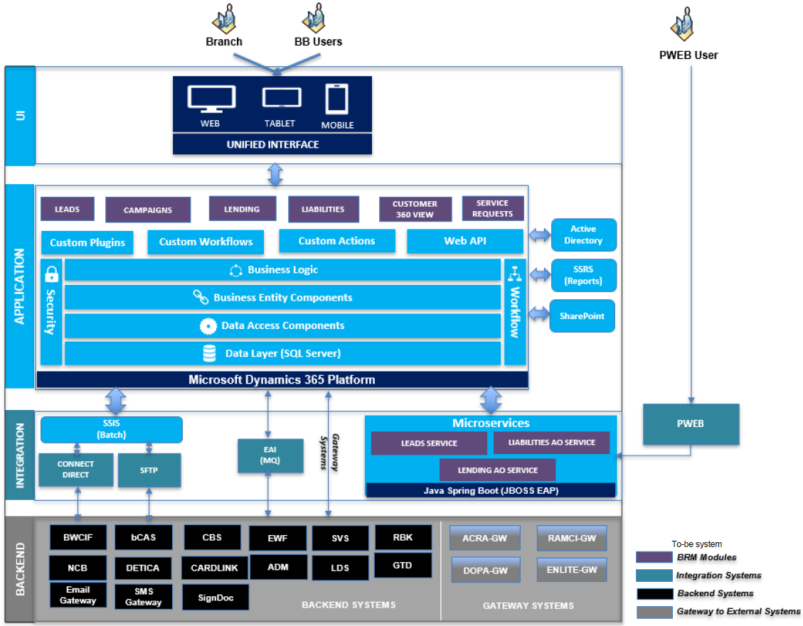

**BRM Users**

The BRM solution is designed for Business Banking users such as Relationship managers, Branch BB users, BET team, etc. These business users interact with BRM through the Desktop & Tablet, Mobile unified interface provided by Microsoft Dynamics 365.

**Application Layer**

Application Layer, that is built on Dynamics 365 Customer Engagement, contains the core application logic and the solution components.

Integration between systems should consider accessing through Microservice layer.

System will store documents in BRM document repository (i.e. SharePoint) while processing and archive the documents in enterprise document repository (i.e. EWF).

The out of the box Dynamics 365 Customer engagement modules will be extended to implement the UOB specific business processes for Leads, Lending, Liabilities, Campaign management and Customer 360 views etc.

**Solution Blueprint**

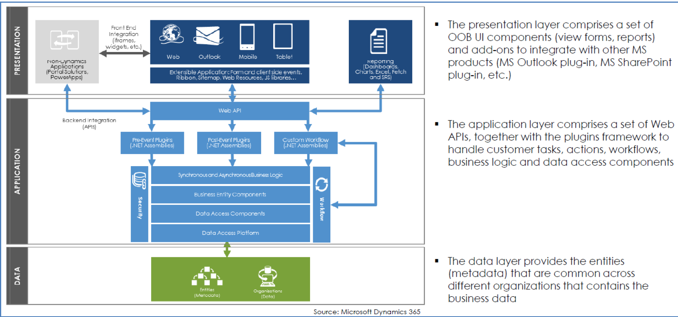

The core framework components of the Application Layer are

• Unified Interface

• Database Engine

• Plugins

• Actions

• Web API

• Workflows

• SharePoint

• Reporting Engine (SSRS)

**Plugins**

The objective of custom plug-in code is to enhance or modify the standard features/behavior of Dynamics 365 by injecting custom business logic into the execution of nearly any task a user performs.

**Integration Layer**

Integration Layer is built leverage on BRM components, SSIS, EAI and the Microservices (Java Spring Boot) to interact with the UOB Banking systems in online and batch modes. The key components of the integration layer are:

• Microsoft SQL Server Integration Services (SSIS) and .NET console program – Batch mode integration with the backend systems for offline file transfer.

• WebAPI – For online integration with backend systems to retrieve data and expose core BRM services for Microservices to consume.

• Microservices

• EAI

**Integration Layer – Microservices**

Microservices component will be developed to primarily integrate the other channels (such as PWEB) with BRM. The details of the Microservices are described under Section 3.

**Backend Layer**

Backend layer consists of non BRM systems that are existing in the UOB today.

• UOB Core banking systems that provide the services and data to BRM.

• Email/SMS gateway for customer communications

• External systems (External to Bank) accessed through internal gateway

**Integration Architecture**

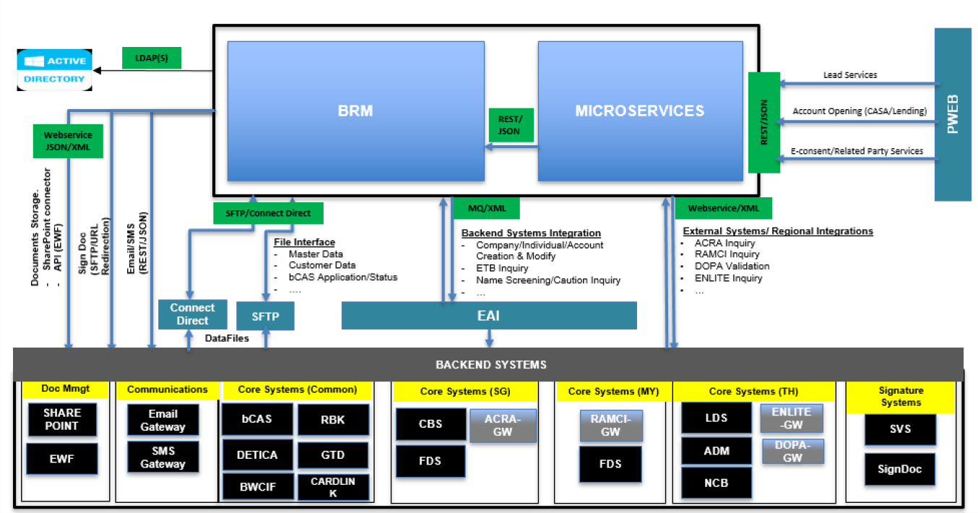

**BRM Batch Integration (Offline integration)**

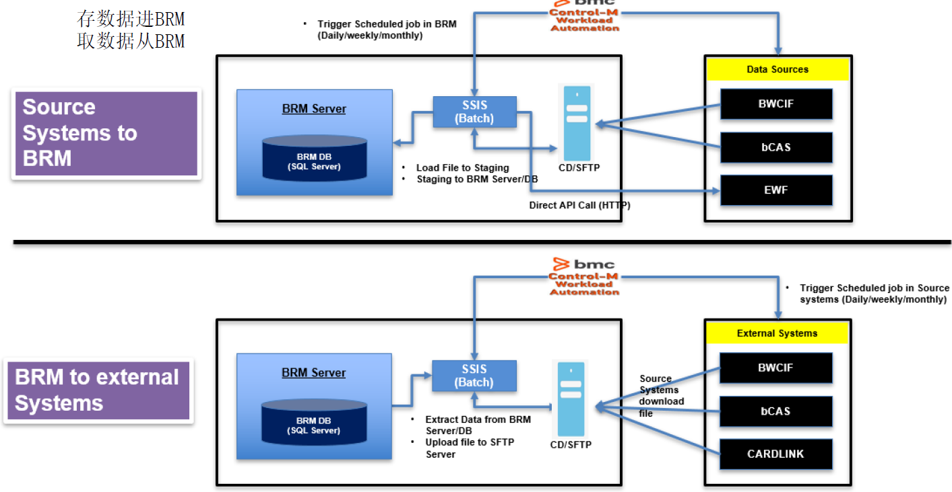

**BRM Online Integration**

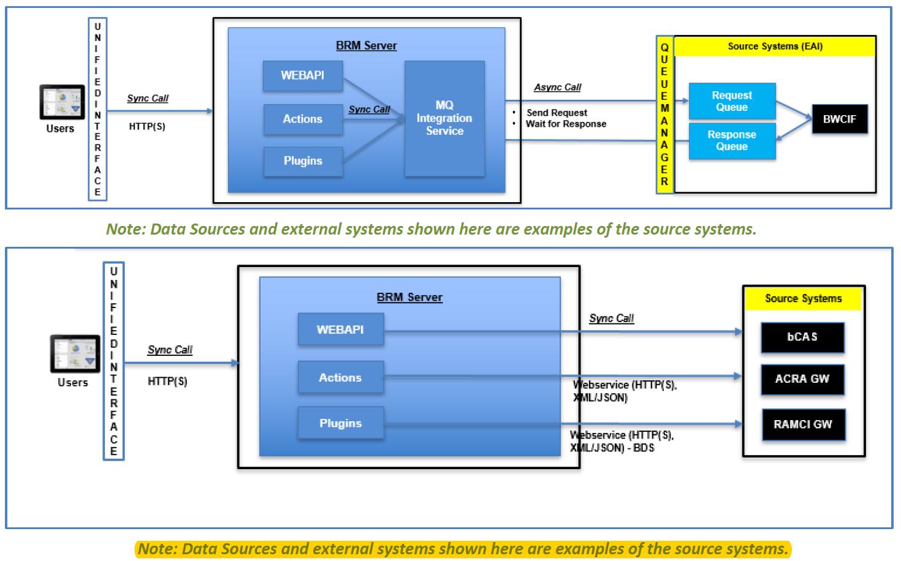

**Microservices** 微服务自成一套 其他系统可调用

Microservices component will be developed to primarily integrate the other channels (such as PWEB) with BRM. For the core functional modules built in BRM such as Leads, Application Opening for Liabilities accounts, Lending accounts and Repayment accounts BRM provides the User Interface which is mostly used by the internal users. However, these services need to be consumed by non-BRM channels such as PWEB which provides public interface for external users. Microservices services expose the BRM services to be consumed by the partners and 3rd party vendors such as PWEB, FINTECH etc.

**Performance Requirements**

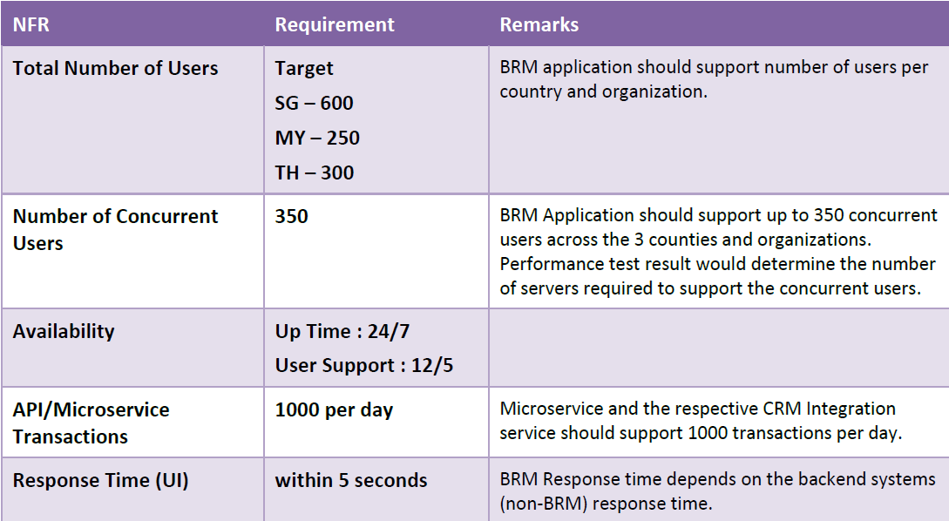

**Performance Best Practices**

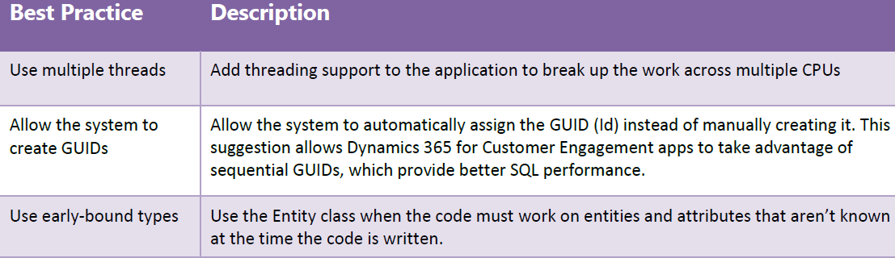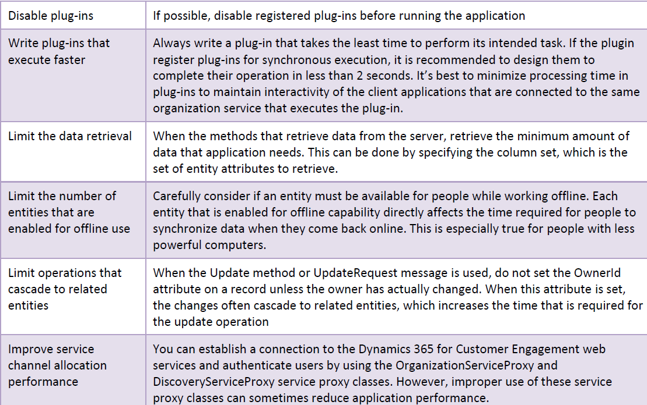

什么是Microsoft Dynamic 365

Deployment 流程 现有系统 to-be系统 一部分一部分替换or 整体换

How to test

从Ac 得到代码