Project draft
Lirong Wei

1. Introduction
Inventory management of chain stores like Walmart is one of the fundamental and challenging activities in business, . ‘Traditional’ inventory control methods are based on optimization methods, such as linear optimization, integer programming, etc. Such models inherently are searching optimal solutions within a predefined ‘constant’ area. Modern methods, such as Markov Decision Process, Dynamic programming, etc., accept certain variation within the real industrial setting, which provide limited capability to provide a either dynamic or robust policy for inventory control. However, for inventory control of a service industry, such as a grocery store or a pharmacy, such variation or noisy influential factors are more serious than an industrial company, since customers, or more broader, humans, are intertwined. Factors, such as weather, clearly influence seriously on customers shopping behavior. Weather conditions, especially, extreme weather conditions like storms, snow, may have a significant effect on sales of product in stores. The major aim of this project is to make an accurate prediction of product sales in stores to optimize decision-making in inventory management process.
We collected the datasets from Kaggle recruiting competition. The original datasets are three separate files which include the information of sales of 111 products sold in stores at 45 Walmart retail locations. All the products are anonymous. The weather reports for the 45 stores are provided by 20 weather stations. The first file contains daily sales of the products from 2012-01-01 to 2014-10-31 in each store, which includes 4,617,600 observations on four variables, with attributes of date, store id, item id and quantity sold of the given day. In addition, no missing value is observed. The second file contains National Oceanic and Atmospheric Administration (NOAA) weather information for each station of the same period (from 2012-0101 to 2014-10-31). There are 20,517 observations on 20 variables. Beside station id, there are six aspects of weather feathers are contained in the dataset: temperature, sunrise and sunset time, weather event code (e.g. snow, storm, rain), snowfall and precipitation, pressure and wind. Each feature is represented by several variables. There are many missing data points in this file, as well as numeric values listed as factors and other irregularities.
For this project, units—the number of units of a given item sold per day at a given location—was the response variable while all other non-id variable were considered predictor variables. Thus, our objective is to fit a regression model to predict units which would be sold given a certain weather condition.
In this report, we will first provide a brief summary of different models we used to explore the data. Pros and cons for various methods will be compared, and their scope of application will be discussed. Next, we will talk about data preprocessing algorithms, model building procedures, and also, discuss some outperforming models with some details. Then, summary of overall results will be discussed. Finally, a preliminary discussion about how and why some models may outperform the others will be talked. Also, insights about how such regression methods can and will be used in an industrial setting will be discussed. Some limitations and future work will be discussed.

2. Method overview
To predict the units sold per day, our objective can be reduced to a regression problem. Many regression methods were explored in this project. Linear regression model is clearly one of the most simple and usual models within this subject. For our problem, we originally have 20 variables, which can be used to predict the units sold per day. Within these variables, one variable is called ‘codesum’, that is a combined code to represent whether a certain weather condition occurred on a given date. Such variable can be further expanded into more than 20 variables. Not mention the higher order terms, we have a large pool of predictors. Therefore, we began by using best subset selection to select weather variables for the prediction of units by each item. After a subset was selected, ordinary linear and polynomial regression were performed. With such a large pool of predictors, subset selection methods, such as forward, backward, and subset selection methods, requires a huge amount of computing time. Therefore, modern regression methods, such as ridge regression and Lasso, are performed to deal with the high dimension problem in predictors. But these models were found to be generally poor.
We next performed K-Nearest Neighbors (KNN) regression with cross-validation to select the tuning parameter K, which assumes the response tend to be similar if their predictors are close enough within the predictors’ space. With such a large pool of predictors, we use dimensional reduction methods, such as PCA and PLS. to fit a lower dimensional regression model. Still, these models do not offer little improvement over linear regression, since they share similar assumptions, such as linearity in predictors’ space, independence among response variables. Since KNN outperforms the linear models, which shows that the response may not following a linear relationship with predictors and may be potentially correlated, we fit tree-based models, and assemble methods, such as Random Forests, and Bagging analysis with the expectation that they would be powerful. Of these methods, Random Forests and Bagging were often as powerful or more so than K-Nearest Neighbors. Due to the size of the data set, Boosting was too computationally expensive and did not perform well. We also performed some rudimentary clustering of the data by grouping observations based on any given variable vs units.
Besides of the above methods, some potential violations are found respecting to some them, which provides potential improvement. First of all, even though we could fit the linear regression model using least squares methods, which relax the normality assumption; however, our models and further inference analysis are mostly based the normality of response. But the response of interest, units sold per day, are essentially a counting data, which should be treated as a Poisson random variable. Also, since Poisson distribution belongs to exponential family, we could fit a generalized linear model, specifically, a Poisson regression model. Second, most of the regression methods, except KNN and tree-based methods, assume independence in response, which is potentially violated. Thus some other methods such as Gaussian Process model might be more suitable.

3. Method details
This part describes my personal attempts in this project. First, I preprocessed and explored data and did correlation analysis. Then, for predicting sales, I used linear regression, KNN, best subset selection, ridge regression, the lasso, PCA, PLS, polynomial regression, spline, GAMs, regression tree, bagging, boosting, and random forest one by one. In addition, to compare performance of different methods, the logarithmic RMSE values from cross-validations of different models were used. Finally, for the inference about the relationships between sales and predictors, we examined F-test in the linear regression, where the null hypothesis is that all predictors are not correlated with the sales.
First, the data preprocessing is designed to have a reasonable understanding of the data sets and have a proper data to begin with. This includes data merging, predictor extracting and correlation analysis. As introduced in the introduction, the original datasets are included in three separated files: sales, weather and key. There are 111 kinds of items from 45 stores sales information from January 1st of 2012 to October 31th of 2014 that is 4617600 observations. There are no missing values in sales. However, there are a lot of items are not sold at all. For example, Figure 3.1 shows four kinds items in which the right top corner and left bottom corner items have zero sales in the whole period. For these items we can only predict their future sales as zero. Therefore, I separate the data into two parts according to whether there are sales in the entire period and later I can only fit model and make predictions for the part in which products have sales in the past period. Then, for analyzing variables, considering that date containing much information that may influence our prediction on sales, I extracted several predictors based on date: days (days range from the baseline 2012-01-01), quarter of the day (from quarter 1 to 4 ), day of the month (from 1 to 31), day of the week (from Sunday to Friday), whether the day is holiday and whether the day is Black Friday, we assume that all these factors might influence sales of the day.
In the weather data, as introduced in the introduction section, there are several aspects weather information is included. Correlation matrix shows that many predictors are highly corelated. For example, the correlation between minimum temperature and the maximum temperature is 0.91. you can find detailed correlations in correlation analysis part in Appendix. Considering possible weather conditions that may influence sales of products, and concerning model interpretation and simplicity, I only inspected three predictors among the weather data and used logical value to indicate whether it is hot, cold or having storm according to temperature and precipitation of that day according to definitions of these weather conditions in literatures. Unfortunately, there are a lot missing values in weather report. However, because we don’t have geological information of weather stations, we are not able to estimate these information, instead, we can only omit these missing values.
At the end of preprocessing, I merged these data and got 236038 observations and 9 predictors to work on. Additionally, to investigate whether collinearity exits I conduct correlation analysis and best subset selection. There is very weak correlation among all predictors (see Appendix for detailed correlation matrix).
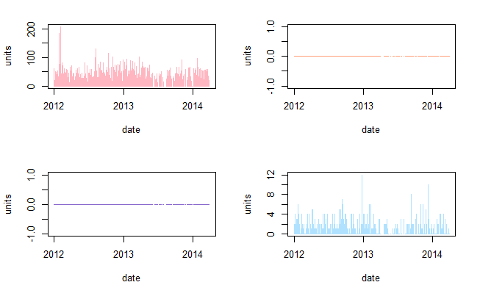
Figure 3.1 Sales data (four example items)
Then, with the data set, I have used 14 models in total that includes: linear regression, ridge regression, the LASSO, PCA, PLS, best subset selection, polynomial regression, spline, gams, k-nearest neighbors regression (KNN), regression tree, boosting, bagging and random forests. All detailed codes are included in Appendix. The data of units along with date is displayed in Figure 3.2. We split the data from day of April 1st of year 2013, perior to that date as training set and others as test set.
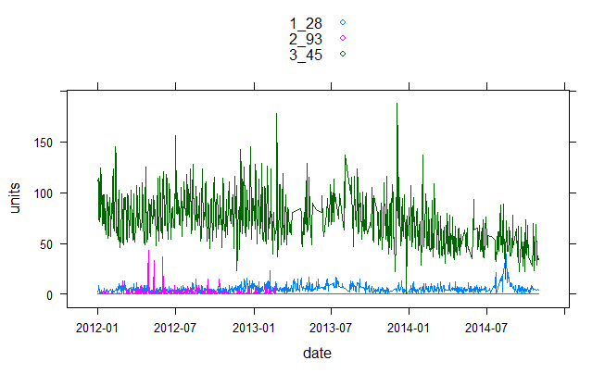
Figure 3.2 Sales of three example items
- Linear regression
Linear regression is the very basic approach for predicting quantitative response. Therefore, it is my first attempted model. When using linear regression model for predicting sales of each product, most of the models have a very low adjusted R². Inspecting diagnosis figures of most product, there seems a non-linear relationship between sales and predictors. Moreover, residuals show strong heteroscedasticity. As the data is time series, correlation of residuals is highly correlated (ACF is shown in Figure 3.3).
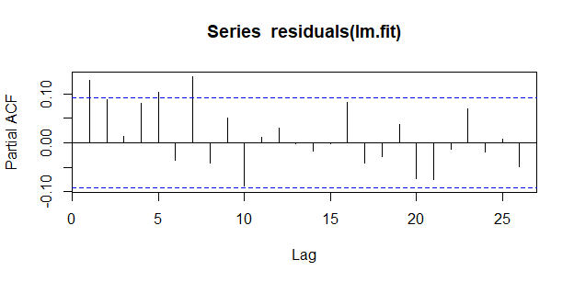
Figure 3.3 Autocorrelation of residuals of item 93

I used root mean squared logarithmic error (RMSLE) to evaluate their accuracy. In this case, linear regression gets 0.9588 error rate. Figure 3.4 shows comparison of actual sales variation and prediction by linear models, and we can see that linear regression can hardly predict extreme variation and overall trend of sales.
(2) Best subset selection
I used best subset selection on each item. As there are too many items, it is hard to investigate which are the best candidate predictors for each item, I used cross validation to select the best subset automatically and then use them to do prediction. The test error of best subset selection method in this case is 0.9558 which is little lower than linear regression model. This also indicate that using different predictors in linear regression does significantly improve the result. Similarly, it failed to capture the variation trend and extreme points of sales in some particular situations. The detailed results are displayed in Appendix.

Figure 3.4 comparison of actual sales (left) and predicted sales(right) by linear regression for test set
(3) Shrinkage methods and dimension reduction methods
I used the best-known two shrinkage regression methods: ridge regression and the lasso. The tuning parameter λ, which is the regularization strength, is selected through cross-validation. In this case, the lasso and ridge regression achieved test error of 0.7471 and 0.7505, respectively, which are lower than LR. The predicted sales along with date are shown in Figure 3.5. For example, for item 28 in store 1 and item 45 in store 3, the shrinkage models seem to perform similarly as linear regression, but for item 93 in store 2 which has no sales during the test period, the estimated sales are zero which outperforms than linear regression.
Moreover, the dimension reduction methods of PCA and PLS are applied. PCA and PLS achieved test error of 0.9361 and 0.9423 which are lower than linear regression but higher than shrinkage methods. I think because our extracted predictors contain different aspects of information, and there are only nine predictors without much collinearity, PCA and PLS do not sufficiently improve accuracy of prediction, as we can also see from the figure 3.5.
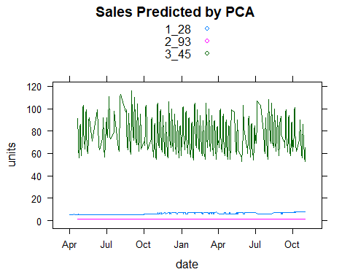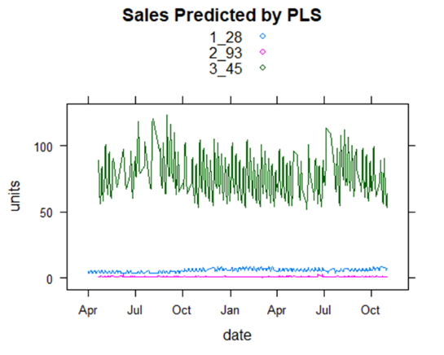
Figure 3.5 Sales along with date predicted by ridge regression, the lasso, PCA and PLS
(4) Extension of linear models
Previous linear models have limited prediction power due to the simplicity of the model and high complexity of the data. Considering the high non-linearity of sales, extension of linear models - polynomial regression, spline and GAMs are applied on the data set in order to get a better prediction accuracy. Through cross-validation, polynomial regression degree is chosen as 10, which will lead to high non-linearity. However, polynomial regression and spline in this case both failed to fit the data on the training set. GAMs also achieved high error on the test set. The potential reason could be because we use half of the data to fit the model and the other half for prediction, therefore the training data set is not enough for fitting a good model. Alternatively, I tried using more data (split data from 2014-04-01, and then 2014-06-01,2014-08-01), to fit the polynomial regression and splines. This approach worked, but the test error was very jumpy.
(5) K-nearest neighbors regression (KNN) and tree-based method
Compared to above methods which are global methods, KNN and tree-based methods are local method. They don’t depend on assumptions about data. In this case, test error of KNN (k=6) is 0.4082 which is much more accurate than above models. As seen in the left of Figure 3.6, sales predicted by KNN along with date shows that KNN seems to catch both extreme conditions and change trend of sales for all three-example items. Regression tree achieved test error of 0.5335 which is much better than linear models. Bagging is doing extremely good on the test set that the test error is 0.3586 which is more accurate than KNN. As shown on the right of Figure 3.5 that the sales along time is very similar to actual data, it follows both trend and extreme situations very well. The results of random forest and boosting on the test set is good but not as good as bagging. But we don’t know whether the bagging performance is just an conccidence on the test set.

Figure 3.6 Sales predicted by KNN and bagging

(7) Comparisons of methods through cross-validation
Finally, I used 5-fold cross-validation on the whole data set to compare prediction accuracy of all the models. As in above methods we are using training set to fit or train models and using test set to validate the method, the performance comparison of methods are not stable. To have a more reliable estimation of test errors, cross-validation(CV) of is performed. Figure 3.7 and Table 3.1 show comparison of methods cv test error. We can see that the results have contradictions with result of a single test set. Shrinkage methods have higher error rate than linear models, dimension reduction methods also do not improve accuracy of linear regression in this case. Polynomial regression, GAMs, an Spline are much more accurate than linear regression, especial polynomial regression which has a very low test error. However, as the data set is not large enough and the controvery results with single test set, I’m afraid of the exist of overfitting. KNN and bagging also have very good accuracy in this case. However, random forest is worse even than linear regression, for some reason the random forest is not suitable for this data set or problem.
Table 3.1 CV errors of different methods
 | Methods | CV error (Root mean squared logarithmic error)
1 | Linear regression | 0.6032775
2 | KNN | 0.5065676
3 | Ridge regression | 0.6329552
4 | The Lasso | 0.6333800
5 | PCA | 0.6182432
6 | PLS | 0.6098334
7 | Best subset selection | 0.6071238
8 | Polynomial regression (degree 10) | 0.4740148
9 | Spline | 0.5684200
10 | GAMs | 0.5556445
11 | Regression Tree | 0.5740989
12 | Bagging | 0.5255336
13 | Random Forests | 0.6199524
14 | Boosting | 0.5724622

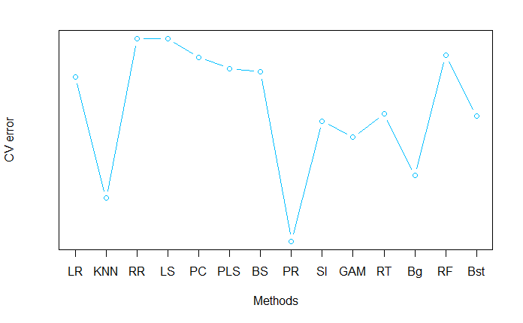
Figure 3.7 CV error comparison of methods

4. Summary of results
Our analysis indicates that K-Nearest Neighbors, Bagging, and Random Forests are consistently the best methods for predicting units across all 111 items. The most important predictors tend to include tmax, stnpressure, and preciptotal, though these will vary across different items and with different preprocessing protocols.
Multiple interesting correlations were observed in the data. Sales of products tended to increase during weekend but tended to decrease during federal holidays. Sales varied across items on hot and cold days, as well as with days with storms and other weather events. Transforming continuous predictors into categorical ones tended to increase the accuracy of the model and showed strong correlations.
In general, the model accuracy was not very robust and tended to vary from item to item. Some items were extremely easy to predict; some were extremely difficult. Some items contained no nonzero unit values and thus were predicted perfectly. Depending on the variable, clustering was able to separate items into two or three groups; however, without knowledge of the identity of the item in question, it is hard to make much use of this information.

5. Conclusions and Takeaway
Based on the results, I have following three aspects of conclusions:
- Model selection based on the trade-off between bias-variance.
Because our data are highly flexible and non-linear, it seems that linear models are not doing good. And as there are not so many predictors, shrinkage and dimension reduction methods are not improving the results. In contrast, methods of KNN, trees and non-linear model outperforms. According to comparison of methods derived from cross-validation, polynomial regression with 10 degree has the best prediction accuracy. However, polynomial regression in this case are adding extra predictors by raising the power to as high as 10, which is highly complex. Therefore, it has high variance and impossible to interpret it convincingly. In addition, it does terribly on a single test set while also requiring a lot of training data. Therefore, we believe that it must overfit on our training set and we would not prefer polynomial regression. Concerning accuracy, KNN and bagging also have very accurate methods. Bagging which is bootstrap aggregation of tress has a low variance. The predicted sales by bagging has a very similar trend change and variation curve with the actual one. KNN, like bagging, but onlying using k nerest points to estimate the predicted points value. They both don’t rely on assumption of data distributions. In this case, we can roughly inteprete them as: using past several days sales, and when the day is weekend, holiday or have weather events we can additionally referring to sales of last weekend, holiday or same weather events days. Therefore, in the process of predicting sales, concerning trade-off between bias and variance of models, I prefer KNN and bagging.
- Analysis of correlation between sales and its predictors
At the same time, we are interested in what factors, especially weather conditions, will influence sales. The F-test in linear regression gives us a good inference in this case. It needs to be note here, there are no collinearity in the data, so we can trust coefficients in the results. The very low p-value correspond to each item indicates clear evidence of a relationship between our predictors and item sales. By examining the p-value associated with each predictor’s t-statistic, we can have a sense of which factor contribute to sales. F-test results suggest that among 111 kinds of items 50 kinds of items are related with cold, hot or storm weather conditions (the detailed item ids and related weather events are in Appendix).
In addition, beside weather predictors, we investigated other predictors such as weekend, holiday and black Friday. The same as we expect, many of item sales are related to weekend, by investigating estimated coefficients and their standard error, we can further decide how large and the direction of the effect of each predictor on sales. Weekends has a non-negative confidence interval, which indicates those items sales will increase on weekend. Some kinds of product also sell more during holiday. However, some other items sales will decrease on holidays. There are two possible reasons that people will go traveling instead of shopping or because of shorter open time of stores during holidays. As we only have less than three years’ data and the data is only a small part of all the products in Walmart stores, black holiday is not showing great correlations with sales in analysis. The detailed conclusive correlation between sales and predictors are shown in Appendix.
- Implication of results in inventory management
This project aims at helping inventory managers or marketing managers to make a wise and effective decision to avoid out-of-stock or overstock situations. According to the predication and inference about the correlation between sales and its predictors, we can provide several implications for people who may be interested in sales forecasting or may in need of inventory management.
Having a good estimation of sales can help people minimize stock in stores while avoiding out of stock situations at the same time. As we know that maintaining appropriate stock level can substantially influence the cost of a company such as their cost of capital, warehouse cost and shortage cost. Therefore, a precise forecast of sales can lead to significant improvements in company costs.
In this project, we made predictions for a given period of sales based on the information of history sales and weather condition. We can’t contro weather, but with weather forecasting we can response early to prepare for sales change especially for those weather-sensitive items. For example, when there is a forecast of storm, replenishment managers should be prepared for a sales increase of item 5, 8, 32, 36, 29, 46, … and planning for a sales decrease of item 37, 45, 48, 58, 77 by adjusted replenish stock process.
However, in this project we only considered about limited factors: holiday, black Friday, weekend and weather. More information about location of the store, opening time of the store and marketing strategy may help in more accurate prediction. For example, with location of the stores, we can even estimate sales according to population size, however, that exceed study of this project. In this project, if we know location of those stores and weather stations, we are also to estimate those missing values in the weather station with adjacent weather stations.

