**Q.4**

**1. answer: $s=\left\{s=G,s=U\right\}.$**

A=t(s(s), G, s, p, t(k), s)

B=t(s(G), g, s, p, t(k), U)







$s=\left\{s\left(s\right)=s\left(G\right)→s=G\right\}⇒$ $\left\{{A°s=(s(s), s, s, p, t(k), s) \atop B°c=(s(s), s, s, p, t(k),U)}\right.$

$s=\left\{s=G,s=U\right\}⇒$ $\left\{{A°s=(s(s), s, s, p, t(k), s) \atop B°c=(s(s), s, s, p, t(k),s)}\right.$

**2**.

A = g (l, M, g, G, U, g, v(m))

B= g (l, v(u), g, v(M), v(G), g, v(M))

$s=\left\{M=v(U)\right\} ⇒ \left\{{A°s = (l, v(U), g, G, U, g, v(v(U)) \atop B°c = (l, v(u), g, v(v(U)), v(G), g, v(v(U)))}\right.$

$s=\left\{\begin{aligned}M=v\left(U\right) \\ G=v\left(M\right)→G=v\left(v\left(U\right)\right)\end{aligned}\right\} ⇒$

$$⇒ \left\{{A°s = (l, v(U), g, v(v\left(U\right)), U, g, v(v(U)) \atop B°c = (l, v(u), g, v(v(U)), v(v(v\left(U\right))), g, v(v(U)))}\right.$$

* $s=\left\{\begin{aligned}M=v\left(U\right) \\ G=v\left(M\right)→G=v\left(v\left(U\right)\right) \\ U=v\left(v\left(v\left(U\right)\right)\right)\end{aligned}\right\} ⇒$ ERROR – infinite loop.

3.

A= m (M, N)

B=n (M, N)

* $s=\left\{\begin{aligned}m=n \\ M_1=M_2 \\ N_1=N_2\end{aligned}\right\} ⇒$ Occurs check Error - Circular connections.

4.

A=p ([v | [V | VV]]

B= p ([[v | V] | VV])

$s=\left\{v=\left[v \right|V] \right\} ⇒ Occurs check Error - Circular connections.$

5.

A= g([T])

B=g(T)

$$s=\left\{\left[T\right]=T\right\} ⇒ Occurs check Error - Circular connections.$$

**Q.5**

**a.**

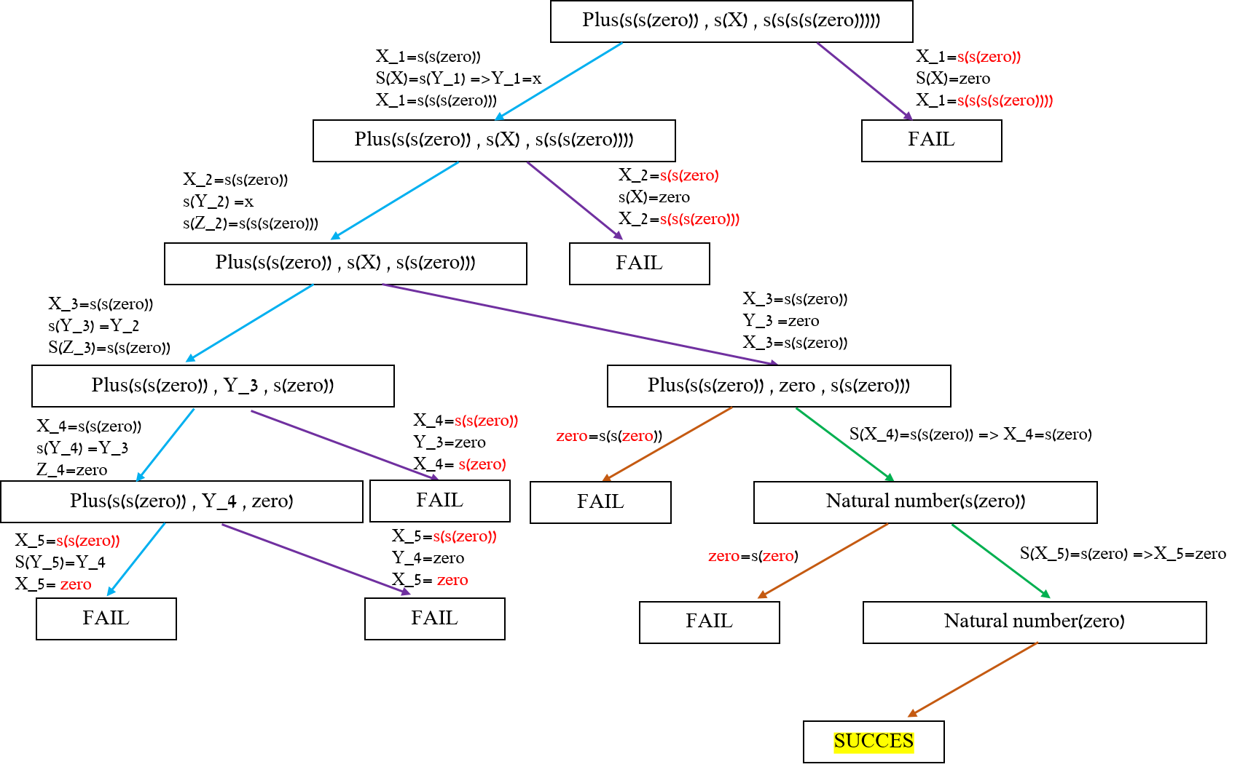

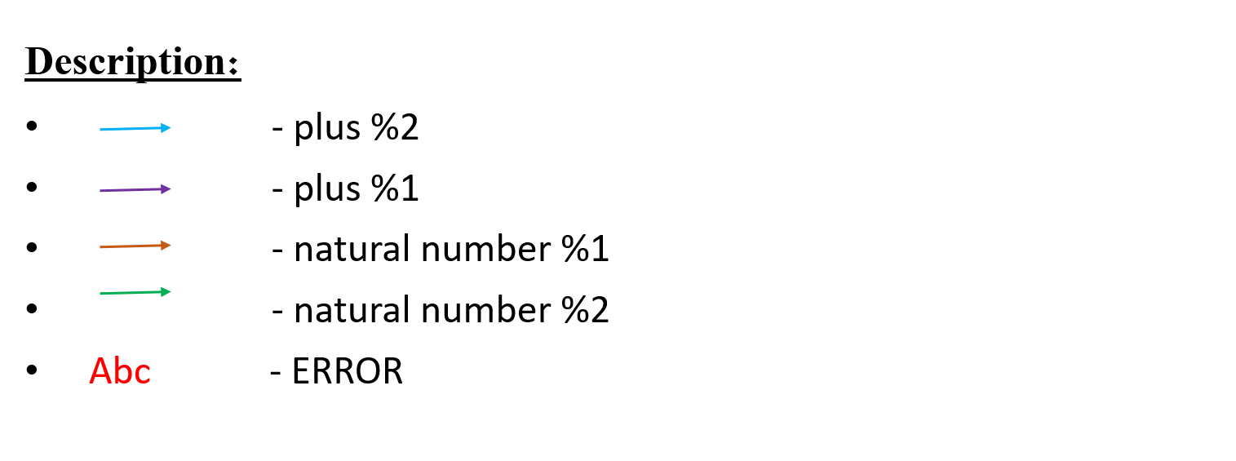

**b.** answer: x=s(zero)

**c.** The tree is a Success-tree, because there is a success path and a success leaf.

**d.** The proof tree in finite, because all his branches are finite (⬄ all paths are

finite).