Lab Exercise Primitive Data Types

- What does this program segment display?

double area = 3.5;
System.out.print("area");
System.out.print(area);

- What is the value of each variable after the computer executes this program segment?

int x = 0, y = 1, z = 2;
x = x++;
y = --y;
z = ++x + 4;

- For each of the following expressions, insert parentheses to show how Java evaluates the expression.
  - v = 4 + 3 / 2;
  - j = 6 – 4.2 * 3 % 2;
  - y = 7 + 6 / 2.1;
  - s = e = 18;

- Consider the Java code below. The code calculates the average of three integers but the output received is incorrect.
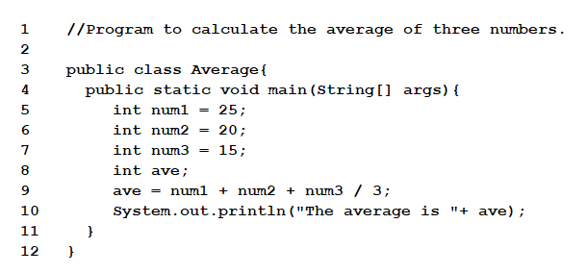i. What is the value of the variable ave after the above code is executed, and what should be the value (according to on-paper calculation)?

ii. What is the type of error contained in the code?

- Rewrite each of the following expressions with a simple assignment operator
  - x += 4;
  - y -= 2;
  - r %= 5;
  - z *= 3 + 2;
  - g /= h – 2;
  - ++count;
  - count--;

- To declare a constant MAX_LENGTH inside a method with value 99.98, you write _______________________

- What is x after the following statements?

int x = 2;
int y = 1;
x *= y + 1;

- The algorithm below shows the steps for solving the problem of calculating body mass index (BMI). Draw the trace table on this algorithm.

- Start
- WeightKG= 53
- HeightCM = 155
- BMI = WeightKG/(HeightCM x HeightCM)
- Print BMI
- End

- What is the output of the following program?

public class Primitive {
public static void main(String[] args) {
double num1 = 0;
double num2 = 4.0;
int num3 = 10;
int num4 = 2;

num1 = num2++ * num3;
num2 += num3 % num4;
num3 = num3 - num4--;
num4 = (int)num1 + (int)num2 + num3 + num4;

System.out.println (num1);
System.out.println (num2);
System.out.println (num3);
System.out.println (num4);
}
}

- What is the output of the following program?

public class Primitive {
public static void main(String[] args) {
double num1 = 0;
double num2 = 4.0;
int num3 = 10;
int num4 = 2;

System.out.println (num1 < num2 && num3 >= num4);
System.out.println (num2 > num3 || num1 < num4);
System.out.println (num3 > num1 || num4 < num3);
System.out.println (!(num4 < num1) &&
!(num2 > num3));

}
}

