Undergraduate AI Capstone NYCU Spr2024 Project #2
Team6 110550170戚維凌110550034孫承瑞110550175鄭栩安
I. Methods
1. Minimax
Minimax is a classic decision-making algorithm used in game theory, particularly in two-player deterministic games with perfect information. The goal is to determine the worst possible outcome for each alternative, and select the one with the best “worst possible outcome”.
However, in Battle Sheep, it was hard for us to find a suitable evaluation function before the game is terminal. Also, the variant rules seemed to be difficult to implement with Minimax. Therefore, we didn’t choose it.
2. Monte Carlo Tree Search (MCTS)
MCTS is a heuristic search algorithm famous for its ability to handle large search spaces. It focuses on the more promising areas, without needing specific knowledge or evaluation functions, so it’s versatile and applicable to various domains.
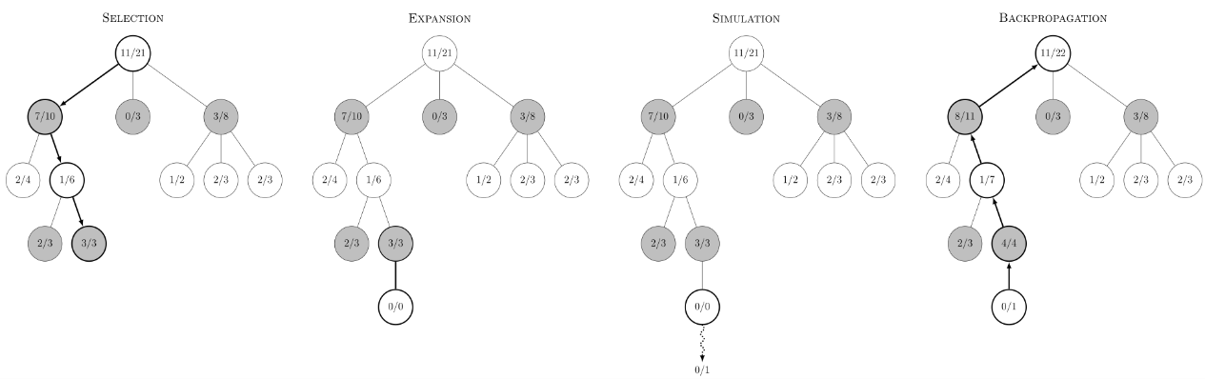
Fig.1. The steps of MCTS.
In Fig. 1., there are four steps in a simulation of MCTS:
- Selection:
Starting from the root node of the search tree, the algorithm traverses down the tree according to a selection policy until reaching a leaf node.
- Expansion:
Once a leaf node is reached, the algorithm expands it by adding one or more child nodes which representing legal moves from the current game state.
- Rollout (Simulation):
The algorithm chooses a newly added child node and completes a rollout from it by simply choosing random moves until the game is over.

- Backpropagation:
After the rollout, the algorithm uses the result to update the value of the nodes along the selection path.
Because of its adaptive nature, we implemented MCTS as our main algorithm.
3. AlphaZero
AlphaZero is an advanced artificial intelligence algorithm developed by DeepMind. It's famous for mastering games like chess, Go, and shogi without human knowledge. AlphaZero consists of a deep neural network that learns to evaluate game states and predict results, combined with the MCTS algorithm for searching and selecting next moves. The network is trained through self-play, where it plays against itself and learns from the outcomes.
We tried to train our own model and combine it with MCTS; however, we failed due to the time limit and the complex details.
II. Implementation Details
Agent 1:
This agent is the basic form which has 4 players, 16 sheep per player and 64-cell playing field within a 12x12 square.
We implemented multi-threaded MCTS to achieve parallelization. In Fig. 2., there are different types of parallelization of MCTS, and we chose the “root parallelization” since it is effective and easy to implement. It builds multiple MCTS trees in parallel, with one thread per tree. Since the threads don’t share information with each other, this method doesn’t require any mutex.
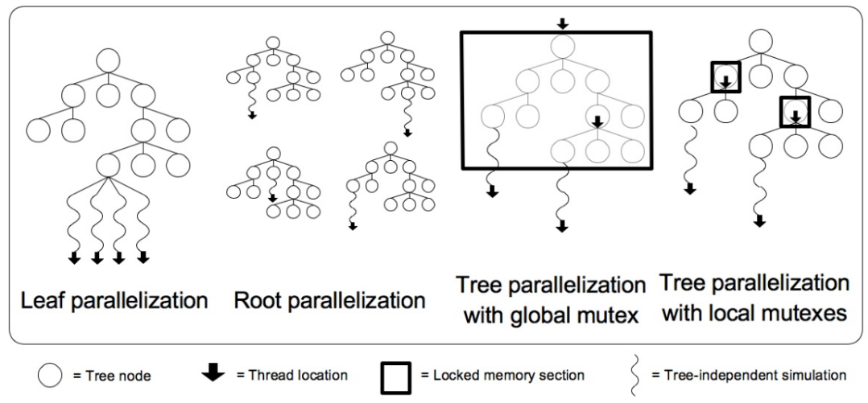
Fig. 2. Four types of parallelization of MCTS
In the selection step of MCTS, we use UCT (Upper Confidence Bounds to Trees) formula as the selection policy because it considers both the estimated value and the uncertainty of the node to balance between exploration and exploitation.
$$\frac{W_{i}}{n_{i}}+c\sqrt{\frac{\ln{N_{i}}}{n_{i}}}$$ | $W_{i}$ is the total score for the node considered after the $i_{th}$ move,  $n_{i}$ is the number of simulations for the node considered after the $i_{th}$ move,  $N_{i}$ is the total number of simulations for the parent node after the $i_{th}$ move,  and $c$ is the exploration parameter, theoretically equal to $\sqrt{2}$.
Equation.1. The UCT formula.

III. Experiments
In this section, we indicate the experiments that include comparison with three aspects in four games,
- Parallel and non-parallel
- The agent being a first player and being a last player
- Different strategies
1. Game1
- Preprocessing:
I loaded all the frames and extracted optical flow as features by the Farneback method using OpenCV.
- Training:
I trained the SVM model using Scikit-learn with linear kernel and C = 0.1.
- Evaluation:
I sum the confusion matrices of 5 folds and calculated the average accuracy score.
IV. Discussion
- Based on your experiments, are the results and observed behaviors what you expect?
Yes, the experiment turned out as expected.
VI. References
- LiaoWC / MCTS (Monte Carlo Tree Search) 演算法, https://liaowc.github.io/blog/mcts-monte-carlo-tree-search/
- David Silver, Julian Schrittwieser, Karen Simonyan / Mastering the Game of Go without Human Knowledge, https://discovery.ucl.ac.uk/id/eprint/10045895/1/agz_unformatted_nature.pdf
- Fig.1. Source: By Rmoss92 - Own work, CC BY-SA 4.0, https://commons.wikimedia.org/w/index.php?curid=88889583

