## Part2 Set object

1.Jobs to be done

1)Improve personal brand

2)Strengthen credibility as a developer and designer

3)Create online repository for my body of work

4)Connet with industry experts

5)Connet with potential freelance clients

6)Drive search results to intentional content

2.Solutions

1)Build a robust website - Create well written copywrite, Video and photography content

2)Prove skillset - Use DSLR photography, photoshop, html, scss, Javascript, React, MongoDB, and Node.js.

3)Create Contact Form - send email with nodemailer or like service.

3.Target Audiences

1)Small Business Owners: Owned successful business for 3+ years. Experimented with social, digital, and traditional marketing. Late 30`s to early 50`s.

2)Web Development Industry Experts: Influencer, Mid-to-senior position in career, College educated, Mid 20`s to late 30`s.

3)Head hunter

4)HR

4.Sitemap

Home

-Skills

-Frontend

-Backend

-Data

-Work history

-Current Employer

-IGT

-Run

-Projects

-About Me

-College

-After College

-Self Taught Journey

-Current Day

-Contact

-Short CTA Section

-Email Contact Form

-Youtube(Not for me)

5.User Journey

1)Considering: hiring for a speaking event, build a website

2)At work desk 8am-5pm, looking to find a front-end developer.

3)On mobile, out to lunch, or on commute home.

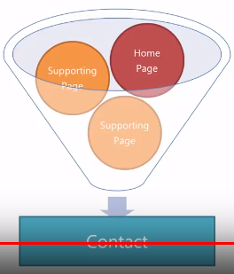

Homepage -> Work history -> Contacts

Homepage -> Skills -> Projects -> Contact

## Part3 Research and Discovery

## Part4 Wireframing