|  |
| --- |
|  |
| Bonus Project Report |
| CSCC11 Bonus |
|  |
| **Zhiqian Chen**  **Lixiang Wei** |
| **2016/12/17** |

|  |
| --- |
|  |

# [Titanic: Machine Learning from Disaster](https://www.google.com/url?q=https://www.kaggle.com/c/titanic&sa=D&ust=1481925662040000&usg=AFQjCNG-PxuZbARX2CQMzXhfx_3IIF8Kvw)

## Problem description

# Viasulize Data

PassengerId Survived Pclass Age SibSp Parch Fare

count 891.000000 891.000000 891.000000 714.000000 891.000000

mean 446.000000 0.383838 2.308642 29.699118 0.523008

std 257.353842 0.486592 0.836071 14.526497 1.102743

min 1.000000 0.000000 1.000000 0.420000 0.000000

25% 223.500000 0.000000 2.000000 NaN 0.000000

50% 446.000000 0.000000 3.000000 NaN 0.000000

75% 668.500000 1.000000 3.000000 NaN 1.000000

max 891.000000 1.000000 3.000000 80.000000 8.000000

Parch Fare

count 891.000000 891.000000

mean 0.381594 32.204208

std 0.806057 49.693429

min 0.000000 0.000000

25% 0.000000 7.910400

50% 0.000000 14.454200

75% 0.000000 31.000000

max 6.000000 512.329200

# Class abd Survived rate

Pclass Survived

1 0.629630

2 0.472826

3 0.242363

# Sex and Survived rate

Sex Survived

0 female 0.742038

1 male 0.188908

# Family Size and Survived Rate

FamilySize Survived

1 0.303538

2 0.552795

3 0.578431

4 0.724138

5 0.200000

6 0.136364

7 0.333333

8 0.000000

11 0.000000

# Aloneness and Survival Rate

IsAlone Survived

0 0.505650

1 0.303538

# Fare and Survived rate

CategoricalFare Survived

0 [0, 7.91] 0.197309

1 (7.91, 14.454] 0.303571

2 (14.454, 31] 0.454955

3 (31, 512.329] 0.581081

# Age and Survived Rate

CategoricalAge Survived

0 (-0.08, 16] 0.527273

1 (16, 32] 0.351648

2 (32, 48] 0.378049   
3 (48, 64] 0.434783

4 (64, 80] 0.090909

From different relationships, we can conclude the Class can affect survival rate, and female has higher survived rate than male. Here we don’t consider title and first name, since if there are more female than male survived, the majority of name will be female’s, then looking for the relationship between name and survived rate doesn’t make sense. Also, the distribution of fare resemble to class, since better classes will match higher fare.

## Baseline Method

R Code:

options(warn=-1)

library(ggplot2)

library(nnet)

library(ROCR)

train <- read.csv("../input/train.csv", header=TRUE, stringsAsFactors = FALSE)

# Set Survived, Pclass, Sex, Embarked as factors

for(i in c(2,3,5, 12)){

train[,i] <- as.factor(train[,i])

}

#Brute NA handling... Deletion of all rows with a NA

#It mainly concerns Age variable

for (i in 1:dim(train)[2])

{

train <- train[!is.na(train[,i]),]

}

nn <- nnet(Survived ~ Age + Fare + Embarked+ SibSp + Parch, train, size = 100)

nn.prediction <- predict(nn, newdata = train)

pred <- prediction(nn.prediction, train$Survived)

tpr <- unlist(performance(pred, "tpr")@y.values)

fpr <- unlist(performance(pred, "fpr")@y.values)

plot(fpr, tpr, main="Auroc Curve", xlab="False Positive Rare", ylab="True Positive Rate", lt=1)

train$nn.error = (train$Survived != ifelse(nn.prediction >.4,1,0))

evels(train$Survived) <- c("Did not Survive", "Survived")

ggplot(train, aes(x=Fare, y=Pclass, colour=nn.error)) +

geom_point(shape=1, position = "jitter") + facet_grid(Sex~Survived) +

scale_colour_manual(values=c("green", "red")) +

ggtitle("Presentation of the performance of the model \n red dot=ERROR") +

ylab("Passenger Class") +

xlab("Fare")

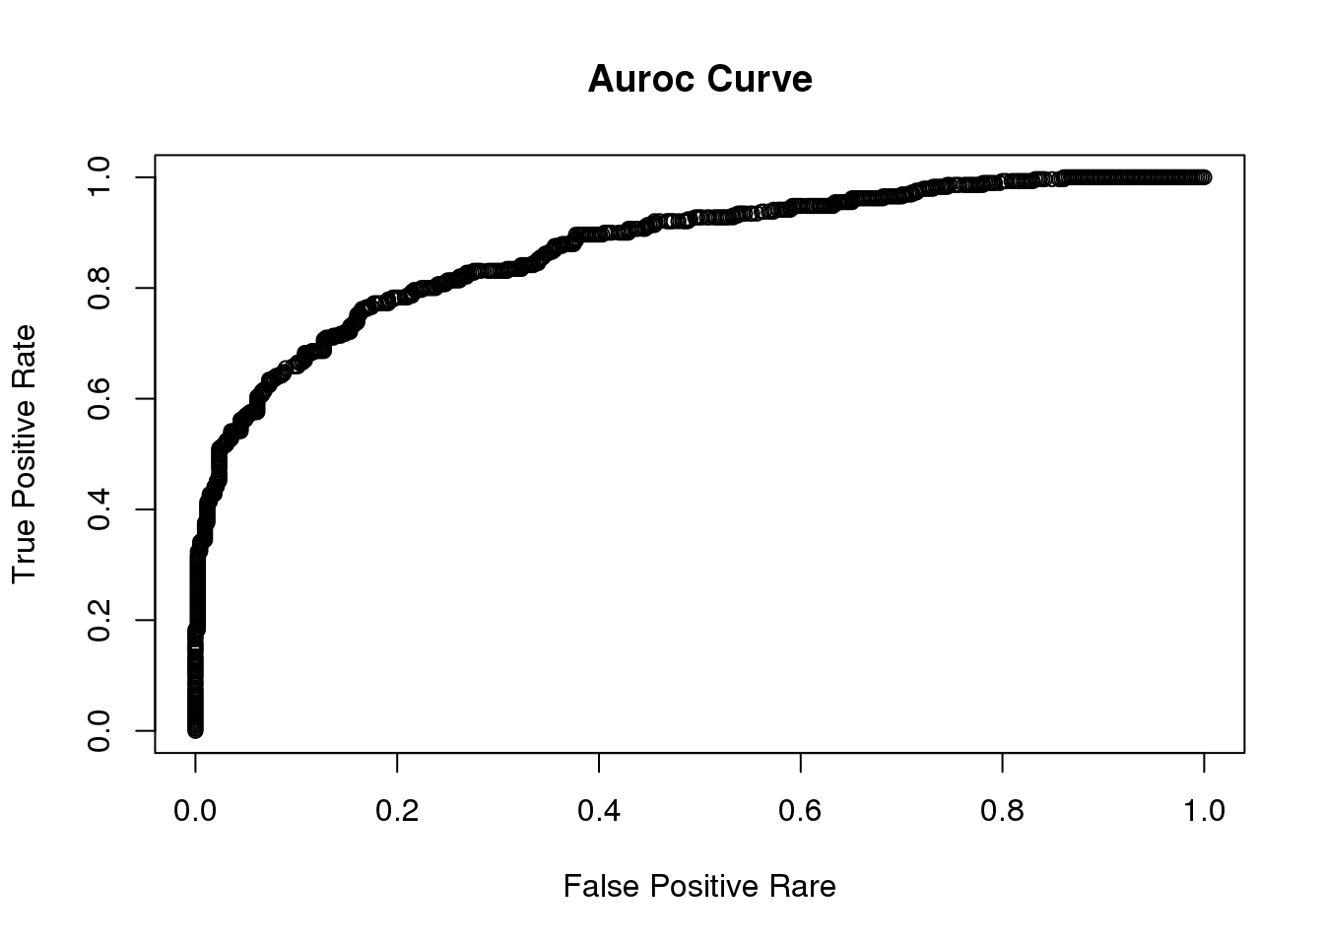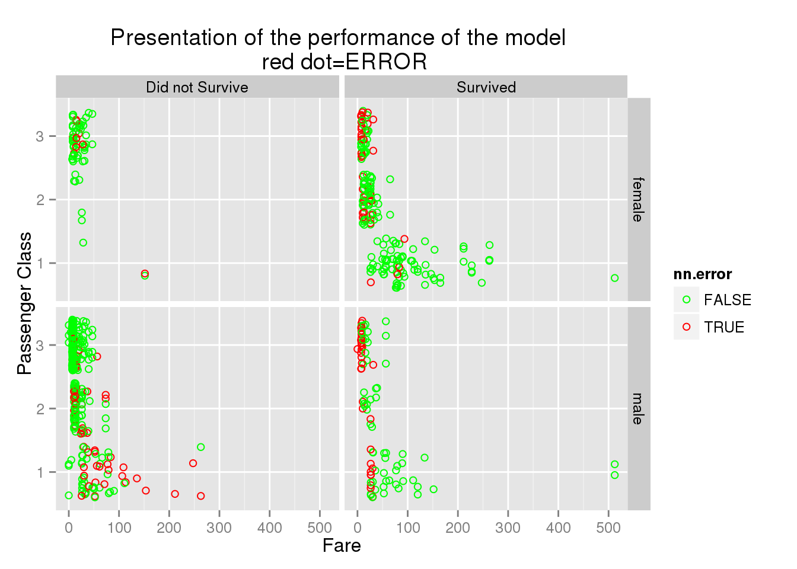

**Advanced baseline from the Kaggle community and Improvement**

Python code:

# Imports

# pandas

import pandas as pd

from pandas import Series,DataFrame

# numpy, matplotlib, seaborn

import numpy as np

import matplotlib.pyplot as plt

import seaborn as sns

#Print you can execute arbitrary python code

train = pd.read_csv("../input/train.csv", dtype={"Age": np.float64}, )

test = pd.read_csv("../input/test.csv", dtype={"Age": np.float64}, )

#Print to standard output, and see the results in the "log" section below after running your script

print("\n\nTop of the training data:")

print(train.head())

print("\n\nSummary statistics of training data")

print(train.describe())

#Any files you save will be available in the output tab below

train.to_csv('copy_of_the_training_data.csv', index=False)

# Check the relation between survived and CLass

print (train[['Pclass', 'Survived']].groupby(['Pclass'], as_index=False).mean())

# Check the relation between survived and Sex

print(train[['Sex', 'Survived']].groupby(['Sex'], as_index=False).mean())

full_data = [train, test]

for dataset in full_data:

dataset['FamilySize'] = dataset['SibSp'] + dataset['Parch'] + 1

print (train[['FamilySize', 'Survived']].groupby(['FamilySize'], as_index=False).mean())

for dataset in full_data:

dataset['IsAlone'] = 0

dataset.loc[dataset['FamilySize'] == 1, 'IsAlone'] = 1

print (train[['IsAlone', 'Survived']].groupby(['IsAlone'], as_index=False).mean())

#Fare also has some missing value and we will replace it with the median. then we categorize it into 4 ranges

# relation between fare and survived rate

for dataset in full_data:

dataset['Fare'] = dataset['Fare'].fillna(train['Fare'].median())

train['CategoricalFare'] = pd.qcut(train['Fare'], 4)

print (train[['CategoricalFare', 'Survived']].groupby(['CategoricalFare'], as_index=False).mean())

# relation between age and survived

for dataset in full_data:

age_avg = dataset['Age'].mean()

age_std = dataset['Age'].std()

age_null_count = dataset['Age'].isnull().sum()

# Fill out null value with randon generated age

age_null_random_list = np.random.randint(age_avg - age_std, age_avg + age_std, size=age_null_count)

dataset['Age'][np.isnan(dataset['Age'])] = age_null_random_list

dataset['Age'] = dataset['Age'].astype(int)

train['CategoricalAge'] = pd.cut(train['Age'], 5)

print (train[['CategoricalAge', 'Survived']].groupby(['CategoricalAge'], as_index=False).mean())

# Data Cleaning

for dataset in full_data:

# Mapping Sex

dataset['Sex'] = dataset['Sex'].map( {'female': 0, 'male': 1} ).astype(int)

# Mapping titles

title_mapping = {"Mr": 1, "Miss": 2, "Mrs": 3, "Master": 4, "Rare": 5}

dataset['Title'] = dataset['Title'].map(title_mapping)

dataset['Title'] = dataset['Title'].fillna(0)

# Mapping Embarked

dataset['Embarked'] = dataset['Embarked'].map( {'S': 0, 'C': 1, 'Q': 2} ).astype(int)

# Mapping Fare

dataset.loc[ dataset['Fare'] <= 7.91, 'Fare'] = 0

dataset.loc[(dataset['Fare'] > 7.91) & (dataset['Fare'] <= 14.454), 'Fare'] = 1

dataset.loc[(dataset['Fare'] > 14.454) & (dataset['Fare'] <= 31), 'Fare'] = 2

dataset.loc[ dataset['Fare'] > 31, 'Fare'] = 3

dataset['Fare'] = dataset['Fare'].astype(int)

# Mapping Age

dataset.loc[ dataset['Age'] <= 16, 'Age'] = 0

dataset.loc[(dataset['Age'] > 16) & (dataset['Age'] <= 32), 'Age'] = 1

dataset.loc[(dataset['Age'] > 32) & (dataset['Age'] <= 48), 'Age'] = 2

dataset.loc[(dataset['Age'] > 48) & (dataset['Age'] <= 64), 'Age'] = 3

dataset.loc[ dataset['Age'] > 64, 'Age'] = 4

# Feature Selection

drop_elements = ['PassengerId', 'Name', 'Ticket', 'Cabin', 'SibSp','Parch', 'FamilySize']

train = train.drop(drop_elements, axis = 1)

train = train.drop(['CategoricalAge', 'CategoricalFare'], axis = 1)

test = test.drop(drop_elements, axis = 1)

print (train.head(10))

train = train.values

test = test.values

# [House Prices: Advanced Regression Techniques](https://www.google.com/url?q=https://www.kaggle.com/c/house-prices-advanced-regression-techniques&sa=D&ust=1481925662040000&usg=AFQjCNHEurVGckQoRdOlbYXX9xVXH2ZwBw)

## Problem description

Everyone wants a dreamed house, but different levels of houses have various prices. Housing prices are determined by multiple factors including the environmental condition, location, neighborhood and so on. Within the dataset, there are 79 explanatory variables can be used to predict the price of each house in Ames, Iowa.

The following is a simple description provided for these 79 variables:

MSSubClass: Identifies the type of dwelling involved in the sale.

MSZoning: Identifies the general zoning classification of the sale.

LotFrontage: Linear feet of street connected to property

LotArea: Lot size in square feet

Street: Type of road access to property

Alley: Type of alley access to property

LotShape: General shape of property

LandContour: Flatness of the property

Utilities: Type of utilities available

LotConfig: Lot configuration

LandSlope: Slope of property

Neighborhood: Physical locations within Ames city limits

Condition1: Proximity to various conditions

Condition2: Proximity to various conditions (if more than one is present)

BldgType: Type of dwelling

HouseStyle: Style of dwelling

OverallQual: Rates the overall material and finish of the house

OverallCond: Rates the overall condition of the house

YearBuilt: Original construction date

YearRemodAdd: Remodel date (same as construction date if no remodeling or additions)

RoofStyle: Type of roof

RoofMatl: Roof material

Exterior1st: Exterior covering on house

Exterior2nd: Exterior covering on house (if more than one material)

MasVnrType: Masonry veneer type

MasVnrArea: Masonry veneer area in square feet

ExterQual: Evaluates the quality of the material on the exterior

ExterCond: Evaluates the present condition of the material on the exterior

Foundation: Type of foundation

BsmtQual: Evaluates the height of the basement

BsmtCond: Evaluates the general condition of the basement

BsmtExposure: Refers to walkout or garden level walls

BsmtFinType1: Rating of basement finished area

BsmtFinSF1: Type 1 finished square feet

BsmtFinType2: Rating of basement finished area (if multiple types)

BsmtFinSF2: Type 2 finished square feet

BsmtUnfSF: Unfinished square feet of basement area

TotalBsmtSF: Total square feet of basement area

Heating: Type of heating

HeatingQC: Heating quality and condition

CentralAir: Central air conditioning

Electrical: Electrical system

1stFlrSF: First Floor square feet

2ndFlrSF: Second floor square feet

LowQualFinSF: Low quality finished square feet (all floors)

GrLivArea: Above grade (ground) living area square feet

BsmtFullBath: Basement full bathrooms

BsmtHalfBath: Basement half bathrooms

FullBath: Full bathrooms above grade

HalfBath: Half baths above grade

Bedroom: Bedrooms above grade (does NOT include basement bedrooms)

Kitchen: Kitchens above grade

KitchenQual: Kitchen quality

TotRmsAbvGrd: Total rooms above grade (does not include bathrooms)

Functional: Home functionality (Assume typical unless deductions are warranted)

Fireplaces: Number of fireplaces

FireplaceQu: Fireplace quality

GarageType: Garage location

GarageYrBlt: Year garage was built

GarageFinish: Interior finish of the garage

GarageCars: Size of garage in car capacity

GarageArea: Size of garage in square feet

GarageQual: Garage quality

GarageCond: Garage condition

PavedDrive: Paved driveway

WoodDeckSF: Wood deck area in square feet

OpenPorchSF: Open porch area in square feet

EnclosedPorch: Enclosed porch area in square feet

3SsnPorch: Three season porch area in square feet

ScreenPorch: Screen porch area in square feet

PoolArea: Pool area in square feet

PoolQC: Pool quality

Fence: Fence quality

MiscFeature: Miscellaneous feature not covered in other categories

MiscVal: $Value of miscellaneous feature

MoSold: Month Sold (MM)

YrSold: Year Sold (YYYY)

SaleType: Type of sale

SaleCondition: Condition of sale

There are 3 datasets

test csv file: 1459 observations and 80 variables(including Id)

train csv file: 1460 observations and 81 variables(including Id and SalePrice)

sample_submission: two columns(Id and SalePrice)

In this report, I will use randomforest to predict the SalePrice for test and using sample_submission to store my prediction.

## Baseline method

library(randomForest)

train <- read.csv("train.csv",header=TRUE,stringsAsFactors=FALSE)

test <- read.csv("test.csv",header=TRUE,stringsAsFactors=FALSE)

submission <- read.csv("sample_submission.csv",header=TRUE,stringsAsFactors=FALSE)

# Deal with missing values

variables <- names(train)

num_var<-names(data.frame(train[which(sapply(train,is.numeric))]))

cat_var<-names(data.frame(train[which(sapply(train,is.character))]))

num_var = num_var[num_var!='SalePrice']

for(i in num_var)

{

if(any(is.na(train[[i]])))

{

train[[i]][is.na(train[[i]])] <- mean(train[[i]],na.rm=TRUE)

}

if(any(is.na(test[[i]]))){

test[[i]][is.na(test[[i]])] <- mean(test[[i]],na.rm=TRUE)

}

}

for(i in cat_var)

{

if(any(is.na(test[[i]]))){

test[[i]][is.na(test[[i]])] <- "MISSING_VALUE"

}

if(any(is.na(train[[i]]))){

train[[i]][is.na(train[[i]])] <- "MISSING_VALUE"

}

}

# for category variable, us it as factor

for(i in cat_var)

{

levels <- sort(unique(c(train[[i]],test[[i]])))

train[[i]] <- factor(train[[i]],levels=levels)

test[[i]] <- factor(test[[i]],levels=levels)

}

Randf <- randomForest(SalePrice~.,train)

submission$SalePrice <- predict(Randf,test)

write.csv(submission,file="submission.csv",row.names=FALSE)

# description of my baseline: first fill in the missing data, and then change categorical variable as factors since when we use randomForest regression to predict the SalePrice, we need numerical data.

**Advanced baseline from the Kaggle community and Improvement**

<https://www.kaggle.com/nithum/house-prices-advanced-regression-techniques/simple-linear-regression-demo>

corr = train.select_dtypes(include = ['float64', 'int64']).corr()

corr['logSalePrice'].sort_values(ascending = False)

model = LinearRegression()

model_rf = RandomForestRegressor(n_estimators= 25)

In this advanced baseline, the author using linear regression and RandomForest (2 models) to predict the sale price. It seems that in this analysis, depending on the correlation, the author only choose 5 variables to predict. However, with so many variables, the price may be predicted well by combination of many variables.

# Lesson Learned

For different situation, we need to use different algorithms, for example, the Housing Price Project, we need to calculate a real value from given variables, which means we should use regression to predict SalePrice. During our course, we have the opportunity to know a stronger regression model – random forest, so we use it here. After this project we also got more understanding about random forest method. Also, we learnt that before using these machine learning algorithms, it is more important to analyze variables, e.g. which variable should be used to predict dependent variable , which variable should be ignored and how to deal with missing data.