**Simple READ ME**

1) When user enter instructions into chat or using voice input, this input will be parse and send to the connected deepseek coder model, then the server will return response (simple explanation/modified code) and show on the screen.

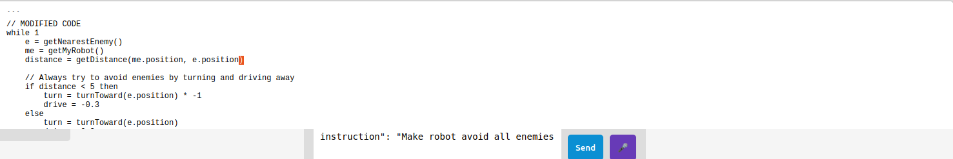

2)

The usage of these buttons:

Toggle Mode: Select between dark mode and light mode.

Avoid: Avoid enemy at the selected coordinate

Attack: Attack enemy at the selected coordinate

Patrol: Patrol enemy at the selected coordinate

Stop: Stop enemy at the selected coordinate

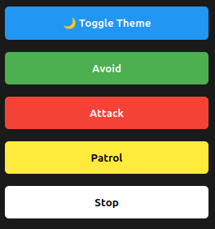

3) This panel will show what instructions the user has been given.

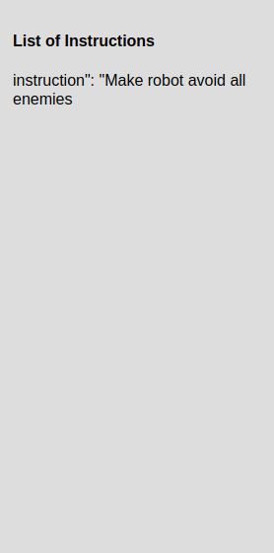

4) This is a map for users to select coordinate.

