# Coronavirus (COVID-19) in United Kingdom

# Weilu Wang

Coronavirus(COVID-19) outbroke in China and started from the end of 2019. In this process report, I plotted a multiple line graph with the data of death population to analysis the situation from January to July in the UK then simulated the SEIRD model with estimated infection rate β and recovery rate γ , then calculated the basic reproduction number R0 to predict the trends of the virus.

Notations*:*

|  |  |  |  |
| --- | --- | --- | --- |
| *Sn(t)* | *Susceptible Population Outside The Care Homes* | *Sc(t)* | *Susceptible Population Inside The Care Homes* |
| *En(t)* | *Exposed Population Outside The Care Homes* | *Ec(t)* | *Exposed Population Inside The Care Homes* |
| *In(t)* | *Infection Population Outside The Care Homes* | *Ic(t)* | *Infection Population Inside The Care Homes* |
| *Rn(t)* | *Recovery Population Outside The Care Homes* | *Rc(t)* | *Recovery Population Inside The Care Homes* |
| *Dn(t)* | *Death population Outside The Care Homes* | *Dc(t)* | *Death Population Inside The Care Homes* |
| *β* | *Infection Rate* | *γ* | *Recovery Rate* |
| *ɑ* | *Transmission Rate* | *μ* | *Death Rate* |
| *t* | *time* | *N* | *Total Population* |

The total population is set as *N = 65000000* and *N = Nn+Nc*, the recovered individuals will not be infected the virus again. Suppose the susceptible population is *S(t)*, the exposed population population is *E(t),* the infected population is *I(t)* and the recovered population is *R(t)*, the following deduction is made:

1. The population that can be infected by the infection population *I(t)* in unit time is in direct proportion to the susceptible population, the proportion coefficient which we also called infection rate is *β*. We assume the infection population is *β*S(t)*I(t)/N* in unit time;
2. The recovered population is in direct proportion to the infection population *I(t)*, the proportion coefficient which we also called the recovery rate is *γ*. We assume the recovered infection population is *γ*I(t)* in unit time;
3. The exposed population indicates the individuals who have been infected but not infectious yet, which have the transmitted rate *γ* to infection population;
4. The death population is in direct proportion to the infection population *I(t)*, the proportion coefficient which we also called the death rate is *μ.* We assume the death population of infection population is *μ*I(t)* in unit time;
5. Note the variables hold the condition:

$dS(t)+dE(t)+dI(t)+dR(t)+dD(t)=$*dN*

We considered to use the SEIRD model as following:

$$\frac{dS(t)}{dt} = −\frac{S(t)*β*I(t)}{N}$$

$$\frac{dE(t)}{dt} = \frac{S(t)*β*I(t)}{N}− E(t)*α$$

$$\frac{dI(t)}{dt} = E(t)*α−I(t)*γ$$

$$\frac{dR(t)}{dt} = I(t)*(γ−μ)$$

$$\frac{dD(t)}{dt} = I(t)*μ$$

With the *I(t), ɑ, γ* and *μ* are decomposed according to the populations “outside the care homes” and “inside the care homes” :

$I(t)= \left(\frac{I_{n}(t) }{I_{c}(t)}\right), ɑ= \left(\frac{ɑ_{n} }{ɑ_{c}}\right), γ= \left(\frac{γ_{n}}{γ_{c}}\right)$*, $μ= \left(\frac{μ_{n}}{μ_{c}}\right)$*

The rate of infection is described by the 2 × 2 matrix

$β(t) = \left(\frac{β_{nn}G_{nn}(t) β_{cn}G_{cn}(t)}{β_{nc}G_{nc}(t) { β}_{cc}G_{cc}(t)}\right)$*,*

where the βxy represents the infection from susceptible individuals to exposed individuals. G(t) represents a time-dependent factor which based on the Google mobility data. To be specific, for each transition rate βx , this factor is given by

$$Gx(t) = 1− px(0.5 ×(1−αb)×tanh(αr(t−αo))+1+f(t)),$$

where

$$f(t)=\left\{\begin{aligned}−(1−αb)×exp(−(t−αo)αf)+(1−αo) for H(t−αo)=1 \\ 0 otherwise\end{aligned}\right.$$

The deduction above can be described in the form of the following differential equation in unit time:

$$\frac{dS_{n}(t)}{dt} = − \frac{S_{n}(t)}{N}(β_{nn}I_{n}(t)+{β_{cn}I}_{c}(t))$$

$$\frac{dE_{n}(t)}{dt} = \frac{S_{n}(t)}{N}(β_{nn}I_{n}(t)+{β_{cn}I}_{c}(t))− E_{n}(t)*ɑ_{n}$$

$$\frac{dI_{n}(t)}{dt} = E_{n}(t)*ɑ_{n}− I_{n}(t)*γ_{n}$$

$$\frac{dR_{n}(t)}{dt} = I_{n}(t)*(γ_{n}−μ_{n})$$

$$\frac{dD_{n}(t)}{dt} = I_{n}(t)*μ_{n}$$

$$\frac{dS_{c}(t)}{dt} = − \frac{S_{c}(t)}{N}(β_{nc}I_{n}(t)+{β_{cc}I}_{c}(t))$$

$$\frac{dE_{c}(t)}{dt} = \frac{S_{c}(t)}{N}(β_{nc}I_{n}(t)+{β_{cc}I}_{c}(t))− E_{c}(t)*α_{c}$$

$$\frac{dI_{c}(t)}{dt} = E_{c}(t)*α_{c}− I_{c}(t)*γ_{c}$$

$$\frac{dR_{c}(t)}{dt} = I_{c}(t)*(γ_{c}−μ_{c})$$

$$\frac{dD_{c}(t)}{dt} = I_{c}(t)*μ_{c}$$

Based on the data given from ONS, the web is : <https://www.ons.gov.uk/peoplepopulationandcommunity/birthsdeathsandmarriages/deaths/datasets/weeklyprovisionalfiguresondeathsregisteredinenglandandwales>

I took the value of “ONS Deaths involving COVID-19” set as “Death Population Caused by COVID-19”, “ONS 2019” set as “2019 Total Death Population”and “ONS All deaths year-to-date” set as “2020 Total Death Population” to plot a graph with time as x-axis and population as y-axis to compare the death situation in 2019 and 2020 with the COVID_19. Show as below:

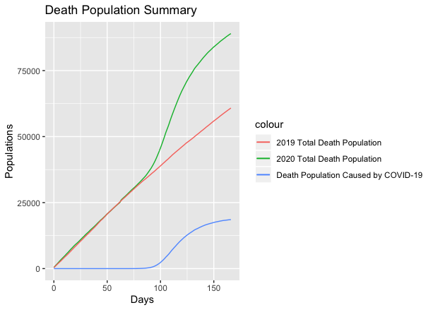

Through the observation of the graph, we assume that the COVID-19 is highly infectious and with high fatality rate. The total death population of 2020 obviously increased with the the deaths caused by COVID_19 compared with the death population in 2019. It shows a similar trend with the the line graph of death population caused by COVID_19, but higher growth rate. After putting five differential equations and the estimate value of different rates into R, the simulation graph of SEIRD model show as below:

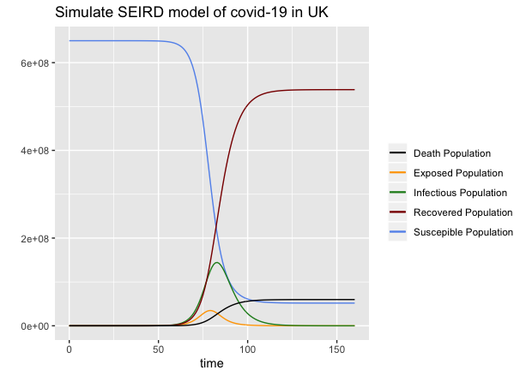

We can easily get the basic reproduction number *R0*:

$$R0=\frac{β }{γ}$$

Set the total population of care-home residents of England and Wales as $N_{c}$ = 418,000 , the death rate $μ_{c}$ = 0.046 and the infection rate $β_{c}$ = 0.4 to simulate the SEIRD model, the plot of it show as below:

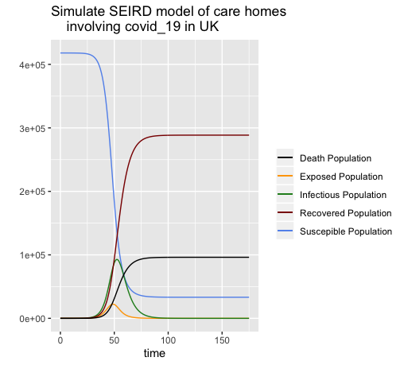

Future Research:

1. Simulate the SEIRD model of the care-home residents then predict the death population, then try to compare the results with the real data.
2. Use method such as MCMC to improve the accuracy of the *α, β ,γ* and *μ..*
3. Calculated the reproduction number $R0$*(t)* in different period to predict the trends of the COVID-19 in UK.