**Attention based BCI**

1. **Attention index**:
   1. **Beta/Theta**: relatively stable and easy to control
   2. **Beta/Alpha**: change rapidly and oversize
   3. **Beta/(Theta+Alpha)**: stable and easy to control
   4. **Low_Beta/(Low_Alpha+Theta)**: small size
   5. **Blinking rate**: other measure modality
   6. **Attention power (AP, Alpha + Beta)**: rarely use

To sum up: Beta and Gamma increase; Theta and Alpha decrease; Blinking rate decreases

1. **Measure Attention Task**:
   1. Sustained Attention to Response Task (SART)/Vigilance Task: Measure sustained attention and selective attention
   2. N back task
   3. Go/noGo test
   4. Conner’s Continuous Performance Test (CPT)
   5. Wisconsin Card Sorting Test
2. **Strategy to increase attention:**
   1. Perform mathematical operations: not continuous/intermittent
   2. Visual imagery (plot an object mentally) or Auditory imagery (generate internal sounds)
   3. Focus on an idea, thought or memory: continuously
   4. Think in a direction to increase value on screen, be motivated
   5. Focus on rhythmic breath

Quantified index: Total time when attention index is larger than threshold; max duration when attention index is above threshold

1. **Maximizing the Attention Level**. Ways to maximize the Attention level vary for different people. Here are some suggestions:
   1. Concentrate on an object.
   2. Carefully read the list of ingredients on a food container.
   3. Memorize some nutrition facts on a food container.
   4. Count backwards from 100 by sixes or sevens.
   5. Do arithmetic operations in your head.
   6. Listen to a rap song and try to understand the words.
   7. Read something in a language you’re not fluent in.
2. **Strategy to decrease attention:**
   1. Not to think about anything/Make mind go blank /Inhibition of thoughts
   2. Look at different parts of the room: ocular movement might effect band powers
3. **Electrode Fp1:**
   1. Free of hair, allow for easy placement
   2. Within frontal lobe, related to brain control/attention

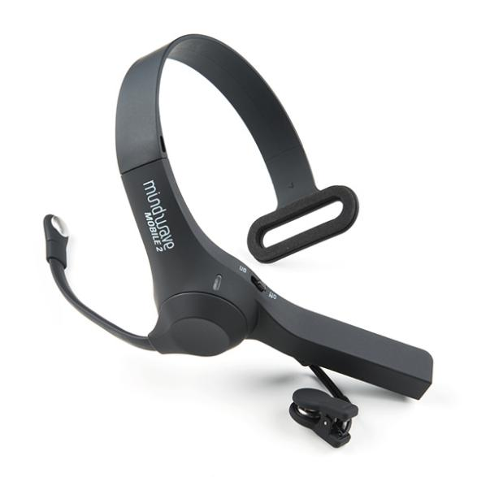 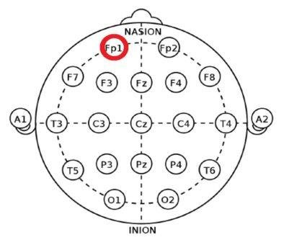

1. Game application:
   1. Two players: Tug of War; seesaw
   2. One player:
2. Contradicted attention index

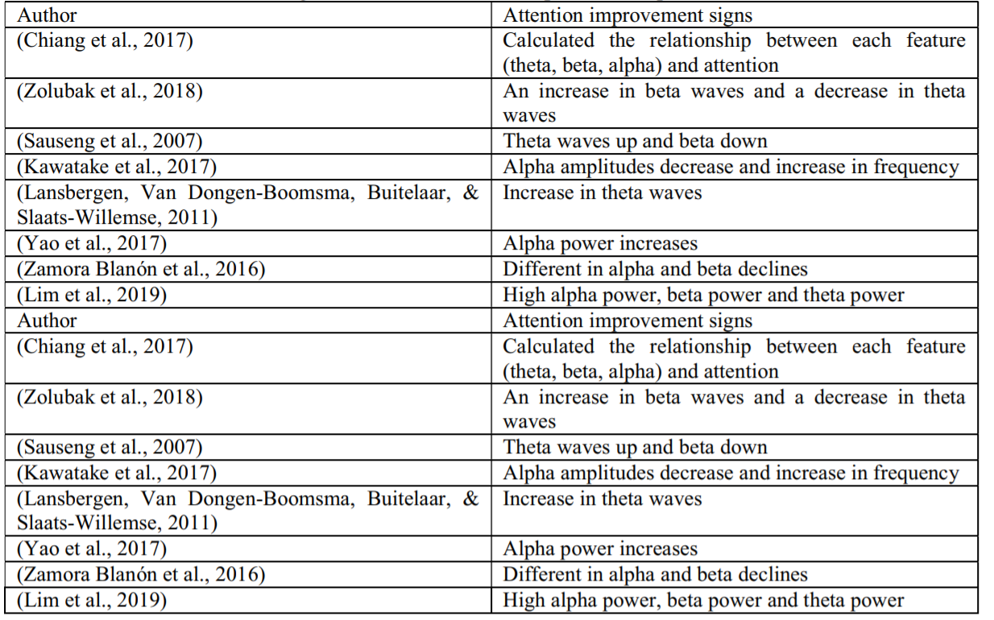

1. Frequency bands

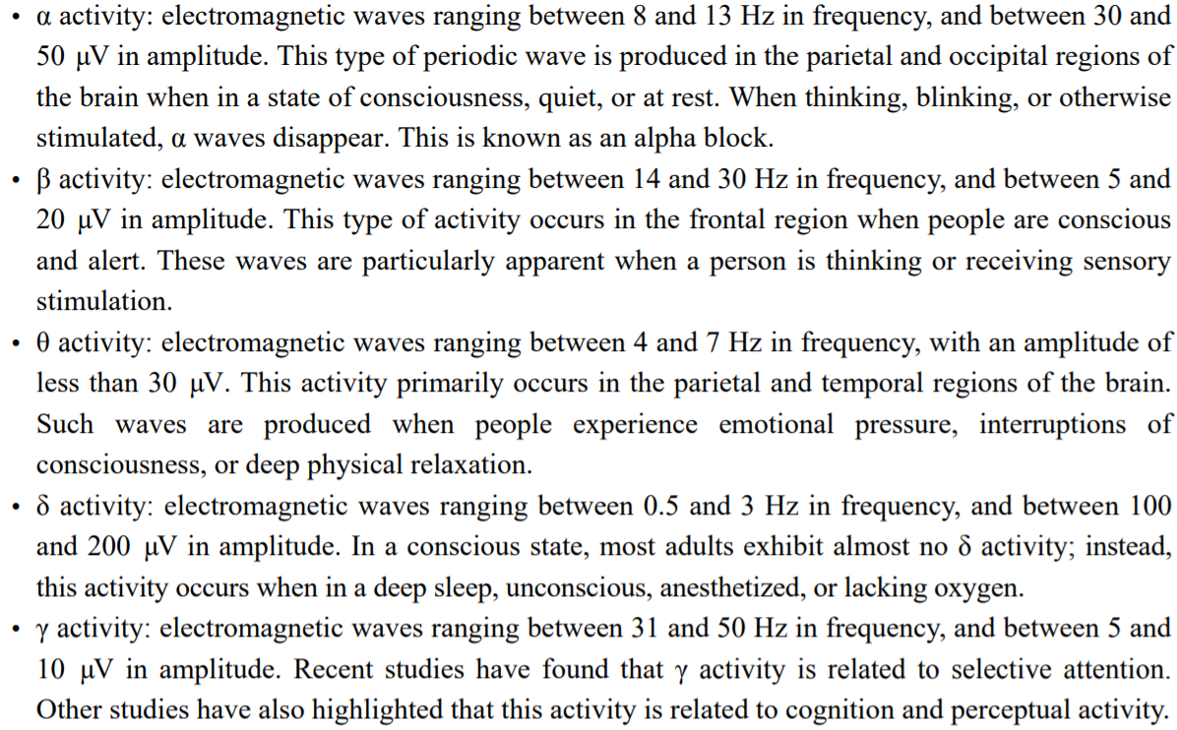

1. Detect/Remove eye blink (BCI applications can also make use of the eye link)
   1. Linear regression
   2. Independent component analysis
2. Single channel EEG denoise:
   1. Simple move median or average with different window sides.
   2. Wavelet based denoise (different wavelet functions and decomposition levels)

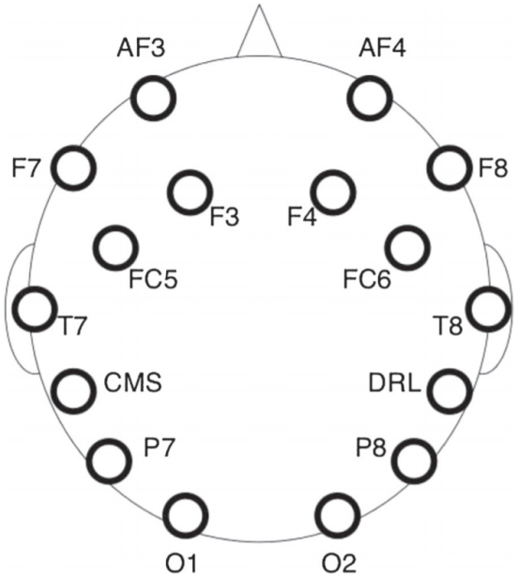

**Epoc**: 14 channels (AF3, F7, F3, FC5, T7, P7, O1, O2, P8, T8, FC6, F4, F8, AF4)

**Insight**: 5 channels (AF3, AF4, T7, T8, Pz)

**Reference**: TP9 and TP10 (CMS and DRL)

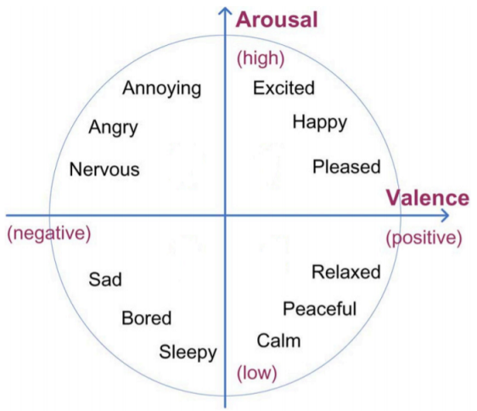 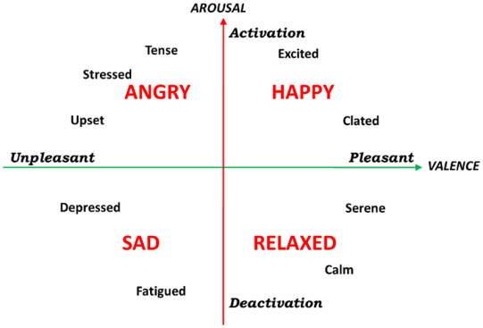

Russel's Circumplex Model

**Emotion Index**: arousal levels and valance values (positive or negative emotional states)

**Arousal levels**: (Beta/Alpha) is calculated using frontal and anterior-frontal electrodes AF3, AF4, F3, F4, F7, F8

**valance values**: (Alpha/Beta)*(left hemispheres - right hemispheres) is calculated by computing the difference of ratio of alpha to beta in right hemispheres and that of left hemispheres, the symmetrically pairs of electrode are AF3-AF4, F3-F4

1. Emotiv Performance Metrics
   1. **Engagement/Boredom (eng)**: is experienced as alertness and the conscious direction of attention towards task-relevant stimuli. It measures the level of immersion in the moment and is a mixture of attention and concentration and contrasts with boredom.
      1. Index 1: (Beta/(Alpha + Theta)) is calculated using all sensors AF3, AF4, F3, F4, F7, F8, FC5, FC6, T7, T8, P7, P8, O1, O2.
      2. Index 2: (Frontal Theta/Parietal Alpha) is calculated by using the Theta average at frontal lobe locations F3, F4, FC5, FC6, and dividing them by the Alpha averages at the parietal locations P7, P8.
      3. Index 3: (Frontal Theta) is calculated using the average of the following frontal lobe locations AF3, AF4, F3, F4, F7, F8, FC5, FC6.
   2. **Focus/Attention (foc)**: is a measure of fixed attention to one specific task.
   3. **Cognitive load**: Cognitive load is a measure of how much conscious information processing and problem solving is happening in the brain.
   4. **Excitement (exc)**: is an awareness or feeling of physiological arousal with a positive value.
   5. **Long term excitement (lex)**: It is calculated from the excitement values of the last minute.
   6. **Stress/Frustration (str)**: is a measure of comfort with the current challenge.
   7. **Relaxation (rel)**: is a measure of an ability to switch off and recover from intense concentration.
   8. **Interest/Affinity (int)**: is the degree of attraction or aversion to the current stimuli, environment or activity and is commonly referred to as Valence.