# IS213 Enterprise Solution Development

# G4T7 - Klein Dining Employee Management System

### Files Attached:

**XSD**

* employees.xsd
* payrolls.xsd
* shifts.xsd

**SCRIPTS**

* Employee_table.sql
* Payroll_table.sql
* cshift.sql
* pshift.sql

**TIBCO**

* Employee.zip
* Payroll.zip
* Cshifts.zip
* Pshifts.zip

**UI**

Payroll Microservice

* payroll_eid.php
* payroll_email.php
* payroll_getall.php
* payroll_period.php

Preferred Shifts Microservice

* preferred_shift.php
* preferred_shift_form.php
* process_shifts.php
* confirmed_preferred.php

Confirmed Shifts Microservice

* confirmed_shifts_eyee.php
* confirmed_shifts_eyer.php
* cshift_eyee_period.php
* confirmed_process.php

Invocation of TIBCO services

* invoke_services.php

General

* login_main.php
* login.php
* employee_nav.php
* employer_nav.php
* employee-view.php
* employer-view.php

Employee Microservice

* addemployee.php
* addemployee-view.php
* editemployee.php
* edit-employee-view.php

*Note: User Scenarios pertaining to the Employee Microservice were left out in our report due to page limit.

### Important Note: Prior to running the below scenarios, please make changes to the file “invoke_services.php”

1. Change const MACHINE in class payroll

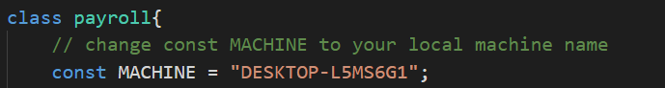

1. Change const MACHINE in class shift

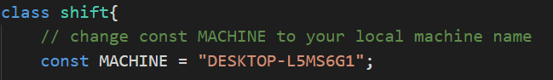

1. Change const MACHINE in class confirmed_shift

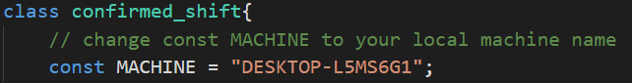

1. Change const MACHINE in class employee

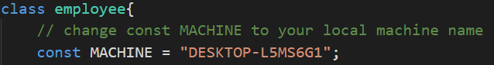

This is to ensure the microservices can be invoked from your local machine.

1. Upload database scripts for Employee_table.sql, Payroll_table.sql, cshift.sql and pshift.sql

This is to ensure the website shows the correct details

### Login Details:

Employee Interface

Username: junhong

Password: 12345

Employer Interface

Username: cheng

Password: password