MStar TVOS
Release Notes
348_AN_DTMB
Beta Release

V1.0

© 2026 MStar Semiconductor, Inc. All rights reserved.

MStar Semiconductor makes no representations or warranties including, for example but not limited to, warranties of merchantability, fitness for a particular purpose, infringement of any intellectual property right or the accuracy or completeness of this document, and reserves the right to make changes without further notice to any products herein to improve reliability, function or design. No responsibility is assumed by MStar Semiconductor arising out of the application or user of any product or circuit described herein; neither does it convey any license under its patent rights, nor the rights of others.

MStar is a trademark of MStar Semiconductor, Inc. Other trademarks or names herein are only for identification purposes only and owned by their respective owners.
REVISION HISTORY
Revision No. | Description | Requester | Date
0.1 | - Initial discussion |  | 07/13/2012
1.0 |  |  | 01/3/2017

TABLE OF CONTENTS
1. INTRODUCTION 1
1.1. Purpose 1
1.2. Deliver Document & File Check List 1
1.3. List of Packages 2
RELEASE DETAIL 3
1.4. Release Version 3
1.5. Release Info 3
1.6. Module Version 3
1.7. Sub Module Info 3
1.8. Test Info & Report 5
1.9. Critical Issues Resolved in This Release 6
1.10. Known Issues (重大問題與應完成而未完成的功能) 6
1.11. 軟體更新列表 7
1.12. Module Changes (Alpha 之後的Release 一定要提供) 7
1.13. API Change or Behavior Change (Alpha 之後的Release都要) 7
2. Performance Check 9
2.1. Brief 9
2.2. Performance Detail 9
3. Quality Check 11
3.1. Brief 11
3.2. Quality Check 11
4. HW ECO Info Check 12
4.1. Brief 12
5. 新功能/新的(HW)變動需要有Module Release Note 13
5.1. Brief 13
5.2. XX 新功能 13
6. Installation 14
6.1. Installation & Upgrade 14
7.1.1 ARM Toolchain 14
7.1.2 Mboot 14
7.1.3 Supernova 14
7.1.4 Android 15
7.1.5 Linux Kernel 15
7.1.6 PM 15
7.1.7 How to Update the MBoot by ISP tool 16
7.1.8 How to Update the MBoot by TFTP 17
7.1.9 How to Update Images by TFTP 18
7.1.10 How to Upgarde Image by USB 18
7.1.11 How to Upgarde Image by OTA 19
7. OTHERS 20
7.1. Build Process Change 20
7.2. Associated Tools Changes 20
7.3. Other Changes 20
7.4. Release给客户时的注意事项 20
7.5. Build Supernova時，如果出現R2 toolchain錯誤訊息 20
8. Secure IC 21
8.1. 燒錄工具 21
8.2. 燒錄方法 21
9. HW Limitiation 22
9.1. Brief 22
9.2. HW Limitation List 22
10. Reference 23
10.1. Reference-1: 產品版本定義 23

INTRODUCTION

Purpose

- Release for Project Name: ASNTV-04.20.010.02.02.348.cus
- Release Type: Beta Release
- Reference board: MST125B-10AAT-16341
- In this solution, the code base is Android 4.4, the broadcast type is DTMB the DRAM size is 768MB, and the eMMC size is 4GB(Toshiba,Micron and Samsung) or 8GB(Hynix)

Deliver Document & File Check List
- 依照 release 階段填寫此表，有提供的勾選 “Check” 欄
- Format為檔案的，在提供 release note 時，以檔案形式一併提供

List of Packages
Component | Software Package
Related tools such as TV_Tool | ISP_Tool.exe
Source codes | AN : ASNTV-04.20.010.02.02.Mainz  SN : ASNTV-04.20.010.02.02.Mainz  MBoot: MBOT-1106.0.0.Mainz.a7.1  Kernel: KERN-3.10.86.Mainz.config_mainz_SMP_arm_android_emmc_nand.a15  Utopia: UTPA2-500.0.13.Mainz  PM : PM-100.1.1.Mainz
Binary codes | SQC:

RELEASE DETAIL

Release Version
Version | ASNTV-04.20.010.02.02.348.cus

Release Info
Date | 2016/12/30
Release Engineer | Gavin.lian

Module Version
AN : ASNTV-04.20.010.02.02.Mainz
SN : ASNTV-04.20.010.02.02.Mainz
MBoot: MBOT-1106.0.0.Mainz.a7.1
Kernel: KERN-3.10.86.Mainz.config_mainz_SMP_arm_android_emmc_nand.a15
Utopia: UTPA2-500.0.13.Mainz
PM : PM-100.1.1.Mainz

Sub Module Info
- Provide the module info here
- Module version definition: ModuleName-MajorVerion.MinorVerion.ReleaseNumber.Stage
ModuleName: Module name, 2~10 letters or numbers
MajorVerion: numbers
MinorVerion: numbers
ReleaseNumber: numbers

Example: MBOT-02.12.1133783.MUJI.SN
PS: <1>. Utopia 的sub lib version 要能夠用 Tool dump 來 (重點)
<2>. VDEC, Audio 等 FW version 也要能夠用Tool dump 來(重點)

Module | Version
Components
APM APM_-01.11.1050628
DLNA DLNA-1.5.10.1182831
drmagent DRMA-01.16.1045679
DSMCC DSMC-01.01.01188769
HbbTVLauncher HBBL-1.1.1186991
HDCP HDCP-02.89.20160913
Mstarlauncher MSTL-1.9.1061467.20141211
mstreamer MST0-02.12.1159391
MWB MWB_-5.0.0.1449.1052220
MWBService MWBS-1.1.1149910
OpenBrowser OPBR-1.4.02.1025023
PVR DPVR-01.07.01443721
QT_v4.8.x QT48-4.8.2.1439.978652
SambaTV FLGO-01.03.1159683
TEE TEE_-25.00.20161003
teletext TT25-01.39.00778869
Utopia UTPA2-205.1.1440152
Utopia_ACE ACE__-205.02.1440152
Utopia_AESDMA AESDMA__-500.03.1440152
Utopia_AUDIOApi AUDIO__-500.03.1448743
Utopia_AUDIODrv AUDIO__-500.03.1490338
Utopia_AUDSP AUDSP__-500.03.1440152
Utopia_AVD AVD__-500.03.1440152
Utopia_CEC CEC__-500.03.1488136
Utopia_CMDQ CMDQ__-500.03.1440152
Utopia_CPU CPU__-500.03.1440152
Utopia_DDC2BI DDC2BI__-500.03.1440152
Utopia_DEMOD DEMOD__-500.03.1440152
Utopia_DLC DLC__-500.03.1440152
Utopia_DMX DMX__-500.03.1487692
Utopia_DSCMB DSCMB__-500.03.1440152
Utopia_GFX GFX__-500.03.1440152
Utopia_GOP GOP__-500.03.1442571
Utopia_GPD GPD__-500.03.1440152
Utopia_GPIO GPIO__-500.03.1440152
Utopia_HSL HSL__-500.03.1440152
Utopia_HWI2C HWI2C__-500.03.1440152
Utopia_IPAUTH IPAUTH__-500.03.1440152
Utopia_IR IR__-500.03.1440152
Utopia_JPEG NJPEG__-500.03.1440152
Utopia_MBX MBX__-500.03.1440152
Utopia_MFE MFE__-500.03.1440152
Utopia_MHL MHL__-500.03.1279154
Utopia_MMFI MMFI__-02.09.609761
Utopia_MsFS MsFS__-03.52.1440152
Utopia_MSPI MSPI__-500.03.1440152
Utopia_MVOP MVOP__-500.03.1440152
Utopia_PCMCIA PCMCIA__-500.03.1440152
Utopia_PM PM__-500.03.1440152
Utopia_PNL PNL__-500.03.1486299
Utopia_PWM PWM__-500.03.1440152
Utopia_PWS PWS__-500.03.1440152
Utopia_RTC RTC__-500.03.1440152
Utopia_SAR SAR__-500.03.1440152
Utopia_SC SC__-500.03.1440152
Utopia_SERFLASH.s FLASH__-500.03.1440152
Utopia_SWI2C SWI2C__-500.03.1440152
Utopia_SYS SYS__-500.03.1440152
Utopia_TSP TSP__-12.46.682006
Utopia_URDMA URDMA__-500.03.1440152
Utopia_VBI VBI__-500.03.1440152
Utopia_VDEC VDEC__-500.03.1491562
Utopia_VE VE__-500.03.1440152
Utopia_VIF VIF__-19.03.1440152
Utopia_WDT WDT__-500.03.1440152
Utopia_XC XC__-500.03.1496981
Vdplayer MM30-01.14.01418825
Vudu_v3.x VUDU-3.1.0.06a2.1029310

Test Info & Report
- 請附上 Test Report 的 PV/SQC 的測試單號: XXXX
(如: TR14052100002)
PS: 需求者請向PM申請權限, 就可以看到此單號的所有大測項及Test Report
- 依照 release 階段填寫此表，有提供的勾選 “Check” 欄

Check | Deliverable | Report ID | Notes
Alpha Release Deliverables
V | SQC Test Report ID | TR16100400009
Beta Release Deliverables
V | PV Test Report ID | TR16102500007
V | AC DC On/Off test report (10000 次 x 2 set)
V | Str test report (10000 次x 2 set)
V | Performance test report ID | TR16102500007
 | Dolby-MS11/MS12/DTS-HD预测试 report ID
 | MEMC效果测试report ID
 | HDMI 2.0/MHL 3.0 预测试 report ID
 | 高/低温老化房测试test report ID
 | Netflix認證預測試test report ID
 | Youtube 認證預測試test report ID
 | BBC 認證預測試test report ID
 | HBBTV 認證預測試Test report ID
 | CI+ 認證預測試test report ID
 | Freview HD 認證預測試Test report ID
 | Amazon 認證預測試Test report ID
 | Freview play認證預測試test report ID
 | DLNA認證預測試test report ID
 | VUDU 認證預測試test report ID
 | CAST TV 認證預測試pass report ID
Regular Release
 | SQC/PV Test Report ID | Ex: TR14111300016

Critical Issues Resolved in This Release
Category | ID | Severity | Summary
MM_Music | 1245657 | critical | [Mainz_125B][An4.4][][FHD][HTML5]浏览器输入http://www.pptv.com/，播放任意视频，按遥控source键切至VGA通道，切换比例模式后，按鼠标右键退出至浏览器播放视频，再按source键，则TV画面黑屏
Android_System | 1271365 | critical | [SQC][Mainz_125B][6TH_DMBT][MUSIC] 播放AAC格式的音樂,音樂播不出來,顯示時間為00(詳情請看附檔)
Boot_STR | 1258029 | critical | [Mainz_125B][An4.4][STR] 关掉watchdog，STR压测6000多次，出现待机呆不下去

Known Issues (重大問題與應完成而未完成的功能)
1246522: [Mainz_125B][An4.4][Android_System]播放在线视频，无声。
1247285: [Mainz_125B][An4.4][Android_System]接上camera，AC起来无法正常拍照，偶遇一次。
1241775: [Mainz_125B][An4.4]在launcher页面下DC起来，概率性闪多个Android logo（见视频）
1264337: [SQC][Mainz_126B][AN6.0][ASEAN][1st_DVB][DTV]OAD更新，Stage2時亂按IR key，機率性更新失敗
1242794: [Mainz_125B][An4.4][MM]播放MM片源，使用鼠标操作相关设置，出现一次MM无响应
1263705: [SQC][Mainz][126B][AN6.0][ASEAN][1st_DVB][DTV]播放指定stream，撥到一半出現garbage畫面卡頓
1263709: [SQC][Mainz][126B][AN6.0][ASEAN][1st_DVB][DTV]播放指定stream，切換resolution後畫面異常
1268672: [SQC][Mainz_126B][AN6.0][ASEAN][1st_DVB][VDEC]DTV播放low4k.120fps.8bit420_hevc_revised.ts ，畫面嚴重拉絲、花屏
1226919: [SQC][Mainz_125B][DTMB][CEC_Quick_Test] CEC畫面變紫色
1270606: [SQC][Mainz_125B][DMBT][AN_Application] www.iqiyi.com 撥放影片 -> 顯示 '此視頻無法撥放' 訊息 (不做任何操作/按下確定後，可正常撥放)

軟體更新列表
- Note:
  - 紀錄此版本與前版本Release 的改動, 如新功能/軟體改進(新功能指此版本才有的功能, 前一版沒有)

Num | Category | 軟體更新列表 (Bug Fix 不用列) | Note
1 | New Feature | HDMI 4k2k 60hz

Module Changes (Alpha 之後的Release 一定要提供)
- Note:
  - PL/PM 要準備好黃色部分
  - 綠色部分, 則由 Module Owner/FM提供

Module (Changes) | Pre  Version | New  Version | Note  由 Module Owner/FM 提供
Android | ASNTV-04.20.010.01.01.Mainz | ASNTV-04.20.010.02.02.Mainz | Eddy-sh.Chen
SN . | ASNTV-04.20.010.01.01.Mainz | ASNTV-04.20.010.02.02.Mainz | Gordon.Hsu.
Utopia | UTPA2-500.0.13.Mainz | UTPA2-500.0.9.Mainz.a1 | Alix.Wu
Kernel | KERN-3.10.86.Mainz.config_  mainz_SMP_arm_android_emmc_nand.a8 | KERN-3.10.86.Mainz.config_  mainz_SMP_arm_android_emmc_nand.a15 | Eddy.lin
Mboot | MBOT-1106.0.0.Mainz.a5 | MBOT-1106.0.0.Mainz.a7.1 | Tequila.Huang

API Change or Behavior Change (Alpha 之後的Release都要)

Code Line: xxx / Chip Name:
前一版
Module (Changes) | Pre  Version | New  Version | API Change 描述
Android | KITKAT_MADISON2_0.1.4 | KITKAT_MADISON2_0.1.5 | Xxxxxxxxxxxxxxxxxxx
………. | ………. | ……….

Performance Check

Brief
- 當Formal Release(Alpha/Beta Release) 時必須填寫此章.
- Performance 可事先排測於 SQC 或撈取 Auto Test 網頁資料.但版本必須相同

Performance Detail
- 標明Requester 希望的 AC/DC Boot time 於下表 (必填)
 | Requester  (人名,可複選) | Requester希望值 | 此版本數據 | 是否達標 | 若無達標  是否有先協議(Y/N) | Note
AC Booting time | Jeffrey.Liao | 17 | 10.75 | 是 | NA
DC Booting time | Jeffrey.Liao | 5 | 4.59 | 是 | NA

Project_Name | G_HQ_Mainz_AN | Note
Config_Name | Mainz_125B_ROM_EMMC_TVOS_DTMB_CMA_TEE | Note
PM | Shower.Lin | Note
Platform 資訊 | AN-TV | Note
現值/標準 | 現值/標準 | Note
AnTuTu 5.1 | 26316 / 16514
APK Launch Time (Settings) 毫秒 | 1190/1810
AC Boot time (TV): ATV無訊號下,UI可操作 | 6.17/10.33 | 若客戶要 PK booting time 或 MP 時, 需要注意以下事項:  <1>. Debug message 是否全關 (Kernel 也要)  <2>.boot 時delay 3 sec 也要關掉  <3>.注意EMMC, Nand Flash 不同, 也會有差異.
AC Boot time (Box): DTV無訊號下,UI可操作
AC Boot time (OTT):Launcher下,UI可操作
AC Boot time (CAST): AC Cast UI出現
DC Boot time (TV): ATV無訊號下,UI可操作 | 4.59/5.46 | 若客戶要 PK booting time 或 MP 時, 需要注意以下事項:  <1>. Debug message 是否全關 (Kernel 也要)  <2>.boot 時delay 3 sec 也要關掉  <3>.注意EMMC, Nand Flash 不同, 也會有差異.
DC Boot time (Box): DTV無訊號下,UI可操作
DC Boot time (OTT):Launcher下,UI可操作
DC Boot time (CAST): AC Cast UI出現
ATV 換台時間 | 0.93/1.20
DTV同頻換台時間 | 0.85/1.33
DTV異頻換台時間 | 0.99/1.18
切換input source 時間 DTV 切 HDMI | 3.97/3.97
切換input source 時間 HDMI 切DTV | 1.93/2.32
切換input source 時間 DTV 切 ATV | 1.63/1.92
切換input source 時間 ATV 切 DTV | 1.93/2.25
切換input source 時間 HDMI 切 HDMI
LX Free Memory => Auto Test 要建 | 330364 kB | (AN Project 必須由Wwnjing 確認過才可以)
備註

Quality Check

Brief
- 當Formal Release(Alpha/Beta Release) 時必須填寫此章.

Quality Check

N | Product Quality items | Status | 何時一定要  Ready | Note
1 | Coverity | 19 | Alpha | [交付條件]  Beta <= 10  Beta 後一個月 <= 0
2 | DI | 75 | NA
3 | 敲磚計畫 | V | Beta
4 | Auto IR (DC on/off Test) | V | Beta
5 | Auto Test (含performance), Auto Build, DZ | V | Alpha
6 | Bandwidth Test | V | Beta
7 | CTS (AN Only) | V | Beta
8 | GMS (AN Only) | Optional需簽約 | Beta
9 | All Cert. need to pass PV | V | Beta
10 | PQ | V | Beta

HW ECO Info Check

Brief
- 當Formal Release(Alpha/Beta Release) 或 Patch 時必須填寫此章.

新功能/新的(HW)變動需要有Module Release Note

Brief
- 當有新功能或新的(HW)變動時, 必須要請 Module Owner 撰寫 debug tips 或release note 告知前線注意事項
- 若有新的變動, 則需update
- 多個module, 自行加入後面的章節

XX 新功能
- XX 新功能Debug Tip/Release Note: ?????

Installation

Installation & Upgrade
All Examples are building for emmc.

ARM Toolchain
Set the ARM toolchain path in the build server:

PATH=/tools/arm-2012.09/bin/:/tools/arm_eabi-2011.03/bin:$PATH

And the toolchain gcc version is 4.7.2

Mboot
Build Code Flow
Step 1: repo init -u ssh:// @ 119.145.230.210 (szgit01):26918/platform/manifest -b c_cn_348_sz_dtmb_an_kitkat-cus
Step 2: repo sync -j32
Step 3: repo forall -c "git config core.filemode false"
Step 4: cd MBoot/sboot/
Step 5: ## Please check your board use eMMC
Step 6: cp configs/mainz/.config.mainz.android.125b.rom_emmc.32bit.tee.kernel .config
Step 7: make menuconfig
Step 8: ## Exit & Save
Step 9: make clean && make
Step 10` ## Get mboot.bin in MBoot/sboot/out/

Supernova
Build Code Flow
Step 1: export PATH=/tools/arm/arm-2012.09/bin:$PATH
Step 1: repo init -u ssh:// @ 119.145.230.210 (szgit01):26918/platform/manifest -b c_cn_348_sz_dtmb_an_kitkat-cus
Step 2: repo sync -j32
Step 3: repo forall -c "git config core.filemode false"
Step 4: repo forall -c "git checkout $TAG"
Step 4: cd projects
Step 5: source buildsettings/build_Mainz_125B_ROM_EMMC_TVOS_DTMB_CMA_TEE.sh
Step 6: 放入hash key 到 customerinfo/inc/Customer_Info.h
Step 7: make rebuild_all -j8 && make image_all
Step 8: cd ../target/dvb.mainz/images/ext4 拿 image

Android
Build Code Flow
Step 1: . /tools/script/java1.6.sh
Step 2: mkdir kitkat-mainz-dev
Step 3: cd kitkat-mainz-dev
Step 4: repo init -u ssh:// @ 119.145.230.210 (szgit01):26918/platform/manifest -b c_cn_348_sz_dtmb_an_kitkat-cus
Step 5: repo sync
Step 6: repo forall -c "git config core.filemode false"
Step 7: source build/envsetup.sh
Step 8: lunch aosp_yangmei-userdebug
Step 9: mcheckout.sh "AN_LABEL" (plz check)
Step 10: make -j32 (an image only) or make BUILD_WITH_SUPERNOVA=true -j32 (an&sn image)
Step 11: releaseimage.sh
Step 12: Get images in ../images/kitkat/yangmei/

Linux Kernel
Build Code Flow
Step 1: export PATH=$PATH:/tools/arm/Linaro/4.9.3/gcc-linaro-4.9-2015.02-3-x86_64_aarch64-linux-gnu/bin/:/tools/arm/Linaro/4.9.3/gcc-linaro-4.9-2015.02-3-x86_64_arm-linux-gnueabi/bin/:/tools/arm/Linaro/gcc-linaro-aarch64-none-elf-4.9-2014.09_linux/bin:/tools/arm/arm-2012.09/bin/:/tools/arm/arm-2010.09/bin:/tools/arm/arm-2011.03/bin/Sync/:/tools/arm/arm-2012.09/bin/
Step 2: mkdir linux-mstar-3.10.86-master
Step 3: cd linux-mstar-3.10.86-master
Step 4: repo init -u ssh:// @ 119.145.230.210 (szgit01):26918/platform/manifest -b c_cn_348_sz_dtmb_an_kitkat-cus
Step 5: cd linaro/
Step 6: cp .config_mainz_SMP_arm_android_emmc_nand .config;
Step 8: ./genlink.sh ;
Step 9: make menuconfig
Step 8: ## Exit & Save
Step 10: make clean;
Step 11: make -j16;
Step 12: mkdir ../kernel_ko;
Step 13: find -L ./ -name "*.ko" -exec cp {} ../kernel_ko \;
Step 14: cp arch/arm/boot/zImage ../kernel_ko/;
Step 15: cp arch/arm/boot/dts/ ../kernel_ko/ -R;
Step 16: ## Get Image in arch/arm/boot/zImage

PM
Build Code Flow
Step1: git clone ssh://hcgit03:29418/mstar/mboot/pm-3.0/zenonia
Step2: Enter zenonia/Project/Mstar/Mainz
Step2: Open project PM51_Mainz.Uv2
Step3: Rebuild all project.

How to Update the MBoot by ISP tool
The ISP tool verions must use v4.9.7 or newer.

- Select the eMMC in Type field and check the check box Erase Device in the Auto page

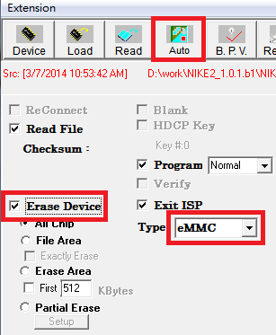

- Connect the Device
  - Press the button Read
  - Select the mboot files
    - EISP Loader File 1 → muninn_EISP_boot_xx_xx.bin
    - EISP Read File 1 →rom_emmc_boot.bin
    - EISP Loader File 2 → muninn_EISP_user_xx_xx.bin
    - EISP Read File 2 → mboot.bin
  - Power on the device and Press the button Connect immediately
PS. If the ISP tool doesn’t connect the device successfully, please try the step 2.3 again.
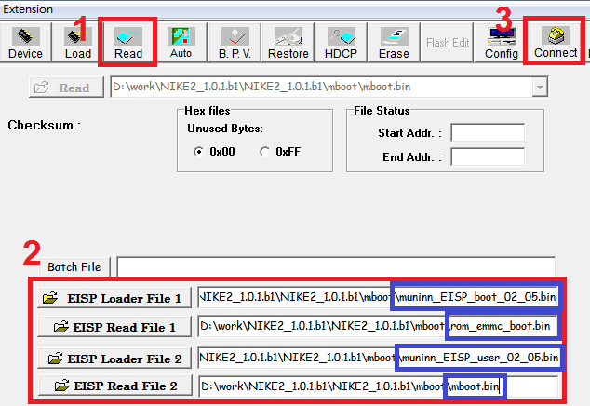

- When the ISP tool connected the device
3.1 Press the button Run in the Auto page.

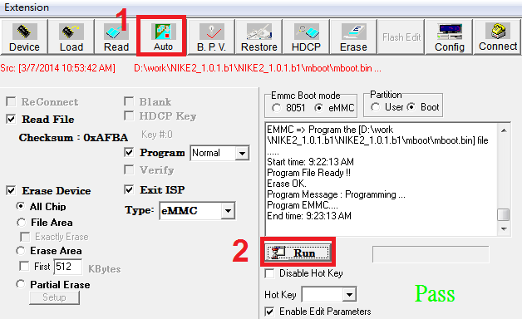

- Wait the progress done, and the ISP tool will show the Pass if the mboot upgrade is successfully.

How to Update the MBoot by TFTP
Put the mboot files in the folder mboot, and use the following command on mboot console:

mstar scripts/[[mboot

How to Update Images by TFTP

Set the Mboot env veriable

- Set the MAC address (for example, your MAC address is 00:11:22:33:44:55:66):

setenv ethaddr 00:11:22:33:44:55:66
setenv macaddr 00:11:22:33:44:55:66

- Auquire the IP address:

estar
dhcp

or set the IP address manually (for example, set the value 192.168.1.2):

setenv ipaddr 192.168.1.2

- Set the TFTP Server IP (for example, the server ip is 192.168.1.1)

setenv serverip 192.168.1.1

- Save env veriable settings

saveenv

Update Images by TFTP

- Update Whole Image: (after setup IP and MAC address in mboot)

mstar auto_update.txt

or

mstar

- Update TVOS(SN) Image: (use these commands if you only want to update TVOS partially)

mstar scripts/[[tvservice
mstar scripts/[[tvcustomer
mstar scripts/[[tvdatabase
mstar scripts/[[tvconfig

How to Upgarde Image by USB
- 把suprenova中的Img文件拷贝到android放Img的目录中也就是把suprenova的Img放到images/kitkat/yangmei下
- 在android目录下执行 ./make_usb_upgrade.sh，依据需要升级的方档选择相应的选项。

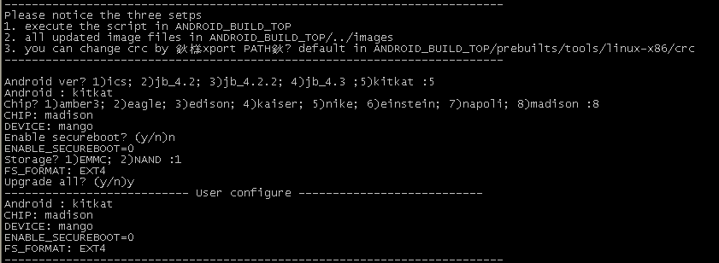

- 在images/kitkat/yangmei下会得到MstarUpgrade.bin文件
- U盘copy 完后在mboot 控制台下执行custar 即可进行升级

How to Upgarde Image by OTA
[Insert the SOP to upgrade image by OTA]

OTHERS

Build Process Change
N/A

Associated Tools Changes
N/A

Other Changes

- Remount 方法有变

mount –o remount rw /tvconfig/
改为
mount –o remount,rw /tvconfig

- Hashkey结构有变，增加
/// the low byte of chip ID (Example:000B = 0x000B)
#define INPUT_DOLBY_VER_LOW_BYTE 0x00
/// the high byte of chip ID (Example:000B = 0x000B)
#define INPUT_DOLBY_VER_HIGH_BYTE 0x00

请注意整合hashkey

Release给客户时的注意事项
- 删除公版hash key。
- 删除公版hdcp key。

Build Supernova時，如果出現R2 toolchain錯誤訊息
啟用開機視頻會需要MM Vdplayer，Vdplayer為了用一個binary 同時相容TEE跟non-TEE，會link TEE library。因此過程中需要使用R2 toolchain:.

- 放入R2的toolchain，可在 build server 目錄 /tools/r2-elf-linux-1.3.5.14 取得
- 確認toolchain “/tools/r2-elf-linux-1.3.5.14/bin/” 在PATH環境變數中.
- Disable TEE時, 還是要留著tee folder

Secure IC
[本單元在 Secure IC ready 後填寫，如果沒有Secure IC，則不需填寫]

燒錄工具
Secure IC燒錄工具檔案路徑，請依storage 格式於下表查詢對應的工具

燒錄方法
提供燒錄的 SOP

HW Limitiation

Brief
- 當Formal Release(Alpha/Beta Release) 時必須填寫此章
- 將已知的 HW Limitiation 條列到下章節中.

HW Limitation List

Reference

Reference-1: 產品版本定義

