2.1

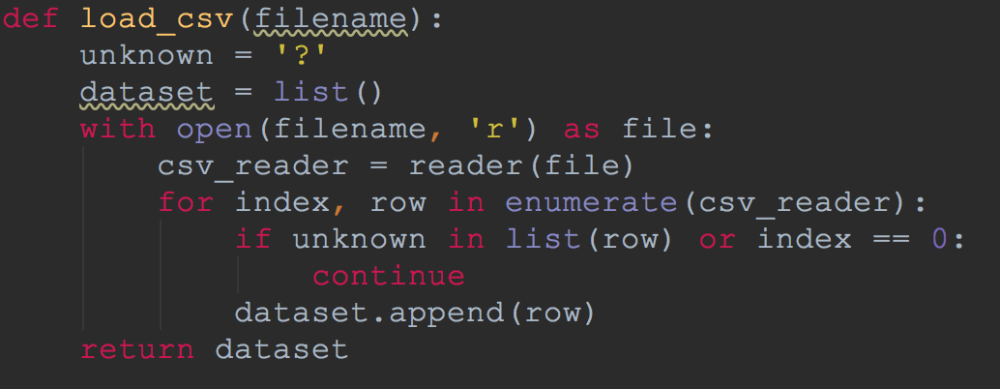

2.2

Because it has some strings in the dataset. We get the number of every category divided by the sum. Then the strings will convert to the number ranged between 0 and 1. Then normalized all the the data.

2.3

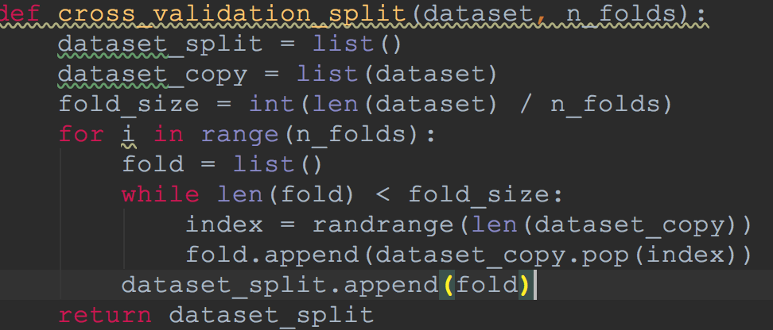

2.4

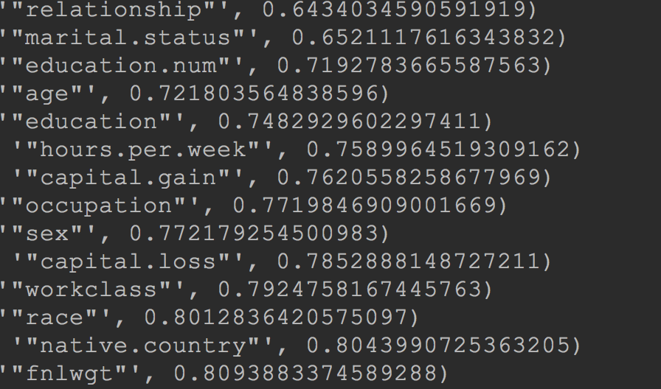

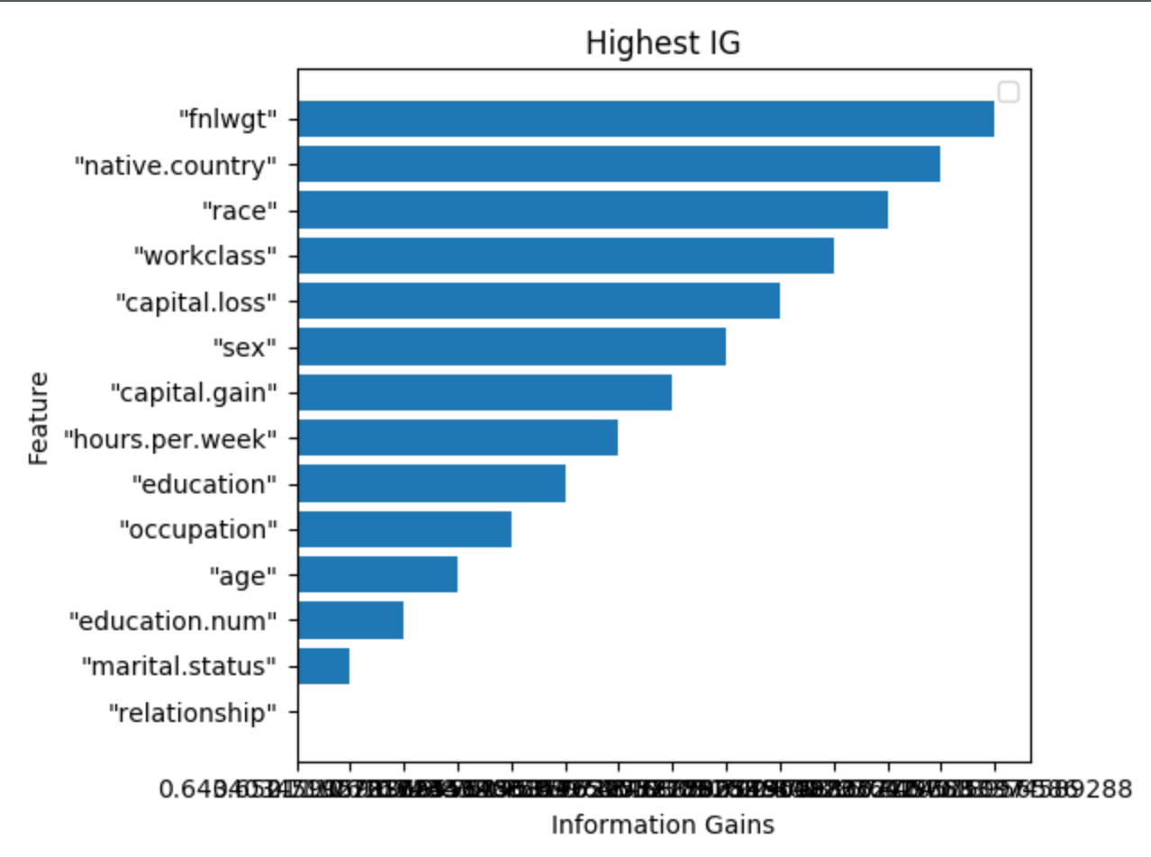

3.1

plot the second and the second reversely features as the X and Y. We plot the decision boundary.

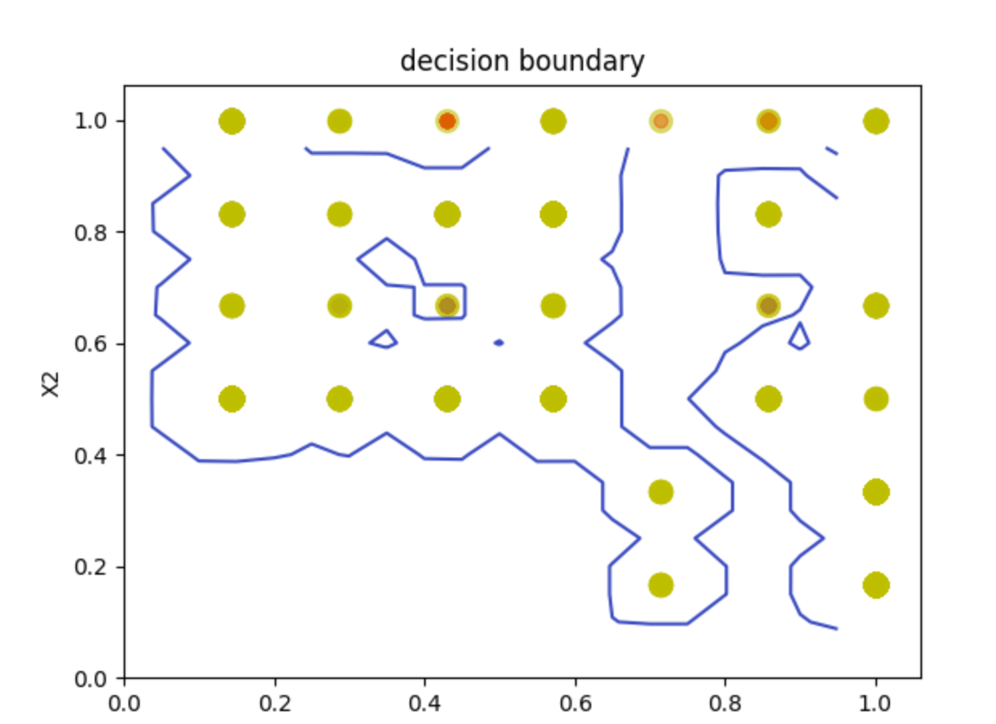

3.2

When we pick a higher C, it will have a better performance than a lower value of C. But if we pick infinite higher, it won’t make the decision boundary by SVM.

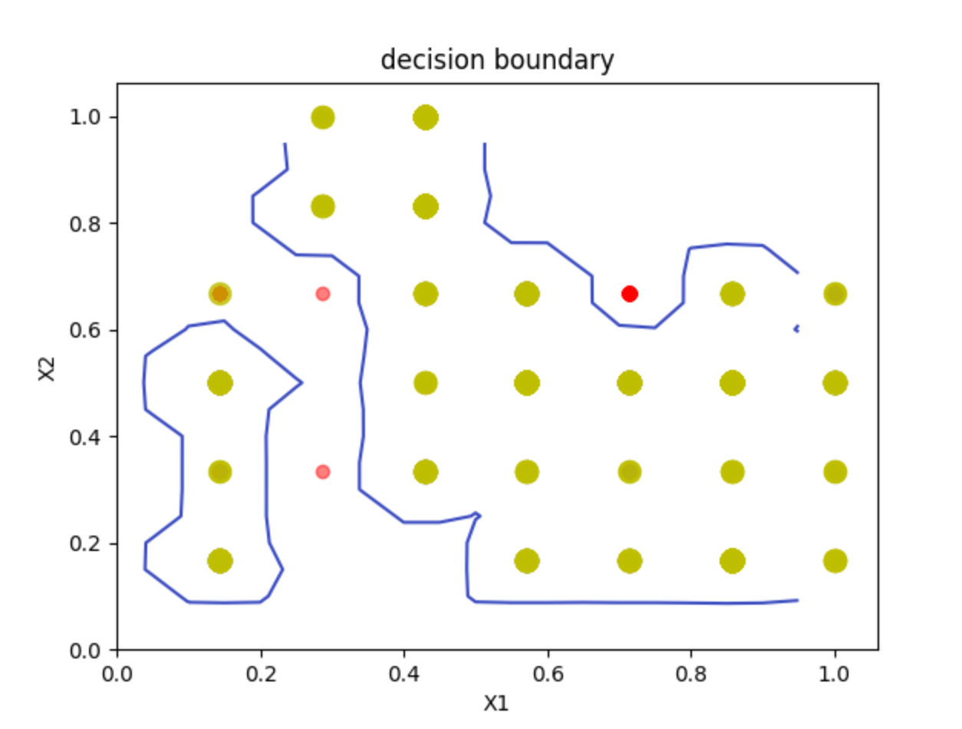

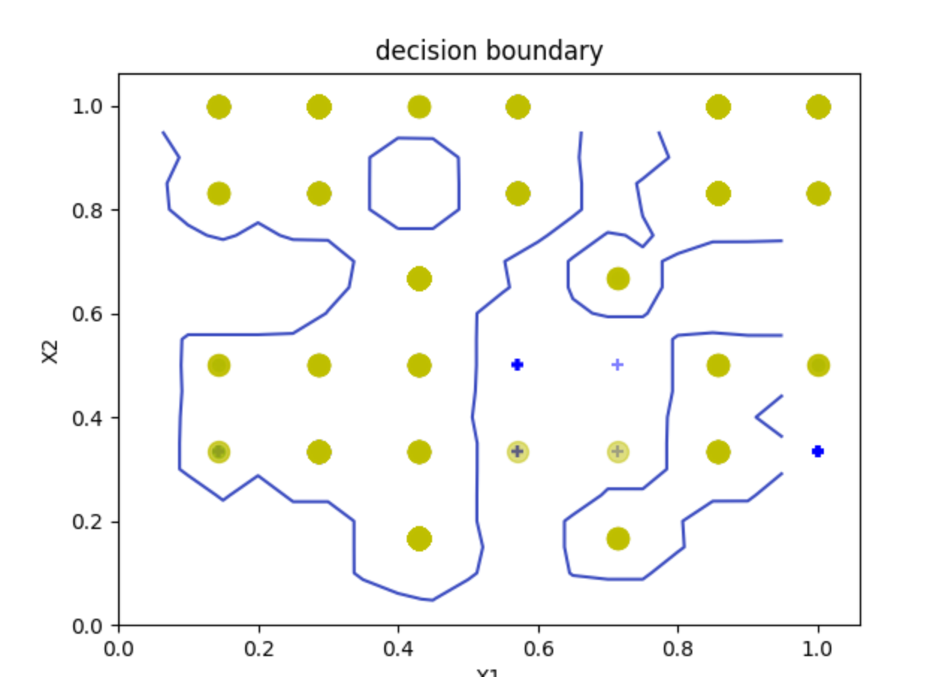

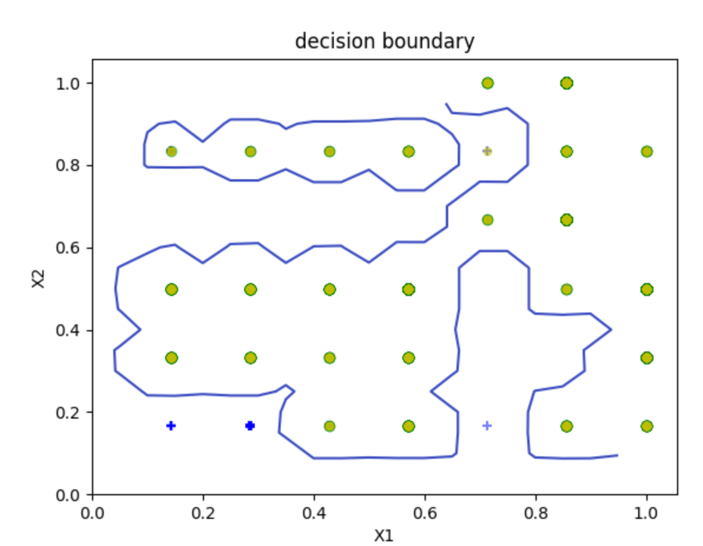

3.3

I just always change the value of C, and run the code to compare the accuracy. The best C maybe between 150 and 200.

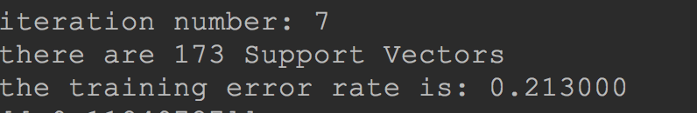

4.1

liner: C tol max_ite



rbf: C gama recall : smop tol max_ite



poly: C degree gama tol max_ite



The accuracy is almost aways 0.80

4.2

add adaboosting to create weak classifiers.

