Prototype of battery powered temperature sensor:

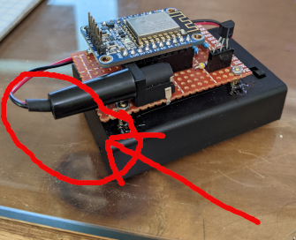
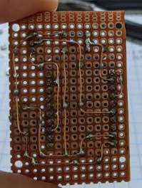
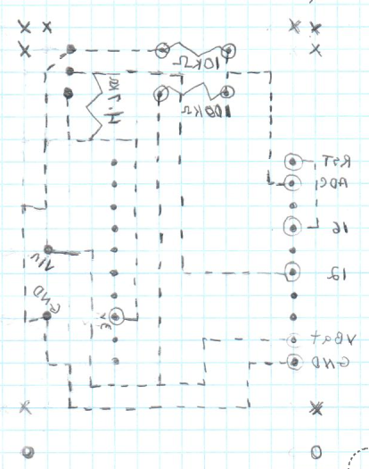
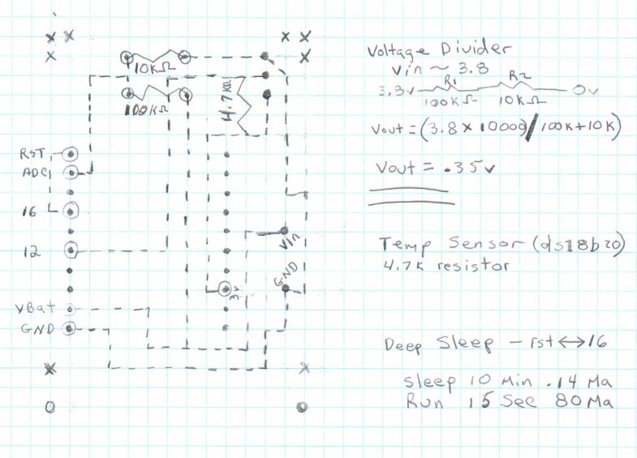
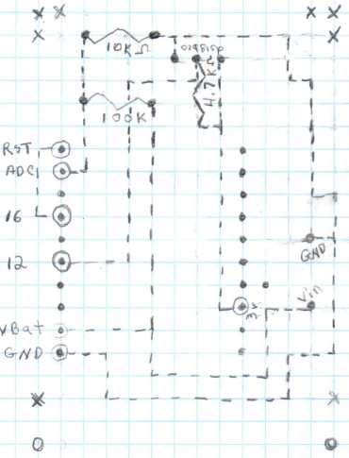
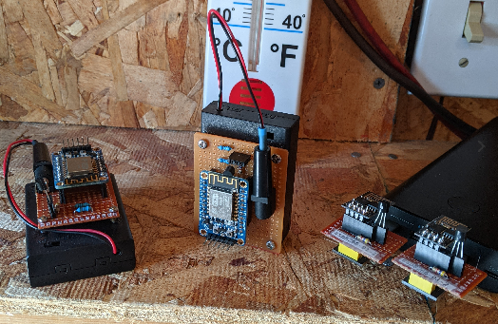
Prototype 1, I Wanted to stand this on end that’s why I aligned the proto-board with battery case :-( proto-2, I will flip connector)
Proto-2 design.
Image of both versions Proto-2 is able to stand up on end. These are battery powered, the other two are usb powered using esp-8266-01 board

