
SPECIFICATIONS FOR LONGHUA LED LMAP
Model: LH-3FCFSWCT

L-3FCFSWCT-1X01000

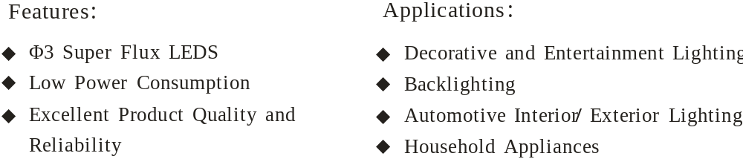

OUTLINE DIMENSIONS AND MATERIALS

尺寸和材料

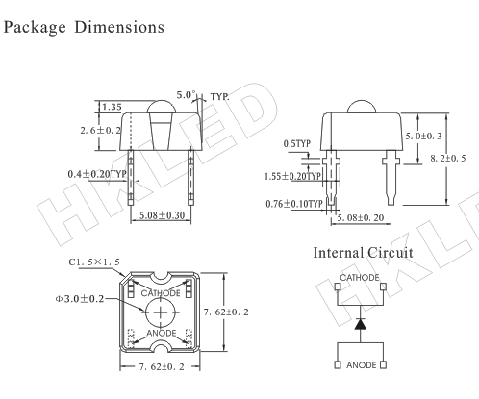

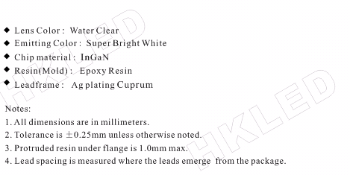

SPECIFICATIONS

Absolute Maximum Ratings

绝对最大额定值
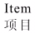 | 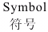 | 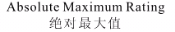 | 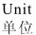
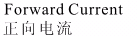 |  | 20 | mA
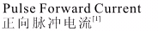 |  | 100 | mA
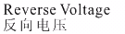 |  | 5 | V
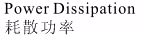 |  | 70 | mW
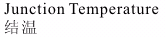 |  | 120 | ℃
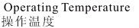 |  | -25 ~ +85 | ℃
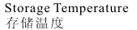 |  | -40 ~ +100 | ℃
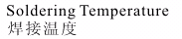 |  | 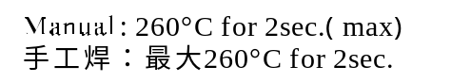

[1] IFP conditions: pluse width 10msec. and duty 0.1
IFP 条件: 脉冲宽度10msec. , 占空比 0.1.

Initial Electrical/Optical Characteristics

初始光电特性
 |  | 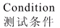 | 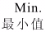 | 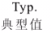 | 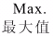
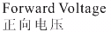 |  | IF=20mA | 2.9 | / | 3.4 | V
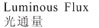 |  | IF=20mA | 5.0 | / | 7.5 | lm
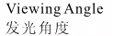 |  | IF=20mA | / | 30 | / | Deg.
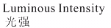 |  | IF=20mA | 8000 | 9000 | /10000 | mcd
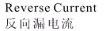 |  | VR=5V | / | / | 10 | uA

BIN CODE

Bin code form: X₁X₂X₃X₄

(1) X₁ : Luminous Flux (If=20mA)
X₁ | Luminous Flux | Unit
E | 3.5-4.5 | lm
F | 4.5-5.5 | lm
G | 5.5-6.5 | lm
H | 6.5-8.0 | lm

X2 X3 : Correlated Color Temperature (If=20mA)
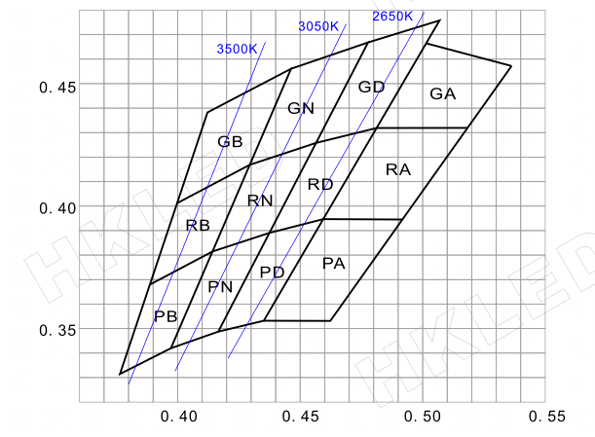
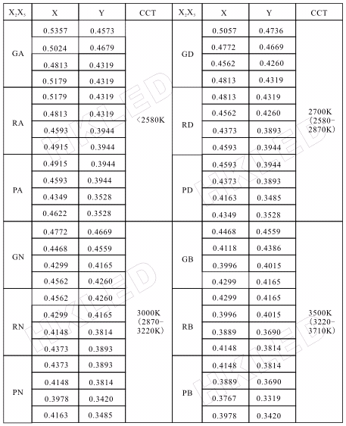
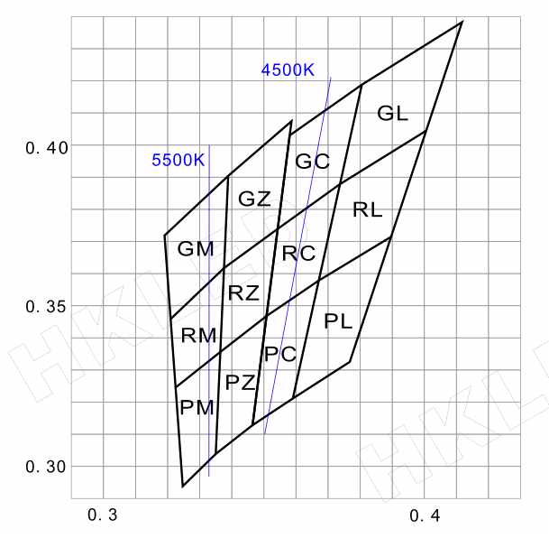
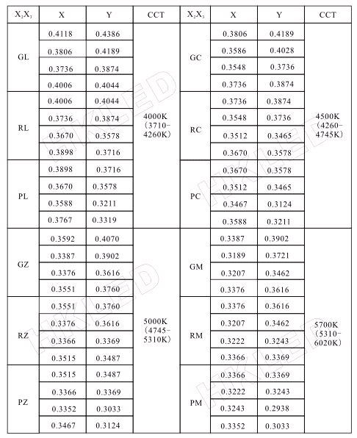
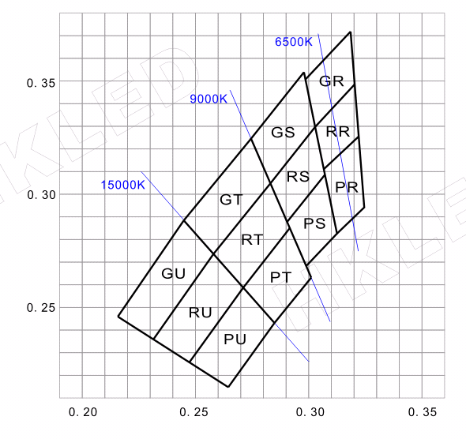
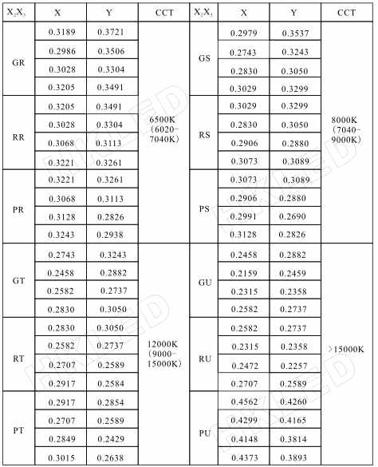

X ₄ : CRI Rank (If=20mA)
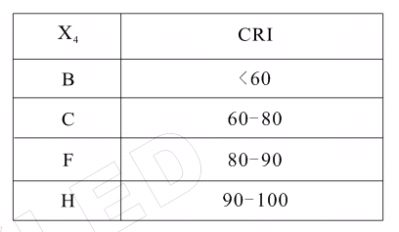

RELIABLITY TESTS

可靠性测试
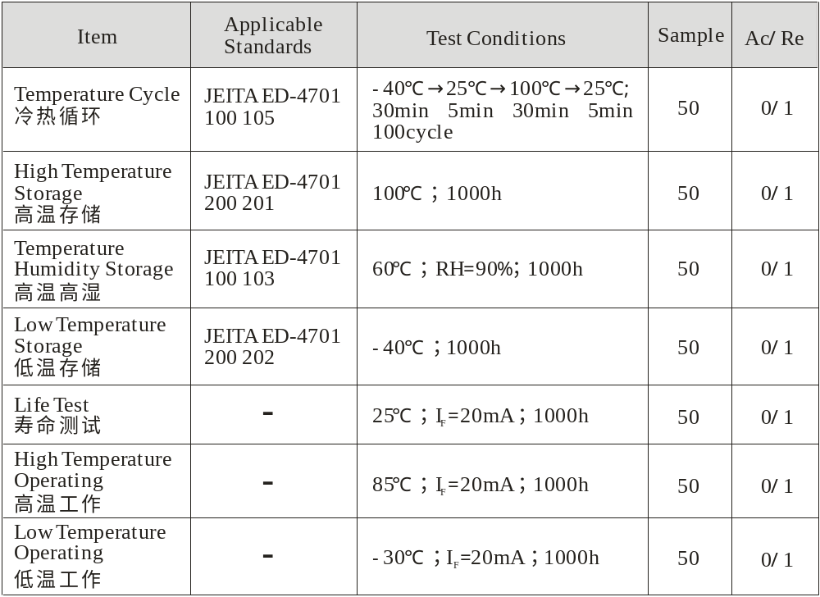

TYPICAL INITIAL OPTICAL/ELECTRICAL CHARACTERISTICS

典型光电特性
Spectrum 光谱 (Ta=25℃ IF=20mA )
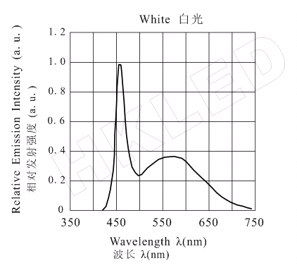

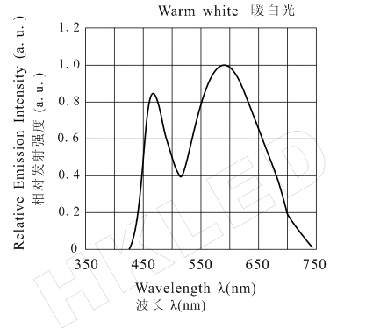

Directivity配光曲线 (Ta=25℃ IF=20mA )
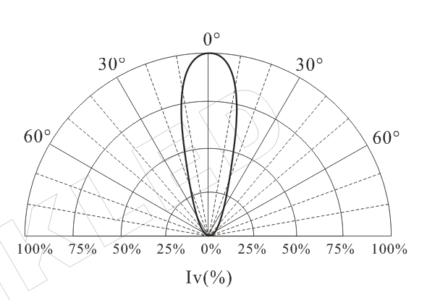

Forward Current & Forward Voltage
伏安特性曲线 (Ta=25℃ )
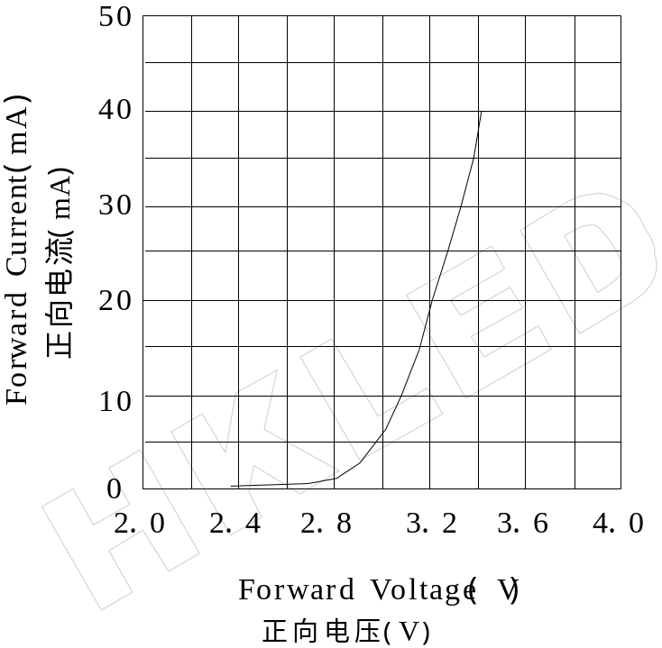

Relative Luminous Flux & Forward Current
相对光通量与正向电流关系特性

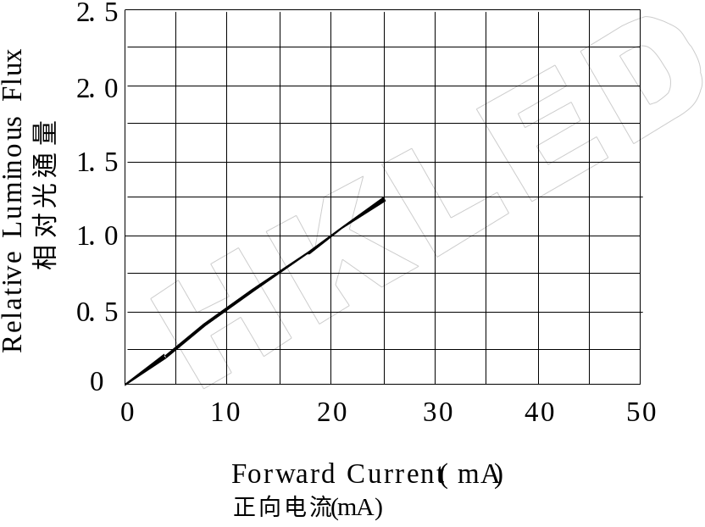

Allowable Forward Current & Ambient Temperature
最大允许正向电流和环境温度关系特性

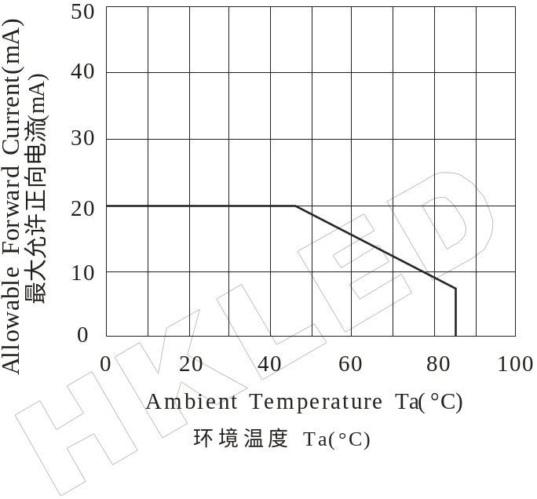

Forward Voltage & Ambient Temperature
正向电压和环境温度关系特性
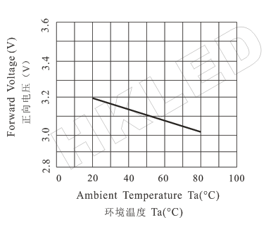

Relative Luminous Flux & Ambient Temperature
相对光通量和环境温度关系特性
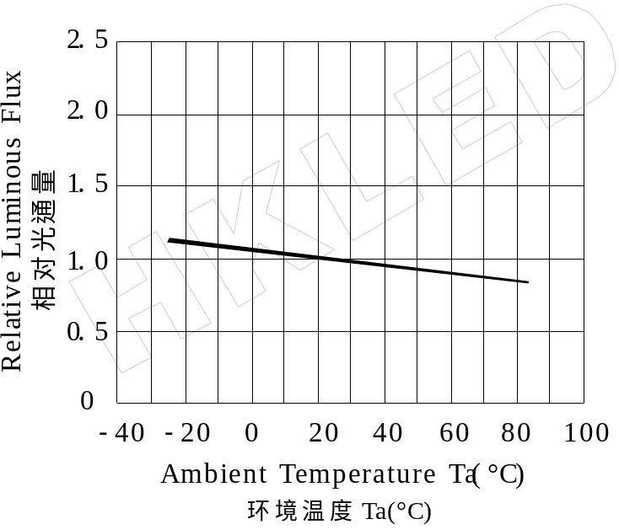

Luminous Flux Attenuation
光衰特性 (IF=20mA Ta=25°C)

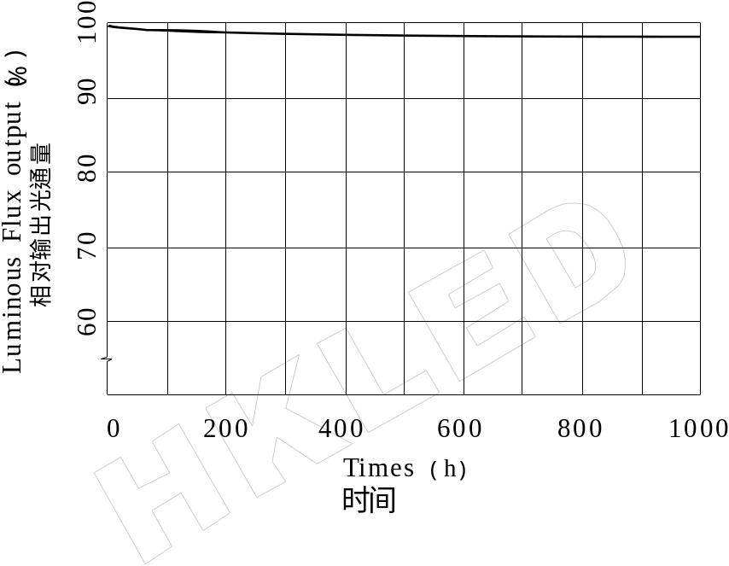

CAUTIONS
