Campaign Spending and Voter Turnout: What the Data Show and What the Research Says
Prepared September 2026
This memo asks two questions of the money spent in American House elections: does it win, and does it get people to the polls? The workbook that accompanies it tests both with official records for 2018 through 2024, and this note sets those results beside forty years of political science on the same questions. The short answer is that spending and winning move together tightly, spending and turnout barely move together at all, and the research explains why the first fact is less impressive than it looks and the second is exactly what one should expect.
The method is simple and runs in one direction. Start with every House race in the country in 2018, 2020 and 2022 where a Democrat faced a Republican, 1,099 races once the FEC filings are matched. For each race take the official vote for each candidate, each candidate's own committee spending over the two-year cycle, and the outside money spent for or against each side. Express both sides as shares: the Democrat's share of the two-party vote and the Democrat's share of the two-party money. Fit a straight line through the 1,099 points, then refit it holding fixed who the incumbent was and which year it was. Then turn to turnout, where the cleanest test is to hold the district lines still: compare the 313 districts that kept the same boundaries and a contested race in both 2018 and 2020, and ask whether the districts where spending rose the most also saw votes cast rise the most. Repeat the turnout test inside Pennsylvania's 70 district-years, where registered voters give a proper denominator, and across seven swing states. Report the slope, its standard error, the p value and the R-squared for each.
On winning, the slope is large and precise (Figure 1). Without controls, a ten-point shift in a race's money share goes with 4.1 points of two-party vote share (standard error 0.07 on the slope, R-squared 0.76). With incumbency and year held fixed the slope falls to 3.2 points per ten points of money, still with a t statistic of 28, and incumbency adds 4.3 points on its own. The side with more money won 88 percent of contested races. Leaving outside money out and counting only the candidates' own committees changes nothing.
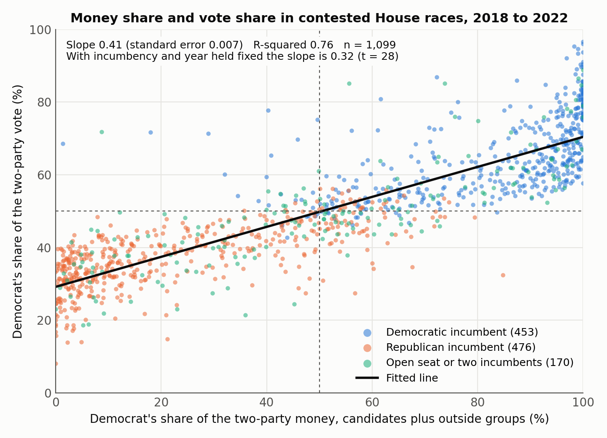
Figure 1. Each point is one contested House race, 2018 to 2022. The line is the ordinary least-squares fit reported in the text.
The research says to read that slope as a ceiling, not an estimate of what a dollar buys. Jacobson's original finding was that challenger spending predicted votes strongly while incumbent spending predicted almost nothing, because incumbents raise and spend most when they are already in trouble. Green and Krasno showed that once challenger quality is measured, incumbent spending matters too. Levitt went further and compared the same pairs of candidates running against each other twice, so that candidate quality cancels out; the effect of spending on vote share nearly vanished, on the order of a third of a point per additional hundred thousand dollars. Gerber, using instruments such as candidate wealth and state population to isolate spending that was not a reaction to the race, found real effects for both sides in Senate elections, roughly equal in size. Erikson and Palfrey formalized the problem: money and closeness cause each other, so a naive regression of votes on money overstates the money. Jacobson's later review settles where the field has settled: campaign spending matters, most for candidates voters know least, and by less than the raw correlations suggest. Our slope of 0.32 sits in the range those older regressions produced before the corrections, which is the right way to describe it.
On turnout, the workbook finds very little, and here the literature is on the same side. In the 313 same-line districts (Figure 2), each additional million dollars spent between 2018 and 2020 goes with 0.11 percentage points more growth in votes cast; the slope is significant at the 5 percent level (p = 0.03) but explains 1.5 percent of the variation, and the proportional version of the test is not significant at all. In Pennsylvania (Figure 3), spending per registered voter does not predict House-race turnout (p = 0.17) or a district's turnout gap to the state (p = 0.54), and neither the advertising dollars nor the mail, phone and field dollars do so on their own. Across the seven swing states the slope is negative and insignificant. The classic observational studies did find that money mobilizes: Cox and Munger reported that both closeness and spending raised turnout in the 1982 House elections, and Jackson found the same for gubernatorial and Senate spending across the states. The largest modern estimate is Enos and Fowler's, who used the boundary between battleground and non-battleground states to show that the full 2012 presidential campaigns raised turnout by seven to eight points where they operated. That is the effect of hundreds of millions of dollars concentrated in a few states over months, with every tool at once. A House race spending a few million dollars in a district that also has a presidential or governor's race at the top of the ballot is a small perturbation on a large tide, and small effects with low R-squared are what such a perturbation should produce.
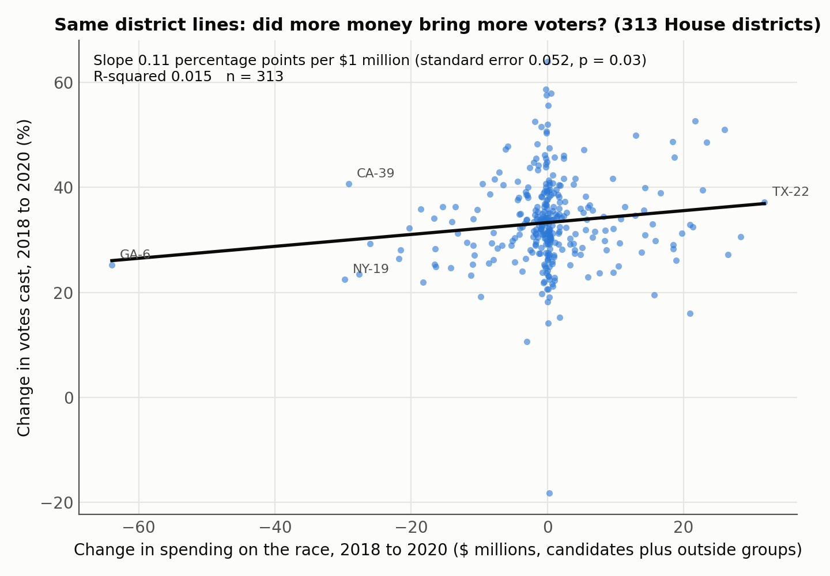
Figure 2. The 313 House districts with unchanged boundaries and a contested race in both 2018 and 2020. The presidential-year surge lifts every district; the slope is the small tilt across them.
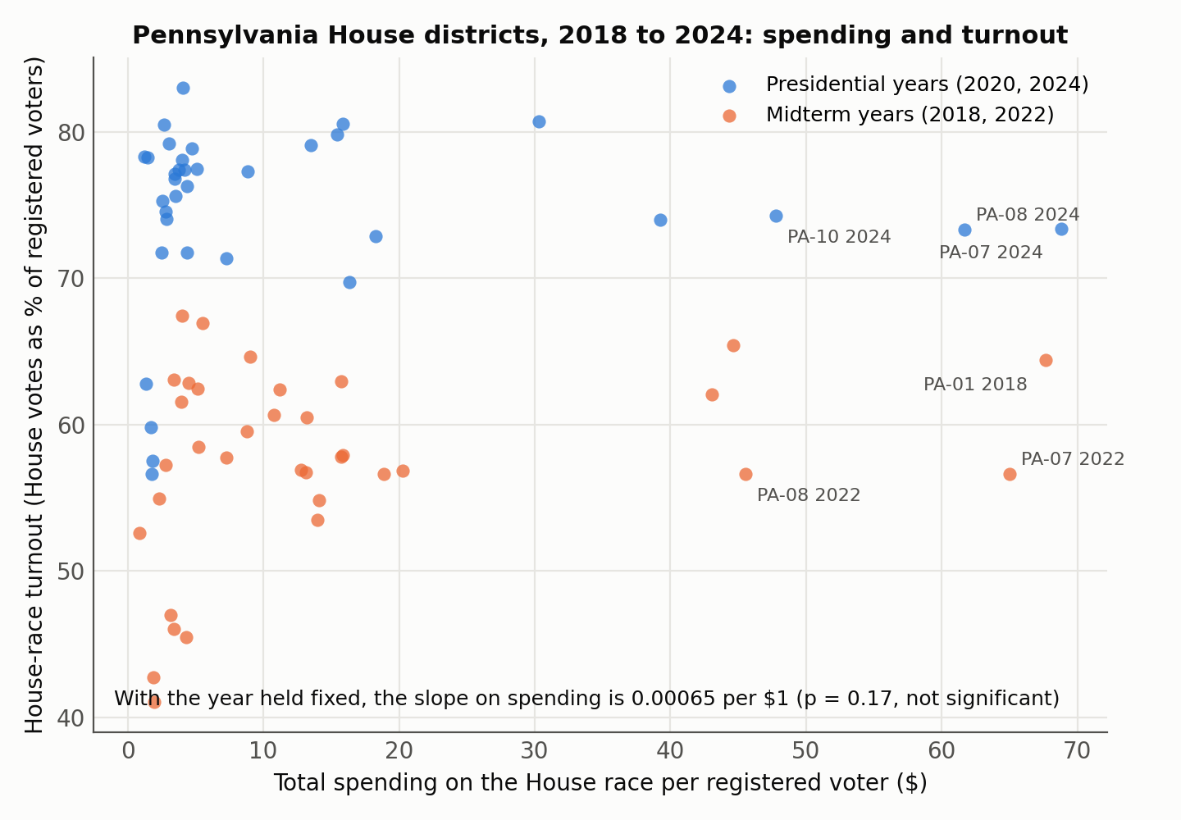
Figure 3. Pennsylvania House districts, 2018 to 2024, from the Department of State precinct files and FEC filings.
The question of which methods work is where the experimental literature is most useful, because no observational dataset, ours included, can separate the tools when campaigns buy them together. Field experiments can. Gerber and Green's first large trial found that door-to-door canvassing raised turnout substantially among the people reached, direct mail raised it slightly, and commercial phone calls did not raise it at all. Two decades of replications, collected in Get Out the Vote, keep that ranking: personal contact at the door is the most cost-effective tool, volunteer phone calls come next, mail and paid phone banks cost several times more per vote produced, and the price per additional vote runs from tens of dollars for canvassing to well over a hundred for mail. Mail can work when it uses social pressure; the mailing that showed households their own and their neighbors' voting records raised turnout by about eight points. Text message reminders raised turnout by about three points in the first randomized test. Even lawn signs have a measured effect, about 1.7 points of vote share in four experiments.
Advertising, which is where most of the money in our workbook goes, is a different story. Krasno and Green used the accident of media markets that straddle battleground and safe states and found that presidential television advertising did little or nothing for turnout. Huber and Arceneaux, with the same kind of design, found that ads persuade rather than mobilize. A randomized experiment in the 2006 Texas governor's race found strong persuasion that faded within a week of the ads stopping. Spenkuch and Toniatti used media market borders across the 2004 to 2012 presidential elections and found that advertising changed who turned out, shifting the partisan mix of the electorate, without changing how many turned out. Sides, Vavreck and Warshaw's study of every race from 2000 to 2018 is the most directly relevant to a House campaign: an advantage of 100 airings moves House vote share by 0.08 to 0.09 points, several times the presidential effect, and the mechanism is persuasion of voters who know little about the candidates, not mobilization. Kalla and Broockman's review of 49 field experiments puts the average persuasive effect of campaign contact and advertising in general elections at zero, with effects appearing only early, in primaries, or on ballot measures. Coppock, Hill and Vavreck ran 59 real-time ad experiments and found effects that were small regardless of message or audience, and Broockman and Green could not detect any effect of online display ads on name recognition or favorability. Freedman, Franz and Goldstein offer the most favorable reading, that ad exposure modestly raises interest and turnout among the least informed.
Put together, the research and the workbook tell one consistent story. Money is a strong signal of who will win because it flows to the candidates and races that were already going to be close or already had the better candidate; the part of the money that actually changes votes is real but much smaller than the 0.32 slope, and it works mostly by persuading low-information voters in down-ballot races, not by bringing new voters out. Turnout responds to sustained personal contact, and to the full weight of a presidential campaign in a targeted state, far more than to advertising dollars, which is why a district-level regression of turnout on total spending finds so little. The advertising share of House candidates' operating budgets in the workbook is between a third and a half (Figure 4); the tools the experiments rank highest, canvassing, volunteer calls and social-pressure mail, are a small fraction of the rest.
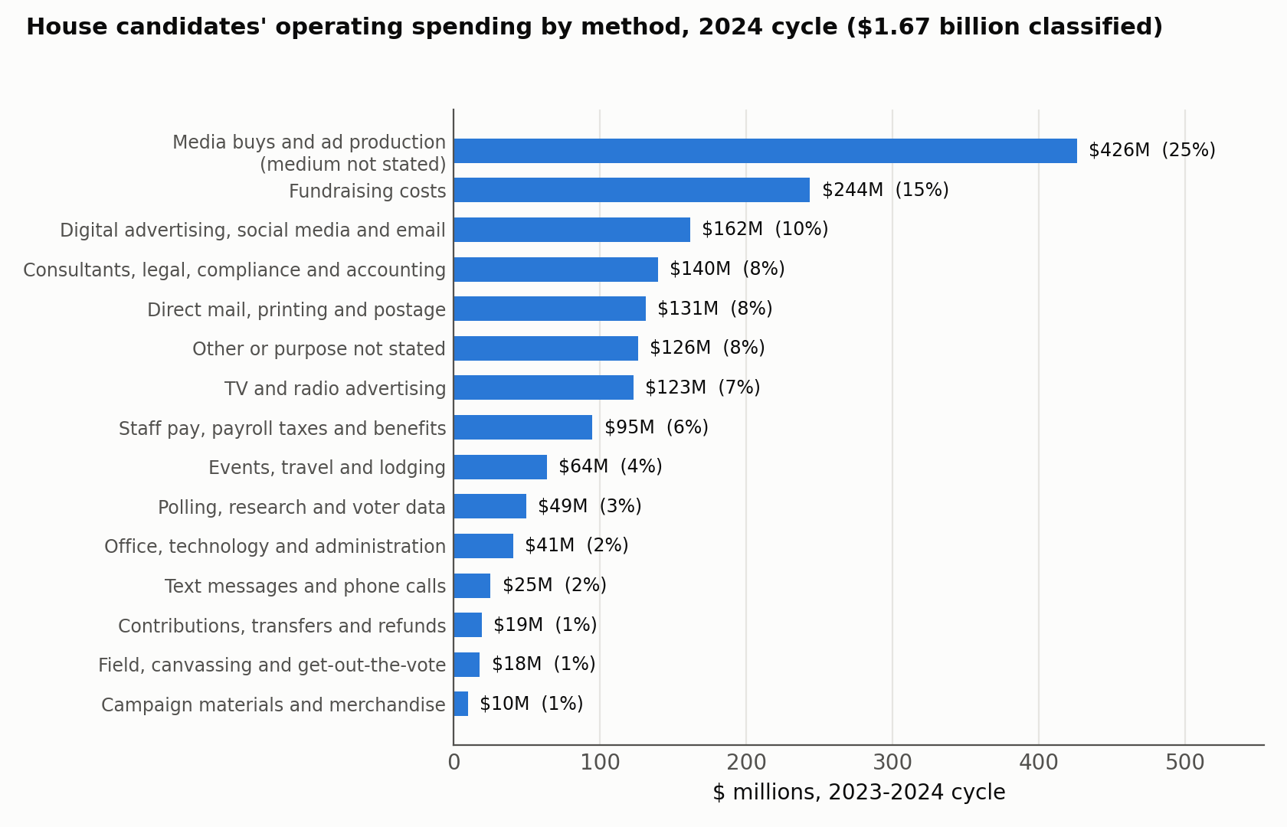
Figure 4. Operating expenses of all House candidate committees in the 2023-2024 cycle, classified from the purpose text in FEC filings; independent expenditures by outside groups are not included.
The way to get past association would be to use the same designs the literature uses. Within PA-07 the precinct file already provides the outcome side at the finest official resolution; what it lacks is the treatment side. A campaign's own contact records, which precincts were canvassed, called, or mailed and when, would allow a within-district comparison of contacted and uncontacted precincts against the registration and turnout base already built, and a randomized allocation of that contact across matched precincts would turn the comparison into an experiment of the kind that produced every reliable number cited above.

Spending: Federal Election Commission, statistical summaries of 24-month campaign activity and the OpenFEC candidate totals and independent expenditure endpoints; operating expenses by purpose from the FEC bulk operating expenditure files, 2017-2024. Votes: FEC, Federal Elections 2018, 2020 and 2022; Pennsylvania Department of State precinct returns and registration files, 2018-2024. Turnout denominators: University of Florida Election Lab, General Election Turnout Rates. All figures in this memo are from the accompanying workbook, Campaign_Spending_vs_Voter_Turnout.xlsx.
Gary C. Jacobson, "The Effects of Campaign Spending in Congressional Elections," American Political Science Review 72, no. 2 (1978): 469-91.
Donald P. Green and Jonathan S. Krasno, "Salvation for the Spendthrift Incumbent: Reestimating the Effects of Campaign Spending in House Elections," American Journal of Political Science 32, no. 4 (1988): 884-907.
Steven D. Levitt, "Using Repeat Challengers to Estimate the Effect of Campaign Spending on Election Outcomes in the U.S. House," Journal of Political Economy 102, no. 4 (1994): 777-98.
Alan Gerber, "Estimating the Effect of Campaign Spending on Senate Election Outcomes Using Instrumental Variables," American Political Science Review 92, no. 2 (1998): 401-11.
Robert S. Erikson and Thomas R. Palfrey, "Equilibria in Campaign Spending Games: Theory and Data," American Political Science Review 94, no. 3 (2000): 595-609.
Gary C. Jacobson, "How Do Campaigns Matter?," Annual Review of Political Science 18 (2015): 31-47.
Gary W. Cox and Michael C. Munger, "Closeness, Expenditures, and Turnout in the 1982 U.S. House Elections," American Political Science Review 83, no. 1 (1989): 217-31; Robert A. Jackson, "The Mobilization of U.S. State Electorates in the 1988 and 1990 Elections," Journal of Politics 59, no. 2 (1997): 520-37.
Ryan D. Enos and Anthony Fowler, "Aggregate Effects of Large-Scale Campaigns on Voter Turnout," Political Science Research and Methods 6, no. 4 (2018): 733-51.
Alan S. Gerber and Donald P. Green, "The Effects of Canvassing, Telephone Calls, and Direct Mail on Voter Turnout: A Field Experiment," American Political Science Review 94, no. 3 (2000): 653-63.
Donald P. Green and Alan S. Gerber, Get Out the Vote: How to Increase Voter Turnout, 4th ed. (Washington, DC: Brookings Institution Press, 2019).
Alan S. Gerber, Donald P. Green, and Christopher W. Larimer, "Social Pressure and Voter Turnout: Evidence from a Large-Scale Field Experiment," American Political Science Review 102, no. 1 (2008): 33-48.
Allison Dale and Aaron Strauss, "Don't Forget to Vote: Text Message Reminders as a Mobilization Tool," American Journal of Political Science 53, no. 4 (2009): 787-804.
Donald P. Green, Jonathan S. Krasno, Alexander Coppock, Benjamin Farrer, Jared L. Lenoir, and Joshua N. Zingher, "The Effects of Lawn Signs on Vote Outcomes: Results from Four Randomized Field Experiments," Electoral Studies 41 (2016): 143-50.
Jonathan S. Krasno and Donald P. Green, "Do Televised Presidential Ads Increase Voter Turnout? Evidence from a Natural Experiment," Journal of Politics 70, no. 1 (2008): 245-61.
Gregory A. Huber and Kevin Arceneaux, "Identifying the Persuasive Effects of Presidential Advertising," American Journal of Political Science 51, no. 4 (2007): 957-77.
Alan S. Gerber, James G. Gimpel, Donald P. Green, and Daron R. Shaw, "How Large and Long-Lasting Are the Persuasive Effects of Televised Campaign Ads? Results from a Randomized Field Experiment," American Political Science Review 105, no. 1 (2011): 135-50.
Jörg L. Spenkuch and David Toniatti, "Political Advertising and Election Results," Quarterly Journal of Economics 133, no. 4 (2018): 1981-2036.
John Sides, Lynn Vavreck, and Christopher Warshaw, "The Effect of Television Advertising in United States Elections," American Political Science Review 116, no. 2 (2022): 702-18.
Joshua L. Kalla and David E. Broockman, "The Minimal Persuasive Effects of Campaign Contact in General Elections: Evidence from 49 Field Experiments," American Political Science Review 112, no. 1 (2018): 148-66.
Alexander Coppock, Seth J. Hill, and Lynn Vavreck, "The Small Effects of Political Advertising Are Small Regardless of Context, Message, Sender, or Receiver: Evidence from 59 Real-Time Randomized Experiments," Science Advances 6, no. 36 (2020): eabc4046; David E. Broockman and Donald P. Green, "Do Online Advertisements Increase Political Candidates' Name Recognition or Favorability? Evidence from Randomized Field Experiments," Political Behavior 36, no. 2 (2014): 263-89.
Paul Freedman, Michael Franz, and Kenneth Goldstein, "Campaign Advertising and Democratic Citizenship," American Journal of Political Science 48, no. 4 (2004): 723-41.

