Three Forecasting Methods for PA-07, 2026
A Walkthrough for the Class: Trend, Beta-Adjusted, and Regression
PA-07 Election Forecasting Project — Kiley

1. The Three Methods at a Glance
All three methods answer the same question — what will PA-07's House vote share look like in 2026? — but they get there through fundamentally different logic. Understanding WHY they differ is more useful than just knowing their final numbers.
Method | Core Idea | Inputs Used | 2026 Forecast
Trend | Draw a straight line through each town's own history and extend it forward | Only that town's own past vote shares (2018-2024) | 47.7% Dem — Republican
Beta-Adjusted | Scale the district's overall projected shift by how much each town historically amplifies or dampens district swings | District-wide trend + each town's own sensitivity (beta) to that trend | 46.8% Dem — Republican
Regression | Predict each town's share from a formula built on several variables at once, fit across all towns together | Registration lean, education, election type, and last cycle's result | 50.6% Dem — Democrat

Two of three call it Republican. The regression — built on the most variables — calls it Democrat, and as Section 4 shows, it's also the method that performed worst when tested against real 2024 results. That disagreement, not any single number, is the actual finding to present to the class.

2. Methodological Differences, Explained

Trend: the simplest possible baseline
Town Share(2026) = a + b × Year, fit on that town's own 4 elections
Each municipality gets its own line. It doesn't know anything about any other town, and it doesn't use any variable except time and that town's own past results. This is intentionally the crudest method in the set — the "beat this" baseline the project description calls for.

Beta-Adjusted: borrowed from finance
Town Share(2026) = Town Share(2024) + β × [District Trend(2026) − District Actual(2024)]
Beta measures how much a town's results move relative to the WHOLE district's movement — the same concept as a stock's beta against a market index. Instead of each town running on its own independent line (as in Trend), every town is tied to a single district-wide shift, scaled by how sensitive that particular town has historically been. A high-beta town gets a bigger nudge than a low-beta town, even though both start from the same district-level assumption.

Regression: many variables, fit together
Town Share = b0 + b1(Reg D−R) + b2(%Bachelor's) + b3(Pres. Year) + b4(Lagged Share)
This is the only method that uses information about the town beyond its own voting history — registration lean and education level — and the only one that estimates all coefficients simultaneously across all 89 towns at once, rather than fitting each town separately. In principle this should be the most powerful method, since it uses the most information. In practice, Section 4 shows why more information didn't translate into a better forecast this time.

3. Which Variables Mattered — and Which Didn't
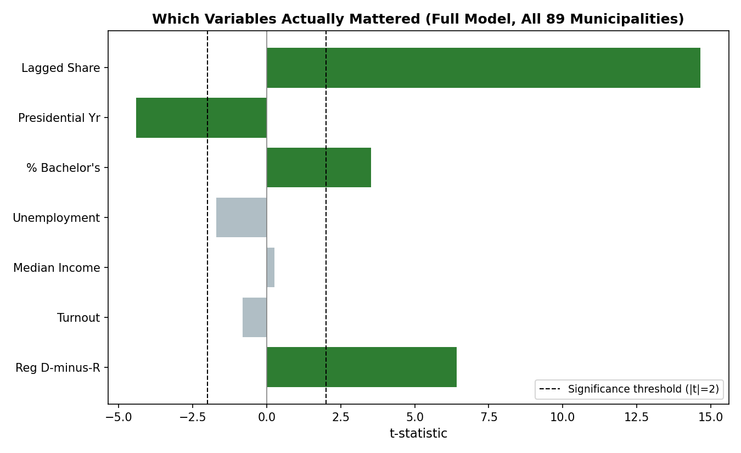
Figure 1. t-statistics for each regression variable. Bars past the dashed line are statistically meaningful; bars that don't reach it are not distinguishable from noise in this sample.
Variable | Mattered? | Why
Lagged Dem Share (last cycle's result) | Yes — by far the strongest | Political lean is sticky. This alone explains most of the model's predictive power.
Registration D-minus-R | Yes | A town's current partisan registration lean is a strong, independent predictor beyond just its last result.
% Bachelor's Degree | Yes | Education remains one of the sharpest dividing lines in recent PA elections, even controlling for registration.
Presidential Year (dummy) | Yes | Presidential-year turnout composition measurably shifts results, independent of anything else in the model.
Turnout % | No | Once registration lean and lagged share are in the model, raw turnout level adds nothing extra.
Median Income | No | Essentially zero effect once education and registration are already accounted for.
Unemployment Rate | Borderline | Close to significant but not reliably so in this sample — worth re-testing with more data.

The practical lesson for the class: adding a variable because it seems intuitively relevant (income, unemployment) doesn't guarantee it helps. Registration lean and lagged share alone carry almost all of the model's explanatory power — everything else is a smaller refinement.

4. Why the Regression — the Most Sophisticated Method — Performed Worst
This is the central teaching moment of this project.
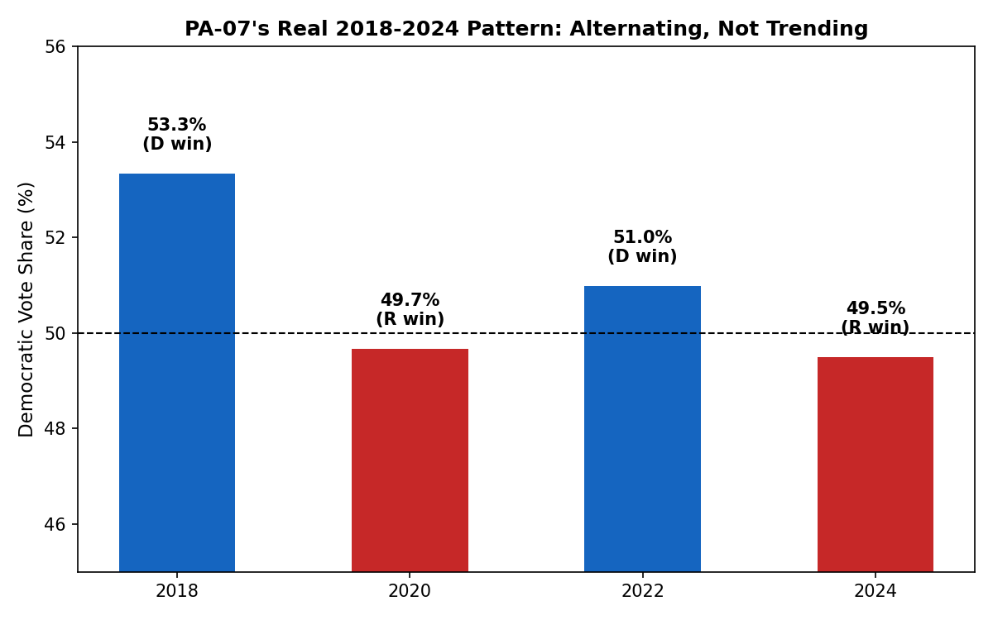
Figure 2. PA-07's real 2018-2024 pattern doesn't trend steadily — it alternates D-R-D-R every single cycle.
The regression leans heavily on the Lagged Dem Share variable — essentially, 'this cycle looks like last cycle, plus some adjustment.' That works well when a district trends steadily in one direction. It works poorly when a district alternates, because the model keeps expecting continuation of a pattern that isn't there. The Trend and Beta-Adjusted methods, which fit a slope across all 4 cycles at once rather than anchoring hard to the most recent result, absorbed the back-and-forth pattern more gracefully.
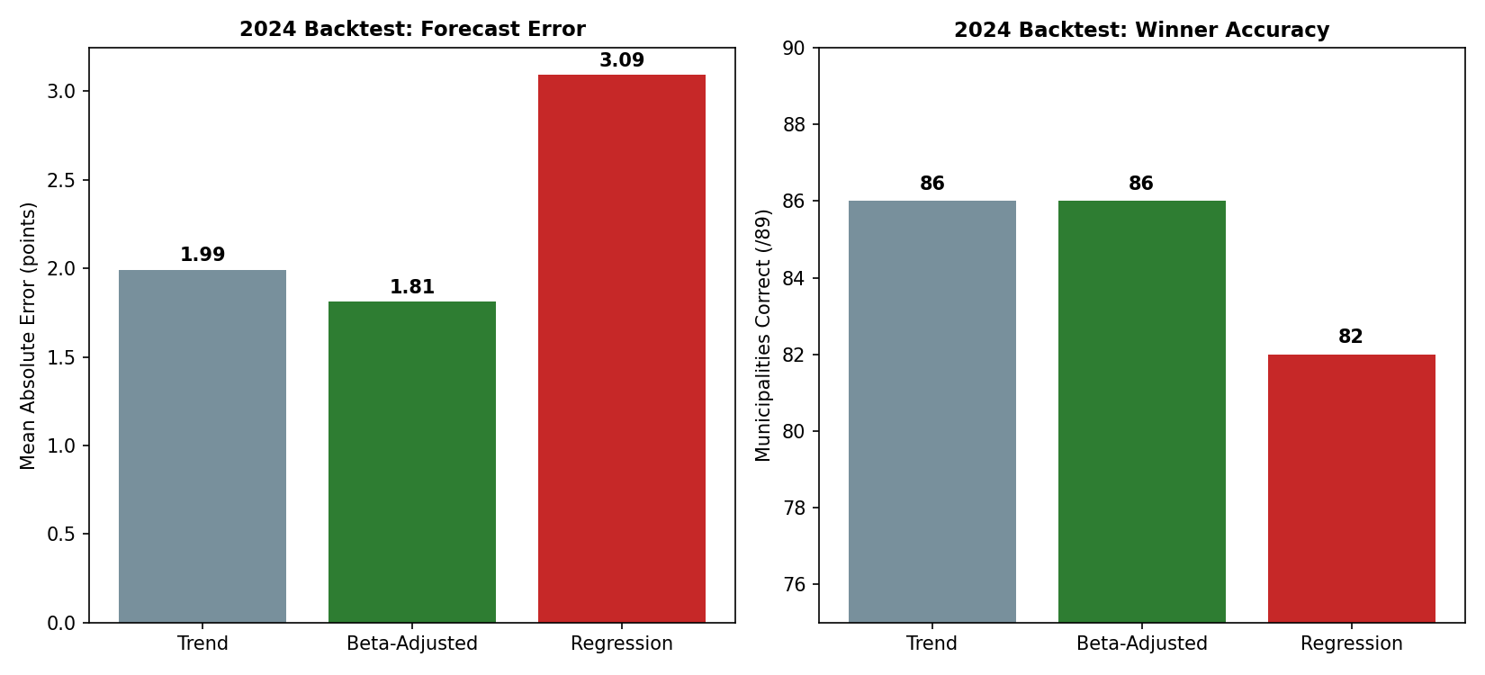
Figure 3. All three methods, tested against real 2024 results using only prior-cycle data. Regression has both the highest error and the lowest accuracy.
Method | 2024 Backtest MAE | 2024 Backtest Accuracy
Trend | 1.99 pts | 86 / 89
Beta-Adjusted | 1.81 pts | 86 / 89
Regression | 3.09 pts | 82 / 89

This is a genuinely useful result to report, not a failure to hide: it shows that a model's success depends on whether its core assumption matches the actual shape of the data, not on how many variables it uses. More sophistication is not automatically better.

5. Suggested Next Steps
- Adopt the beta-adjusted forecast as the class's primary point estimate for now, since it has the best track record — but present all three, since the spread between them is itself the honest uncertainty range.
- Test whether a modified regression — one that down-weights the lagged-share term, or adds an explicit 'alternation' term — handles the D-R-D-R pattern better than the current specification.
- Test Mail D-Share (from the companion Registration & Voting Mechanism analysis) as a new regression predictor — it correlates with actual results at r=0.53, stronger than turnout alone, and hasn't been tried yet.
- Re-run this entire comparison once more 2026 data exists (primary results, updated registration), to see whether the ranking holds or shifts again as the election gets closer.
- Consider an ensemble: average the three methods' forecasts rather than picking one, and test whether the average backtests better than any single method alone — a standard practice among real election forecasters.

