### Hi [Name],

### Let’s stay connected.

### Cummins Allison is the leading innovator and provider of cheque, currency and coin handling solutions. In the past you had indicated interest in being informed on products, services, events, and offers available in your market.

### We would love to continue sending you information regarding our products, services and events that are of interest to you. It takes just one click to stay connected!

### [YES, continue sending me new product news and updates.]

### Of course, you can unsubscribe at any time. If you’d like to stop receiving emails from us, click the unsubscribe link and you’ll be removed from our mailing list immediately.

### If you have any questions or concerns please do not hesitate to contact us. Thank you in advance for continuing your business relationship with Cummins Allison.

### If we have not received your consent by June 30, 2017 you will be automatically removed from our mailing list. Click here for more information about CASL and Canada’s anti-spam legistlation.

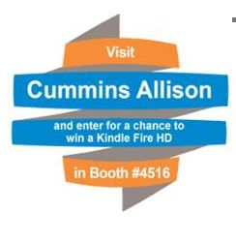

Potential Copy??? I see us using just the two blue areas and leaving the orange areas blank…

**Count, Sort, Image and Authenticate**

Innovative solutions for processing currency, coins, cheques and more

**It’s easy to stay connected.**

To continue receiving product news and

information from Cummins Allison,

pease click the consent button below.

**[YES, continue sending me new product**

**news and updates.]**

If we have not received your consent by June

30, 2017 you will be automatically removed from

our mailing list. Click here for more

information about CASL and Canada’s anti-spam legistlation.